**Steps to configure MongoDB**

1. Download the *MongoDB* (version 2.4.9) from the following URL

**http://downloads.mongodb.org/win32/mongodb-win32-x86_64-2.4.9.zip**

1. Copy downloaded file in your local machine(say D:\ mongodb-win32-x86_64-2.4.9.zip)
2. Extract the zip file in a folder (say D:\work\mongodb-win32-x86_64-2.4.9\). In this document this path is referred as ***MONGO_DIR.***
3. Open a command prompt and navigate to ***MONGO_DIR\*** ***mongodb-win32-x86_64-2.4.9\bin.***
4. Create a empty subdirectory in bin directory with name **data**.
5. Run the command “*mongod.exe –dbpath ..\data\ --auth*”.
6. In another terminal navigate to ***MONGO_DIR\*** ***mongodb-win32-x86_64-2.4.9\bin.***
7. Run the command “*mongo.exe*”.
8. Run the command “use admin”.
9. Run the command “db.addUser( { user: "myadmin",pwd: "myadmin",roles: ["read" , "readWrite" , "dbAdmin" , "userAdmin" , "clusterAdmin" , "readAnyDatabase" , "readWriteAnyDatabase" , "dbAdminAnyDatabase" , "userAdminAnyDatabase"] } )”
10. Close the terminal started in step 7.
11. Stop the service running in step 4’s terminal.
12. Run the command “*mongod.exe –dbpath ..\data\ --auth*”.
13. Download the MongoDB client *UMongo* from the following URL

<https://s3.amazonaws.com/edgytech/umongo-windows-all_1-6-2.zip>

1. Copy downloaded file in your local machine(say D:\ umongo-windows-all_1-6-2.zip)
2. Extract the zip file in a folder (say D:\work\umongo-windows-all_1-6-2\). In this document this path is referred as ***UMONGO_DIR.***
3. Open a command prompt and navigate to ***UMONGO_DIR\*** ***umongo-windows-all_1-6-2\bin.***
4. Run the command “*mongo.exe*”.
5. A UI should open.
6. In this UI press Cltr+K key from keyboard.
7. Another popup should open as follows

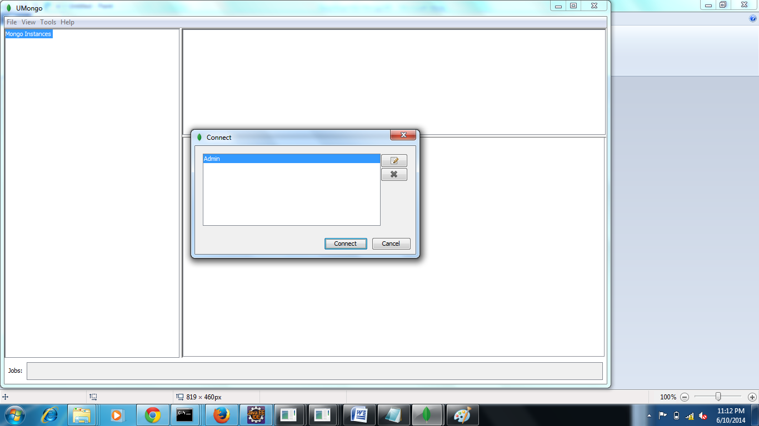

1. Click on edit button as highlighted below

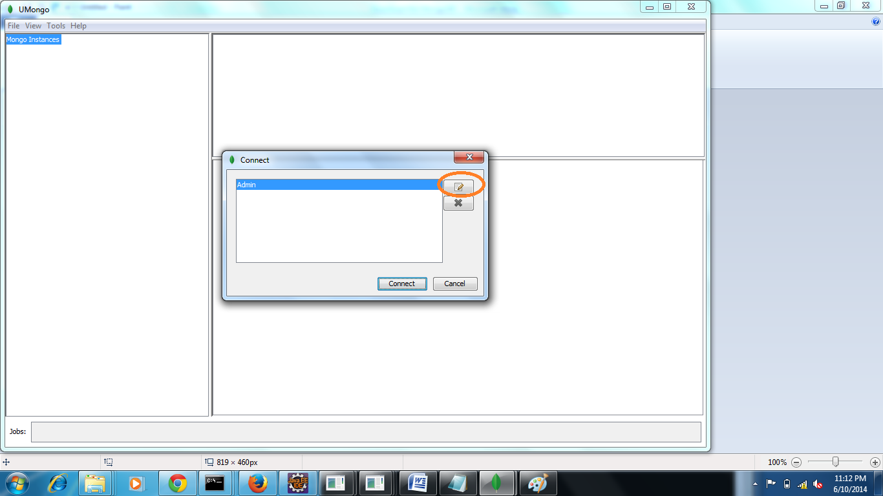

1. A window will open fill the values as shown below

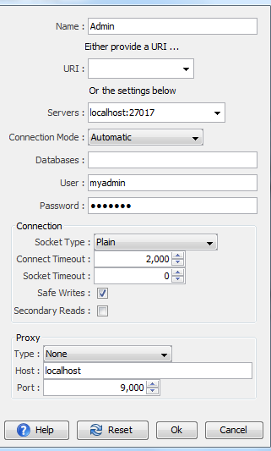

1. Press Ok. The following window would appear

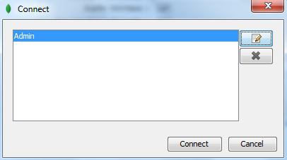

1. Press the Connect Button. The following window would open

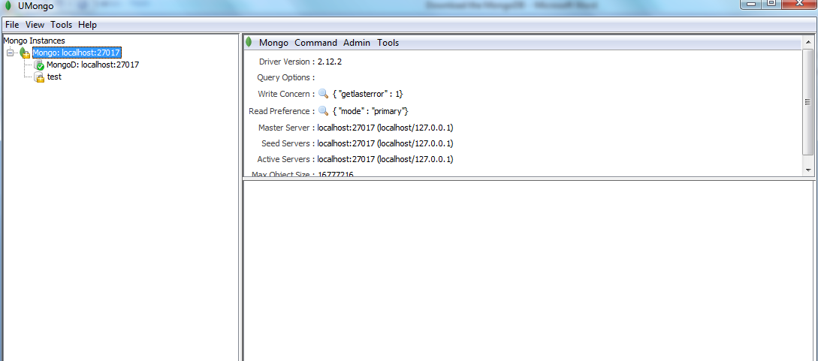

1. Right click on the highlighted text in above window. The following options should appear

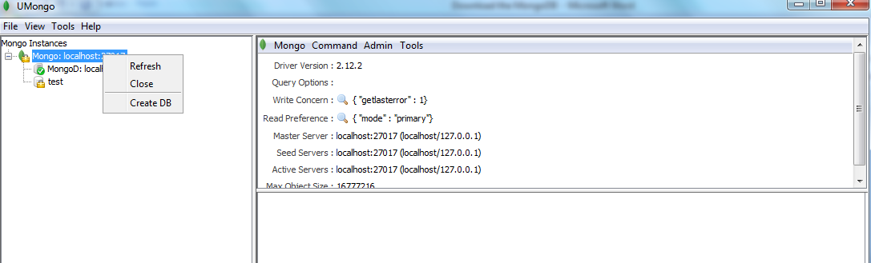

1. Click on Create DB option. The following window would appear

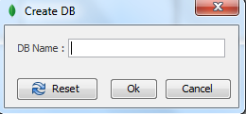

1. Insert db name as “**WineAccess**”. Press OK
2. Now select db “WineAccess” from the left panel and User menu from the right panel as shown in following window

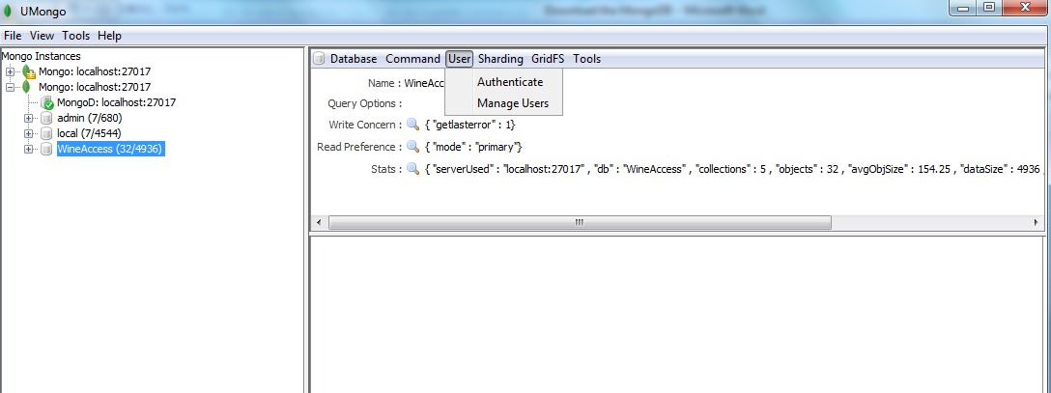

1. Click on Manage Users. The following window would appear

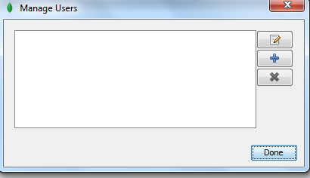

1. Press the Add Button (Icon for +) on right. The following window would appear

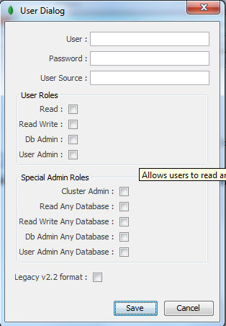

1. Create a user mongo having password mongo as shown below

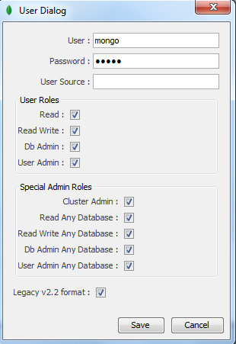

1. Click Save button.