Steps to Configure Lucene search engine

1. Download the elasticSearch from the URL  
   [**http://www.elasticsearch.org/downloads/1-0-0/**](http://www.elasticsearch.org/downloads/1-0-0/)
2. Copy the compressed file in a location and extract its content. For this document It is assumed that **<Elastic_Search_Home>** represents the directory.
3. Open a command prompt and navigate to **<Elastic_Search_Home>\bin.**
4. Run the following commands
   * plugin.bat -install elasticsearch/elasticsearch-mapper-attachments/1.9.0
   * plugin.bat -i com.github.richardwilly98.elasticsearch/elasticsearch-river-mongodb/2.0.0
   * elasticsearch.bat
5. Open a new terminal and navigate to directory where MongoDB is installed. Say this location is **<MONGO_DB_HOME>**
6. cd bin
7. run command

mongod.exe --dbpath ..\data\ --replSet=rs01

1. Open a new terminal and navigate to **<MONGO_DB_HOME>\bin**
2. Run following commands
   * mongo.exe
   * rs.initiate()
   * rs.slaveOk()
3. Run the mongo client( for example Umongo) by following the steps(17-20,25,29) as mentioned in “Steps_To_Configure_MongoDB.doc” present in the same directory.
4. Right click on “WineAccess”. The following window should appear

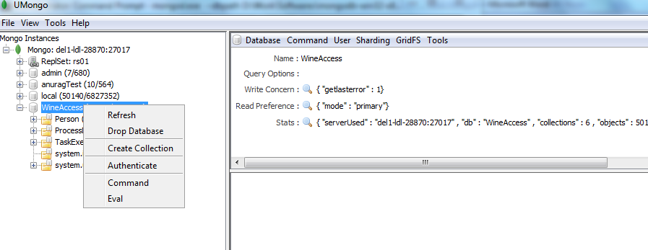

1. Click on Create Collection menu item.
2. The following window should open

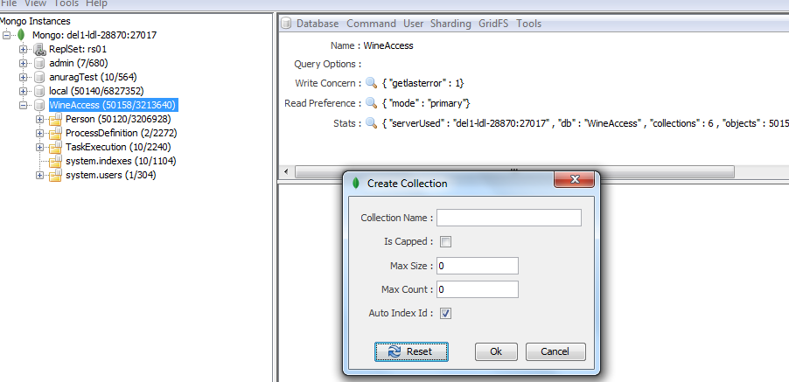

1. Enter Collection Name as **Person** and press OK.
2. Expand WineAccess db and select Person Collection. Do a right click as shown below

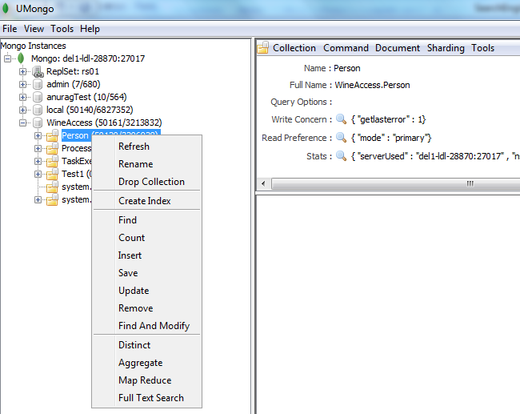

1. Select I*nsert* menu the following window should open

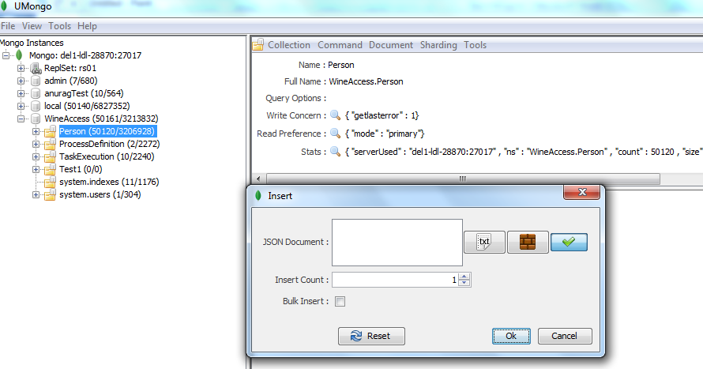

1. In the “json document” textbox paste the following json

{"firstName":"Anurag","lastName":"Jain"}

1. In the “Insert Count” textbox update it to 50000.
2. Press OK.
3. Open rest client in mozila firefox.
4. Set custom header "Content-Type" as "application/json".
5. In the method dropdown select PUT.
6. In the URL placeholder type following URL.

http://localhost:9200/_river/wineaccess/_meta

1. In the request body paste the following json

{

"type": "mongodb",

"mongodb": {

"servers":

[

{ "host": "localhost", "port": 27017}

],

"credentials":

[

{ "db": "admin", "user": "myadmin", "password": "myadmin" }

],

"db": "WineAccess",

"collection": "Person"

},

"index": {

"name": "mongoindex",

"type": "person"

}

}

1. Restrart the elastic serach(which was started in step 4 of this document).
2. Open browser and hit the following URL

<http://localhost:9200/mongoindex/_search?q=firstName:Anurag>

1. Search Result should start appearing