Autonomous Multi-Agent Research Scientist
(Primary Domain: Education | Extensions: Healthcare & Agriculture)

Project Overview
Project Type: Agentic AI Application
Primary Track: Education
Extensions: Healthcare, Agriculture

One-line Description
An agentic AI application where multiple autonomous agents collaboratively plan, reason, evaluate, and refine educational workflows, with safe and scalable extensions to healthcare and agriculture.

Why This Project
Education lacks scalable personalization. Students learn at different speeds and with different gaps, but current AI tools provide one-shot responses without planning, evaluation, or self-improvement.
This project demonstrates true Agentic AI by simulating how a team of intelligent agents autonomously work together—similar to human educators—to plan tasks, reason deeply, critique outputs, and improve results without repeated human prompting.

Problem Statement
Students have diverse learning needs, yet learning support systems remain mostly static and manual.
Existing AI tools respond to prompts but lack autonomy, iteration, and quality control.
Problem:
How can we design an autonomous AI system that plans learning tasks, reasons deeply, critiques itself, and continuously improves educational support with minimal human intervention?

Solution Summary
We propose a Multi-Agent Research & Learning Engine composed of specialized AI agents that collaborate in an autonomous loop:
- Planner Agent – Breaks tasks into steps
- Research Agent – Gathers relevant domain knowledge
- Reasoning Agent – Synthesizes structured explanations
- Critic Agent – Evaluates quality, clarity, and safety
- Writer Agent (Optional) – Formats final output
The system iterates automatically until predefined quality thresholds are met.

Agent Architecture (Core System)

Agents & Responsibilities
Planner Agent
- Understands user intent
- Creates an execution plan
- Controls task flow
Research Agent
- Retrieves or generates relevant knowledge
- Identifies key concepts and sources
Reasoning Agent
- Builds structured explanations
- Resolves contradictions
- Applies domain logic
Critic Agent
- Evaluates correctness, clarity, and safety
- Assigns quality score
- Triggers refinement loop if needed
Writer Agent (Optional)
- Formats output for user readability

Autonomy Loop (Decision Flow)
User Query
↓
Planner Agent
↓
Research Agent
↓
Reasoning Agent
↓
Critic Agent
↺
(Refine if score < threshold)
↓
Final Output
The loop runs autonomously without repeated human prompting.

Domain Strategy

🎓 Primary Domain: Education (Fully Implemented)
Core Use Cases
- Personalized study plans
- Concept explanations at different difficulty levels
- Learning gap analysis
- Feedback on student answers
Education is the primary demo and fully implemented domain
Healthcare (Extension)
Use Cases
- Research summaries
- Health risk factor explanations
- Policy and guideline analysis
Safety Guardrail:
No diagnosis or treatment recommendations are provided.

Agriculture (Extension)
Use Cases
- Crop yield analysis
- Pest and weather impact explanations
- Best-practice recommendations
The same agentic engine is reused with domain-specific rules and guardrails.

Frontend Design

Frontend Technology
- Language: Python
- Framework: Streamlit

Frontend Purpose
- Enable judges and users to interact with the agent system
- Clearly display agent reasoning and autonomy
- Focus on transparency over visual complexity

Key Screens
- Domain selector (Education default)
- Natural language input field
- Agent reasoning panels (Planner, Research, Reasoning, Critic)
- Final response with confidence score

Technology Stack

Backend / AI Layer
- Language: Python
- LLM Provider: OpenAI / Gemini / Claude (API-based)
- Agent Logic: Custom Python modules
- Memory: JSON / Python dictionaries
- Control: Rule-based iteration with quality thresholds

Frontend
• Framework: Streamlit

Folder Structure (Initial / Planning Stage)
agentic-edu-research-assistant/
│
├──
README.md
│
├──
frontend/
│ └──
app.py
│
├──
agents/
└── project_document.md

|

└── project_document.pdf

|

└── streamlit_ui.png

|

└── screenshots/

|

└── system_architecture.png

|

├── docs/
│
└── flow_diagram.png

|

│
│
│
│
└── llm.provider.py

|

│ ├──
planner_agent.py
│ ├──
research_agent.py
│ ├──
reasoning_agent.py
│ └──
critic_agent.py
│
├──
database/
│ ├──
models.py
│ └──
schema.sql
│
├──
utils/
│ ├──
domain_contexts.py

│ ├──
evaluation.py

│
├──
requirements.txt
└──
.gitignore
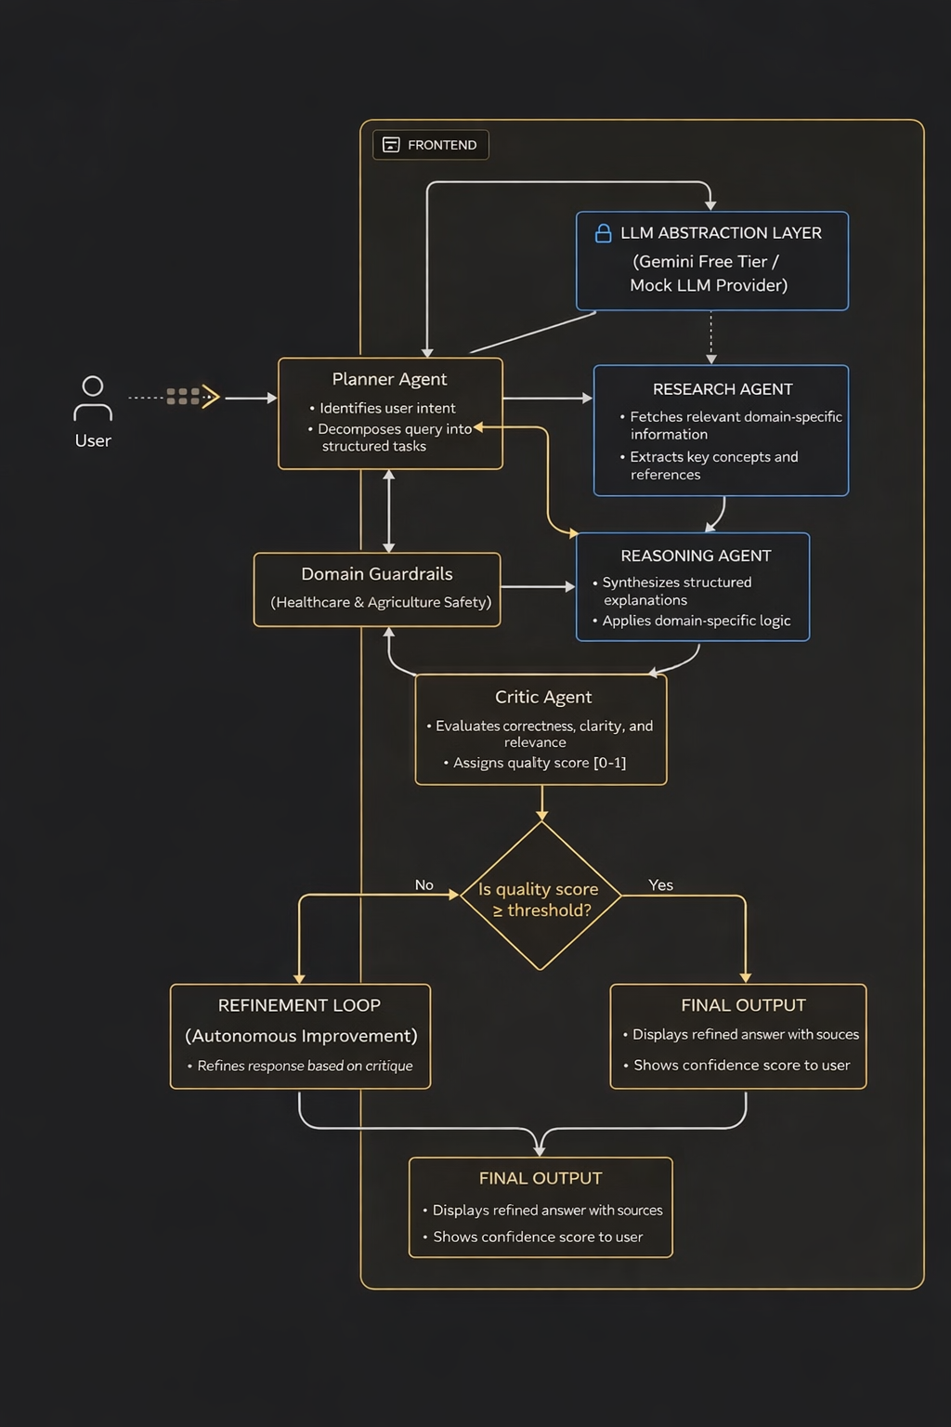

10.Database Schema (Design Level)

Purpose of Database
- Store user interactions
- Track queries and agent outputs
- Record evaluation scores
- Demonstrate scalability and seriousness Tables users
- user_id (PK)
- name
- email
- password
- created_at queries
- query_id (PK)
- user_id (FK)
- domain
- query_text
- created_at
agent_outputs
- output_id (PK)
- query_id (FK)
- agent_name
- output_text • created_at evaluations
- evaluation_id (PK)
- query_id (FK)
- score (0–1)
- feedback
- approved final_results
- result_id (PK)
- query_id (FK)
- final_answer
- confidence_score
- generated_at

11.Milestones (Team of 2–3)
- Day 1: Architecture and prompt design
- Day 2: Planner and Research agents
- Day 3: Reasoning and Critic agents
- Day 4: Frontend demo
- Day 5: Pitch preparation and Q&A

12.Ethical and Responsible AI
- No medical or legal advice
- Transparent system limitations
- Bias awareness
- Explainable agent reasoning

13.Use of Generative AI Tools (Disclosure)
Generative AI tools such as ChatGPT were used as development assistants for ideation, prompt refinement, debugging, and documentation. The autonomous multi-agent architecture, control logic, and evaluation mechanisms were fully designed and implemented by the team.

14.Expected Outcome
- Working agentic AI demo
- Clear autonomy and self-evaluation
- Strong education-focused impact
- Safe and scalable domain extensions

15.Conclusion
This project demonstrates true Agentic AI by moving beyond single-prompt systems into autonomous, collaborative intelligence. With education as the primary focus and healthcare and agriculture as structured extensions, it strongly aligns with the vision of AI IGNITE 2025.

End of Document

