**TECHATHON**

**PRODUCT DEVELOPMENT**

**LOGIN SYSTEM**

**BY**

**M.ROHIT, R.RIYAZUDDIN, REAIA RANJITH**

Our project is a multi role multi user login system. The login system consists of 2 roles- ADMIN AND USER. If we enter the admin part we can see the text fields for username and password and same in the case of user also. It also has a show password option. It has a forgot password button in both admin and user login page. A sign up option is added for new users.

Forgot password is also added. If we click that it asks for email id which is already stored in the database. So if we enter the email id a rest link is sent to the email and after that you can reset your password.

**FEATURES:**

Simple design

Fast accessible

User friendly

**LANGUAGES USED:**

**FRONT END:** HTML,CSS, JAVASCRIPT

**BACK END:** PHP,MySql

**SCREENSHOTS:**

**HOME PAGE:**

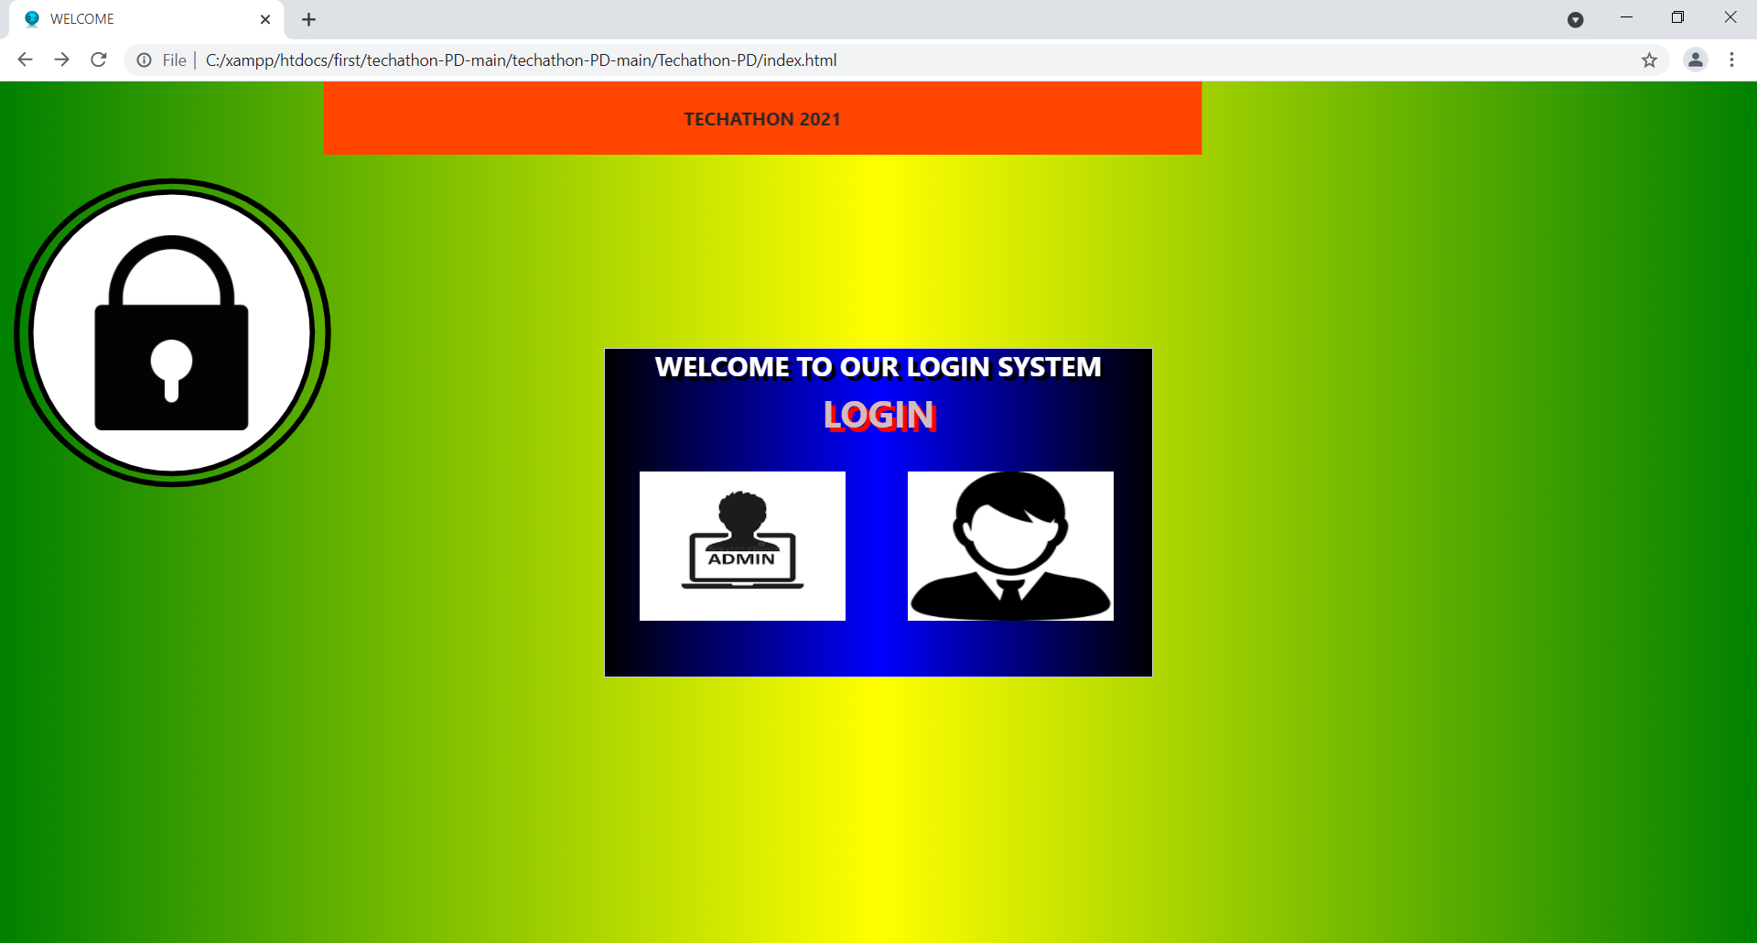

**LOGIN PAGE FOR ADMIN:**

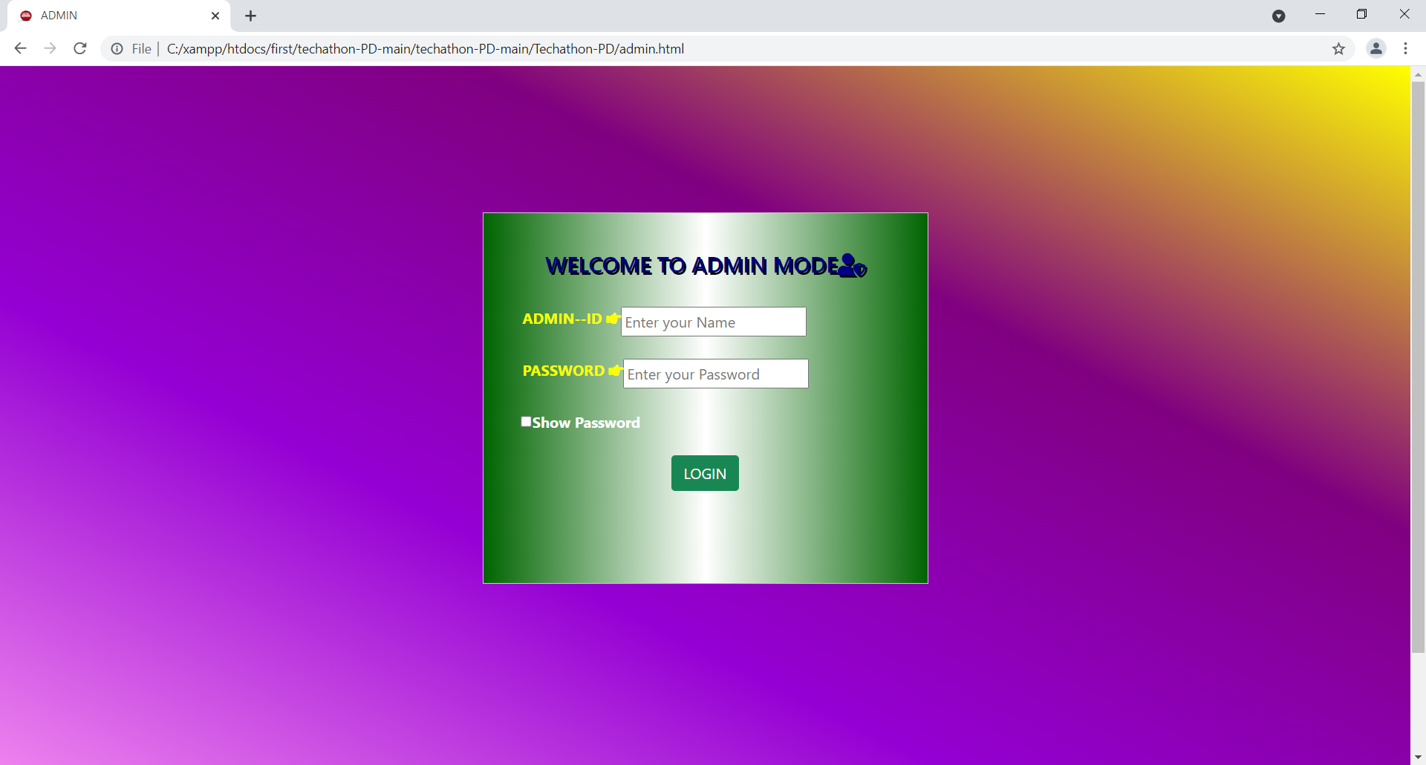

**LOGIN PAGE FOR USER:**

