Software Development Life Cycle

Software Development Life Cycle (SDLC) is a process used by the software industry to design, develop and test high quality softwares. The SDLC aims to produce a high-quality software that meets or exceeds customer expectations, reaches completion within times and cost estimates.

Other related methodologies are Agile Model, RAD Model, Rapid Application Development and Prototyping Models.

The following figure is a graphical representation of the various stages of a typical SDLC.

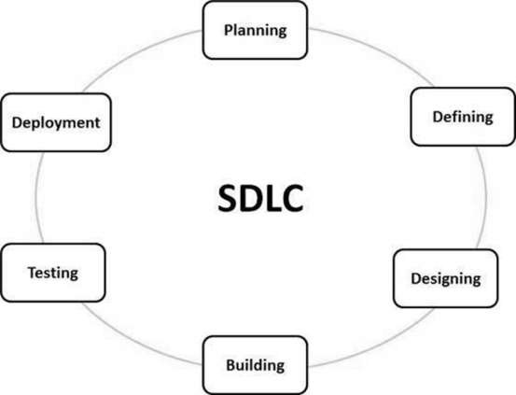

**SDLC Models**

Following are the most important and popular SDLC models followed in the industry −

* Waterfall Model
* Iterative Model
* Spiral Model
* V-Model
* Big Bang Model

## Waterfall Model - Design

Waterfall approach was first SDLC Model to be used widely in Software Engineering to ensure success of the project. In "The Waterfall" approach, the whole process of software development is divided into separate phases. In this Waterfall model, typically, the outcome of one phase acts as the input for the next phase sequentially.

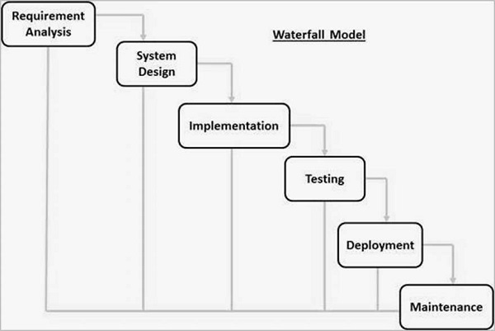

Some situations where the use of Waterfall model is most appropriate are −

* Requirements are very well documented, clear and fixed.
* Product definition is stable.
* Technology is understood and is not dynamic.
* There are no ambiguous requirements.
* Ample resources with required expertise are available to support the product.
* The project is short.

## Iterative Model - Design

Iterative process starts with a simple implementation of a subset of the software requirements and iteratively enhances the evolving versions until the full system is implemented. At each iteration, design modifications are made and new functional capabilities are added. The basic idea behind this method is to develop a system through repeated cycles (iterative) and in smaller portions at a time.

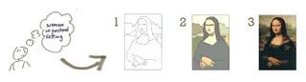

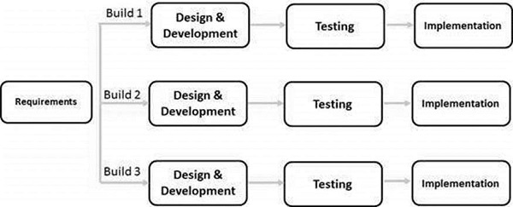

[**Spiral Model**](https://www.guru99.com/what-is-spiral-model-when-to-use-advantages-disadvantages.html)

The spiral model has four phases. A software project repeatedly passes through these phases in iterations called Spirals.

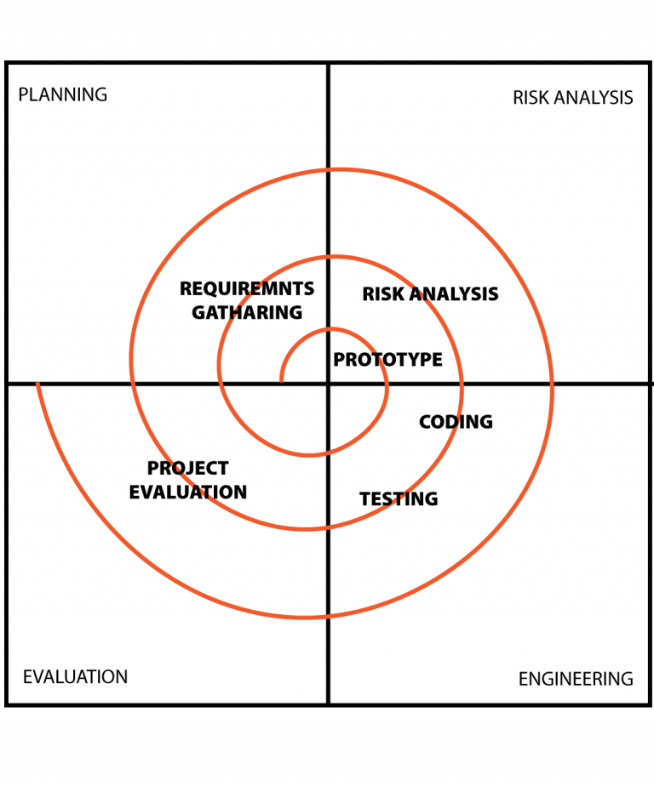

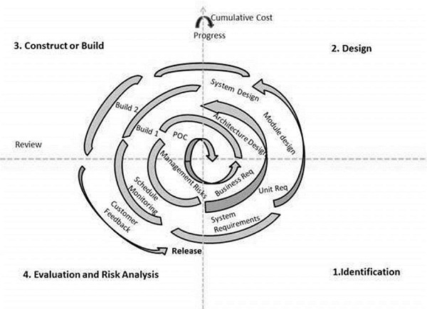

The following pointers explain the typical uses of a Spiral Model −

* When there is a budget constraint and risk evaluation is important.
* For medium to high-risk projects.
* Long-term project commitment because of potential changes to economic priorities as the requirements change with time.
* Customer is not sure of their requirements which is usually the case.
* Requirements are complex and need evaluation to get clarity.
* New product line which should be released in phases to get enough customer feedback.
* Significant changes are expected in the product during the development cycle.

The advantages of the Spiral SDLC Model are as follows −

* Changing requirements can be accommodated.
* Allows extensive use of prototypes.
* Requirements can be captured more accurately.
* Users see the system early.
* Development can be divided into smaller parts and the risky parts can be developed earlier which helps in better risk management.

The disadvantages of the Spiral SDLC Model are as follows −

* Management is more complex.
* End of the project may not be known early.
* Not suitable for small or low risk projects and could be expensive for small projects.
* Process is complex
* Spiral may go on indefinitely.
* Large number of intermediate stages requires excessive documentation.

## V-Model – Design

The V-model is an SDLC model where execution of processes happens in a sequential manner in a V-shape. It is also known as **Verification and Validation model**.

Under the V-Model, the corresponding testing phase of the development phase is planned in parallel. So, there are Verification phases on one side of the ‘V’ and Validation phases on the other side. The Coding Phase joins the two sides of the V-Model.

**Verification:** It involves static analysis technique (review) done without executing code. It is the process of evaluation of the product development phase to find whether specified requirements meet.

**Validation:** It involves dynamic analysis technique (functional, non-functional), testing done by executing code. Validation is the process to evaluate the software after the completion of the development phase to determine whether software meets the customer expectations and requirements

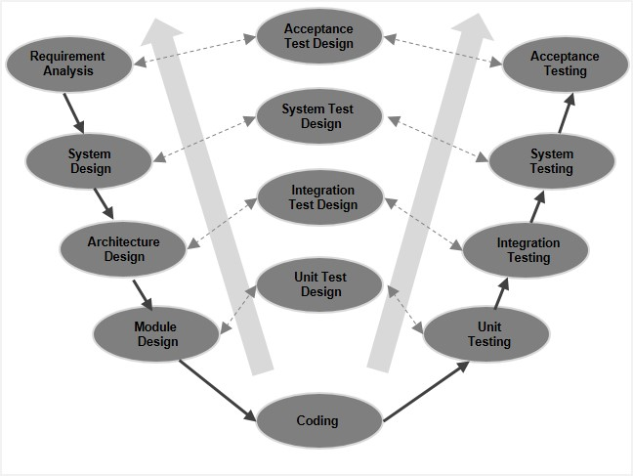

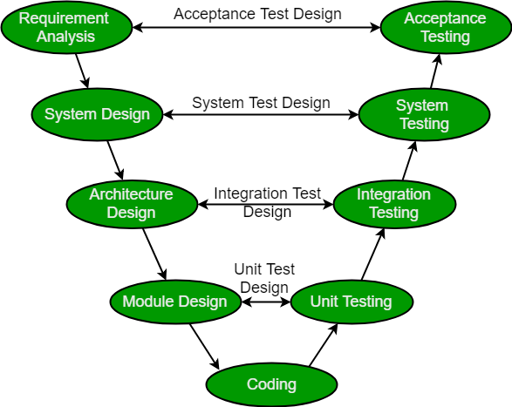

## Big Bang Model

## No one using Big Bang Model for developing a software.