Step 1 - Install XAMPP and check that APACHE and MYSQL are started

Download Xampp latest version.

Install Xampp.

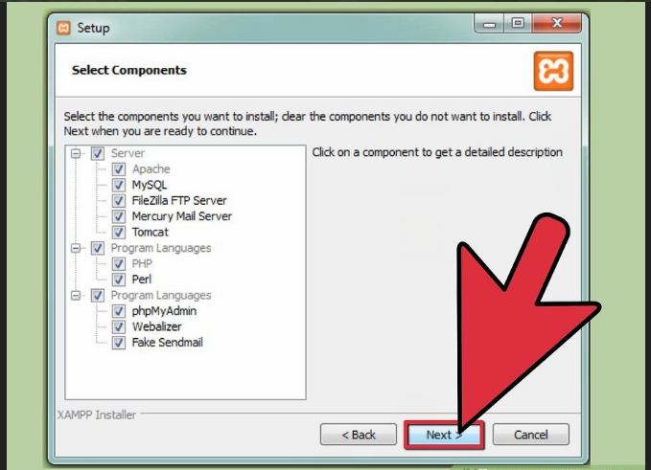

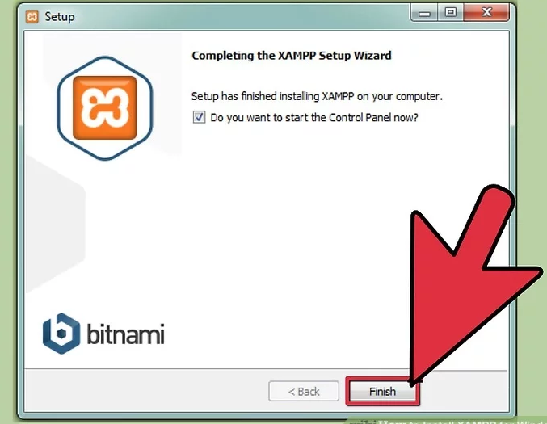

Start the Apache and MySQL components. You can also start the other components, if you plan to use them.

Verify the Apache install, by clicking on the Apache administrative link in the Control Panel.

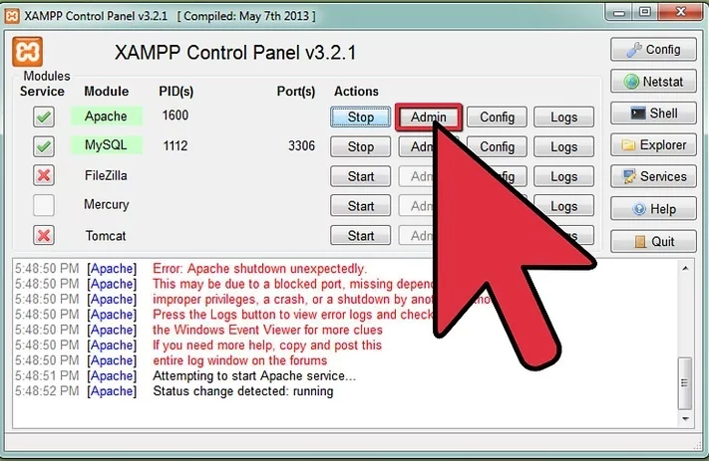

Verify the MySQL installation, by clicking on the MySQL administrative link in the XAMPP Control Panel.

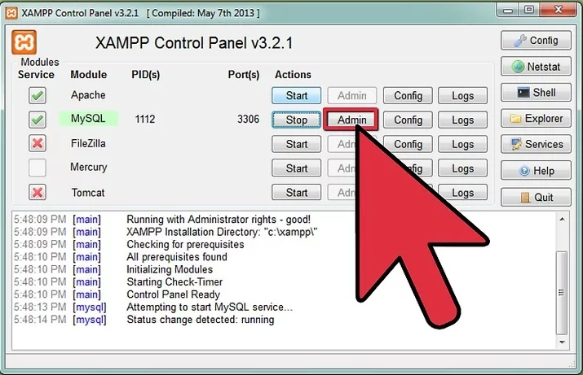

If the verification steps are successful, XAMPP should be successfully installed on your PC. Open a browser and enter "localhost/phpmyadmin " on your address bar.

You’ll find a php.ini(C:\xampp\php\php.ini) file where Xampp is Installed. Open the File and make the following changes to run Sql Script.

a) upload_max_filesize  to 50M

                                b) post_max_size to 100M

                                c) max_input_time 200

                                d) max_execution_time 200

Then restart the APACHE and MYSQL from XAMPP.

Update hibernate.cfg.xml

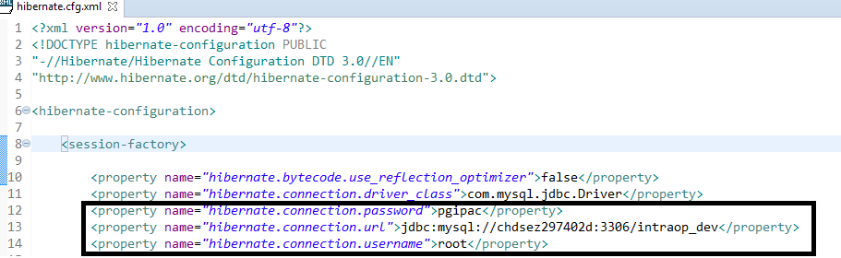

Update the config.inc.php

You’ll find a config.inc.php file where Xampp is Installed.

Path : LocalDisk(where xampp is installed)🡪 xampp🡪phpMyAdmin🡪 config.inc.php

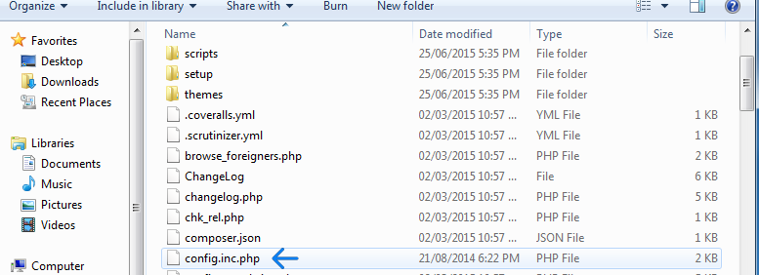

Open “Config.inc.php” file in Text editor like Notepad+  
  
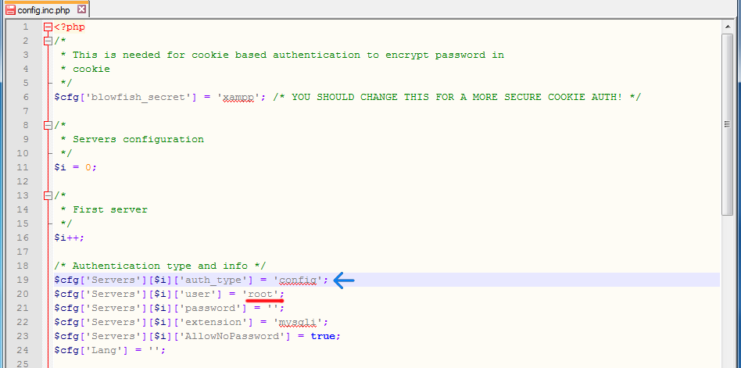

update password for root from blank to "pgipac"

Create the blank database in phpmyadmin

**Open** your browser and enter<http://localhost/phpmyadmin>. This will bring you to the MySQL setup page.

**Step 2:** **Enter** a name for the database, then **click** on the **Create** button.

e.g: DataBase Name: your_database

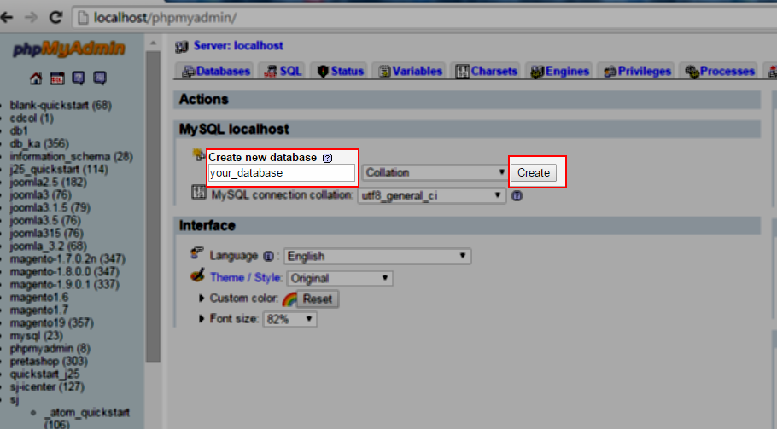

**Ensure** the database was successfully created:

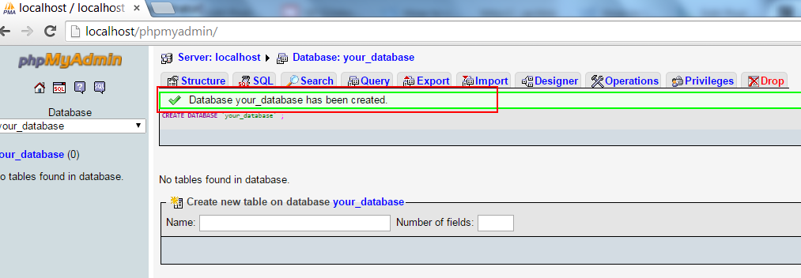

Import the DbScript [ Data + SQL Structure].

Click on Import option from top menu section and upload you files.

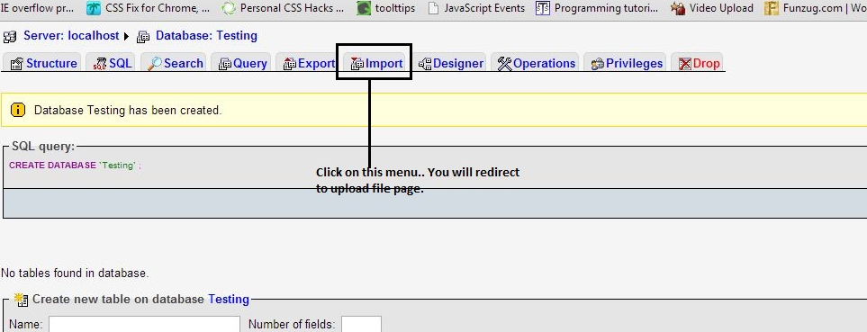

After that select your DbScript and upload it.

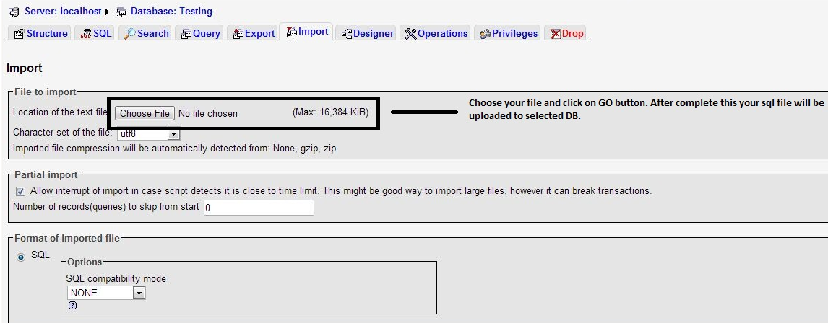

Install Google and Mozilla FireFox.

1. Visit the Mozilla website. The Download link in the green box will automatically detect your operating system and language.
2. If you want to download Firefox in another language, or for a different operating system, licktheSystems & Language link right below the Download button.
3. Click the download button. Your download will start immediately. Once the file is finished downloading, click on it to start the installation. Windows may ask for confirmation before running the file.
4. Launch Firefox. After a few moments, Firefox will be installed, and you can start browsing the web. You can choose to launch the program immediately, or launch it yourself later.

Install JRE ( Java Run time ) to have the Application Jar executed.

1. Go to http://www.oracle.com/technetwork/java/javase/downloads/index.html.
2. Under Java Platform, Standard Edition, select either the current release, or click Previous Releases to install an earlier supported version. You can use either the JDK or JRE. The JDK includes the JRE. Do not use any non-supported version or edition of the Java JRE or JDK.
3. Follow the navigation aids to download the JRE or JDK that is appropriate for your operating system.
4. Follow the installation instructions that are provided with the JRE.

Verify the JRE Version

These steps verify the JRE version that is installed on the server machine.

1. On the keyboard, press the Win (Windows) key and the R key simultaneously to open the Run box. Alternatively, you can select Start, then Run.
2. In the Run box, type cmd to run the Windows command console.
3. Issue the following command:

Java -version

Install the Driver for Belkin and ATEN USB Converters