Abstract

This document will help any consultant, Junior Resident and support staff to operate the AIMS Application. This document covers all the required steps on how to start the case , enter all relevant details and finally shifting out the patient to PACU.

Quick start guide

Anesthesia Information Management System

Table of Contents

1. Application Startup 2

2. Steps to search a Patient and load a Case 4

3. Steps to find scheduled Cases and load a Case 7

4. Steps to perform when Case is loaded 9

1. Scan Infusion Pump 10

2. Scan S5 Patient Monitor and Anesthesia machine 12

5. Steps to Add Medication Manually 14

6. Steps to Add Test 19

7. Steps to Add Fluids 20

8. Steps to Add Output 23

9. Steps to mark an Event 24

10. Steps to perform Shift Out of Patient 27

# Application Startup

1: Open PGI-AIMS

2: Log in with below credentials

Username: drtanvir

Password: pgi@123

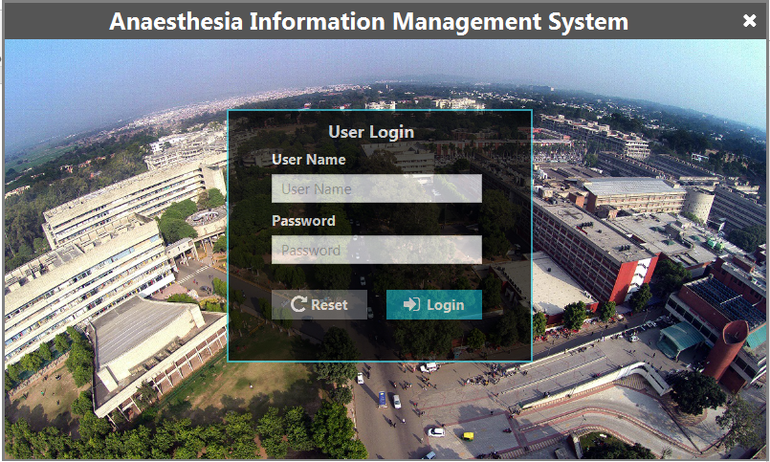

3: Add Patient

Step 1: Click on Add Patient Button on **Menu Bar.**

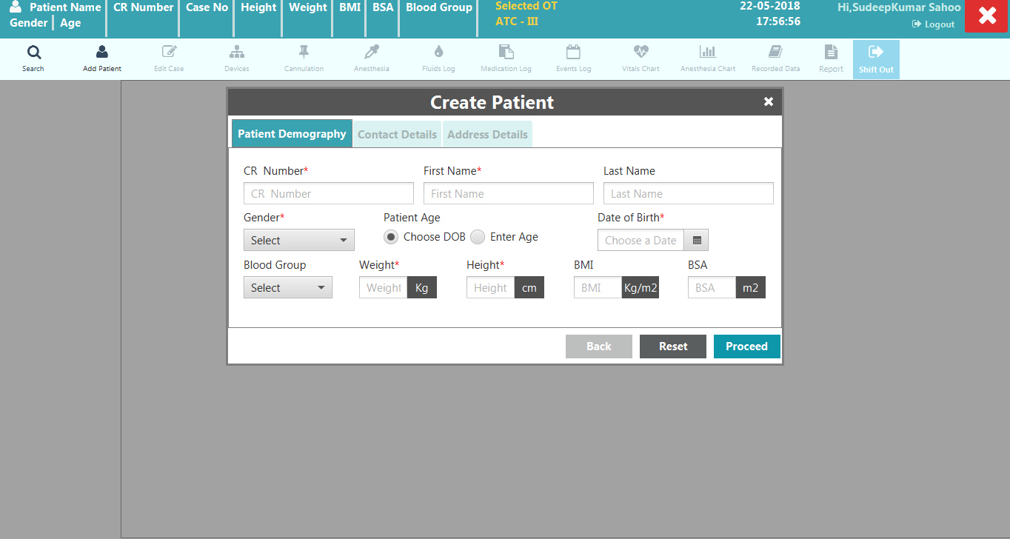

Step 2: Fill at least all the mandatory fields and click on proceed and save it.

Step 3: On successful Add Patient, it will be redirected to Create Case Screen.

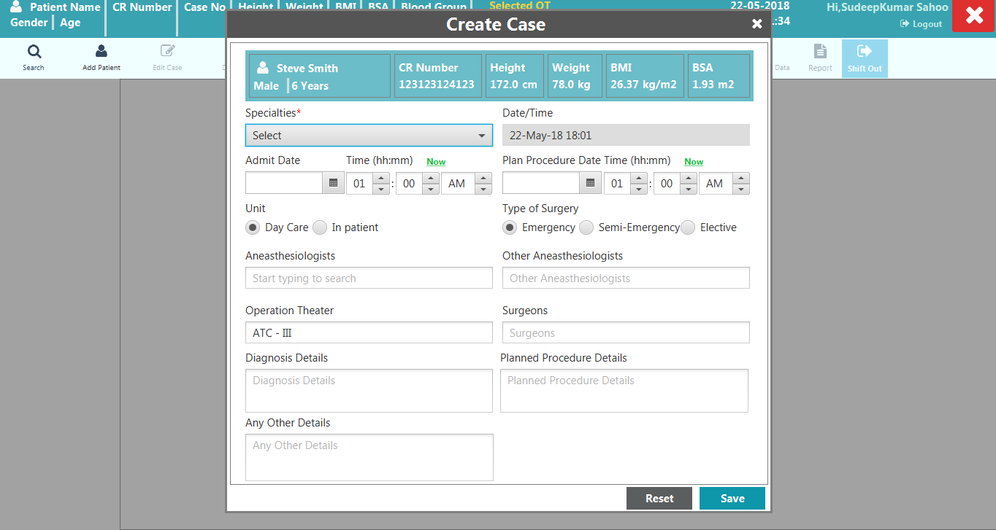

Step 4: Fill mandatory Fields and click on save to create a case.

Step 5: On successful Create Case it will be redirected to Application Dashboard Screen.

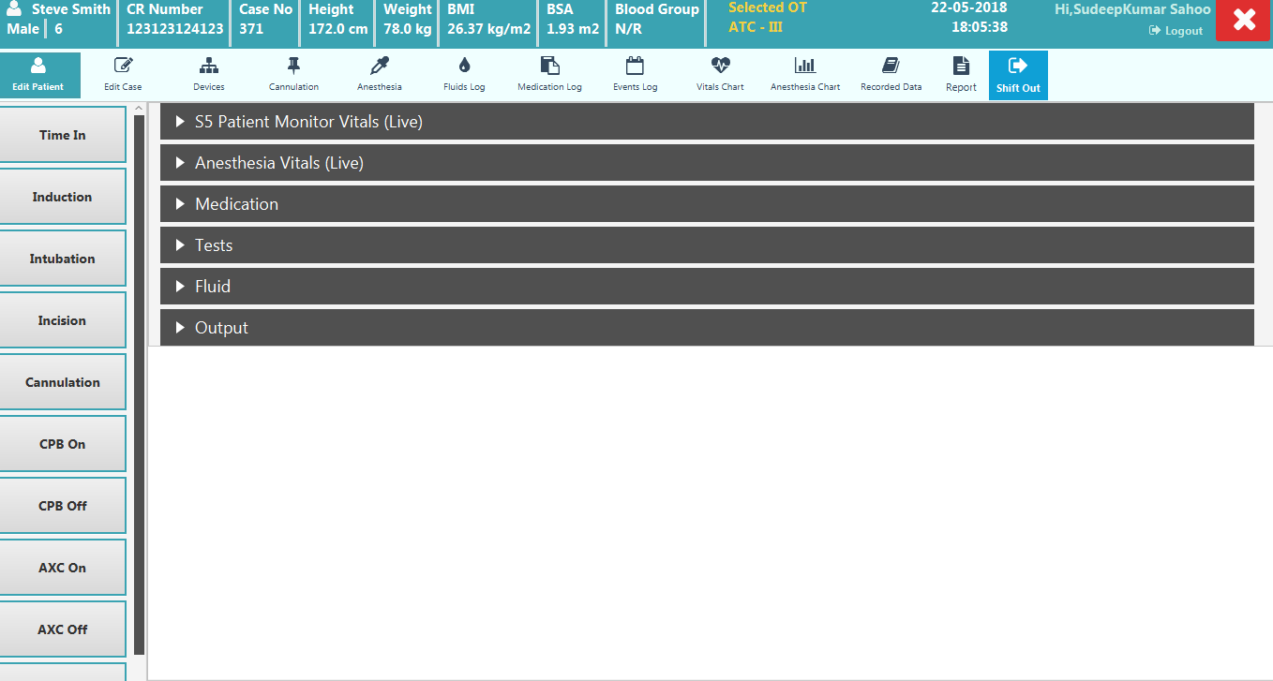

# 2. Steps to search a Patient and load a Case

Step 1: Click on Search Patient Button on **Menu Bar.**



Step 2: Enter Search criteria and click on Search button. It will fetch all the patient details matching with search criteria.

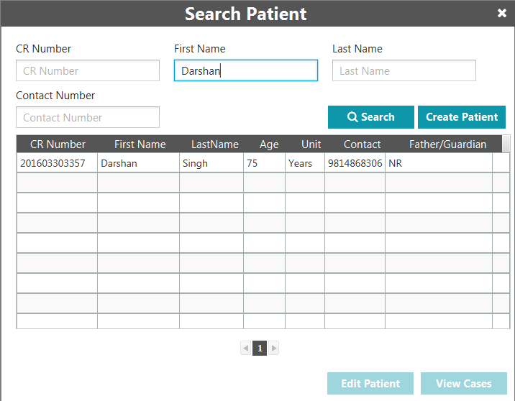

Step 3: Select a Patient and click on View All Case button. It will open View All Cases window where you can see all cases of the selected patient.

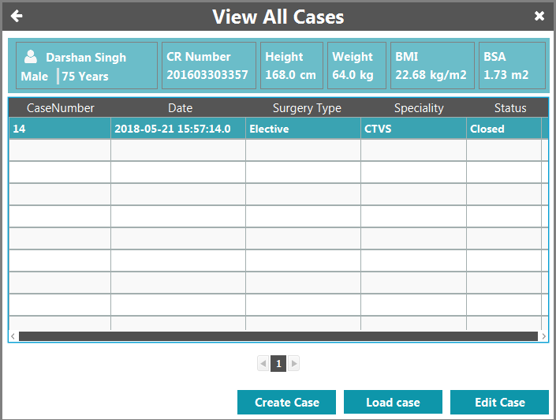

Step 4: To load a case select a case and click on Load case button. It will close View All Cases window and Main Dashboard will be opened.

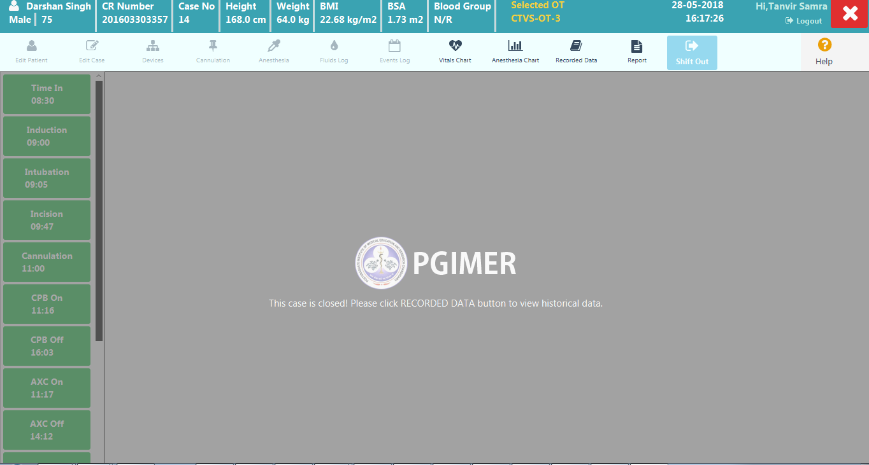

# Steps to find scheduled Cases and load a Case

Step 1: Click on Scheduled Cases Button on **Menu Bar.**



Step 2: You can see all the cases and patient details from last 7 days as default. You can change search criteria and find scheduled cases for new search criteria.

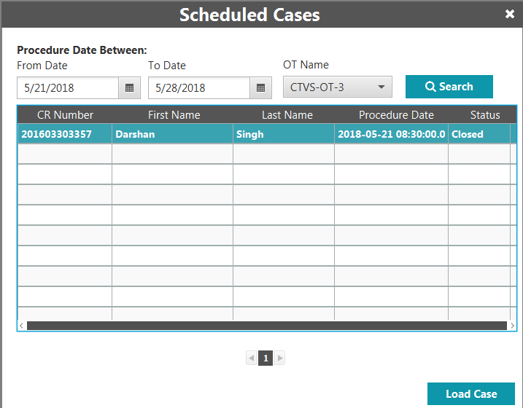

Step 3: To load a case select a case and click on Load Case button. It will close the window and Main Dashboard will be opened



# Steps to perform when Case is loaded

1. When Case is loaded, following will be the view visible on the desktop.

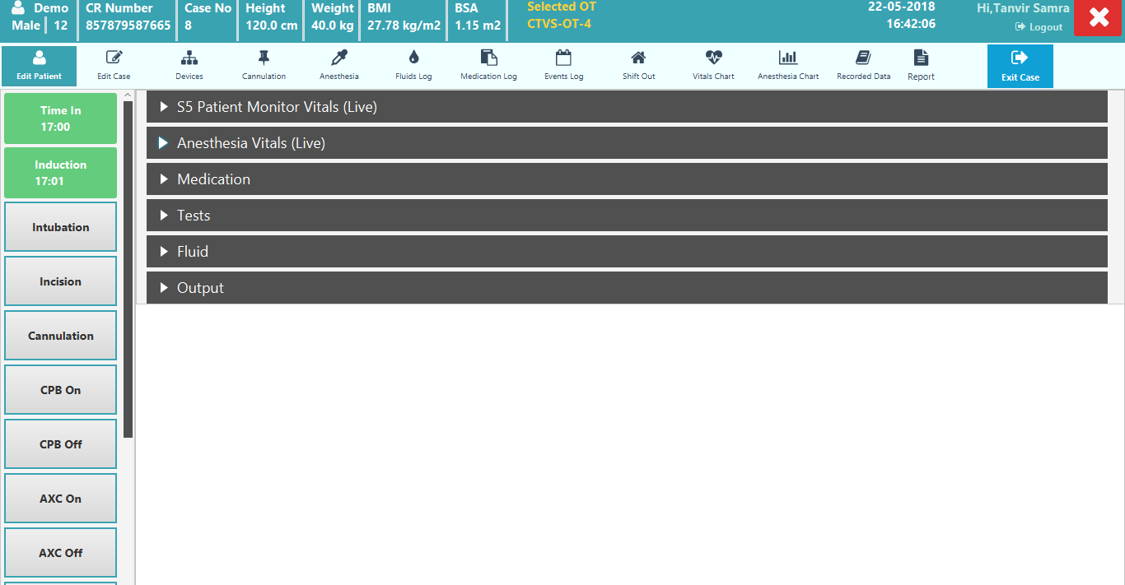

Step 2. Ensure the S5 Patient Monitor and Anesthesia Machines we have the data cables connected at back of the machine.

Step 3. 2 USB to Serial converters (a. Belkin converter connected to Patient Monitor data cables, b. Aten converter connected to Anesthesia data cable).

Step 3. Both these USB Converters to be connected to the USB Port on Desktop Machine.

Step 4. If connecting the Fresenius Syringe Pump, connect the data cable from Pump to the Belkin USB 2 serial converter. Connect this USB 2 Serial converter to desktop machine.

Step 5. Now you are ready for Scanning Activity, ensure the Case has been started in the Anesthesia machine. Click on the **Devices Icon** on the **Menu Bar** in the application.



Step 6. Following window will open

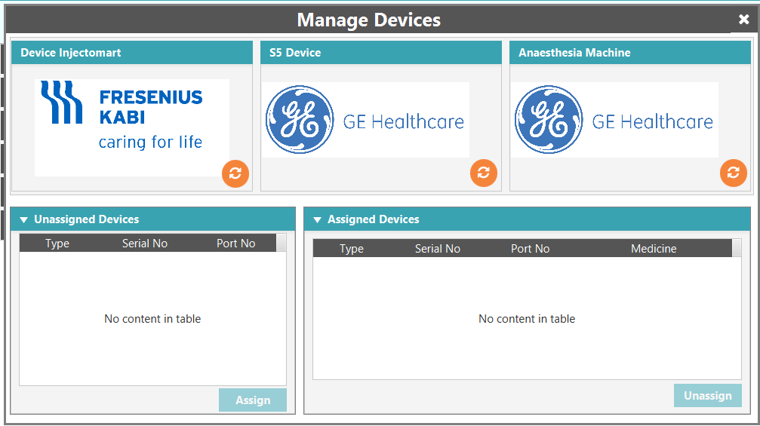

## Scan Infusion Pump

1. Click on the orange icon shown in the image above to scan the respective devices. In case we have number of Fresenius Pumps, then by default start scanning the pumps first.

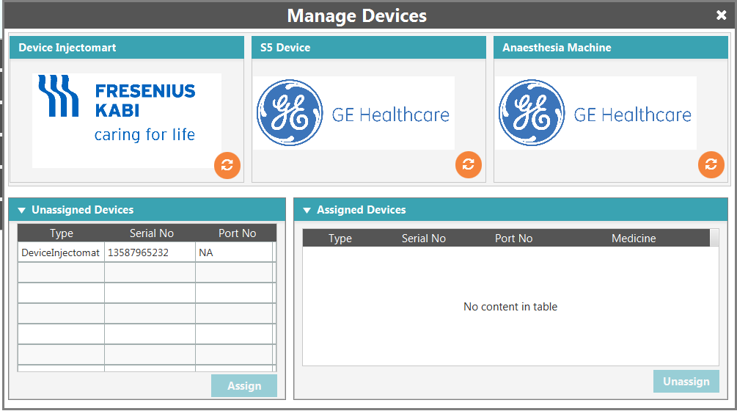

1. Select the scanned Infusion pump under the Unassigned Devices and Click the Assign Button, a new pop up will open.

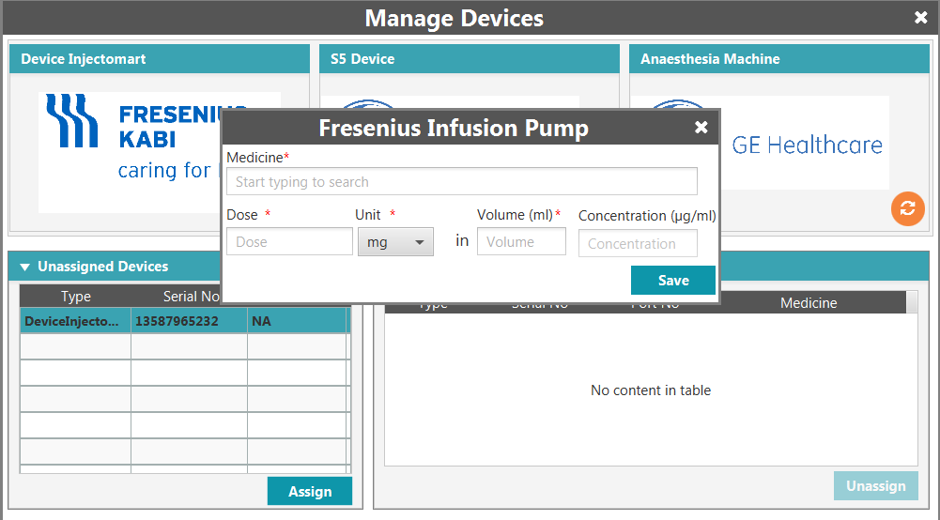

1. Enter medication details and click on save. It will move to the right side window titled: Assigned Devices.

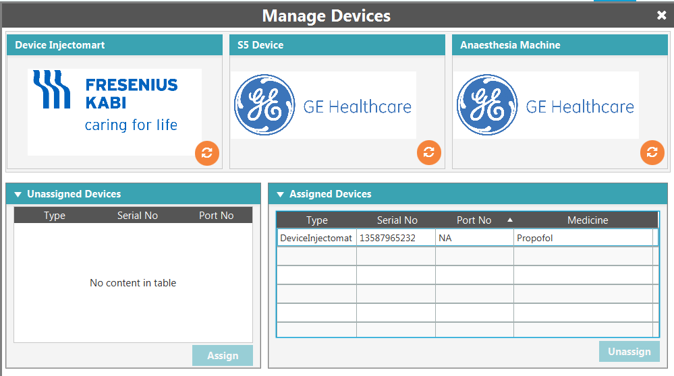

## Scan S5 Patient Monitor and Anesthesia machine

1. Similarly click on orange icon on S5 Device and Anesthesia Machine Box and let the scanning finish. After scanning is done, the devices will appear in the box shown below.

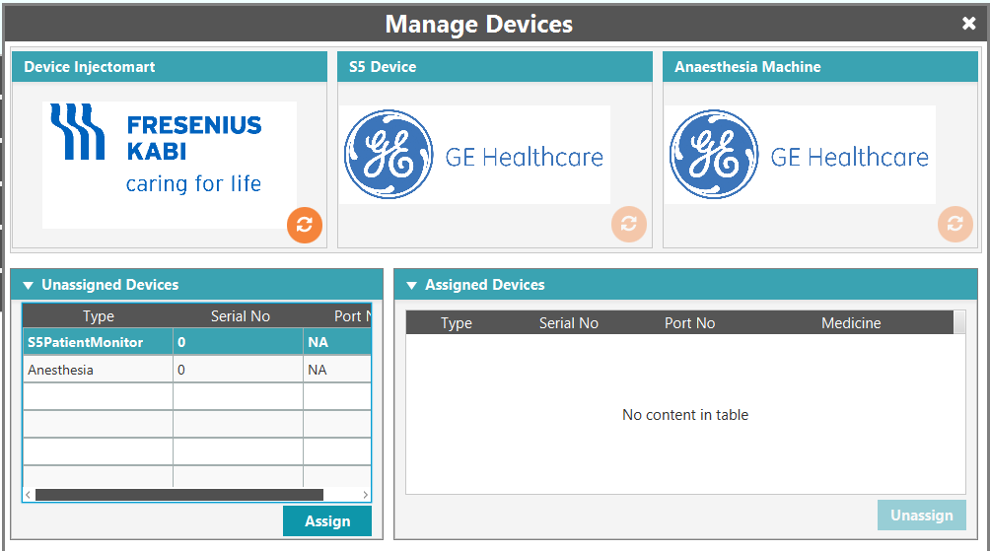

1. Select the respective device under the Unassigned Devices and Click the Assign Button, they will move to the right side window titled: Assigned Devices.

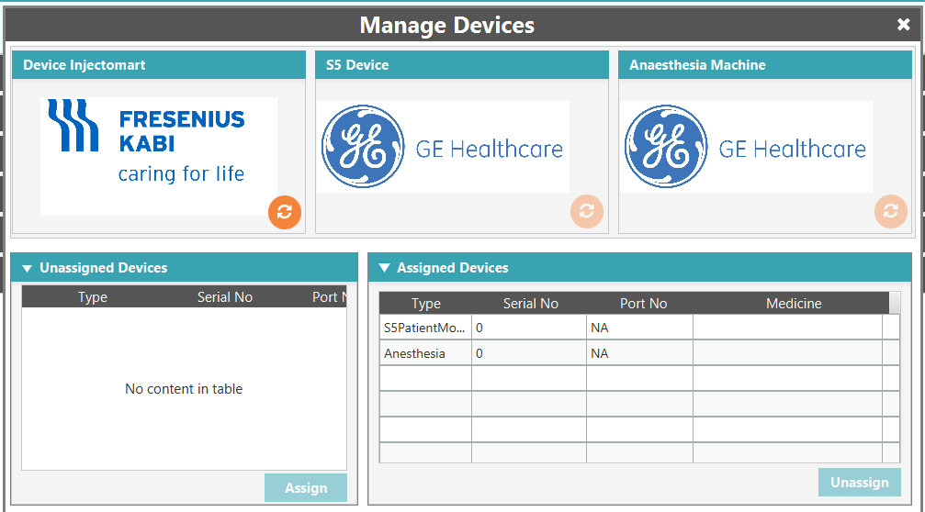

Step 7. Close this window, now the data should show up in the Live Grid.

1. Data for Infusion Pump, as shown below.

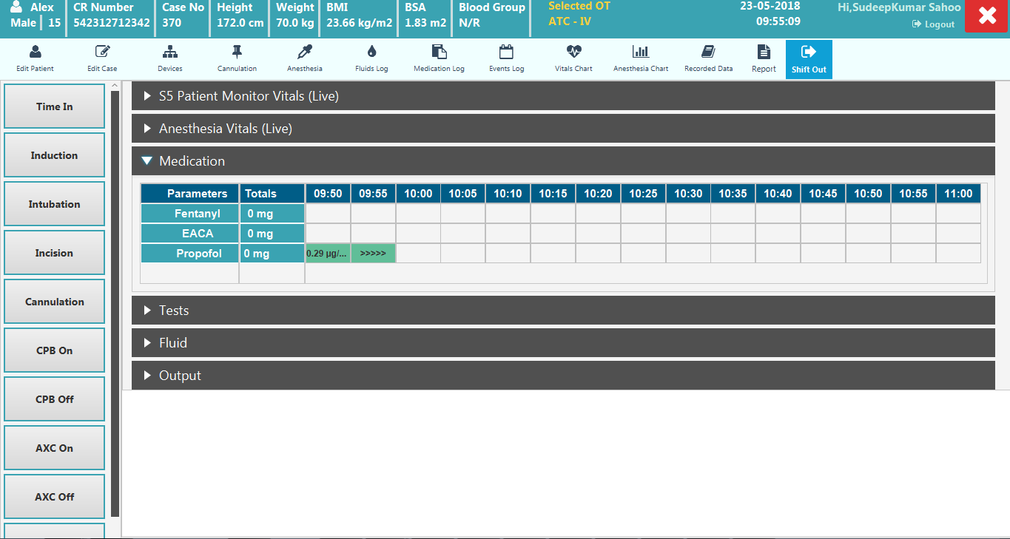

1. Data for S5 and Anesthesia on the main Dashboard, as shown below.

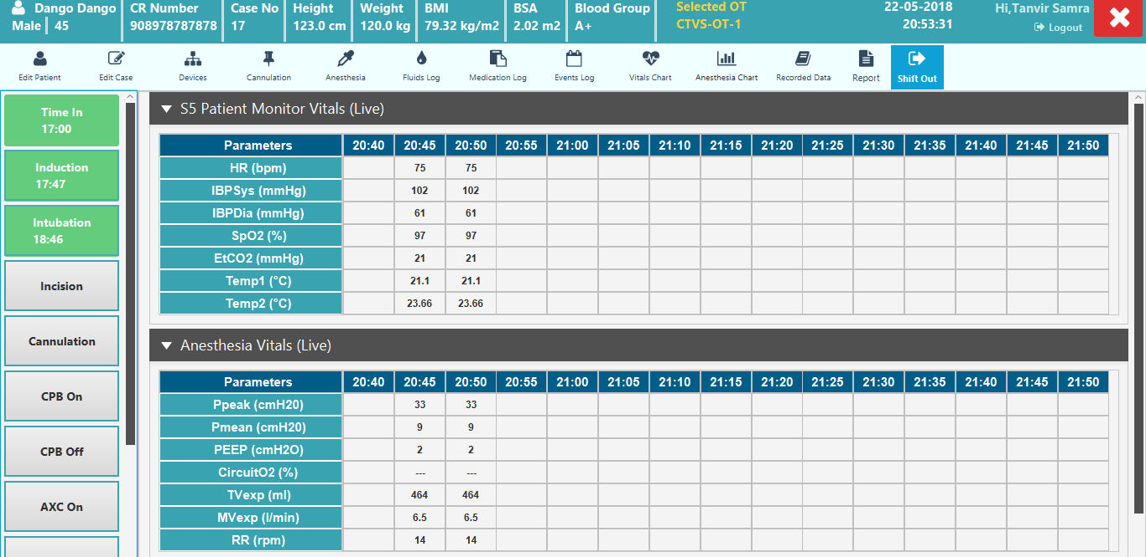

# Steps to Add Medication Manually

Step 1: Open Medication panel in Main Dashboard. You can see a live grid with frequently used medicine already added to the grid.

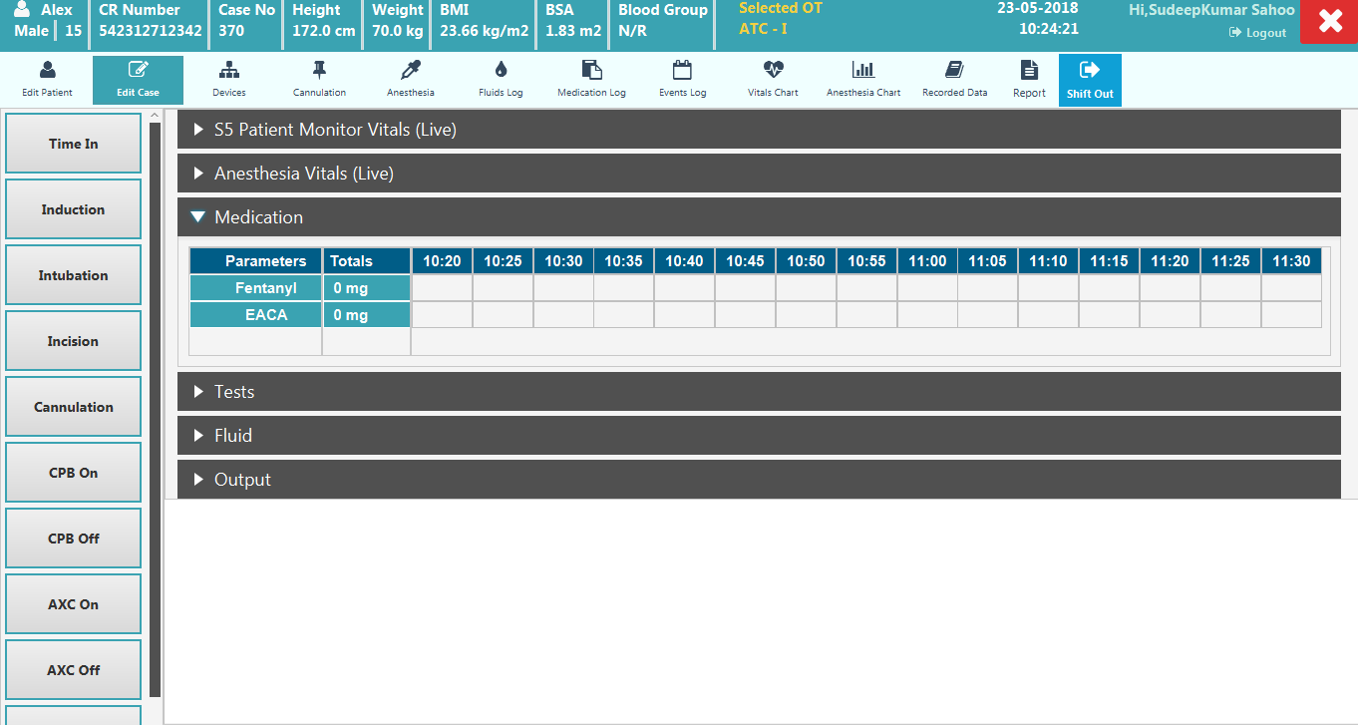

Step 2: If you want to add other medicine, right click on the time box and click on Add Medicine. A new pop up will open to search medicine and add.

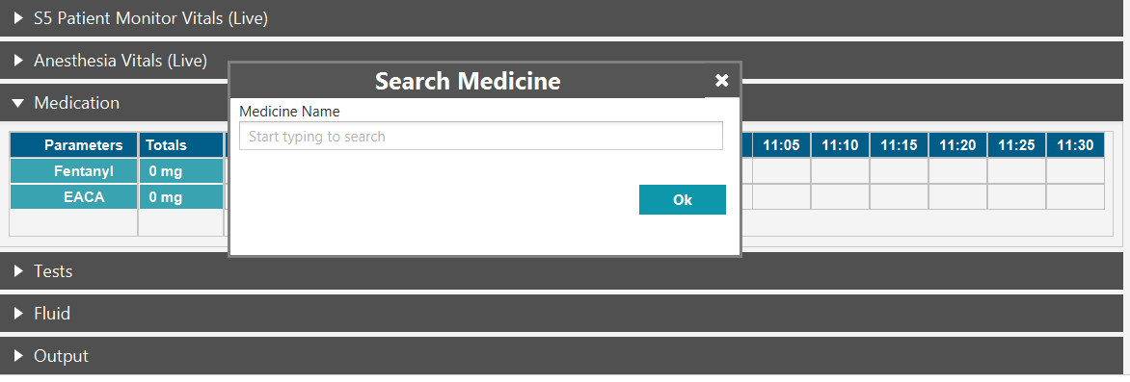

Step 3: You can search desired medicine and click on OK. It will be added to the Medication grid in main Dashboard.

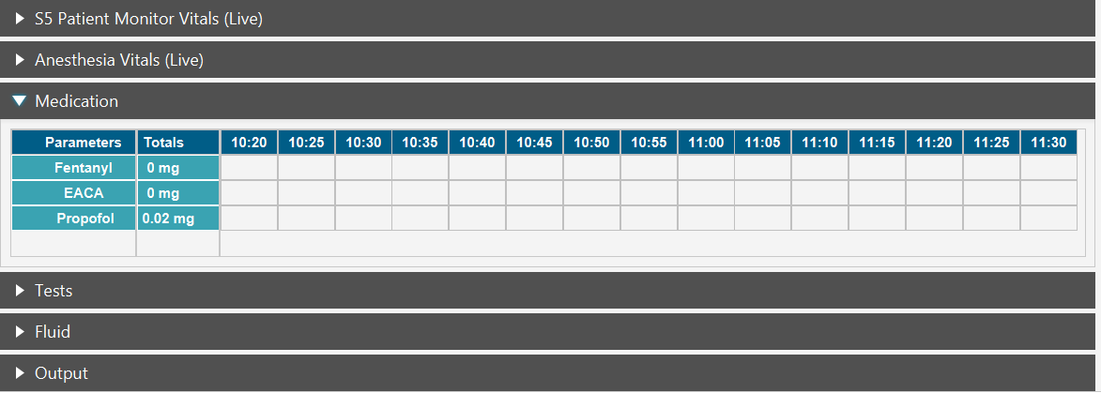

Step 4: To add Bolus, right click on the time box and click on Bolus. It will open Add Bolus pop up.

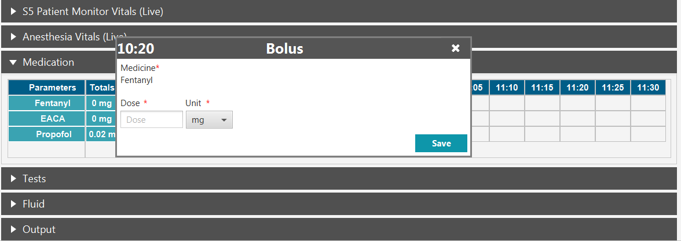

Step 5: Fill the mandatory fields and click on save. It will close the Add Bolus pop up and the Medicine will be added to Medication Live Grid.

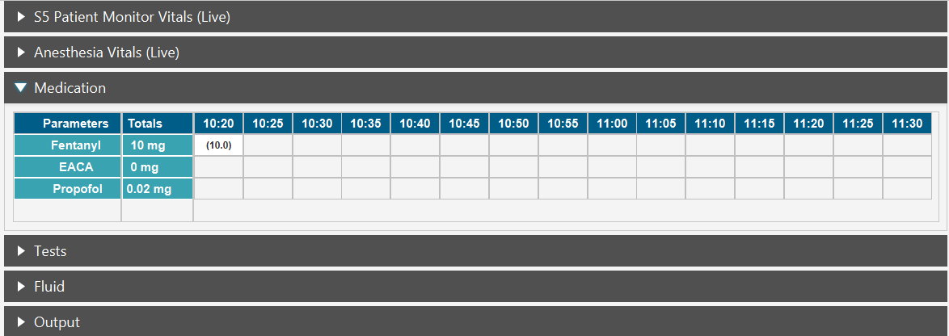

Step 6: To add Infusion manually, right click on the time box and click on Start Infusion. It will open Infusion pop up.

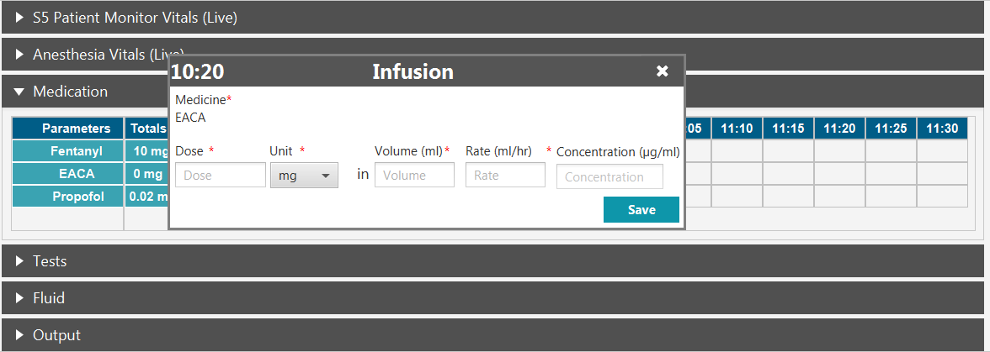

Step 7: Fill all mandatory fields and click on save. It will close the Infusion pop up and the Medicine will be added to Medication Live Grid as infusion in progress.

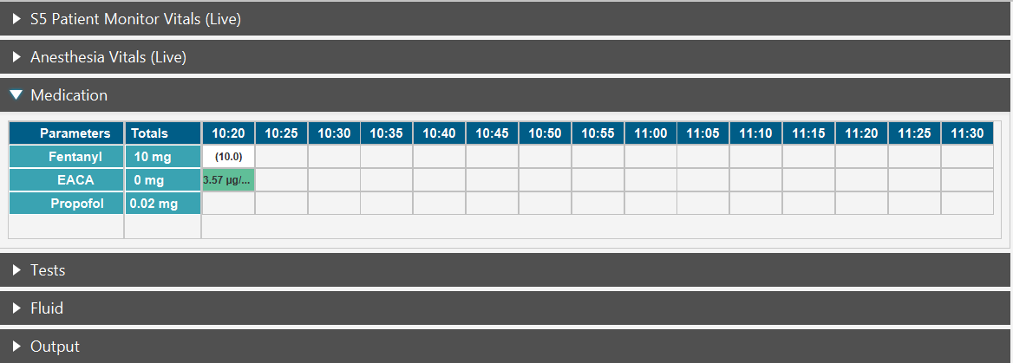

Step 8: To stop Infusion right click on the desired time box and click on Stop Infusion.

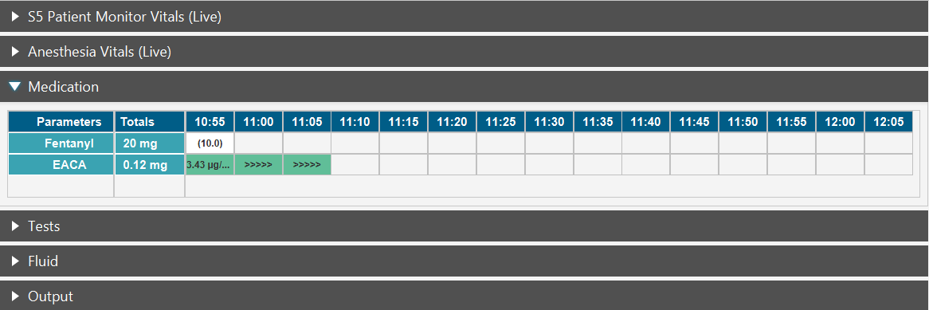

Step 9: Now Stop Infusion pop up will open with all infusion Details.

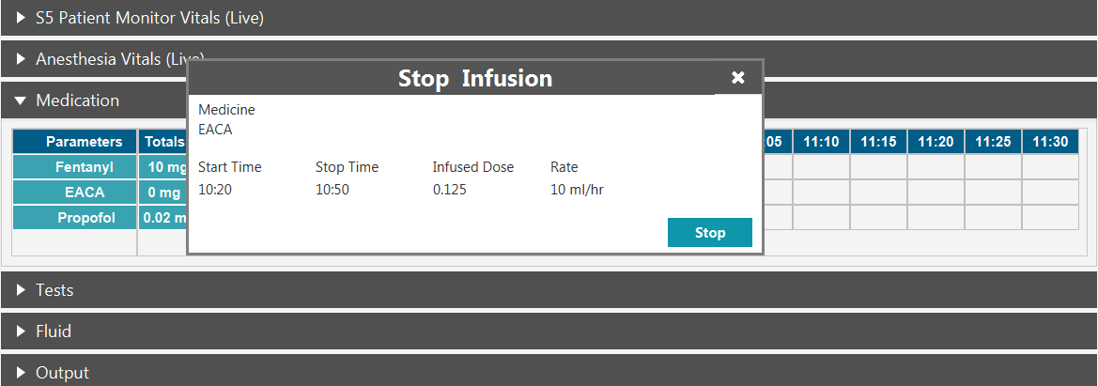

Step 10: Click on Stop. It will close stop Infusion pop up and the selected medication will be marked as stop in the Medication Live Grid.

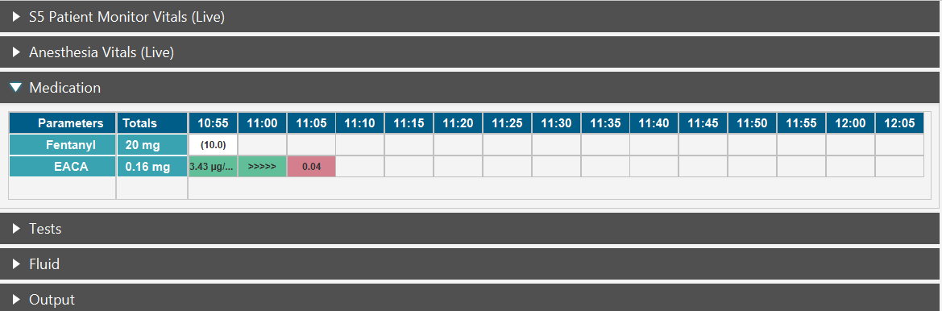

# Steps to Add Test

Step 1: Open Tests panel in Main Dashboard. You can see frequently used Test panels already added.

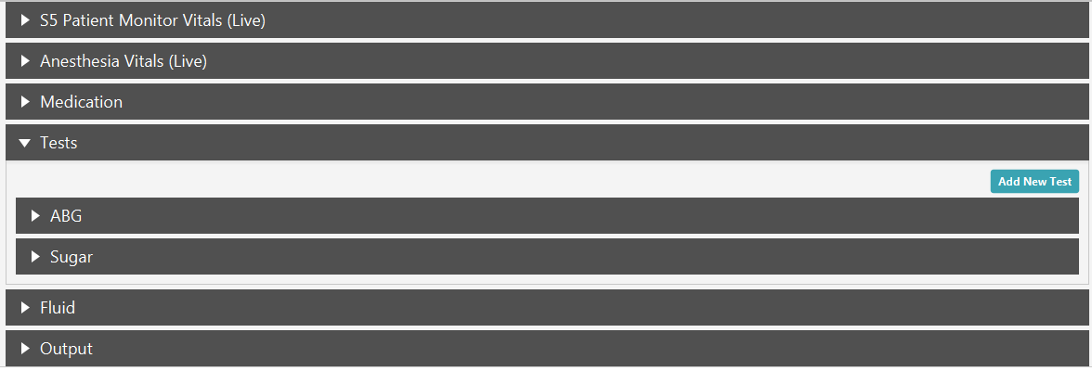

Step 2: If you want to add a new Test, click on the Add New Test button on the Tests panel. It will open to add new test to the panel.

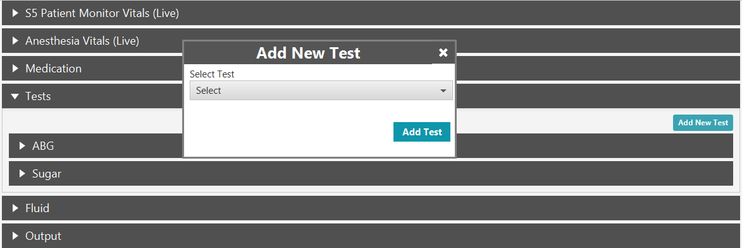

Step 3: Select the Test you want to add and click on Add Test. In our case we added ACT test.

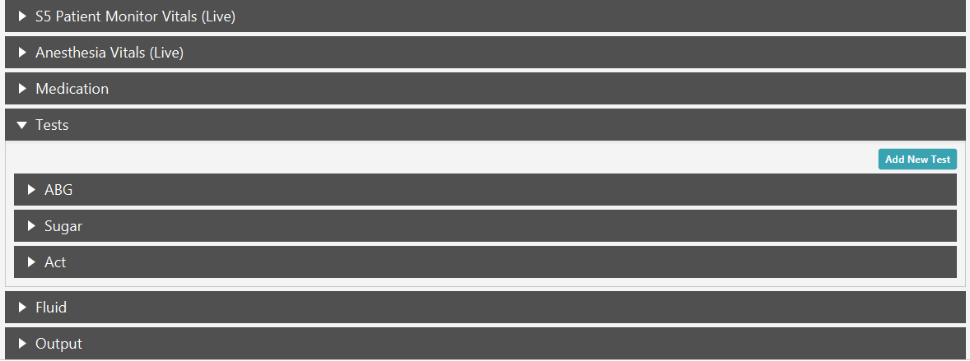

Step 4: Expand the ABG collapsible panel and click on the time box and click on Enter values. It will open Test window.

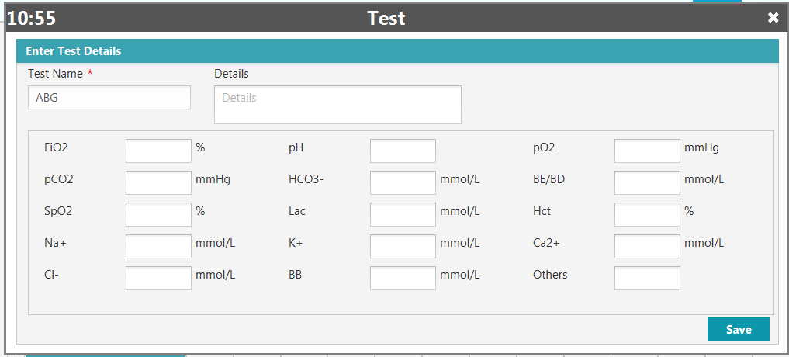

Step 5: Enter test values and click on save. It will close test Window and test values will be added to Test Live Grid in Main Dashboard.

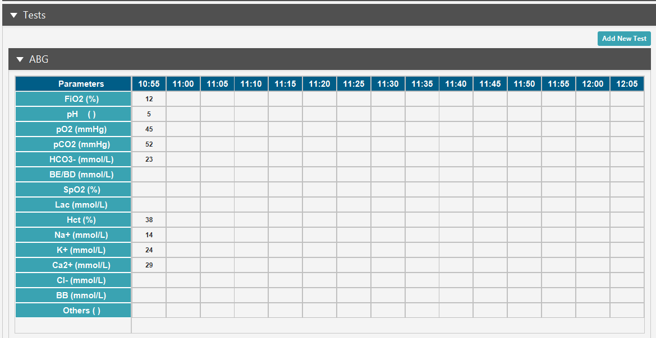

# Steps to Add Fluids

Step 1: Open Fluids panel in Main Dashboard. You can see a live grid with frequently used Fluids already added to the grid.

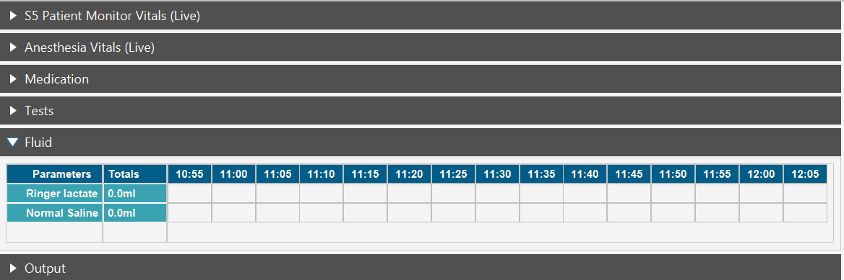

Step 2: If you want to add other Fluid, right click on the time grid box and click on Add New Fluid.

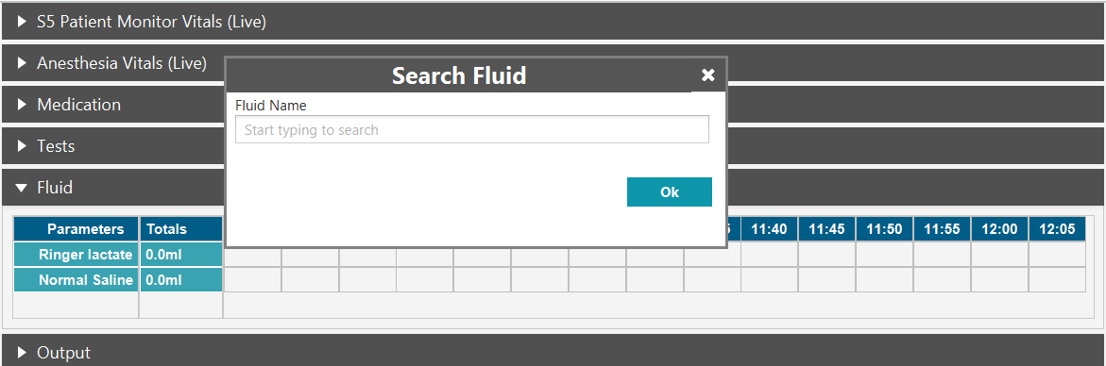

Step 3: You can search desired fluid and click on Ok. It will be added to the Fluids grid in main Dashboard.

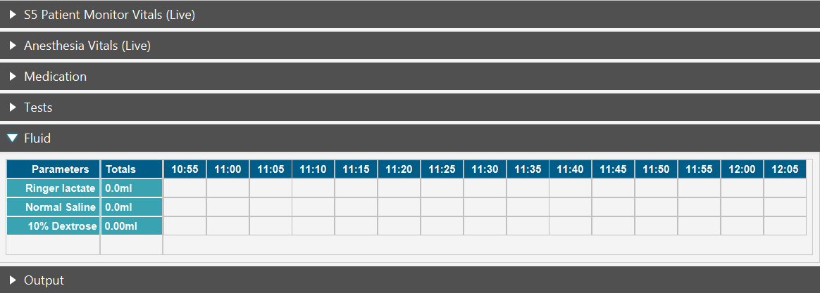

Step 4: To start Fluid, right click on the time box and click on Start. It will open Fluid pop up.

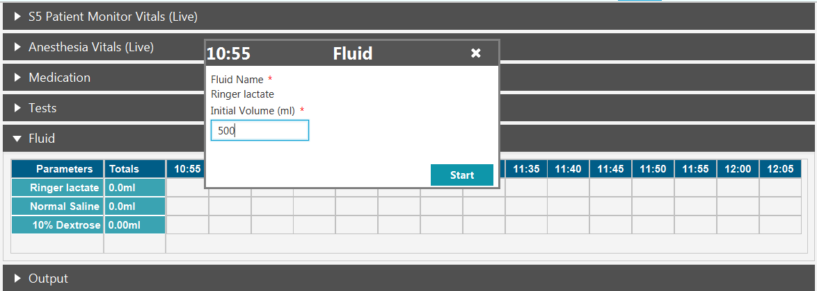

Step 5: Enter Initial volume in the bag and click on start. It will be marked as start in the Live Grid in Dashboard.

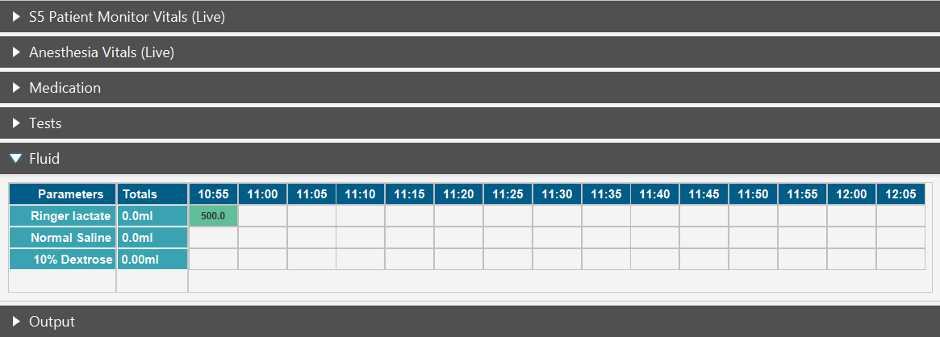

Step 6: To stop Fluid, click on the time box and click on Stop. It will open Fluid pop up with initial volume in the bag.

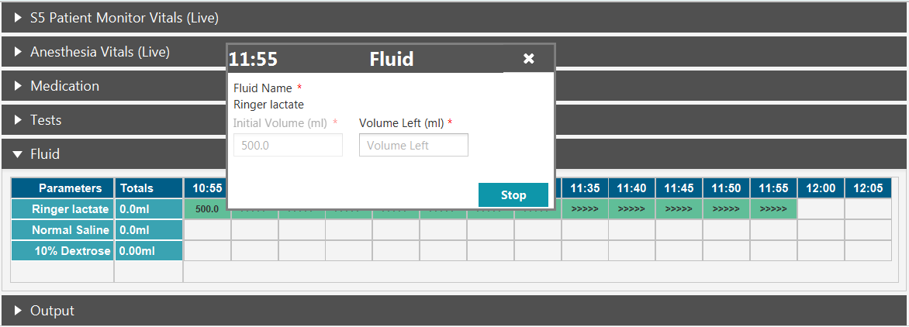

Step 7: Enter Volume left in the bag and click on stop. It will be marked as stop in the Live Grid in Dashboard and total fluid volume will be updated.

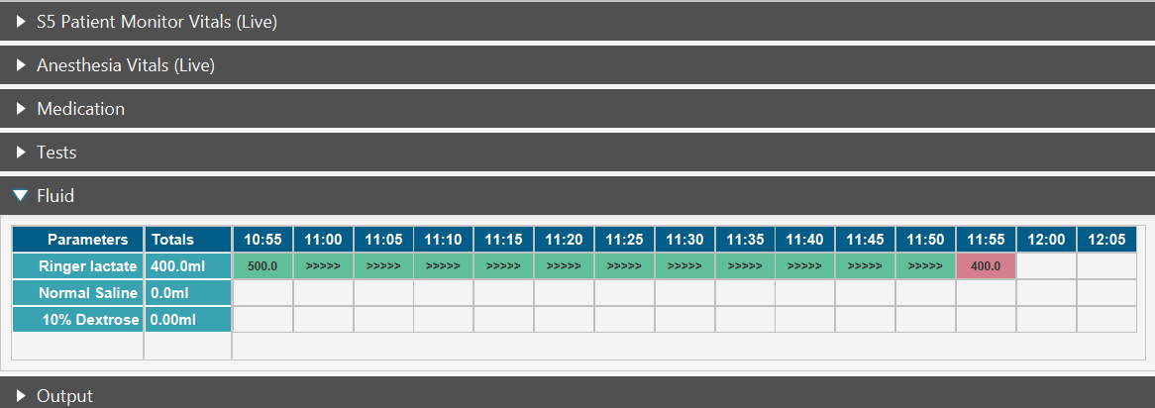

# Steps to Add Output

Step 1: Open Output panel in Main Dashboard. Right Click on time box and click on Enter value.

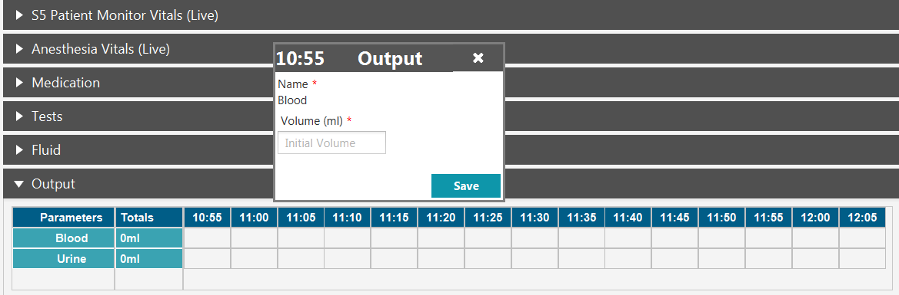

Step 2: Enter the Output volume and click on save. It will close the pop up and total output will be updated in the Output Live Grid.

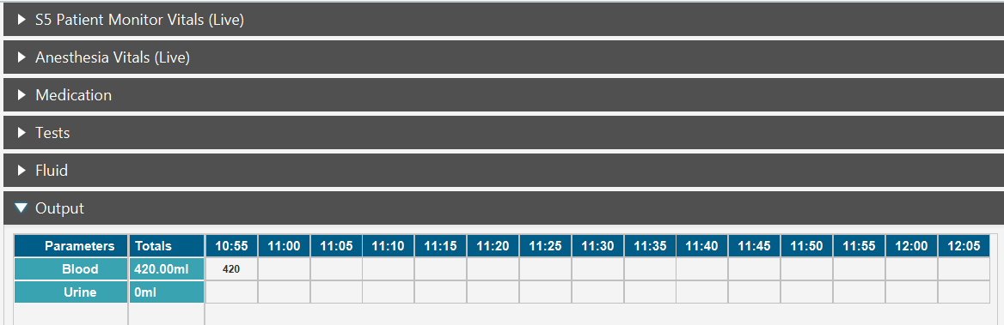

# Steps to mark an Event

Step 1: Click on Event name on the Dashboard sidebar. Add Event pop up will be opened.

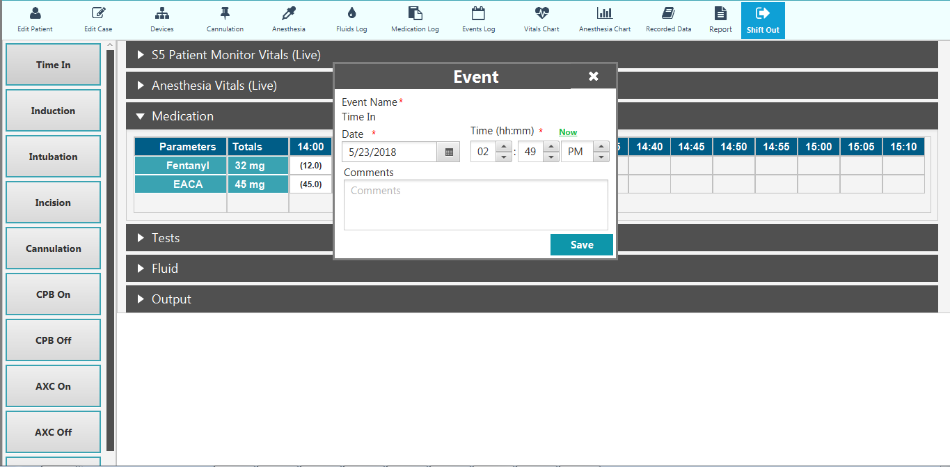

Step 2: Enter Time and click on save. It will close the Event pop up and the selected events will be marked as executes on the Dashboard side bar.

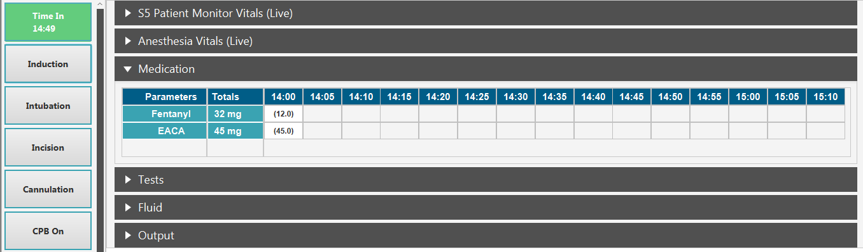

Step 3: Executed Events can be edited from Events log window. Click on Events log button on Menu Bar.



Step 4: Event log window will be opened where you can edit or delete an executed Event or can add a Custom Event.

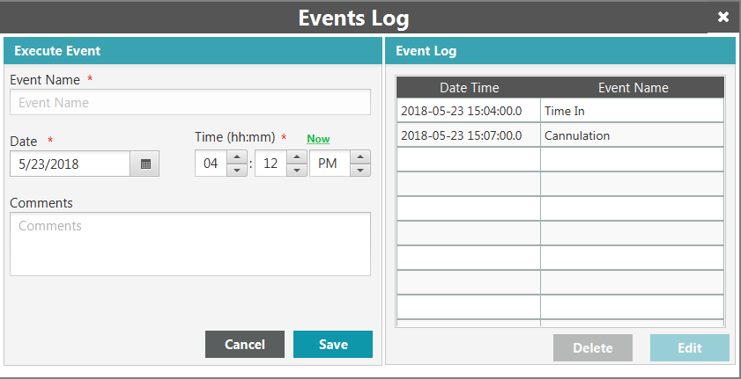

a: To add a custom Event, enter mandatory fields and click on save. The custom Events will be updated under Events Log.

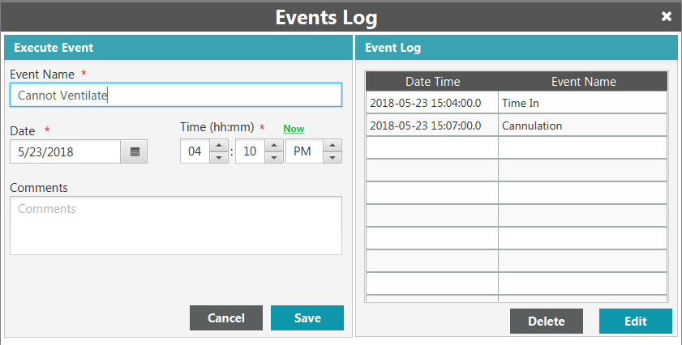

b: To edit an executed Event, select the record under Evets Log and click on Edit button. The events details will be filled under Execute Event. Edit the values and click on Update button to save.

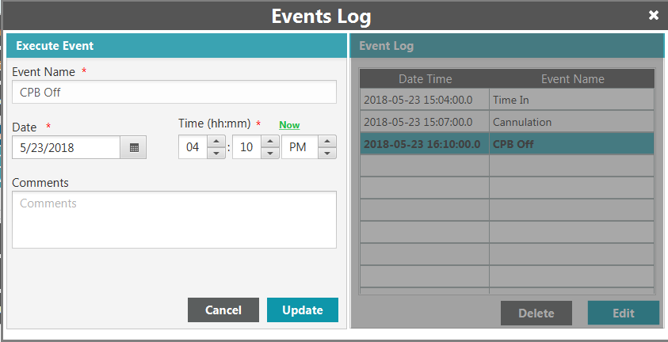

c: To delete an executed Event, select the record under Evets Log and click on Delete button. A prompt for confirmation will be opened, asking Are you sure, you want to delete the record? Click on Ok to delete the selected record.

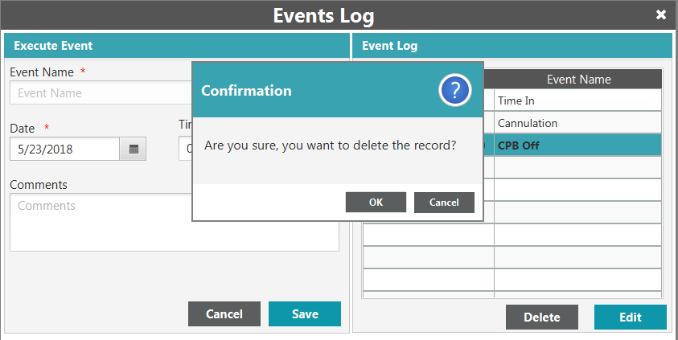

Step 4: Now close the Event log window, the changes will be updated on the Dashboard Events side bar.

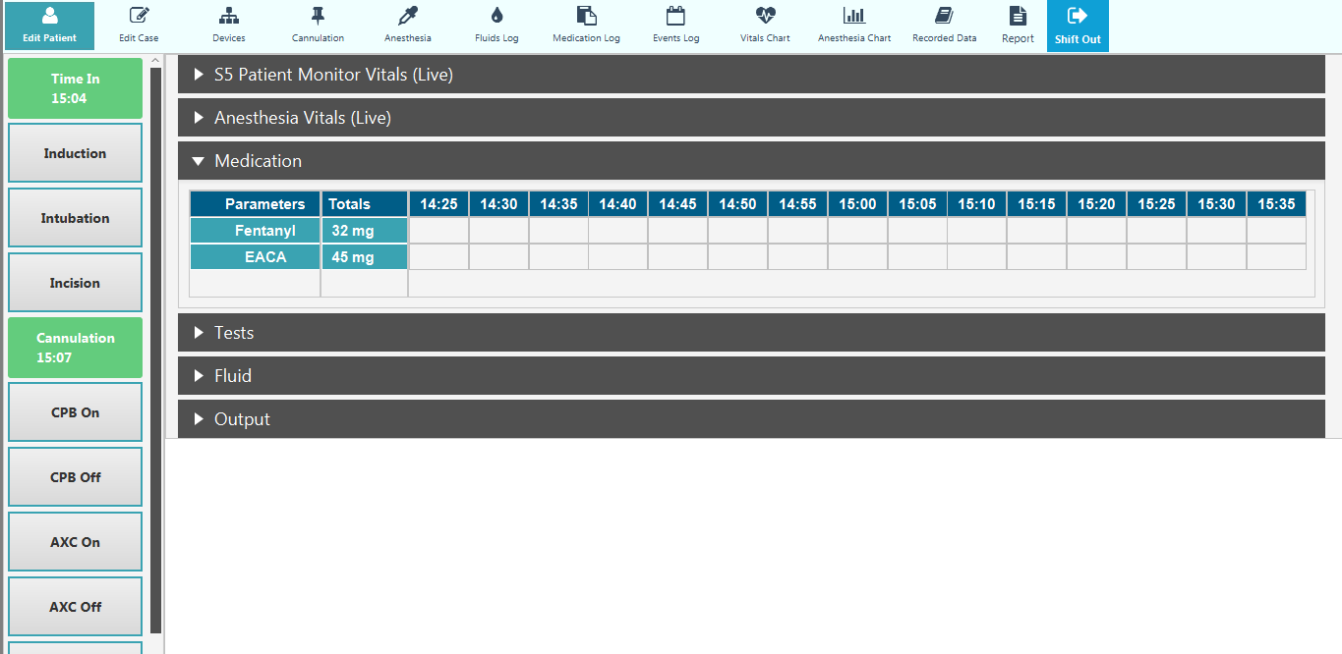

# Steps to perform Shift Out of Patient

Step 1: Click on Shift Out Button on **Menu Bar**

Step 2: You have click Ok on the prompt for confirmation, asking Do you really want to proceed with closure of the case?

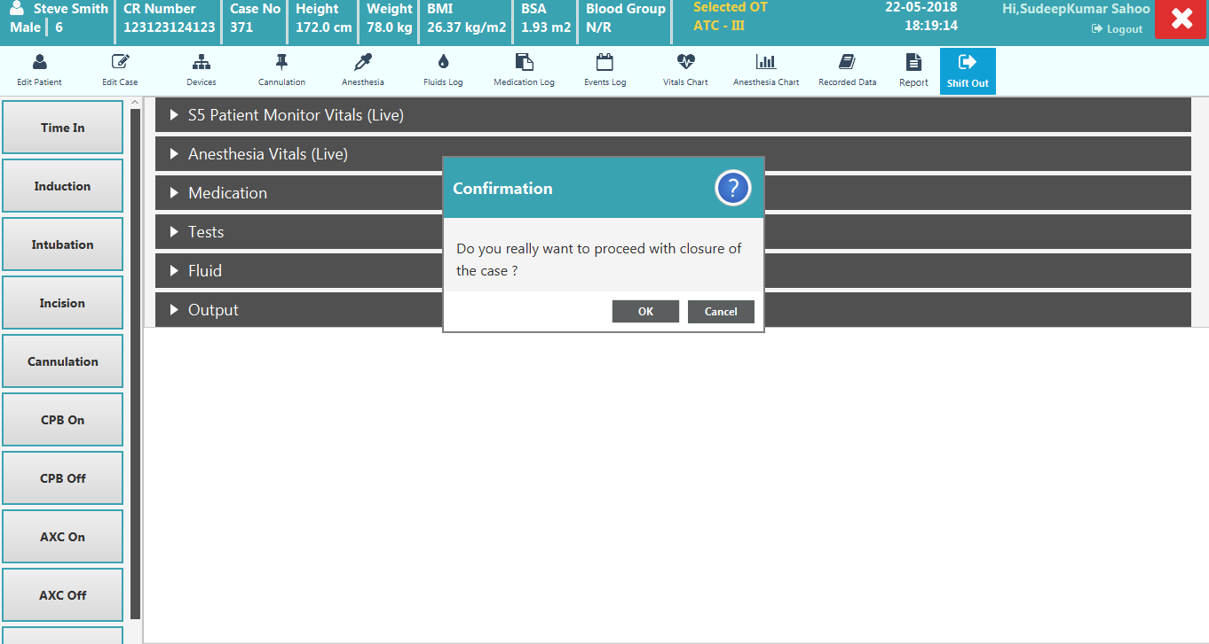

Step 3: On click on Ok it will open Shift Out window. Fill mandatory fields and click on save to Shift Out.

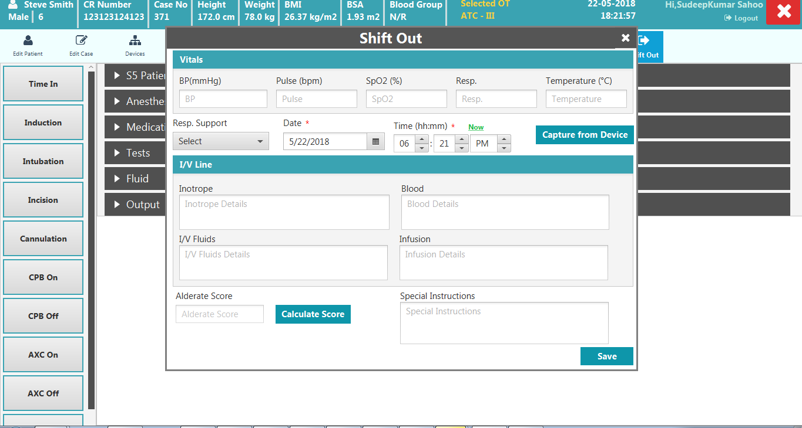

Step 3: On Save, case will be closed and it will open Dashboard Window in read only mode.

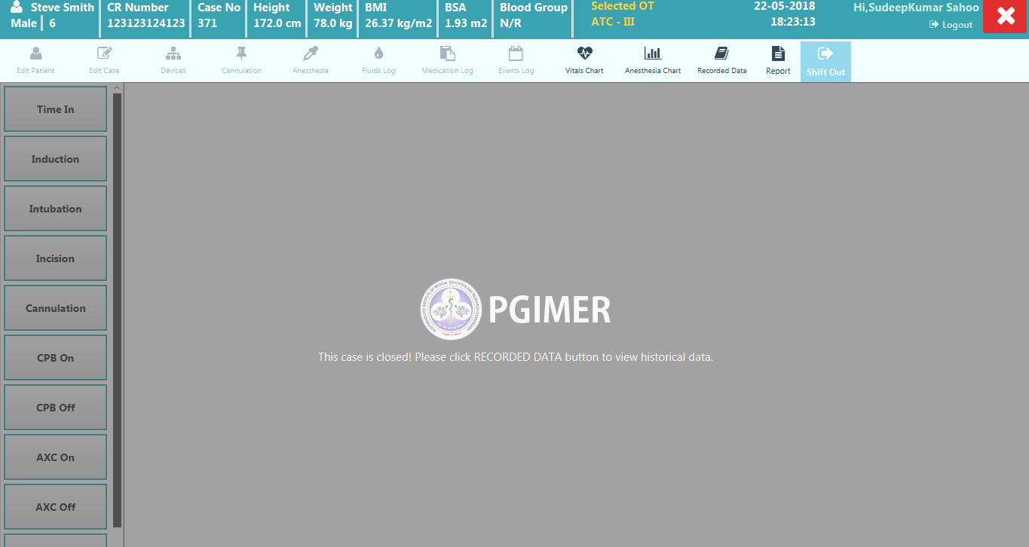

Step 4: You can now see Vital Trend chart, Anesthesia Trend Chart, Recorded Data and can generate Anesthesia Report.

1. **How to Generate Report**

Step 1: Click on the Report Button on the Menu Bar to generate the report. Once report is generated it will open up as PDF, which get saved in the C:\Intraop_Reports folder under today’s date.

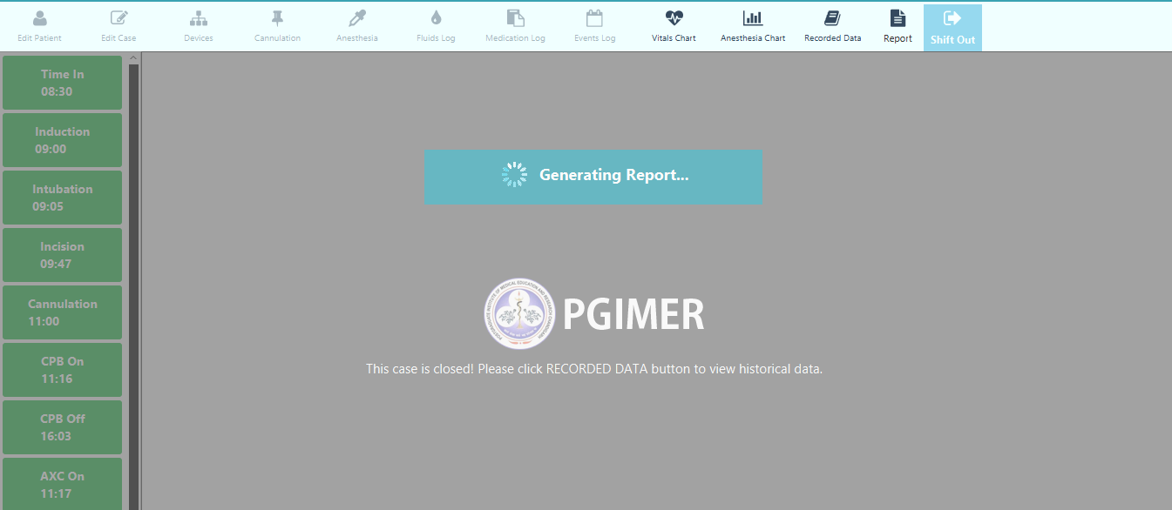

1. **How to View Recorded Data**

Step 1: Click on the Vital Chart on the Menu Bar to see Vital Trend Chart. You can click on next and previous button to move across the pages. To Zoom into the trend chart, you can Set the Time line preference accordingly.

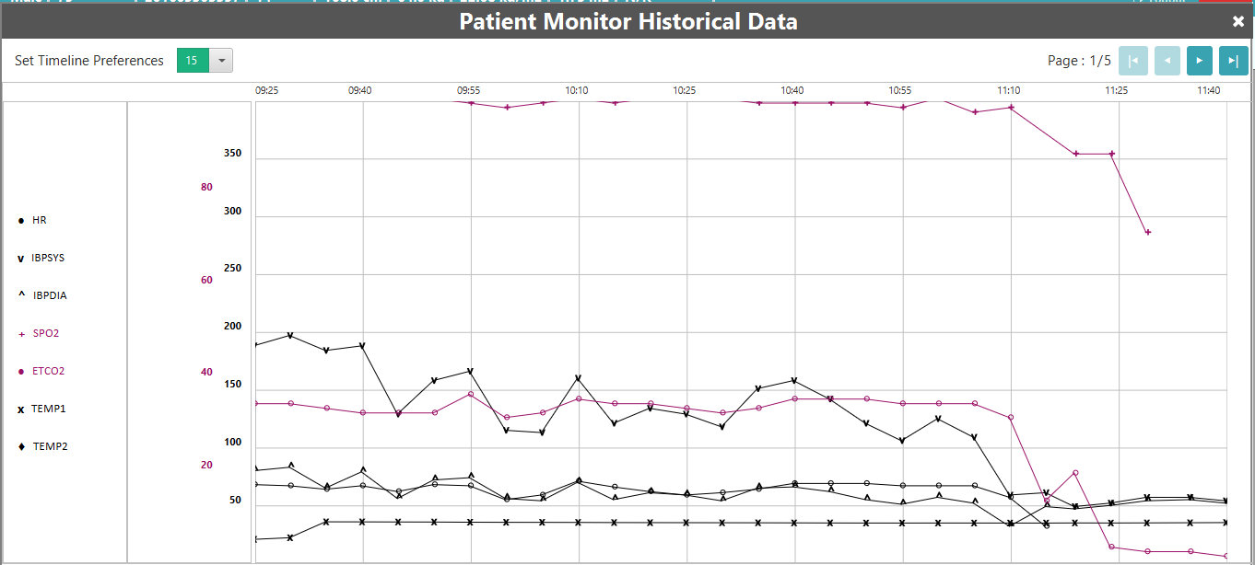

Step 2: Click on the Anesthesia Chart on the Menu Bar to see Anesthesia Trend Chart. You can click on next and previous button to move across the pages. To Zoom into the trend chart, you can Set the Time line preference accordingly.

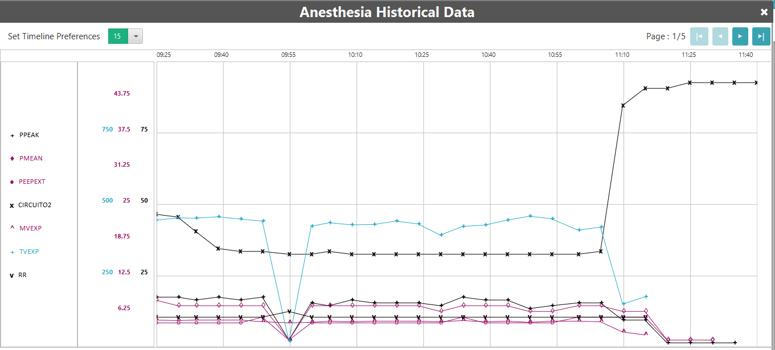

Step 3: Click on Recorded Data on Menu Bar to see the recorded data.

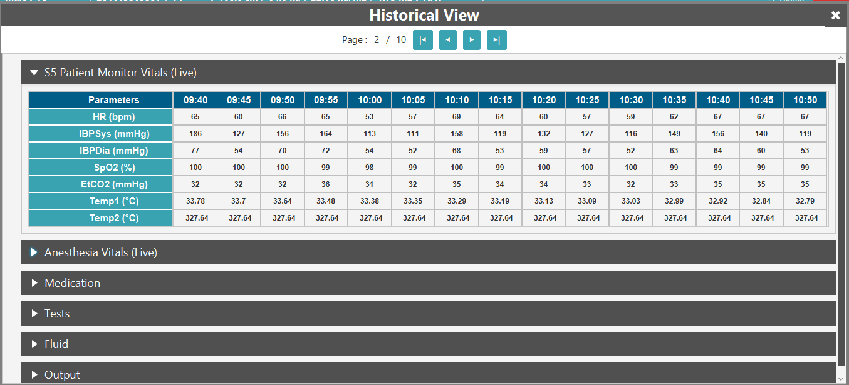

**Note: To start a new case, please close the application and run it again.**