***Activity Recognition Using AlphaPose &***

***Machine Learning (XGBOOST)***

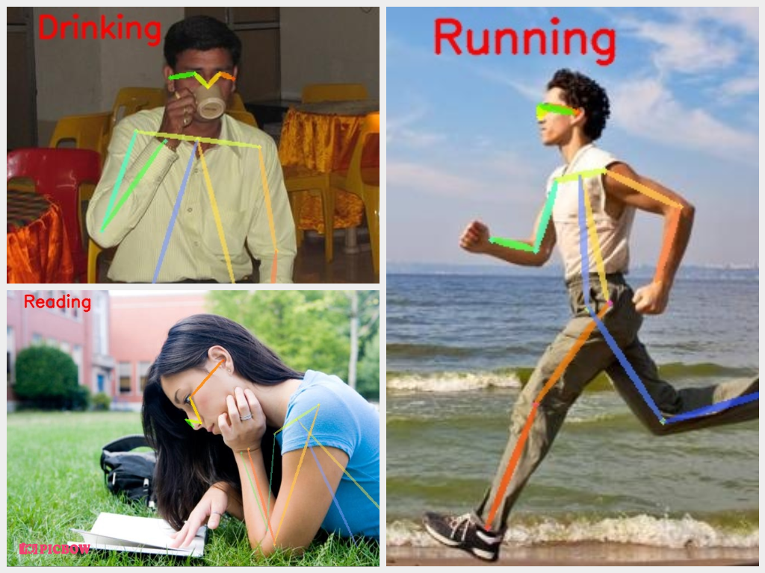

## 

## ***Description :-***

1. This implemantation is based on official **Alphapose** repository ( <https://github.com/MVIG-SJTU/AlphaPose> ).
2. In this project we have used Alphapose and XGBOOST for activity recognition.

* ***Why we have choose this “AlphaPose” over other Pose models :-***

***1) AlphaPose*** is an accurate multi-person pose estimator, which is the **first open-**source system that achieves 70+ mAP (75 mAP) on COCO dataset and 80+ mAP (82.1 mAP) on MPII dataset.

***2)*** To match poses that correspond to the same person across frames, we also provide an efficient online pose tracker called Pose Flow. It is the first open-source online pose tracker that achieves both 60+ mAP (66.5 mAP) and 50+ MOTA (58.3 MOTA) on PoseTrack Challenge dataset.

**3)** AlphaPose supports both Linux and Windows.

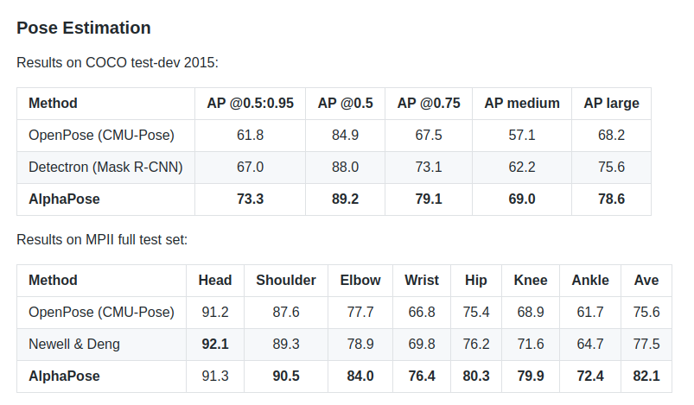

* ***Working Flow :-***

1. First after running the **AlphaPose** model on image it will gives us Skeleton & one json file which contains the keypoints of detected persons of that image.

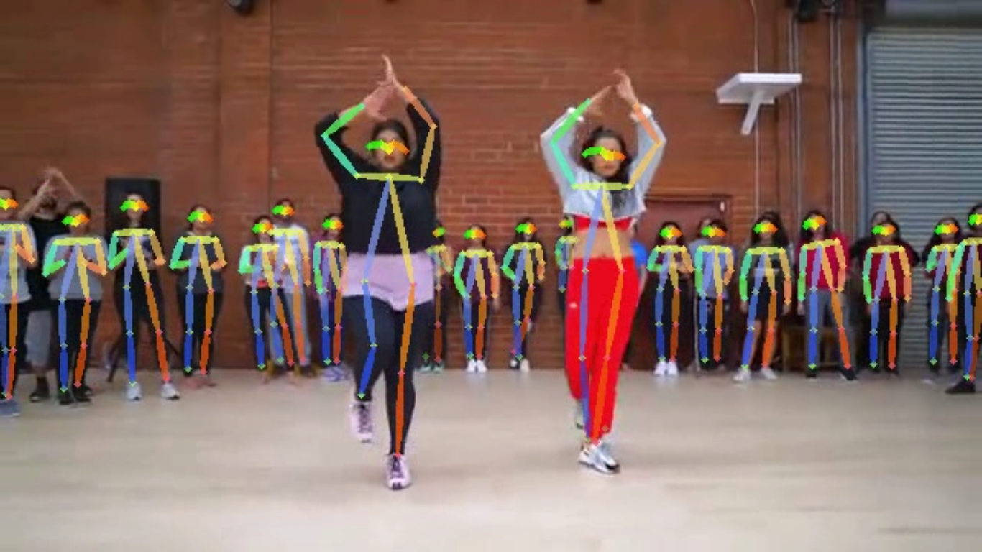

(Skeleton)

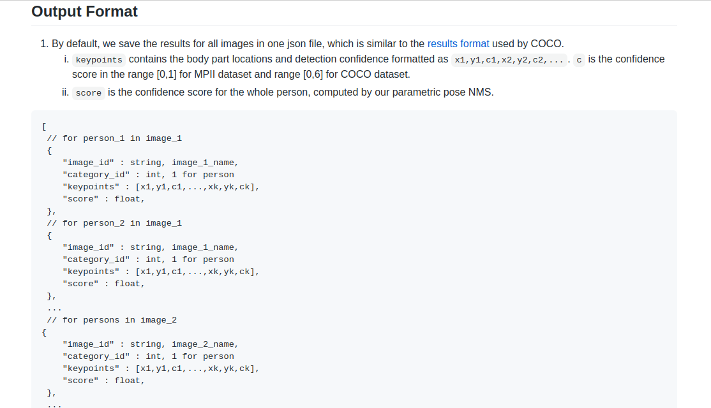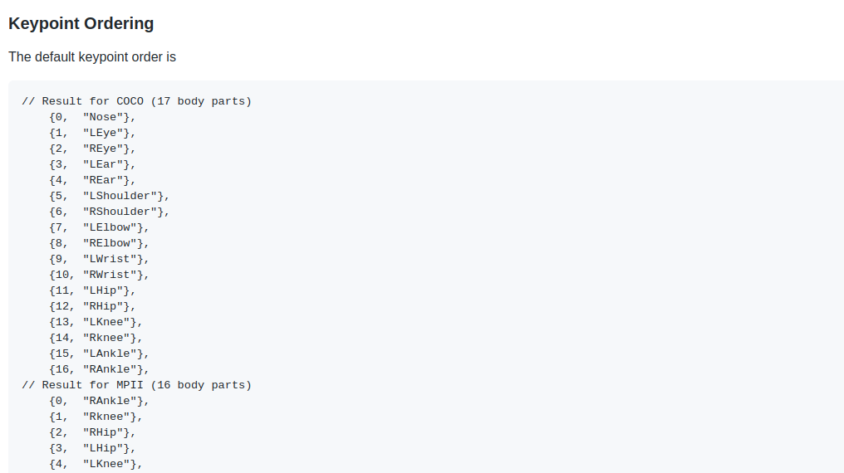

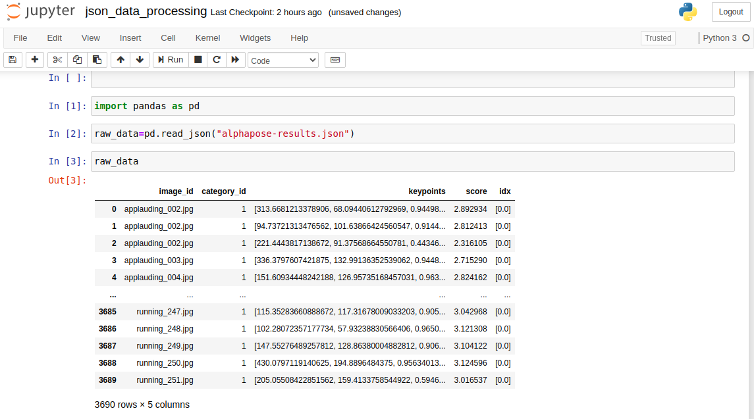 ***raw json file***

**2)** Now based on that keypoints we can train any Machine Learning model to recognize the activity along with AlphaPose.

* ***Custom Traning for Activity Recognition :-***

***1)*** First we will take ‘Human Activity’ image dataset and we will run the AlphaPose model on that images.our dataset is look like,

**A) Training Dataset :-**

|  |  |
| --- | --- |
| ***Categories*** | ***Images*** |
| Applauding | 250 |
| Drinking | 250 |
| Jumping | 250 |
| Reading | 250 |
| Running | 250 |
| Phoning | 250 |
| ***Total*** | ***1500*** |

**2)** After running the model on dataset we will get the corrosponding json file.



**3)** Now we can use any ML model to train this data for activity prediction.here we have used “XGBOOST”model because of it’s better performance on the dataset.

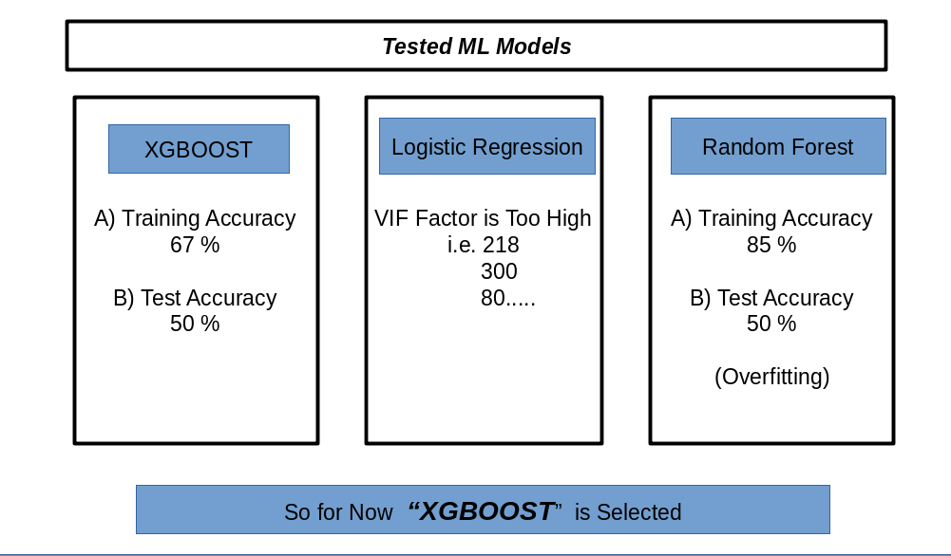

**4)** So in this way now you can combine your ML model with Alphapose for activity prediction.

* ***Results :-***

