

**INTERNSHIP END TERM PROJECT REPORT**

(Project Semester July-Dec 2018)

**On**

**Shoppersdealpoint (Ecommerce Web Application)**

**by**

**Rohit Manral**

**External Supervisor**

**Mr. Surya Prakash Tripathi**

**Sr. Java Consultant**

**Apex TG India pvt. Ltd.**

**DECLARATION**

I hereby declare that the project work entitled “**Shoppersdeal**” is an authentic record of my own work carried out as Full-term Internship under the guidance of **Mr. Surya Prakash Tripathi** (Sr. Java Consultant, Apex TG India pvt. Ltd) (External Faculty Advisor) during July-Dec 2018.

**ACKNOWLEDGEMENT**

The satisfaction that accompanies the successful completion of the task would be incomplete without the mention of the people whose ceaseless cooperation made it possible, whose constant guidance and encouragement crown all efforts with success. We are grateful to our Project Guide **Mr. Surya Prakash Tripathi** sir for the inspiration and the constructive suggestions that helped us in preparation of the project **Shoppersdeal**.

**Shoppersdeal Team**

**Rohit Manral**

**TABLE OF CONTENTS**

**1) Organization Overview……………………………………………………1-2**

**2) Introduction and scope of project………………………………………...3**

2.1) Problems/Needs…………………………………………………………3

2.2) Solutions/Approach……………………………………………………..3

2.3) Objectives………………………………………………………………4

2.4) Project Overview……………………………………………………...4

2.5) Project Category……………………………………………………….5

**3) Exixting System……………………………………………………………6**

3.1) Need for new system……………………………………………...........6

**4) Problem Analysis………………………………………………………….7**

4.1) Business Rules and Requirements…………………………………….7-8

4.2) Exclusion cost………………………………………………………….8

4.2.1) Cost……………………………………………………………….8

4.2.2) Feasibility Analysis……………………………………………….8

4.2.2.1) Technical Feasibility…………………………………………..8-9

4.2.2.2) Economical Feasibility………………………………………...9

4.2.2.3) Operational Feasibility…………………………………………9

4.3) Foundation and Impact………………………………………………...9

4.3.1) Assumptions……………………………………………………...9

4.3.2) Issues and constraints…………………………………………….9

4.3.3) Risk Assesments………………………………………………….10

**5) System Features…………………………………………………………….10**

**6) Other Non-Functional Requirements……………………………………..11**

**7) Software Development Life Cycle…………………………………………11**

**Phase of software development life cycle**

1. Feasibility Study…………………………………………………………12

2. Requirement Analysis……………………………………………………12

3) System Designing………………………………………………………..18

4) Coding……………………………………………………………………13

5) System Testing…………………………………………………………...13

6) Implementation Evaluation and Maintainance…………………………...13

**8) Software Requirement Specification……………………………………..14-17**

8.1) General Overview…………………………………………………….14

8.2) System Overview……………………………………………………..14

8.3) Functional Specification………………………………………………14

8.4) Products Specification…………………………………………………15

8.5) User Classes and Characteristics………………………………………16

8.6) Technical Requirements……………………………………………….17

**9) Design……………………………………………………………………..18**

9.1) Logical Design………………………………………………………18

9.1.1) Data Flow Diagram……………………………………………...18

9.1.2) First Level DFD………………………………………………….19

9.1.3) Second Level DFD admin……………………………………….20

9.1.4) Second Level DFD member……………………………………..21

9.1.5) Second Level DFD visitor………………………………………….22

9.1.6) Second level DFD Order Track…………………………………….23

9.2) Use Case Diagram…………………………………………………….24-27

9.3) Flow Chart……………………………………………………………28-29

9.4) ER diagram…………………………………………………………….30

10) **Testing…………………………………………………………………….31-33**

10.1) Testing Objectives………………………………………………….31

10.2) Levels of testing…………………………………………………32-33

**11) Test Cases………………………………………………………………33-57**

**12) Implementation and Maintainance…………………………………...58-61**

12.1) Introduction……………………………………………………..58

12.2) Maintainance and conversion types……………………...............59-61

**13) Project Legacy…………………………………………………………..62**

13.1) Current Status of the prpject……………………………………...62

13.2) Future Enhancement………………………………………………62

13.3) Technical and Managerial Skill Learnt……………………………62

**14) Pseudo Codes……………………………………………………………..63**

**15) Databas Snapshot………………………………………………………64-66**

**16) Interface snapshot Complete user manual……………………………68-78**

**17) Source Code……………………………………………………………79-171**

**18) Bibliography……………………………………………………………172**

**ORGANISATION OVERVIEW**

Apex TG India Pvt. Ltd. focuses on delivering sophisticated technology-enabled solutions, consulting and Training to maximize complex business needs. Founded in 2007 and based in New Delhi NCR Noida.

Apex TG India Pvt. Ltd. deals in IT Consulting, Training and Development services and providing substantial and concrete results to the clients from across the globe. Provides technical, management and personal skills development, focused on developing better brains for better business. Company work on the principal that unique high quality portfolio, builds skills in five inter-related areas:

a) Management & Leadership Essentials: The essential skills required to be a successful manager and leader.

b) Learn, Absorb and Understand: Learn more efficiently, take better notes, think and plan effectively and be well informed.

C) Write, Speak and influence: Make a positive impression, be remembered, build relationships and influence effectively – in every interaction.

d) Creative Thinking and Innovation: Generate new perspectives and ideas, solve real problems and enhance decision making and team working.

e) Engagement and personal balance: Enhance engagement and motivation, reduce stress levels and improve performance.

**APEX TG INDIA PVT. LTD DEALS WITH THE FOLLOWING:**

1. Development

i) Software Development

ii) Web Development

iii) Ecommerce web development

2. Web Design

3. DotNet Industrial Training

4. Java Industrial Training

5. Software Testing Training

6. SEO/SMO Training

7. Web Designing Training

8. Digital Marketing Training

9. Networking Training

**DEALS WITH FOLLOWING TECHNOLOGIES:**

1. DotNet 4.5.2

2. Java 8

3. PHP 5.6

4. Oracle 11G

5. Cloud Computing

6. SAS

7. IBM Mainframe

8. Embeded System

9. Software testing

10. C and C++ programming

11. Android

12. Data Ware house

13. RedHat Linux

14. ERP

15. Auto CAD

16. SEO

17. CISCO CCNA

**INTRODUCTION AND SCOPE OF PROJECT**

The Shoppersdeal is the part of the sample application that provides customers with online shopping. Through a Web browser, a customer can browse the catalog, place items to purchase into a virtual shopping cart. Create and sign in to a user account, and purchase the shopping cart contents by placing an order. After placing an order for selected items a user can make payment with through a credit card or through cash on delivery. There is no need to wait in long queue for purchase. Customer can purchase products sitting at home by viewing images of different category of products and adding in shopping cart.

Shopperdeal (shopping websites) will use some sort of shopping cart - this is a virtual trolley into which a person can place items, then take them to the checkout when you want to pay. The checkout must be in a secure server in order for your transaction to be secure (in case of card payment).

**PROBLEMS/NEEDS**

i) Time Consuming process

ii) Difficulty to finding the products

iii) Incovenient

iv) Difficult to compare prices

v) High Price

vi) Limited Products

vii) Limited operation period

viii) Less information about the product.

**SOLUTIONS/APPROACH**

These steps will be considered to solve above mentioned problems

i) Do not have to spend time to travel.

ii) Easy to find any product you want by simply browsing the website.

iii) Convenience

iv) Easy to compare product and prices

v) Discounts are available

vi) Available 24x7

vii) Broader product Range

viii) Quality of information about the product.

**OBJECTIVES**

Our objective was to look at online retail from a customer’s point-of-view and determine which of the biggest ecommerce sites was providing the best customer experience.

1) To shop while in the comfort of your own home, without having to step out of the door   
2) To be able to easily save money and compare prices from website to website   
3) Online resellers tent to sell at a lower price due to less overhead expenses

**PROJECT OVERVIEW**

Project is divided into following module-

A. **ADMIN MODULE**

Admin can perform following tasks:

a) Add/Remove Products

b) Update Product information

c) Acces the DataBase

d) Add/Block Users

**B**. **USER MODULE**

Users can perform the following task:

a) SignUP

b) Sign In

c) Change Pasword

d) Request for password from Admin if forgot the password.

f) Browse products/View products

g) Select the products and Add to Cart

h) Place Order

i) Make Payment

**C. VISTORS**

a) Browse the web sites

b) View the products

**PROJECT CATEGORY**

This project is basically categorized as RDBMS. The project is based on three tier architecture**.** The three tier architecture where the application is divided into three logical constituents.

1. **Presentation layer –** In this layer mainly following pages contained:
   1. Web Pages
   2. User Control
   3. Master Pages
2. **Business Layer –** Business Logic,
   1. Result Engine
   2. User permissions logic
   3. Access Rights
3. **Data Layer –** Provide handling and validation of data (MySQL in this case).

**EXISTING SYSTEM**

i) In the existing system all transactions, dealings of products, purchasing of products were done manually which is time consuming.

ii) Reports are prepared manually as and when needed. Maintaining of reports is very tedious task.

iii) To buy any product user has to collect information about it either byvisiting the shop or asking people which is the better one.

iv) There is no computer system to handling all payments. All calculations are performed manually which may not be correct always.

v) Any internet user can use this existing website to search for any kindof products, select particular products from a wide range of products.

vi) Once they make their minds to purchase any particular item, they can place an order and can make payments through various available payment options.

**NEED FOR NEW SYSTEM**

i) Online Shopping Portal is a specific requirement of the client thatintegrates the buying and selling services specifically to their customers.

ii) Need for the new system is due to major drawbacks of existingsystem.

iii) Reports can be generated at any time within few seconds, so thatmanual labour is not required, and also analysis can be performedmuch more frequently which helps in taking decision.

iv) The details regarding all users, products can also be maintained astheir information is very helpful and sometimes becomes a criticalrequirement.

v) Allows user to get registered from their places and transact for therequired product.

vi) To overcome these problems in existing system we develop “Shoppersdealpoint”.(online shopping web application)

**PROBLEM ANALYSIS**

**BUSINESS RULES AND REQUIREMENTS**

|  |  |  |
| --- | --- | --- |
| Sr. NO | Description | Notes |
| 1 | User Requirements | Step by step Report: Excellent Planning. Organization and management. To avoid the conflicts you can analyse the effects easily in response to particular action. |
| 2 | Functional requirements | 1. Modules for admin to handle the administration task. 2. Module for user to manage user information. 3. Modules to manage product category and information 4. Module for managing roles and menus. 5. Module to Place online order 6. Modules for users to slect the products, add products to the cart, make payments. |
| 3 | Reporting Requirements | Users can get reports of the ordered products from the admin as a mail. |
| 4 | Security Requirements | Data Security: Proper Backup of data   * The access to the system must be through the secure and authenticated login, authorizations, etc. |
| 5 | Non-Functional requirements | * Secure access of confidential by using roles based authentication. * 24 X 7 availability. * Better component design to get better performance at peak. |

**Table 1-Business Rules and Requirements**

**EXCLUSIONS COST**

**Cost:**

* The cost management and budgeting is not to be considered in the current release.
* If the Project is to be extended on large scale then the cost factor on the resources will be included but has been excluded for the time being.

**Feasibility Analysis:**

Feasibility study is the process of determination of whether or not a project is worth doing.

Feasibility analysis is completed in three phases:

1. Technical feasibility
2. Economical feasibility
3. Operational feasibility

**Technical Feasibility:**

The technical issue usually raised during the feasibility stage of the investigation includes the following:

* Does the necessary technology exist to do what is suggested?
* Do the proposed equipment’s have the technical capacity to hold the data required to use the new system?
* Will the proposed system provide adequate response to inquiries, regardless of the number or location of users?
* Can the system be upgraded if developed?
* Are there technical guarantees of accuracy, reliability, ease of access and data security?

**Economical Feasibility:**

A system can be developed technically and that will be used if installed must still be a good investment for the organization. In the economical feasibility, the development cost in creating the system is evaluated against the ultimate benefit derived from the new systems.

Financial benefits must equal or exceed the costs. The system is economically feasible. It does not require any addition hardware or software. Since the interface for this system is developed using the existing resources and technologies, there is nominal expenditure and economical feasibility for certain.

**Operational Feasibility:**

Proposed projects are beneficial only if they can be turned out into information system that will meet the organizations operating requirements. Operational feasibility aspects of the project are to be taken as an important part of the project implementation. The well-planned design would ensure the optimal utilization of the computer resources and would help in the improvement of performance status.

**FOUNDATION AND IMPACT**

**Assumptions:**

* It has been assumed that the system will provide an interface for the user which is easy to understand and implement.
* It is assumed that end user have at least basic knowledge of using computer based applications.

**Issues and constraints:**

* Security Requirements for the user i.e. authenticated and authorized access.
* Unauthorized access is prohibited.
* User related information should be in valid format.

**Risk Assessments:**

* Lack/Unavailability of resources at the time of Survey.
* Conflict in time management

**SYSTEM FEATURES**

**User Master: -** This includes creating user accounts to each of User and admin separately. This includes taking pertinent information from them and then initializing the database. The database needs to be properly updated on each transaction by the user and all the details of his/her account should figure in the account listing. The security of the account also should be dealt with.

**User Type: -** There are two types of users

1. Admin
2. Customers or users

The details of which will be dealt with in the design specification. Each of these details is kept in the user account where he is kept updated about all his information.

**OTHER NON-FUNCTIONAL REQUIREMENTS**

**Safety Requirements: -** Suitable safety has to be taken while allowing a user creates profile on Shoppersdealpoint site. There could be possible misuse of the system by bogus user, experts. Also during profile transactions the Unreliable networks may cause further problems. So such practices need to be avoided.

**Software Quality Attribute: -** The system is easy to load and light. It adds to the quality and usability of the system. Some other quality considerations such as adaptability, availability, robustness, testability, and usability will also be very seriously taken to consideration.

**Web site Rule: -** Nothing is above user satisfaction. So the rules need to be kept flexible to meet user needs and preferences at different times.

**SOFTWARE DEVELOPMENT LIFE CYCLE**

Software development organization follows some process when developing a software product. A key component of any software development process is the life cycle model on which the process is based. The particular life cycle model can significantly affect overall life cycle costs associated with a software product. Life cycle of the software starts from concept exploration and at the retirement of the software.



Fig: - Software Development Life Cycle

**PHASES OF SOFTWARE DEVELOPMENT LIFE CYCLE**

The software development life cycle is classically thought of as the set of activities that analysts, designers and users carry out to develop and implement an information system.

The system development life cycle consists of the following activities:

1. Feasibility Study

2. Requirement Analysis

3. Designing

4. Coding

5. System Testing

6. Implementation and Maintenance.

1. **Feasibility Study**: An important outcome of the preliminary investigation is the determination that system is feasible or not. In the conduct of feasibility study, there are three major distinct and interrelated areas were taken into consideration. They are as follows:

* **Technical Feasibility**: The System of operation which was functioning earlier was totally manual, with no kind of automation or computerization. All the departments were maintaining separate registers for keeping various records. The computerized system is technically feasible as it is efficient, less time consuming, can produce outputs faster, can input large amount of data in limited time scale and easier to use in operation.
* **Operational Feasibility**: The ultimate users i.e. the people who are supposed to use the system are trained for a period of time so as to get familiar with the new system and its operation. They are taught about the new skills and the new technology and how the technology will be useful to them in their functioning. Operational feasibility is concerned with human, organizational and political aspects.
* **Economical Feasibility**: The computerized system is economically feasible in the sense the cost of the hardware and software and the cost to training of personnel of the company to operate the system and the installation cost is less than the cost of maintaining the registers.

1. **Requirements analysis**: Analysis of requirements includes studying the existing system and collecting data. During analysis, data are collected on the available files, decision points and transaction handled by the present system. Once the structured analysis is completed, the analyst has affirmed understanding of what is to be done.
2. **System Designing**: The design of an information system produces the details that clearly describe how a system will meet the requirements identified during system analysis. System analysts begin the design process by identifying reports and other outputs system will produce. The system design also describes the data to be input, calculated or stored.
3. **Coding**: This is the phase in which computer based system is constructed from the specifications prepared in the design phase. Equipment is acquired and installed during the development phase. All necessary procedure, manuals software specifications, and other documentation are completed. The staff is trained.
4. **System Testing**: During system testing, the system is used experimentally to ensure that the software does not fail. In other words we can say that it will run according to its specifications and in the way users expect. Special test data are input for processing, and the result examined.
5. **Implementation, Evaluation and Maintenance**: Implementation is the process of having systems personnel check out and put new equipments into use, train users, install the new application and construct any files of data needed to use it.

Evaluation of the system is performed to identify its strength and weaknesses. Maintenance is necessary to eliminate errors in the working system during its working life and to tune the system to any variations in its working environment. The importance of maintenance is to continue to bring the new system to standards.

**SRS (SOFTWARE REQUIREMENT SPECIFICATION)**

**GENERAL OVERVIEW**

Requirements specification involved coming up with a detailed documentation of what the proposed system was supposed to do. All the functionalities of the new system are described indetail. It involves description of the user requirements into structures that can be automated.They prescribe a reduced level of abstraction.

**SYSTEM OVERVIEW**

Generally, the system represented by this report is meant to offer sevenmain functionalities:

1. Buying and ordering items online

2. Paying of items online

3. Admin managing shop store

4. Secure records of customers

5. Manage transaction of customers.

6. Generate reports of the shops to management (admin)

7. Ease to use and user friendly interface

**FUNCTIONAL SPECIFICATIONS**

i) Users should registered before buying or ordering products online to make thetransaction secure.

ii) Once the user register and have an account he/she can be able to buy or order product online.

iii) Admin must be able to view the transaction made by the customers buyviewing of reports when logged in.

iv) Admin must be able to view the transaction made by the customers buyviewing of reports when logged in.

v) The user transaction should be secure. That is authentication mechanism will be built into the application to prevent unauthorized persons from accessinganother customers’ account.

vi) Admin should be able to manage the stock in the storethrough editing, removing andadding.

**PRODUCTS SPECIFICATIONS**

It consists of these modules:

* Authentication and Authorization.
  + Login and session.
  + User authentication.
  + Roles assign by admin user.
  + Roles assign user wise.
* Order the product
* View the product
* Select the product
* Add to cart
* Fill users detail and address
* Place order
* Make Payment
* Password recovery
* Change password

**USER CLASSES AND CHARACTERISTICS**

**ADMINSTRATOR**

These are the users who use to manage (Controls) whole website and its contents. They have the privileges to manage the database. Few of the administrator modules are as follows:

* Insert the product details
* Add/Remove products
* Manage other users.
* Access and maintain all users.

**USERS**

There are other users who are created by admin user and assign role and responsibility, according assigned role other user will use the website and make work more efficient. These are the users for whom we are making this website. After registration procedure they will be registered to use our website and who is not part of institute they can’t allowed to purchase from our website, for this they must be registered with us.

**TECHNICAL REQUIREMENTS**

**FRONT END**

i) Presentation Layer: **Java Server Pages**

* User friendly
* Separation of work (design and coding)
* Write once and run anywhere

ii) Middle tier: **Java Beans and Servlet.**

iii) Database Layer: **MySql**

iv) Web development language: HTML5, CSS, and BOOTSTRAP.

**SOFTWARE REQUIREMENTS**

* Windows XP/windows7/windows8 operating system and above
* MySQL
* JSP & Java
* TOMCAT Server
* Weblogic
* DreamWeaver
* Google chrome or Mozilla Firefox browser.

**HARDWARE REQUIREMENTS**

* Pentium machine with 466 Mhz processor speed
* 500 MB RAM
* 10.2 GB Hard Disk

**DESIGN**

**LOGICAL DESIGN**

**DATA FLOW DIAGRAM(DFD):**

The DFD’s represents the flow of the data among the different processes, entities and records. There are 0-level (context diagram), 1-level DFD’s and 2-level DFD’s. The 0-level DFD represents the overall entities participating in the system excluding the detailed functionality of the system.

The 1-level DFD represents the whole system whereas the 2-level DFD focus more closely on one particular process in the level 1.

**CONTEXT LEVEL DFD**

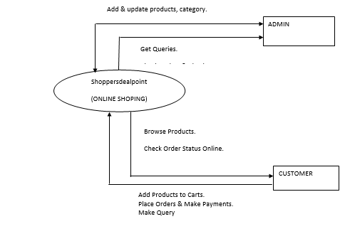

**FIRST LEVEL DFD**

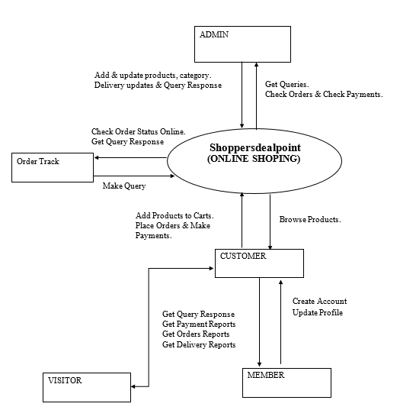

**SECOND LEVEL DFD (ADMIN)**

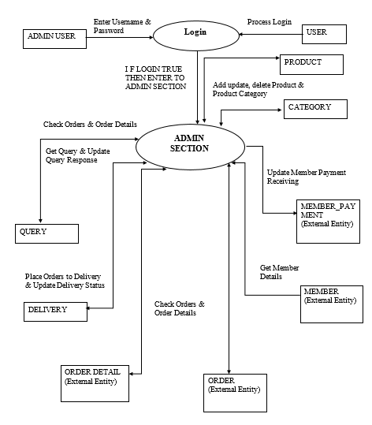

**SECOND LEVEL DFD (MEMBER):**

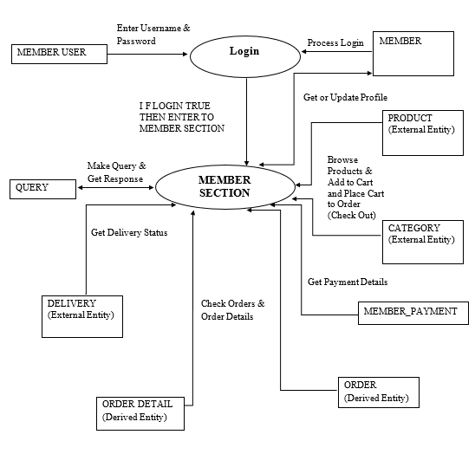

**SECOND LEVEL DFD (VISITOR)**

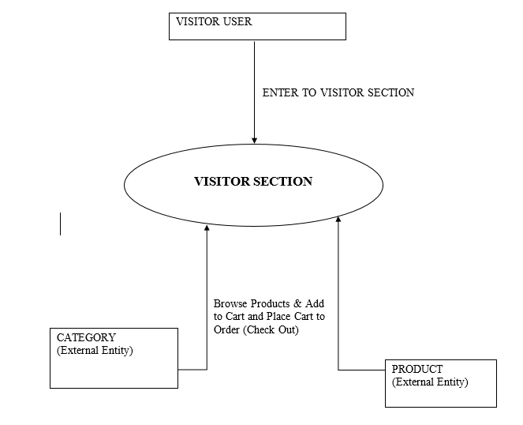

**SECOND LEVEL DFD (ORDER TRACK)**

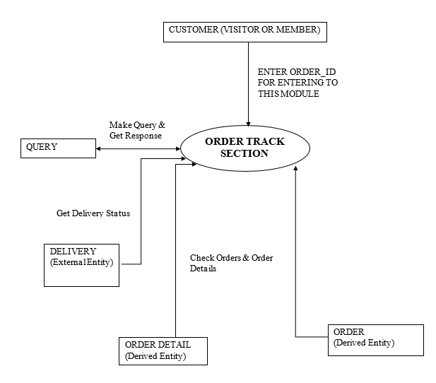

**USE CASE DIAGRAM**

Use Case diagrams are used to chart out the user requirements. This diagram represents the different use cases, actors in a system with their relationships.

**USE CASE OF SHOPPERDEALPOINT**

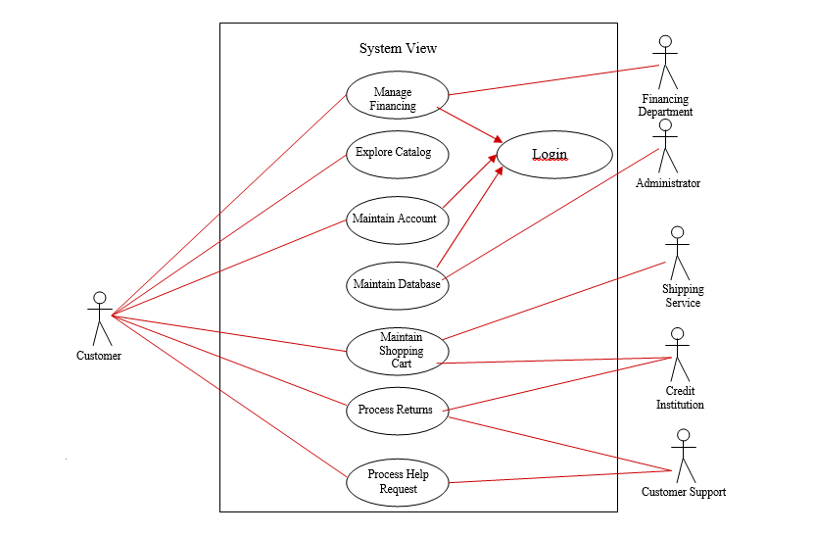

**MAINTAINING THE SHOPPING CART (ADMIN) MODULE**

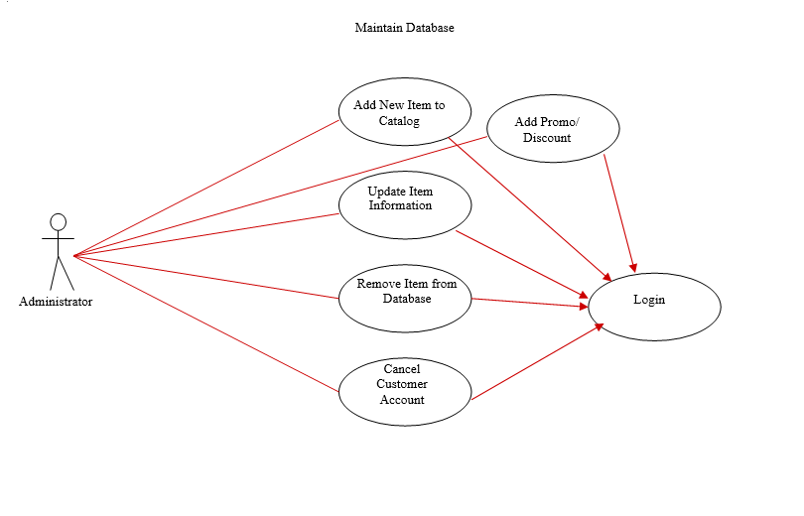

**MAINTAIN ACCOUNT (USER)**

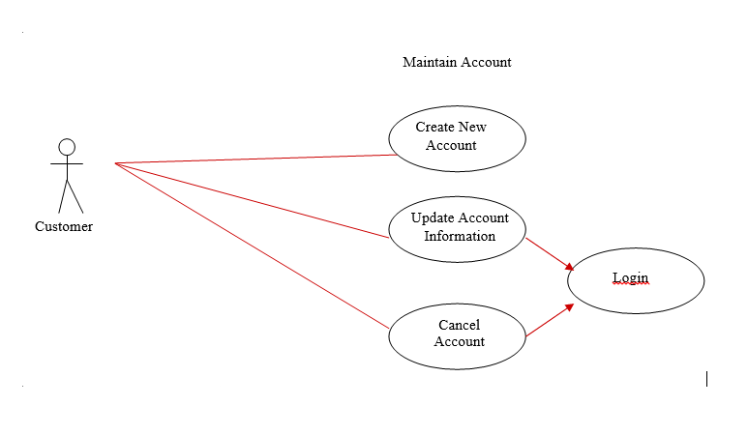

**EXPLORE CATALOG**

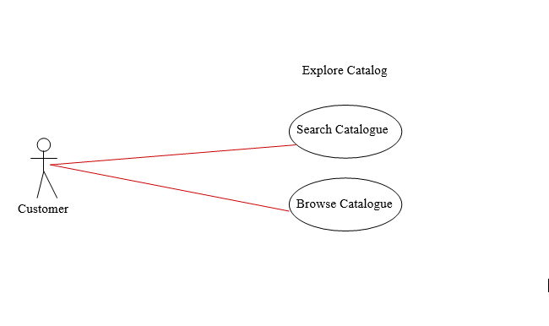

**MAKE PAYMENT**

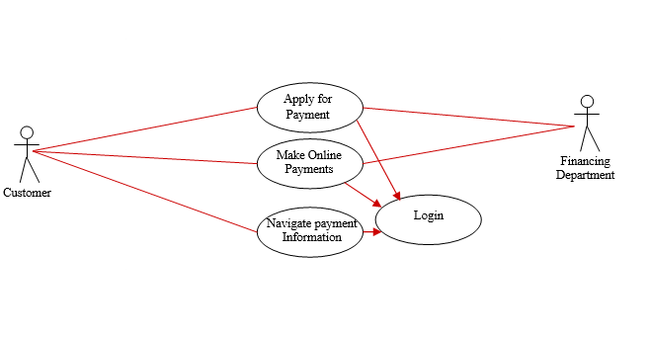

**FLOW CHART**

Flow Charts are the Pictorial representations of the flow of the data of the Travel with Glance System. In flowcharts the Start/Stop is represented by eclipse, Input/output is shown by rectangles, operations are shown in parallelogram, and diamonds represents the Decision box.

**LOGIN MODULE**

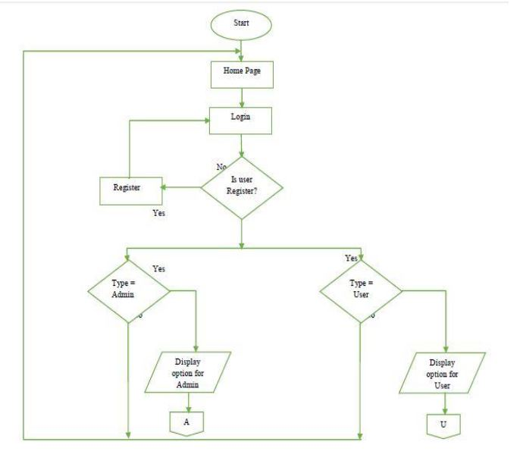

**FLOW CHART FOR THE SYSTEM**

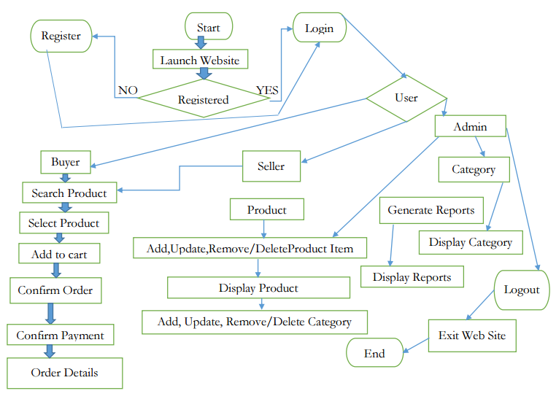

**ENTITY RELATIONSHIP DIAGRAM**

1 M M M

place

Has

Product

ORDER

User

1

1 M

Has

Has

Has

M 1 1

DELIVERY

M

Are

STOCK

CATEGORY

M

SALE

**TESTING**

Software testing is an investigation conducted to provide information about the quality of the product or service under test. Software testing can also provide an objective, independent view of the software to allow the business to appreciate and understand the risks at the software implementation. Software testing is any activity aimed at evaluating an attribute or capability of a program or system and determining that it meets its required results. Software Testing is the process of executing a program or system with the intent of finding errors. Software testing can also be stated as the process of validating and verifying that a software program/application/product:

|  |  |  |
| --- | --- | --- |
| FUNCTIONALITY  (EXTERIOR QUALITY) | ENGINEERING  (INTERIOR QUALITY) | ADAPTABILITY  (FUTURE QUALITY) |
| CORRECTNESS  EFFICIENCY  FLEXIBILITY  RELAIABILITY | TESTABILITY  REUSABILITY  USABILITY | DOCUMENTATION  MAINTAINABILITY  INTEGRITY  STRUCTURE |

**Table 1: Typical Software quality factors**

**TESTING OBJECTIVES**

The main objectives of testing is to uncover a host of errors, systematically and with minimum effort and time, starting formally, we can say,

1. Testing is the process of executing a program with the intent of finding errors.
2. A successful test is one that uncovers an as yet of finding errors.
3. A good test case is one that has a high probability of finding errors, if it exits.
4. The tests are independent to detect possible errors.
5. The software more or less confirms to the quality and reliable standards.

**LEVELS OF TESTING**

1. **UNIT TESTING**

* Unit Testing is primarily carried out by the developers.
* It deals with the functional correctness and the completeness of individual program units.
* Whit box testing methods are employed.

1. **INTEGRATION TESTING**

* It deals when several program units are integrated.
* **Regression Testing**: Change of behaviour due to modification or addition is called ‘Regression’; it is used to bring changes from worst to least.
* **Incremental Integration Testing**: Checks out for bugs which encounter when a module has been integrated to the existing.
* **Smoke Testing**: It is the battery of test which checks the basic functionality of program. It fails then the program is not sent for further testing.

1. **SYSTEM TESTING**

* It deals with testing the whole program system for its intended purpose.
* **Recovery Testing:** System is forced to fail and checked out how well the system recovers the failure.
* **Security Testing:** Checks the capability of system to defend itself from hostile attack on programs and data.
* **Load and Stress Testing**: The system is tested for max load and extreme stress points are figured out.
* **Performance Testing**: Used to determine the processing speed.
* **Installation Testing:** Installation and uninstallation is checked out in the target platform.

1. **ACCEPTANCE TESTING**

* **UAT** ensures that the project satisfies the customer requirements.
* **Alpha Testing**: It is the test done by the client at the developer’s site.
* **Beta Testing**: It is the test done by the end user at the client’s site.
* **Long Term Testing**: Checks out for faults occurrence in a long term usage of the product.
* **Compatibility Testing**: Determines how well the product is substantial to product transition.

1. **ALPHA TESTING**

Alpha testing is testing of an application when development is about to complete. Minor design changes can still be made as a result of alpha testing. Alpha testing is typically performed by a group that is independent of the design team, but still within the company, e.g. in-house software test engineers, or software QA engineers.

1. **BETA TESTING**

Beta testing is testing of an application when development and testing are essentially completed and final bugs and problems need to be found before the final release. Beta testing is typically performed by end-users or others, not programmers, software engineersor test engineers.

**TEST CASES**

**TEST CASES FOR LOGIN FORM**

|  |  |  |  |  |  |  |  |  |
| --- | --- | --- | --- | --- | --- | --- | --- | --- |
|  |  |  | | | | | |  |
|  |  |  | | | | | |  |
|  |  | |  |  |  |  |  | |
| Test Suite: User Login Form | | |  |  |  | Date of Creation:20-04-2016 | | |
| Created By: |  | |  |  | Implemented On: 20-04-2016 | | | |
| Gokul chetri |  | |  |  |  |  |  |  |
| Pre-Requisites: | Weblogic or Tom Cat server, MySql, Login Form, Google chrome,JDK 8 | | | | | | |  |
|  | Mozilla Firefox 5.0 | |  |  |  |  |  |  |
| Validation: | Required Field Validator: (User Name, Password) | | | |  |  |  |  |
| Valid Classes | User Name→(email id, Max length =100) | | | |  |  |  |  |
|  | Password →(A-Z, a-z,1234567890, Max length =20, Special character (~! @#$%^&*_+=- | | | | | | | |
|  | }{[]\|’;:”/.,<>?)) | | | |  |  |  |  |
| Invalid Classes | User Name→(Spaces, invalid email format) | | | | | | |  |
|  | Password→(Spaces) | | | |  |  |  |  |
| User Interface | Login Form | |  |  |  |  |  |  |
| User Name and | As per the login person or as generated by in the database | | | | | | |  |
| Password |  | |  |  |  |  |  |  |
| Test Case Id | Description | |  | Expected Result |  | Actual Result |  | Rem |
|  |  | |  |  |  |  |  | arks |
|  |  | |  |  |  |  |  |  |

|  |  |  |  |  |  |
| --- | --- | --- | --- | --- | --- |
| TC-ULG-01 | Leave all fields (User Name |  | It should display | Error message | Pass |
|  | and password) empty and | | error message in | displayed in |  |
|  | click on Login button. |  | validation | validation summary |  |
|  |  |  | summary | “Enter User name and |  |
|  |  |  | User ID and | Password |  |
|  |  |  | Password |  |  |
|  |  |  | respectively. |  |  |
| TC-ULG-03 | Enter alphabets and Numbers in the  User Name field. |  | It  should accept both values. | It accept  Alphabets and numbers. | Pass |
|  |  |  |
|  |  |  |  |
|  |  |  |  |  |  |
| TC-ULG-04 | Enter spaces in the User |  | It should not | It does not allows | Pass |
|  | Name field. |  | allow spaces. | spaces to be entered |  |
|  |  |  |  | in the User Name field. |  |
| TC-ULG-05 | Enter special characters |  | It should accept | It does accepts | Pass |
|  | in User Name field such |  | special | special characters in |  |
|  | as!@#$ %^&*()_+=- |  | characters in User | User Name field except invalid email address. |  |
|  | {}|:”?><,\ | / | Name field but valid email address only |  |  |
| TC-ULG-06 | Check for maximum |  | It should not | It does not exceed | Pass |
|  | length of characters for |  | accept infinite | the maximum length. |  |
|  | the User Name field. |  | characters in User |  |  |
|  |  |  | Name field. |  |  |
| TC-ULG-07 | Enter numeric values in |  | It should accept | It accepts the | Pass |
|  | the User Name field. |  | Alpha-numeric | Alpha-numeric values  Along with @example.com |  |
|  |  |  | Values followed by @example.com | (email id) |  |
| TC-ULG-08 | Enter the Password field  and leave the User Name  field blank. |  | It should display | It displays an error | Pass |
|  |  | an error message | message “ User |  |
|  |  | in validation | Name field” |  |
|  |  | summary |  |  |
|  |  | “Enter user name |  |  |
|  |  | field. |  |  |
|  |  |  |  |  |  |
| TC-ULG-09 | Enter alphabets in the |  | It should accept | It accepts the | Pass |
|  | Password field |  | the alphabets in | alphabets either they |  |
|  | (Both Capitals and |  | Password field. | are in capital letters |  |
|  | small). |  |  | or small letters. |  |
| TC-ULG-10 | Enter spaces in Password | | It should not | It does not accept the | Pass |
|  | Field. |  | accept spaces in | spaces in Password |  |
|  |  |  | the Password | field. |  |
|  |  |  | field. |  |  |
| TC-ULG-11 | Enter special characters |  | It should accept | It accepts special | Pass |
|  | in Password field such |  | special characters | characters in |  |
|  | as!@#$ %^&*()_+=- |  | in Password field. | Password field. |  |
|  | {}|:”?><,\ | / |  |  |  |
| TC-ULG-12 | Check for maximum |  | It should not | It does not exceed | Pass |
|  | length of characters for |  | accept infinite | the maximum length. |  |
|  | the Password field. |  | characters in |  |  |

|  |  |  |  |  |  |  |  |  |  |  |
| --- | --- | --- | --- | --- | --- | --- | --- | --- | --- | --- |
|  |  |  |  |  | Password field. | |  |  |  |  |
| TC-ULG-13 |  | Enter numeric values in | |  | It should accept | | It accepts the |  | Pass |  |
|  |  | the Password field. | |  | numeric values | | numeric values. |  |  |  |
|  |  |  |  |  | also. | |  |  |  |  |
| TC-ULG-14 |  | Enter invalid User Name and | |  | It should display | | It displays an error |  | Pass |  |
|  |  | Password and click on | |  | an error message. | | message “ | |  |  |
|  |  | Login button. | |  |  |  | User Name and |  |  |  |
|  |  |  |  |  |  |  | password” is incorrect | |  |  |
| TC-ULG-15 |  | Enter valid User Id and | |  | Login should be | | Login successful and |  | Pass |  |
|  |  | Password and click on | |  | successful. | | is redirected to the |  |  |  |
|  |  | Login button. | |  |  |  | page as per login. |  |  |  |
| TC-ULG-16 |  | Click the Reset button | |  | It should clear all | | It clears the entered |  | Pass |  |
|  |  |  |  |  | the entered fields | | fields. |  |  |  |
|  |  |  |  |  | prior to login | |  |  |  |  |

**TEST CASES FOR FORGOT PASSWORD FIRST PAGE**

|  |  |  |  |  |  |  |  |
| --- | --- | --- | --- | --- | --- | --- | --- |
|  |  |  |  |  |  |  | |
| Test Suite: User Forgot Password Form | |  |  |  | Date of Creation:20-04-2016 | | |
| Created By: |  |  |  | Implemented On: 20-04-2016 | | | |
| Gokul chetri |  |  |  |  |  |  |  |
| Pre-Requisites: | Weblogic or Tom Cat server, MySql, Login Form, Google chrome,JDK 8, | | | | | |  |
|  | Mozilla Firefox 5.0 |  |  |  |  |  |  |
| Validation: | Required Field Validator: (User Name) | | |  |  |  |  |
| Valid Classes | User Name→(valid email id, Max length =200) | | | | | | |
|  |
|  |  | | |  |  |  |  |
| Invalid Classes | User Name→(Spaces, ivalid email id) | | | | | |  |
|  |  | | |  |  |  |  |
| User Interface | Login Form |  |  |  |  |  |  |
| User Id and | As per the login person or as generated by in the database | | | | | |  |
| Password |  |  |  |  |  |  |  |
| Test Case Id | Description |  | Expected Result |  | Actual Result |  | Rem |
|  |  |  |  |  |  |  | arks |
|  |  |  |  |  |  |  |  |

|  |  |  |  |  |  |
| --- | --- | --- | --- | --- | --- |
| TC-ULG-01 | LeaveUser Name |  | It should display | Error message | Pass |
|  | empty and | | error message in | displayed |  |
|  | click on Next button. |  |  |  |  |
|  |  |  |  | “Enter User name” |  |
|  |  |  | User ID |  |  |
|  |  |  |  |  |  |
|  |  |  | required |  |  |
| TC-ULG-03 | Enter alphabets and Numbers in the  User Name field. Ie: email id |  | It  should accept both values. | It accept  Alphabets and numbers. Ie: email id only | Pass |
|  |  |  |
|  |  |  |  |
|  |  |  |  |  |  |
| TC-ULG-04 | Enter spaces in the User |  | It should not | It does not allows | Pass |
|  | Name field. |  | allow spaces. | spaces to be entered |  |
|  |  |  |  | in the User Name field. |  |
| TC-ULG-05 | Enter special characters |  | It should | It does accepts | Pass |
|  | in User Name field such |  | accept special | special characters in |  |
|  | as!@#$ %^&*()_+=- |  | characters in User | User Name field. Except invalid email id. |  |
|  | {}|:”?><,\ | / | Name field. Except invalid email id. |  |  |
| TC-ULG-06 | Check for maximum |  | It should not | It does not exceed | Pass |
|  | length of characters for |  | accept infinite | the maximum length. |  |
|  | the User Name field. |  | characters in User |  |  |
|  |  |  | Name field. |  |  |

**TEST CASES FOR FORGOT PASSWORD NEXT PAGE**

|  |  |  |  |  |  |  |  |
| --- | --- | --- | --- | --- | --- | --- | --- |
| Test Suite: User Forgot Password Form | |  |  |  | Date of Creation:20-04-2016 | | |
| Created By: |  |  |  | Implemented On: 20-04-2016 | | | |
| Gokul chetri |  |  |  |  |  |  |  |
| Pre-Requisites: | Weblogic or Tom Cat server, MySql, Login Form, Google chrome,JDK 8, | | | | | |  |
|  | Mozilla Firefox 5.0 |  |  |  |  |  |  |
| Validation: | Required Field Validator: (User Name) | | |  |  |  |  |
| Valid Classes | Valid EmailId( Max length =100) | | | | | | |
|  |
|  |  | | |  |  |  |  |
| Invalid Classes | Emailid (Spaces) | | | | | |  |
|  |  | | |  |  |  |  |
| User Interface | Forgot Password Next |  |  |  |  |  |  |
| User Id and | As per the login person or as generated by in the database | | | | | |  |
| Password |  |  |  |  |  |  |  |
| Test Case Id | Description |  | Expected Result |  | Actual Result |  | Rem |
|  |  |  |  |  |  |  | arks |
|  |  |  |  |  |  |  |  |

|  |  |  |  |  |  |
| --- | --- | --- | --- | --- | --- |
| TC-ULG-01 | Leave Email |  | It should display | Error message | Pass |
|  | empty and | | error message in | displayed |  |
|  | click on Submit button. |  |  |  |  |
|  |  |  |  | “Enter Email ID” |  |
|  |  |  | Email required |  |  |
|  |  |  |  |  |  |
|  |  |  |  |  |  |
| TC-ULG-03 | Enter proper email format.  . |  | It  should accept proper email id values. | It accept  Alphabets and numbers with special character but in proper format. | Pass |
|  |  |  |
|  |  |  |  |
|  |  |  |  |  |  |
| TC-ULG-04 | Enter spaces in the |  | It should not | It does not allows | Pass |
|  | Email Id field. |  | allow spaces. | spaces to be entered |  |
|  |  |  |  | in the Email ID field. |  |
| TC-ULG-05 | Enter special characters |  | It should | It accepts | Pass |
|  | in Email Id field such |  | accept special | special characters in |  |
|  | as!@#$ %^&*()_+=- |  | characters in | Email ID. |  |
|  | {}|:”?><,\ | / | Email Id field. |  |  |
| TC-ULG-06 | Check for maximum |  | It should not | It does not exceed | Pass |
|  | length of characters for |  | accept infinite | the maximum length. |  |
|  | the Email ID field. |  | characters in |  |  |
|  |  |  | Email ID field. |  |  |

**TEST CASES FOR USER SIGNUP**

|  |  |  |  |  |  |  |  |  |  |  |  |  |
| --- | --- | --- | --- | --- | --- | --- | --- | --- | --- | --- | --- | --- |
| Test Suite: Employee Details | | | | | | | | Date of Creation:20-04-2016 | | | | |
|  | | |  | | | | |  | | | | |
| Created By: | | |  | | | | | Implemented On:20-04-2016 | | | | |
| Gokul chetri | | |  | | | | |  | | | | |
|  | | |  | | | | |  | | | | |
|  | | |  | | | | | | | | | |
| Pre- | | | Weblogic or Tom Cat server, MySql, Login Form, Google chrome,JDK 8, | | | | | | | | | |
| Requisites: | | | Mozilla Firefox 5.0 | | | | |  | | | | |
|  | | |  | | | | | | | | | |
| Validation: | | | Required Field Validation: Name, Password, confirm password, | | | | | | | | | |
|  | | |
|  | | |
|  | | |
|  | | |
|  | | | Email, Mobile no. | | | | |  | | | | |
|  | | | Functional Cases(Mozilla Firefox) Test | | | | |  | | | | |
|  | | |  | | | | |  | | | | |
| Valid | | | Name→ (A-z, a-z, spaces, Max length =30) | | | | |  | | | | |
| Classes | | | Password (A-Z,a-z,special character,1234567890, Max length=20)  Confirm Password (A-Z,a-z,special character,1234567890, Max length=20)  Email Id(special caharetr, alphabets and numeric values, max character=100) | | | | |  | | | | |
|  | | | Mobile no(0-10, max length=10) | | | | | | | | | |
|  | | |
|  | | |
|  | | |
|  | | |
|  | | |
|  | | |
|  | | |
|  | | |  | | | | |  | | | | |
| Invalid | | | Name →(0-10, (! @~#$%^&*()_+|}{[]\”:’;?><,./~))  Email(space and invalid email id)  Password(Spaces)  Mobile number(Alphabet and special character) | | | | | | | | | |
| Classes | | |  | | | | | | | | | |
|  | | |  | | | | | | | |  | |
|  | | |  | | | | | | | |  | |
|  | | |  | | | | | | | |  | |
|  | | |  | | | | | | | | | |
|  | | |  | | | | | | | |  | |
|  | | |  | | | | | | | | | |
|  | | |  | | | | | | | |  | |
|  | | |  | | |  | |  | | |  | |
| Test Case Id | | | Description | | | Expected Result | | Actual Result | | | Rem | |
|  | | |  | | |  | |  | | | arks | |
|  | | |  | | |  | |  | | |  | |
|  | | | fields blank | | | Display in the Error | | Please fill out the fields: Name, password, confirm password, email id and mobile number. | | |  | |
| TC-ED-01 | | | and Press | | | Message Right of the control. | | pass | |
|  | | | Submit Button | | |  | |  | |
|  | | |  | | |  | |  | |
|  | | |  | | |  | |  | | |  | |
| TC-ED-02 | | | Leave all | | | Nothing should | | Nothing Will Happen. | | | Pass | |
|  | | | fields blank | | | happen. | |  | | |  | |
|  | | | and Press | | |  | |  | | |  | |
|  | | | Reset Button | | |  | |  | | |  | |
|  | | |  | | |  | |  | | |  | |
| TC-ED-03 | | |  | | |  | | Error message displayes enter valid email Id | | | Pass | |
|  | | | Enter invalid email Id | | | Should give error message | |  | | |  | |
|  | | |  | | |  | |  | | |  | |
|  | | |  | | |  | |  | | |  | |
| TC-ED-04 | | | Enter Numeric | | | It should Accept | | Numeric is Accepted. | | | Pass | |
|  | | | (1234) in | | | the Numeric fields in | |  | | |  | |
|  | | | Name Field. | | | Name Field. | |  | | |  | |
|  | | |  | | |  | |  | | |  | |
| TC-ED-05 | | | Enter Special | | | Special Characters | | Special Characters are not | | | Pass | |
|  | | | Characters (! | | | should Accepted | | Accepted in Name Field. | | |  | |
|  | | | @#$%^&*()_- | | | Name Field. | |  | | |  | |
|  | | | <,>.?/~`) in | | |  | |  | | |  | |
|  | | | Name Field | | |  | |  | | |  | |
|  | | |  | | |  | |  | | |  | |
| TC-ED-06 | | | Enter | | | Alphabets Should | | Alphabets are Accepted in | | | Pass | |
|  | | | Alphabets (A- | | | Accept in Name | | Name Field. | | |  | |
|  | | | Z, a-z) in | | | Field | |  | | |  | |
|  | | | Name Field. | | |  | |  | | |  | |
|  | | |  | | |  | |  | | |  | |
| TC-ED-07 | | | Enter Spaces | | | Spaces should | | Spaces are not Accepted in | | | Pass | |
|  | | | in Name | | | Accept in Name | | Name Field. | | |  | |
|  | | | Field. | | | Field. | |  | | |  | |
|  | | |  | | |  | |  | | |  | |
| TC-ED-08 | | | Leave the | | | Error Message should  displayed | | Error Message “Enter First Name” | | | Pass | |
|  | | | Name Field | | |  | |
|  | | | Blank and | | |  | |
|  | | | Click On | | |  | |  | | |  | |
|  | | | submit Button | | |  | |  | | |  | |
|  | | |  | | |  | |  | | |  | |
| TC-ED-09 | | | Enter | | | Max length Must Give. | | Max length is given. | | | Pass | |
|  | | | Maximum | | | It should not Accept | |  | | |  | |
|  | | | Alphabets in | | | Infinite Characters in | |  | | |  | |
|  | | | The Name | | | Name Field | |  | | |  | |
|  | | | Field. | | |  | |  | | |  | |
|  | | |  | | |  | |  | | |  | |
| TC-ED-10 | | | Enter Numeric | | | It should Accept | | Numeric is Accepted. | | | Pass | |
|  | | | (1234) in password field | | | the Numeric fields in | |  | | |  | |
|  | | |  | | | Password Field. | |  | | |  | |
|  | | |  | | |  | |  | | |  | |
| TC-ED-11 | | | Enter Special | | | Special Characters | | Special Characters are | | | Pass | |
|  | | | Characters (! | | | should Accepted | | Accepted in password Field. | | |  | |
|  | | | @#$%^&*()_- | | | In password Field. | |  | | |  | |
|  | | | <,>.?/~`) in | | |  | |  | | |  | |
|  | | | password | | |  | |  | | |  | |
|  | | | Field. | | |  | |  | | |  | |
|  | | |  | | |  | |  | | |  | |
| TC-ED-12 | | | Enter | | | Alphabets Should | | Alphabets are Accepted in | | | Pass | |
|  | | | Alphabets (A- | | | Accept in password | | Password Field. | | |  | |
|  | | | Z, a-z) in password field | | | Field. | |  | | |  | |
|  | | |  | | |  | |  | | |  | |
|  | | |  | | |  | |  | | |  | |
| TC-ED-13 | | | Enter Spaces | | | Spaces should not | | Spaces are not Accepted in | | | Pass | |
|  | | | in password field | | | Accept in passwsord | | Password Field. | | |  | |
|  | | |  | | | Field. | |  | | |  | |
|  | | |  | | |  | |  | | |  | |
| TC-ED-14 | | | Leave the | | | Error Message should | | Error Message displays in the | | | Pass | |
|  | | | password Field. | | | display in the Error | | Message Summary ”Enter | | |  | |
|  | | | Blank and | | | Message Summary | | The password” | | |  | |
|  | | | Click On | | |  | |  | | |  | |
|  | | | submit Button | | |  | |  | | |  | |
|  | | |  | | |  | |  | | |  | |
| TC-ED-15 | | | Enter max length in password | | | Max length Must Give. | | Max length is given. | | | Pass | |
|  | | |  | | |  | |  | | |  | |
|  | | |  | | |  | |  | | |  | |
|  | | |  | | |  | |  | | |  | |
|  | | |  | | |  | |  | | |  | |

|  |  |  |  |  |
| --- | --- | --- | --- | --- |
|  |  |  |  |  |
| TC-ED-16 | Leave the | Error Message should | Error Message displays in the | Pass |
|  | Email Field | display in the Error | Message Summary ” Enter |  |
|  | Blank and | Message Summary | Email” |  |
|  | Click On |  |  |  |
|  | submit Button |  |  |  |
|  |  |  |  |  |
| TC-ED-17 | Enter Special | Message should | Message Displays in Email | Pass |
|  | Characters (! | Display in Email | Field. |  |
|  | #$%^&*()_- | Field. |  |  |
|  | <,>.?/~`) |  |  |  |
|  | In Email Field. |  |  |  |
|  |  |  |  |  |
| TC-ED-18 | Enter Spaces | Spaces should not | Spaces are not Accepted in | Pass |
|  | in Email Field. | Accept in Email Field. | Email Field. |  |
|  |  |  |  |  |
| TC-ED-19 | Enter | It should not Accept | Alphabet is not Accepted in | Pass |
|  | Alphabets in mobile number | the alphabets in fields in mobile number filed | Mobile number field. |  |
|  |  |  |  |  |
|  |  |  |  |  |
|  |  |  |  |  |
| TC-ED-20 | Enter Special | Special Characters | Special Characters are not | Pass |
|  | Characters (! | should not Accepted | Accepted in Mobile number field |  |
|  | @#$%^&*()_- | in Mobile number field |  |  |
|  | <,>.?~`)in |  |  |  |
|  | Mobile number field |  |  |  |
|  |  |  |  |  |
| TC-ED-21 | Enter another value in confirm password | Should not accept other value than password entered in tha previous field. | Message displayed password did not matched. | Pass |
|  |  |  |  |  |
|  |  |  |  |  |
|  |  |  |  |  |
|  |  |  |  |  |
| TC-ED-22 | Enter Spaces | Spaces should not | Spaces are not Accepted in | Pass |
|  | in mobile number | Accept in mobile number | Mobile number |  |
|  |  |  |  |  |
|  |  |  |  |  |
| TC-ED-23 | Enter | It should Accept the | Numeric is Accepted Contact | Pass |
|  | Numeric(1234 | Numeric fields in | Number Field |  |
|  | ) in Contact | Contact Number Field |  |  |
|  | Number Field |  |  |  |
|  |  |  |  |  |
| TC-ED-24 | Enter Special | Special Characters | Special Characters are not | Pass |
|  | Characters (! | should not Accepted | Accepted in Contact Number |  |
|  | @#$%^&*()_- | in Contact Number | Field. |  |
|  | <,>.?~`) in | Field. |  |  |
|  | Contact Number Field |  |  |  |
|  |  |  |  |  |
|  | Reset button after entering the fields. | Should clear all fields. | Cleared all fields |  |
| TC-ED-25 |  |  |  |  |
|  |  |  |  |  |
|  |  |  |  |  |
|  |  |  |  |  |
|  | Press reset without entering values in filed. | Should do nothing. | Nothing happend |  |
| TC-ED-26 |  |  |  |  |
|  |  |  |  |  |
|  |  |  |  |  |
|  |  |  |  |  |

**TEST CASES FOR USER CHANGE PASSWORD**

|  |  |  |  |  |  |  |  |
| --- | --- | --- | --- | --- | --- | --- | --- |
| Test Suite: User Change Password Form | |  |  |  | Date of Creation:20-04-2016 | | |
| Created By: |  |  |  | Implemented On: 20-04-2016 | | | |
| Gokul chetri |  |  |  |  |  |  |  |
| Pre-Requisites: | Weblogic or Tom Cat server, MySql, Login Form, Google chrome,JDK 8, | | | | | |  |
|  | Mozilla Firefox 5.0 |  |  |  |  |  |  |
| Validation: | Required Field Validator: (User Name, old password, new password, confirm new password) | | |  |  |  |  |
| Valid Classes | Valid EmailId( Max length =100)  Old password(max length 20,A-Z,a-z,numbers and special characters) | | | | | | |
|  |
|  | new password(max length 20,A-Z,a-z,numbers and special characters)  confirm new password(max length 20,A-Z,a-z,numbers and special characters) | | |  |  |  |  |
| Invalid Classes | Emailid (Spaces)  Old password(wrong entry of old password, spaces)  New password(spaces)  Confirm new password(spaces) | | | | | |  |
|  |  | | |  |  |  |  |
| User Interface | Change password |  |  |  |  |  |  |
| User Id and | As per the login person or as generated by in the database | | | | | |  |
| Password |  |  |  |  |  |  |  |
| Test Case Id | Description |  | Expected Result |  | Actual Result |  | Rem |
|  |  |  |  |  |  |  | arks |
|  |  |  |  |  |  |  |  |

|  |  |  |  |  |  |
| --- | --- | --- | --- | --- | --- |
| TC-ULG-01 | Leave Email |  | It should display | Error message | Pass |
|  | empty and | | error message in | displayed |  |
|  | click on Submit button. |  |  |  |  |
|  |  |  |  | “Enter Email ID” |  |
|  |  |  | Email required |  |  |
|  |  |  |  |  |  |
|  |  |  |  |  |  |
| TC-ULG-03 | Enter proper email format.  . |  | It  should accept proper email id values. | It accept  Alphabets and numbers with special character but in proper format. | Pass |
|  |  |  |
|  |  |  |  |
|  |  |  |  |  |  |
| TC-ULG-04 | Enter spaces in the |  | It should not | It does not allows | Pass |
|  | Email Id field. |  | allow spaces. | spaces to be entered |  |
|  |  |  |  | in the Email ID field. |  |
| TC-ULG-05 | Enter special characters |  | It should | It accepts | Pass |
|  | in Email Id field such |  | accept special | special characters in |  |
|  | as!@#$ %^&*()_+=- |  | characters in | Email ID. |  |
|  | {}|:”?><,\ | / | Email Id field. |  |  |
| TC-ULG-06 | Check for maximum |  | It should not | It does not exceed | Pass |
|  | length of characters for |  | accept infinite | the maximum length. |  |
|  | the Email ID field. |  | characters in |  |  |
|  |  |  | Email ID field. |  |  |

|  |  |  |  |  |
| --- | --- | --- | --- | --- |
| TC-ULG-07 | Enter wrong old password | It should not accept wrong input of current  password | Display alert message current password did not matched. | pass |
| TC-ULG-08 | Enter special characters in password field  Such as ! @ # $ 5 ^ & * ()< > ? / \ | Shoul accept all the special character | Accept all the special character | pass |
| TC-ULG-09 | Enter spaces in password field | Should not accept spaces in new password field | New password field does not accept spaces | pass |
|  |  |  |  |  |
| TC-ULG-10 | Enter diiferent value from new password in confirm password field. | Should not accept the different value. | Give alert message password does not matched | pass |
| TC-ULG-11 | Click submit button without filling the fields | Should give alert about the field. | Display alert to fill the empty fields. | pass |
| TC-ULG-12 | Click reset button after filling the fields | Should clear all. | Clear all the fields. | pass |
| TC-ULG-13 | Click reset button without filling the fields. | Do nothing. | Do not have any effect. | pass |

**TEST CASES FOR USER CHECKOUT**

|  |  |  |  |  |  |  |  |
| --- | --- | --- | --- | --- | --- | --- | --- |
| Test Suite: User checkout Form | |  |  |  | Date of Creation:20-04-2016 | | |
| Created By: |  |  |  | Implemented On: 20-04-2016 | | | |
| Gokul chetri |  |  |  |  |  |  |  |
| Pre-Requisites: | Weblogic or Tom Cat server, MySql, Login Form, Google chrome,JDK 8, | | | | | |  |
|  | Mozilla Firefox 5.0 |  |  |  |  |  |  |
| Validation: | Required Field Validator: (User Name, permanent address, shipping address, current city,land mark, area code, state) | | |  |  |  |  |
| Valid Classes | Valid EmailId( Max length =100)  Parmanent address(max length 200,A-Z,a-z,numbers and special characters) | | | | | | |
|  |
|  | shipingaddress(max length 200,A-Z,a-z,numbers and special characters)  current city(max length 100,A-Z,a-z,numbers and special characters)  state(max length=100,A-Z,a-z,numbers,special character)  pincode(number max length=10)  land mark(alphabet, special character and numbers, max length=100) | | |  |  |  |  |
| Invalid Classes | Emailid (Spaces)  Permanent address(do not exceed max caharacter)  Current city(do not exceed max character)  Area code(A-Z,a-z,special character) | | | | | |  |
|  |  | | |  |  |  |  |
| User Interface | Check out |  |  |  |  |  |  |
| User Id and | As per the login person or as generated by in the database | | | | | |  |
| Password |  |  |  |  |  |  |  |
| Test Case Id | Description |  | Expected Result |  | Actual Result |  | Rem |
|  |  |  |  |  |  |  | arks |
|  |  |  |  |  |  |  |  |

|  |  |  |  |  |  |
| --- | --- | --- | --- | --- | --- |
| TC-ULG-01 | Leave Email |  | It should display | Error message | Pass |
|  | empty and | | error message in | displayed |  |
|  | click on Submit button. |  |  |  |  |
|  |  |  |  | “Enter Email ID” |  |
|  |  |  | Email required |  |  |
|  |  |  |  |  |  |
|  |  |  |  |  |  |
| TC-ULG-03 | Enter proper email format.  . |  | It  should accept proper email id values. | It accept  Alphabets and numbers with special character but in proper format. | Pass |
|  |  |  |
|  |  |  |  |
|  |  |  |  |  |  |
| TC-ULG-04 | Enter spaces in the |  | It should not | It does not allows | Pass |
|  | Email Id field. |  | allow spaces. | spaces to be entered |  |
|  |  |  |  | in the Email ID field. |  |
| TC-ULG-05 | Enter special characters |  | It should | It accepts | Pass |
|  | in Email Id field such |  | accept special | special characters in |  |
|  | as!@#$ %^&*()_+=- |  | characters in | Email ID. |  |
|  | {}|:”?><,\ | / | Email Id field. |  |  |
| TC-ULG-06 | Check for maximum |  | It should not | It does not exceed | Pass |
|  | length of characters for |  | accept infinite | the maximum length. |  |
|  | the Email ID field. |  | characters in |  |  |
|  |  |  | Email ID field. |  |  |
|  |  |  |  |  |  |

|  |  |  |  |  |
| --- | --- | --- | --- | --- |
| TC-ULG-07 | Enter special characters in permanent address  As !@#$%^&*()+=-{}[]:;”><,/ | It should accept special characters in permanent address. | Accept all the special characters in permanent adress | pass |
| TC-ULG-08 | Enter spaces in permanent adress | It should accept spaces in permanent address. | Accept spaces in permanent adress | pass |
| TC-ULG-09 | Leave empty permanent address | It should display error message permanent address required. | Display error message permanent address required. | pass |
| TC-ULG-10 | Enter special characters in shipping address  As !@#$%^&*()+=-{}[]:;”><,/ | It should accept special characters in shipping address. | Accept all the special characters in shipping adress | pass |
| TC-ULG-11 | Enter spaces in shipping address. | It should accept spaces in shipping address. | Accepts space in shipping address | pass |
| TC-ULG-12 | Leave empty shipping address | It should display error message shipping address required | Display error message shipping address required | pass |
| TC-ULG-13 | Enter special characters in city  As !@#$%^&*()+=-{}[]:;”><,/ | It should accept special characters in city | Accept all the special characters in city | pass |
| TC-ULG-14 | Enter spaces in city. | It should accept spaces in city | Accepts space in city | pass |
| TC-ULG-15 | Leave empty city | It should display error message city  Is empty | Display error message city required | pass |
| TC-ULG-16 | Enter special characters in land mark As !@#$%^&*()+=-{}[]:;”><,/ | It should accept special characters in landmark | Accept all the special characters in land mark | pass |
| TC-ULG-17 | Enter spaces in landmark | It should accept spaces in land mark | Accepts space in land mark | pass |
| TC-ULG-18 | Leave empty land mark | It should display error message land mark is empty | Display error message land mark required | pass |
| TC-ULG-18 | Enter (1234567890) in landmark | should  Accept alpha numeric value in land mark | Accept alpha-numeric values in land mark. | pass |
| TC-ULG-19 | Enter (1234567890) in area code | should  Only accept numeric value | Accept numbers in area code. | pass |
| TC-ULG-20 | Enter special characters in Area code As !@#$%^&*()+=-{}[]:;”><,/ | Should not accept special characters in area code | Give error message that special character not allowed. | pass |
| TC-ULG-21 | Enter spaces in Area code | Should not accept spaces in area code | Not accepted spaces in area code | pass |
| TC-ULG-22 | Leave empty Area code | Should give error message not be empty Area code | Give error message area code is empty | pass |
| TC-ULG-23 | Enter special characters in State | Should be accepted | Accept special characters in state | pass |
| TC-ULG-24 | Enter spaces in State | Should accept spaces in state | Accept spaces in state | pass |
| TC-ULG-25 | Leave empty State | Shoul give error empty state. | Give error message state is empty | pass |
| TC-ULG-26 | Leave empty all fields in checkout and click submit | Should give error fields are empty | Give error fields are empty | pass |
| TC-ULG-27 | Click reset after filling the fields | Should clear all fields | Clear all the fileds | pass |
| TC-ULG-28 | Click reset during empty fields. | Should do nothing. | Do not change anything | pass |
| TC-ULG-29 | Enter maximum characters in permanent address | Max length must give. It should not accept infinite characters in permanent address. | Max length is given in the permanent address | Pass |
| TC-ULG-30 | Enter maximum characters in shipping address | Max length must give. It should not accept infinite characters in shipping address. | Max length is given in the shipping address | Pass |
| TC-ULG-31 | Enter maximum characters in city | Max length must give. It should not accept infinite characters in city. | Max length is given in the city | Pass |
| TC-ULG-32 | Enter maximum characters in land mark | Max length must give. It should not accept infinite characters in land mark | Max length is given in the land mark | pass |
| TC-ULG-33 | Enter maximum characters in area code | Max length must give. It should not accept infinite characters in area code | Max length is given in the area code | pass |
| TC-ULG-34 | Enter maximum characters in state | Max length must give. It should not accept infinite characters in state | Max length is given in the state | pass |

**IMPLEMENTATION AND MAINTENANCE**

**INTRODUCTION**

In system development life cycle, Implementation is the fourth phase. Implementation proceeds just after the system development phase come into existence. Implementation refers to the final process of moving the solution from development status to production status. Depending on your project, this process is often called deployment, go-live, rollout or installation. The implementation phase deals with issues of quality, performance, baselines, libraries, and debugging. The end deliverable is the product itself. During the Implementation Phase, the automated system/application is moved from development status to production status. The process of implementation is dependent on the characteristics of the project and the IT solution, and thus may be synonymous with installation, deployment, rollout, or go-live. If necessary, data conversion, phased implementation, and training for using, operating, and maintaining the system are accomplished during the Implementation Phase. From a system security perspective, the final system must be certified and accredited for use in the production environment during the Implementation Phase. The Implementation Phase ends with a formal decision to release the final project into the Operations and Maintenance Phase.

**DIRECT CONVERSION:**

The old system is stopped and the new system replaces it immediately. It is a quick transition, which may not be possible if the changes are large.

**PHASE CONVERSION:**

In this phase, only parts of a new application or only a few forms at a time are converted. A phased conversion allows a gradual implementation process to take place within an organization.

**PILOT CONVERSION:**

In this type of conversion only one department or other work site serves as a test site. A new system can be tried out at this site until developers feel it can be implemented throughout the organization.

**PARALLEL CONVERSION:**

In this phase, both the old and the new system are operated until the project development team and end user management agrees to switch completely over to the new system.

**POST IMPLEMENTATION**

**INTERNALIZATION:**

Internalization means globalization. It is aimed at developers and team leaders wanting to create applications which run in more than one language and region.

**MULTILINGUAL**

Multilingual means that the application supports the different languages. It is localization so it can be helpful to various candidates who do not understand the English language.

**MAINTENANCE:**

The maintenance phase involves making changes to hardware, software, and documentation to support its operational effectiveness. It includes making changes to improve a system's performance, correct problems, enhance security, or address user requirements. Maintenance includes all the activity after the installation of software that is performed to keep the system operational. As we have mentioned earlier, software often has design faults. Once when the customers starts using the developed system then the actual problems comes up and needs to be solved from time to time. This process where the care is taken for the developed product is known as maintenance.

**MAINTENANCE IS OF THESE TYPES**

**CORRECTIVE MAINTENANCE**

Corrective maintenance is a maintenance task or operation done in order to identify, isolate or separate and rectify a particular fault. This is performed in order to restore the failed machine, equipment or system to an operational condition. Corrective maintenance can be either planned or unplanned.

Corrective maintenance performed due to a breakdown could be either planned or unplanned.It improves equipment and its components so that preventive maintenance can be carried out reliably. Equipment with design weakness must be redesigned to improve reliability or improving maintainability.

Corrective maintenance refers to changes made to repair defects in the design, coding, or implementation of the system.  Most corrective maintenance problems surface soon after installation.

When corrective maintenance problems surface, they are typically urgent and need to be resolved to continue normal business activities.

  Corrective maintenance adds little or no value to an organization; it simply focuses on removing defects from an existing system without adding new functionality.

**ADAPTIVE MAINTENANCE**

Adaptive maintenance involves making changes to an information system to evolve its functionality to changing business needs or to migrate to a different operating environment.Adaptive maintenance adds enhancements to an operational system, such as new features, increased capability, or changes that improve efficiency or maintainability.An adaptive maintenance project is like a mini-SDLC project, and that adaptive maintenance can be even more difficult than new systems development because the enhancements must work within the constraints of an existing system.

Adaptive maintenance is usually less urgent than corrective maintenance because business and technical changes typically occur over some period of time.Adaptive maintenance is generally a small part of an organization’s maintenance effort, but does add Value to the organization.

Adaptive maintenance includes changes to the functionality of the system developed for specific customer needs. Adaptive maintenance also implies the need for modifications of certain functionalities, although the system works as expected and in this sense that there is no fault or error in the system.

**PERFECTIVE MAINTENANCE**

Perfective maintenance involves making enhancements to improve processing performance, interface usability, or to add desired, but not necessarily required, system features.

The objective of perfective maintenance is to improve response time, system efficiency, reliability, or maintainability.During system operation, changes in user activity or data pattern can cause a decline in efficiency, and perfective maintenance might be needed to restore performance.Usually, the perfective maintenance work is initiated by the IT department, while the corrective and adaptive maintenance work is normally requested by users.

**PREVENTIVE MAINTENANCE**

It is a daily maintenance, design to retain the healthy condition of system and prevent failure through the prevention of deterioration, periodic inspection or equipment condition diagnosis, to measure deterioration. It is further divided into periodic maintenance and predictive maintenance. Just like human life is extended by preventive medicine, the equipment service life can be prolonged by doing preventive maintenance.

Preventive maintenance involves changes made to a system to reduce the chance of future system failure. An example of preventive maintenance might be to increase the number of records that a system can process far beyond what is currently needed or to generalize how a system sends report information to a printer so that so that the system can adapt to changes in printer technology.

Preventive maintenance is less likely to occur as compared to corrective maintenance.

**PROJECT LEGACY**

**CURRENT STATUS OF THE PROJECT**

1. This website is developed in 3-tier architecture so it is very flexible and very secure.
2. Security is provided by roles.
3. No direct queries are used only stored procedures are used in data base so it very fast.
4. Environment is user friendly so any one can use it easily it is easy to understand.
5. Every user gets his/her password by email so it provides security to the users.
6. If any user can forget his password he can easily recover it.
7. All menus are dynamic so it is easy to add/remove a new link.
8. Master tables are used for future use.
9. Users can easily view their profile.

**FUTURE ENHANCEMENTS**

* The system can be used as online shopping portal in ral life. Any one who wants to sale their items online or wants to build online store, he/she can use this application for their use.
* Uses of new controls of jsp into this website and fully responsive website.

**TECHNICAL AND MANAGERIAL SKILLS LEARNT**

We have learnt about Servlet, JSP, HTML, Bootstrap, MySql, and Java Scripts.

* In MySQL we have learned about stored procedures, Query Handling and some more features of it.
* In JSP we have learned about various controls, validating data, stored data in the database with the help of XML etc.
* In managerial skills we have learned about team work, Group Effort and coordination in group and the way to work on the Live Projects.

**PSEUDO CODE**

Step1: Logon to website “Shoppersdealpint”

Step2: If user not register Please SignUP.

Step3: Enter into the Login Page and Sign In

Step4: if Username and Password is valid then Goto Step5

Step5: if Role is equal to “1”

Step6: Open Admin Section

Step7: Admin will view their respective menus

Step8: Admin can access their respective menus and insert, update, delete the respective data or search the data.

Step9: Else if Role is equal to “2”

Step10: Open User Section

Step11: Users will view his respective menus which is provided by Admin

Step13: User can access their respective menus and search, view products, add products to cart, fill shipping address, place order and make payment.

Step14: Else

Step15: Show Error Message “Username and Password is invalid”

Step16: Goto Login Page and again Enter the Username and Password

Step17: Repeat steps 4 to 13

Step18: End

**DATABASE SNAPSHOT:**

**TABLES**

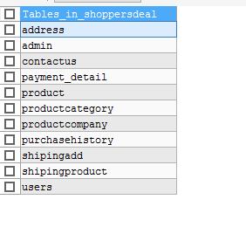

**TABLE1: ADMIN**

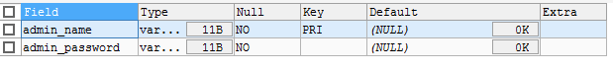

**TABLE2: USERS**

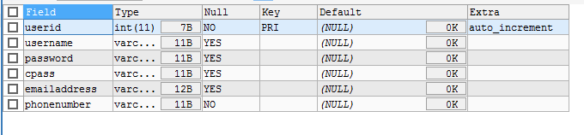

**TABLE3: PRODUCT CATEGORY**

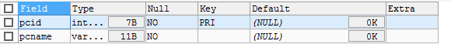

**TABLE4: PRODUCT**

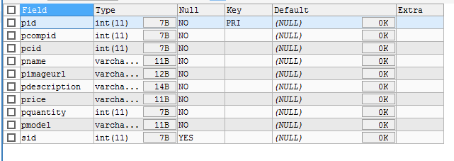

**TABLE 5: PRODUCTCOMPANY**

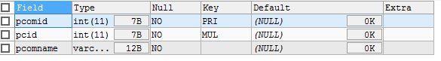

**TABLE 6: PAYMENTDETAILS**

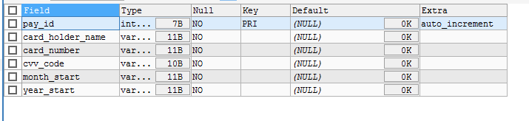

**TABLE7: PURCHASE_HISTORY**

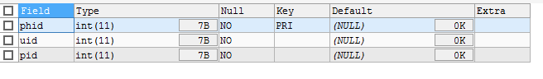

**TABLE 8: ADDRESS**

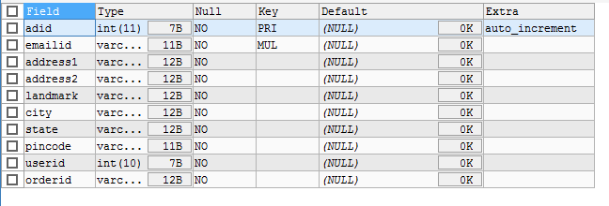

**TABLE 9: SHIPPING ADDRESS**

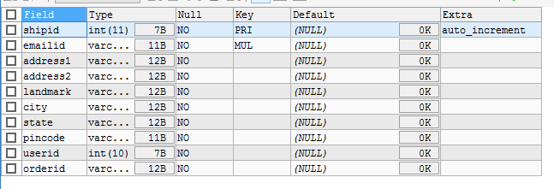

**TABLE10: SHIPPING_PRODUCT**

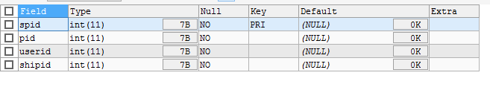

**TABLE11: CONTACT US**

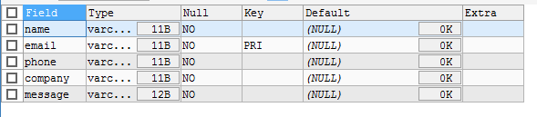

**INTERFACE SNAP SHOT (USER MANUAL)**

**1.HOME PAGE**

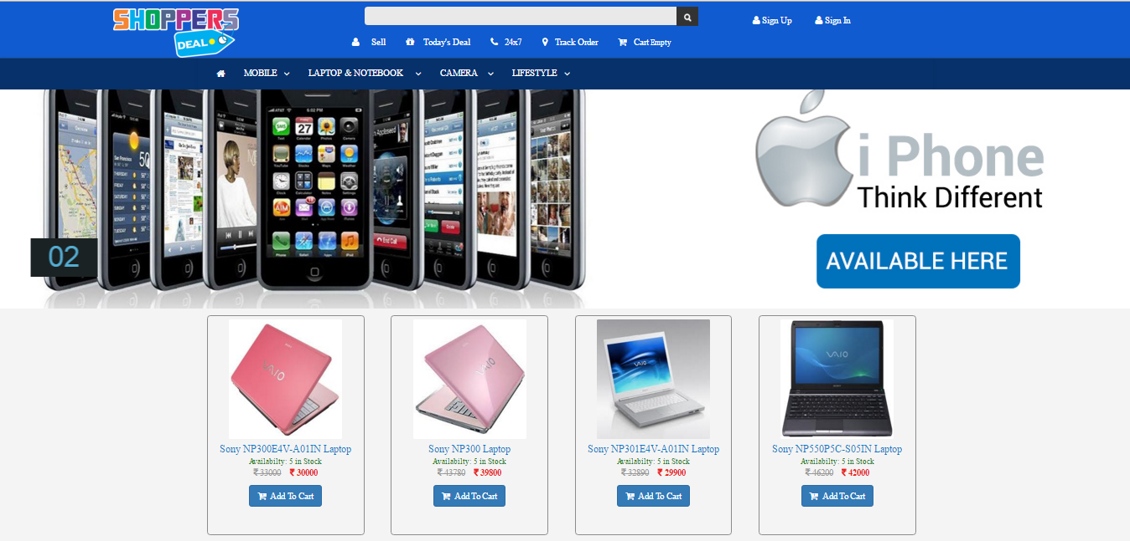



**Description:** This interface will show all the menus or operations that can be view and acces by users.

**2 LOGIN**

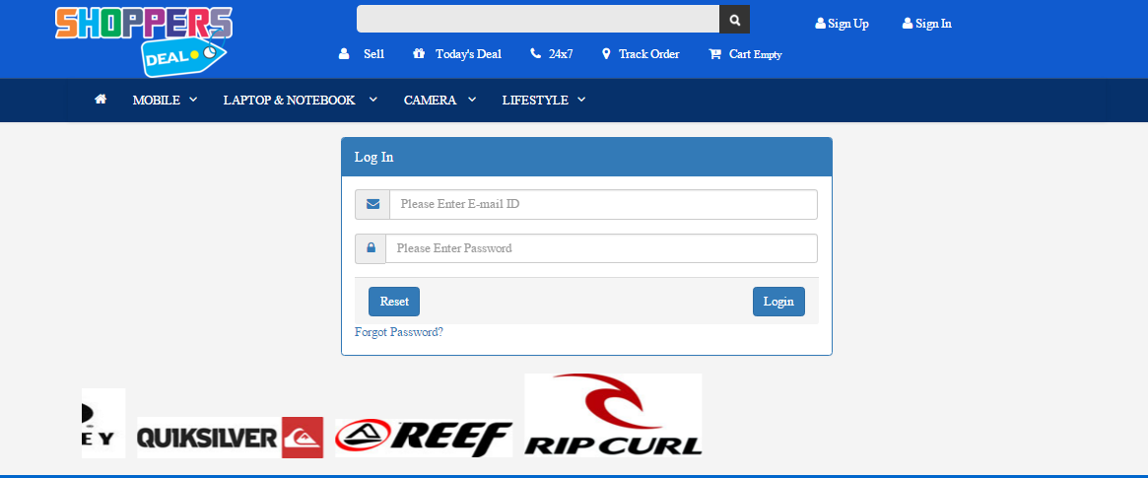

**Description:** This Interface will take the username and password and according to their roles they will enter their user section.

**3. CHANGE PASSWORD**

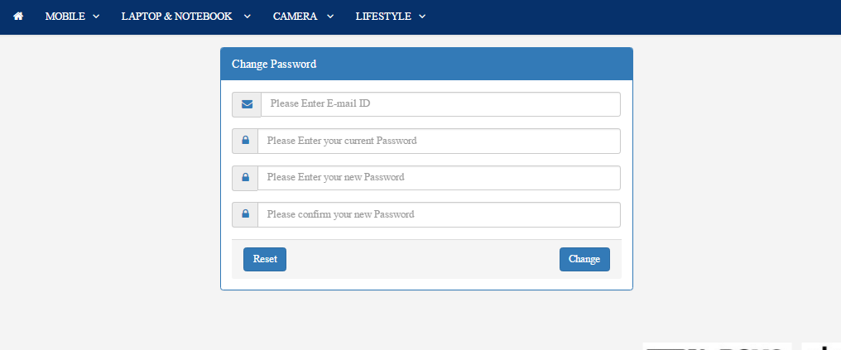

**Description:** By this interface, users can reset their password.

**4. SIGN UP**

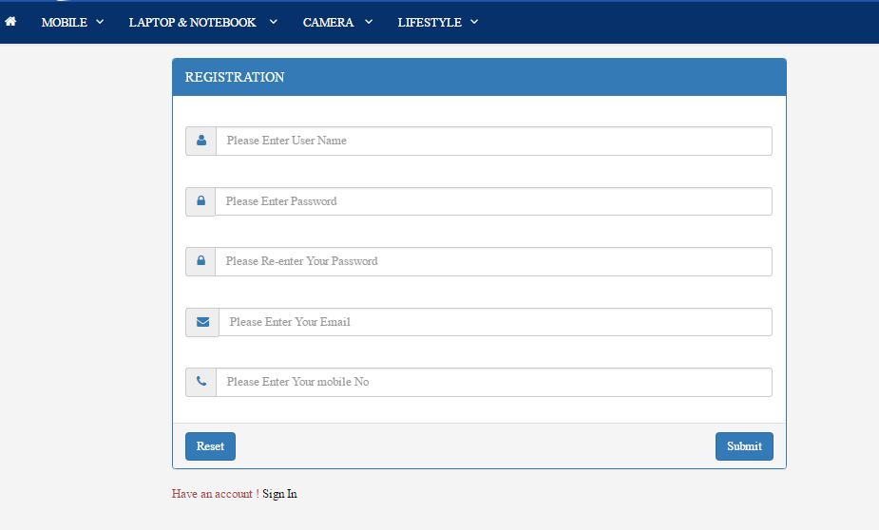

**Description**: this is a registration form for a user where they can fill the required information and create an account on shoppersdealpoint website. In this case they have to fill simple details like- User Name, Valid Email Id, phone number, and have to create password.

**5. FORGET PASSWORD**

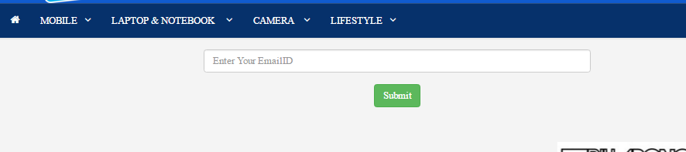

**Description:**

In this, If user have forgot the password then user can request his/her password in their respective email by which user had registerd. User have to enter his/her respective email id in the field and submit. User can check the password in the respective email inbox.

**6. VIEW PRODUCTS**



**7. ADD TO CART**

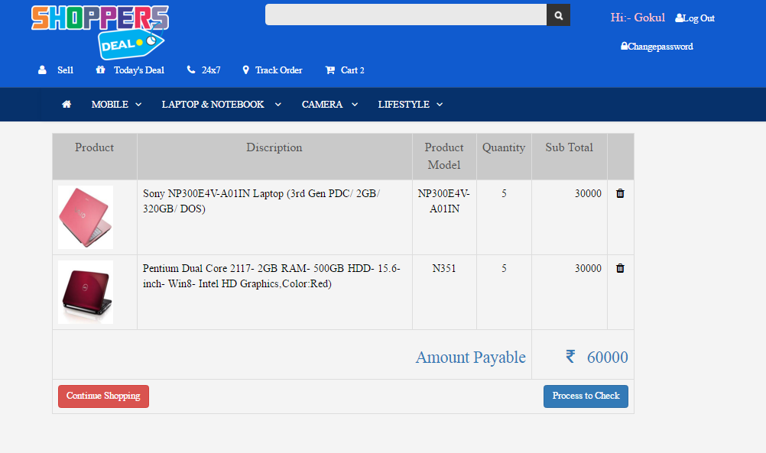

Description: user can add items to the cart by simply selecting items and have to click add to cart. By signing in user can process further.

**8. PROCESS TO CHECK**

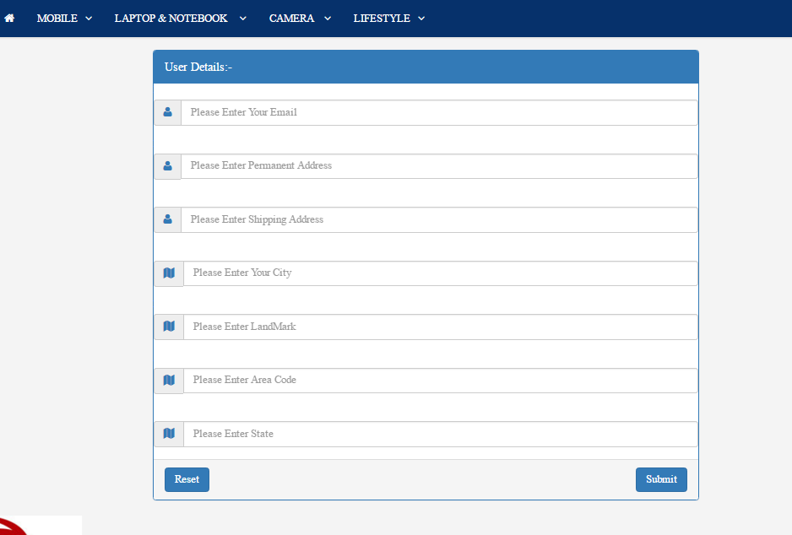

Description: User can process to check by simply click on process to check. Then above shown page will be open. Here have to fill information about his Email Id, Parmanent Address, Shipping Address, Cureent city, Land Mark, Area Code, and State. If incase entered wrong value then user can reset it by click on reset button.

**9. PROCESS CHECKOUT**

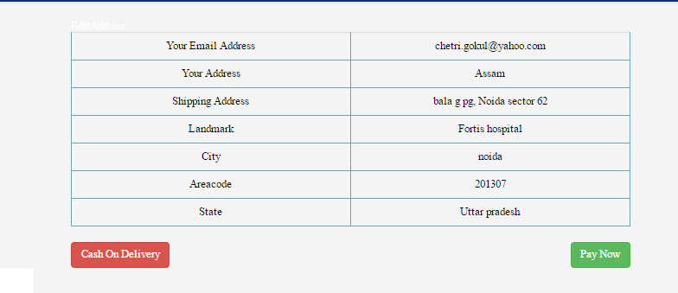

Description: Here user can check the details about shipping and processed to place oreder by pay now or cash on delivery.

**10. ORDER DETAILS**

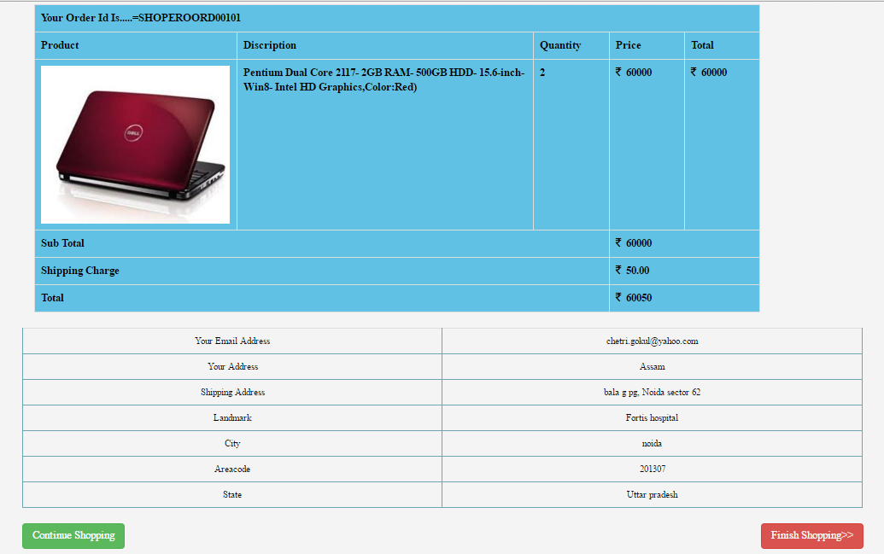

Description: Here user can get order details along with delivery address. And also have option to continue shopping or finish shoping.

**11. FINISH SHOPPING**

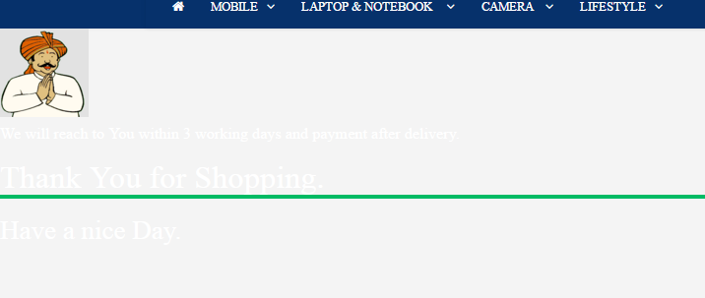

**18. BIBLIOGRAPHY**

**1)** <http://www.tutorialspoint.com/java/>

2) <http://www.javatpoint.com/java-tutorial>

3) <http://javabeginnerstutorial.com/core-java/>

**Books:**

1) The complete Java Reference