**Documentation**

|  |  |
| --- | --- |
| **Title** | BMI Calculator |
| **Description** | This project read the raw json data. Calculate BMI for each record and show corresponding category and Heath risk factor as well. |
| **URL** | https://github.com/rohitmehtam/code-20211009-rohitmehta |
| **Language** | Python3.9 |

How to execute the Script:-

1. Read the Readme file provided with the project and install all the modules in the testing environment.
2. Define the Json file path in the SampleProject.py in “_baseUrl” parameter.

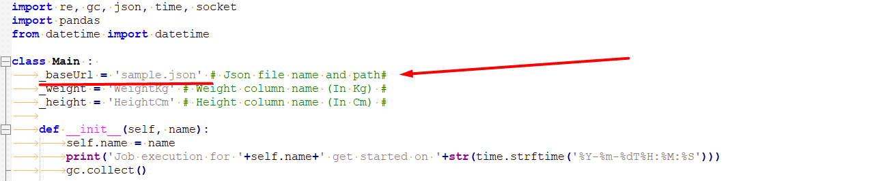

1. Define “_weight” parameter value same as provided in the json file.

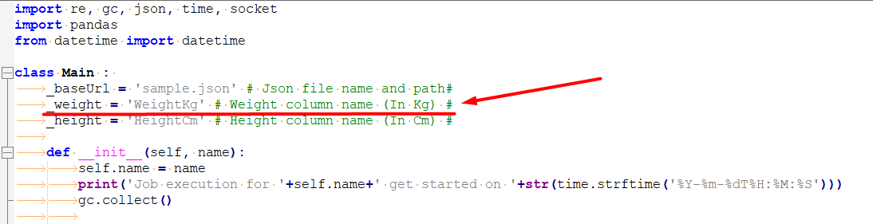

1. Define “_height” parameter value same as provided in the json file.

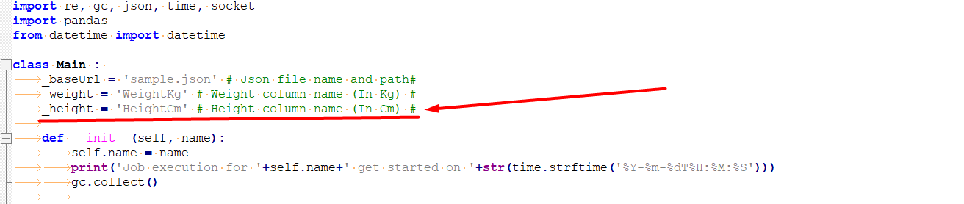

1. If “Height” value is provided in meter set cm = False in SampleProject1.py file

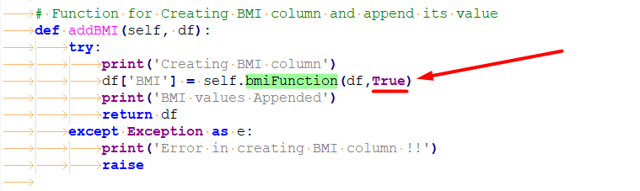

1. Execute the SampleProject1.py file.