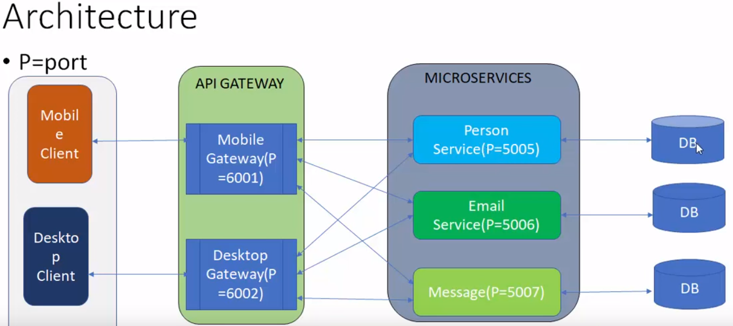

**Solution**: microServiceSLN

**Services**:

* Message.api
* Person.api

**Gateway**:

* microServiceSLN.Desktop.Gateway
* microServiceSLN.Mobile.Gateway

**Core**:

* microService.Database
* microService.Infra

**Visual Code create webapi commands**

* dotnet new sln --name microServiceSLN
* dotnet new webapi --name Person.api --framework netcoreapp2.1
* dotnet new webapi --name Message.api --framework netcoreapp2.1
* dotnet new webapi --name microServiceSLN.Desktop.Gateway --framework netcoreapp2.1
* dotnet new webapi --name microServiceSLN.Mobile.Gateway --framework netcoreapp2.1
* dotnet new classlib --name microService.Infra --framework netcoreapp2.1
* dotnet new classlib --name microService.Database --framework netcoreapp2.1
* code .

**Github commands**

* git init
* git add *
* git commit –m “initial commit”
* git remote add origin <https://github.com/rohitnagvenkar/api-gateway-microservice.git>
* git push –u origin master

Changed the port number for the Message and Person API by going into the file properties/launchSettings.json

**Database**

* dbo.Person
* dbo.PersonHistory
* dbo.PersonImage
* dbo.PersonMobile
* dbo.Relation
* dbo.Roles
* dbo.UserLogin
* dbo.Village

**EntityFramework creation command:**

dotnet -ef dbcontext scaffold "Server=(localdb)\MSSQLLocalDB;Database=microserviceDB;Trusted_Connection=True;" Microsoft.EntityFrameworkCore.SqlServer -o ../../Core/microService.Database/DomainModel --context-dir ../../Core/microService.Database/DomainContext -c "microserviceContext" –force

changed the port number for Mobile gateway and installed ocelot.

created an ocelot.json file.

* dotnet add package Ocelot