

**Mobile App System Requirement Specification**

**MouthLab_Advanced**

|  |  |
| --- | --- |
| **Version**  **Status**  **Date** | 1.1  Draft  25-Jun-2018 |
|  |  |

***Confidentiality Notice***

Copyright (c) 2018 eInfochips. - All rights reserved

This document is authored by eInfochips and is eInfochips intellectual property, including the copyrights in all countries in the world. This document is provided under a license to use only with all other rights, including ownership rights, being retained by eInfochips. This file may not be distributed, copied, or reproduced in any manner, electronic or otherwise, without the express written consent of eInfochips.

*Contents*

1 Document Details 4

1.1 Revision & Approval History 4

1.2 Definition, Acronyms and Abbreviations 4

1.3 References 4

2 introduction 6

2.1 Purpose of the Document 6

2.2 Intended Audience 6

3 SYSTEM OVERVIEW 7

3.1 Overview 7

3.2 Scope 7

3.3 Out of Scope 7

4 functional RequiREment 8

4.1 Login 8

4.2 Registration 9

4.3 Care-giver circle 11

4.4 Patients health status 13

4.5 Daily concerning symptoms 14

4.6 Health statistics 16

4.7 Cloud, device and iOS app communication 17

4.8 Alarm Scheduling 19

4.9 Notification 20

4.10 Calibration Factor 21

4.11 Care-giver Authentication 23

5 External Interface 25

5.1 User Interface 25

5.2 Hardware Interface 25

5.3 Software Interface 25

6 Acceptance Criteria 26

6.1 Overall Acceptance Criteria 26

6.2 Acceptance Test Scenarios 26

7 Special user requirements 27

7.1 Performance Requirements 27

7.2 Security 27

7.3 Portability 27

7.4 Maintainability 27

7.5 Data Definition and Database 27

7.6 Backup and Recovery 27

7.7 Legal (Statutory Demand) 27

7.8 Regulatory Demand 27

7.9 Installation 27

7.10 User Manual and Help 27

8 Standards 28

9 requirement Management 29

10 ASsumptions 30

11 Queries on requirement 31

12 FMEA 32

12.1 Updated FMEA 32

13 Appendix 33

# Document Details

## Revision & Approval History

|  |  |  |  |  |  |  |  |  |
| --- | --- | --- | --- | --- | --- | --- | --- | --- |
| **Version** | **Author** | | **Reviewer** | | | **Approver** | | |
| **Name** | **Date**  **(DD-MM-YYYY)** | | **Name** | **Date**  **(DD-MMM-YYYY)** | | **Name** | **Date**  **(DD-MM-YYYY)** |
| Draft 0.1 | Sandhiya | 17-02-2018 | | Porus/Kishor | 22-02-2018 | |  |  |
| 1.0 | Sandhiya | 28-02-2018 | | Chinmay | 05-03-2018 | | Chinmay | 21-03-2018 |
| 1.1 | Sandhiya | 25-06-2018 | |  |  | |  |  |
|  |  |  | |  |  | |  |  |
|  |  |  | |  |  | |  |  |
|  |  |  | |  |  | |  |  |
|  |  |  | |  |  | |  |  |

| **Version** | **Description of Change** |
| --- | --- |
| Draft 0.1 | Created initial draft version |
| 1.0 | Baseline |
| 1.1 | QEG comments |
|  |  |
|  |  |
|  |  |
|  |  |

## Definition, Acronyms and Abbreviations

| Definition/Acronym/Abbreviation | Description |
| --- | --- |
| BLE | Bluetooth Low Energy |
| ECG | Electrocardiography |

## References

| No. | Document | Version | Remarks |
| --- | --- | --- | --- |
| 1 | ei_SW_TMP_iOLS_MDx_Mouthlab Advanced |  |  |
| 2 | Requirements v5_CD.docx |  | Considered as initial requirement reference document |
| 3 | MDX Patient Dashboard (02.06.18) v1.0.1.PDF |  | Considered as initial requirement reference document |
| 4 | Requirements figures v1.pptx |  | Considered as initial requirement reference document |
| 5 | Requirements v5_CD from MDx |  | Considered as initial requirement reference document |

# introduction

## Purpose of the Document

This document captures the System Requirements of Mobile Application [iOS] used for iOLS MouthLab Advanced device and forms the basis of System Design development.

## Intended Audience

This document will be referred by mobile App developers and testers, other project team members (Hardware design Team, Firmware development team, QEG team) along with the other project owner/ stake holders as appropriate.

# SYSTEM OVERVIEW

## Overview

This application will allow users to monitor the measurements taken by MouthLab advanced device from their iPhone. This application is a small part of a larger set which will be added on to one at a time.

The existing system sends data to Windows Tablet using Tablet algorithm and BLE module. But the new advanced system has 4G LTE module using which data will be sent to cloud mobile.

The advantages of having mobile application are

* Monitor the patient data from anywhere anytime
* Receive/Send data to cloud
* Receive data from device via. BLE and send to cloud via. LTE
* Act as Bluetooth tether for device.

Cloud

Mobile App

MouthLab Advanced device

Figure 1 Connection of Mobile App To other sub-system

## Scope

* This application will be built for iOS version 11.
* All devices that support this version will be able to run this application.
* Also the devices which run older version of iOS [up to version 9] will also be able to run this application.
* The Xcode development tools will be used to develop mobile app.
* Three to four (3-4) screens will be provided.

## Out of Scope

1. The registration and approval of mobile application with the Apple server is out of scope.
2. User test case plan and test reports
3. Any other requirement not described in SRS.

# functional RequiREment

## iOS Mobile Phone Application Requirements

Following diagram gives the high level idea of steps towards mobile app creation.

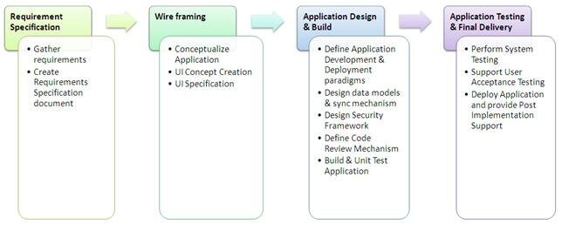

Figure 1 Functional Steps for Mobile App

### Login

Each users will have a account associated. User can login to app using the credentials.

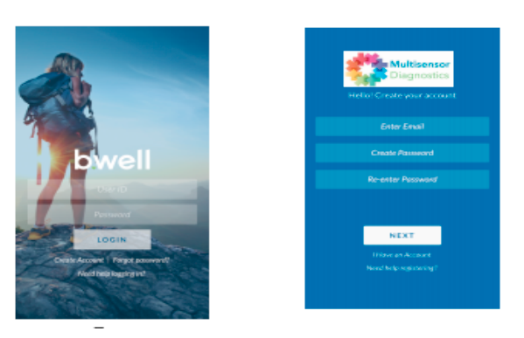

Login screen Credentials screen

|  |  |
| --- | --- |
| Term | Description |
| REQ ID | RQ01 |
| Purpose | Login to app using credentials. |
| Derived Requirement | A access token will be provided from AWS incognito once successfully logged in. |
| Access Restrictions | Any registered user can login into the app. |
| Input(s) | * Server URL/IP address * User name * Password |
| Output(s) | Login status: success or failure. |
| Process | * Open app by clicking icon. * Enter User Name, and password as an input, then click on Login button * If valid input, then it will redirect to Home page. |
| Mandatory Fields | * Username * Password |
| Pre Loaded Values | NA |
| Default Values | NA |
| Data Latency Period | NA |
| Data Retention Period | Data will be visible to user, until app is in foreground. |
| Data Rate/ <Daily> Number of transaction | NA |
| External Events | When user clicks on login button, this event is triggered. |
| Temporal Events | * Call Login API (REST API) to server * Authenticate/Un-authenticate the User |
| Validation Rules | Username and password are mandatory fields. |
| Constraints | Restful API handling |
| Effects on other systems/sub system | NA |
| Testability with respect to test environment  (Yes/No) | Yes |
| Acceptance Criteria | User must be able to login to the app with the provided credentials.  User gets redirected to home page. |

### Registration

Any user can register using their e-mail. The confirmation code will be send to the user emailID. On verification of code, the user will be registered and can access the account.

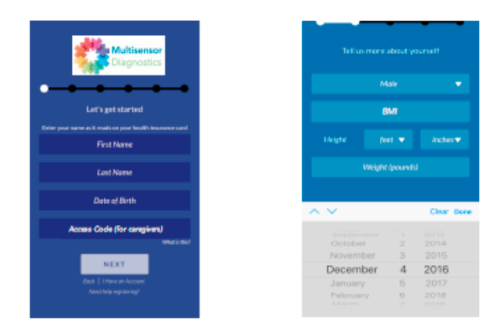 Details screen(i) Details screen(II)

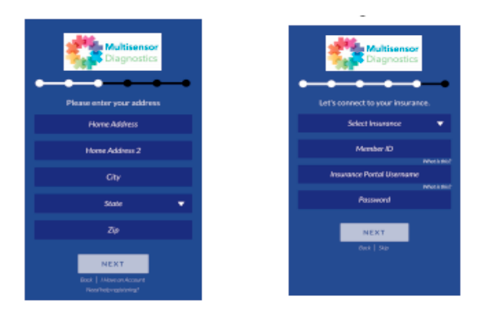

Address screen Insurance Screen

|  |  |
| --- | --- |
| Term | Description |
| REQ ID | RQ02 |
| Purpose | Registration for users. |
| Derived Requirement | A confirmation code is send to the user. Upon, verification user can access account. |
| Access Restrictions | User can register into the app. |
| Input(s) | First name, Last name, Phone number, emailID, Password |
| Output(s) | Registration status: success or failure. |
| Process | * Open app by clicking icon. * If not Registered, register new user * Code confirmation mail send. * Upon verification, redirected to home screen. |
| Mandatory Fields | First name, Last name, Phone number, emailID, Password |
| Pre Loaded Values | NA |
| Default Values | NA |
| Data Latency Period | NA |
| Data Retention Period | Data will be visible to user, until app is in foreground. |
| Data Rate/ <Daily> Number of transaction | NA |
| External Events | When user clicks on register button, this event is triggered. |
| Temporal Events | * Call register API (REST API) to server |
| Validation Rules | First name, last name, phone number, emailID and password are mandatory field. Standard phone number regex format is required. One emailID will be registered once. Password must be min. 8 characters and have one alphanumeric and one special character. |
| Constraints | Restful API handling |
| Effects on other systems/sub system | NA |
| Testability with respect to test environment  (Yes/No) | Yes |
| Acceptance Criteria | User should be able to register upon email verification. |

### Care-giver circle

There will be list of care- givers associated with each patient. They can see all the patients’ details.

If more than 5 patients are associated with a care-giver, the drop-down list will be displayed instead of circle.

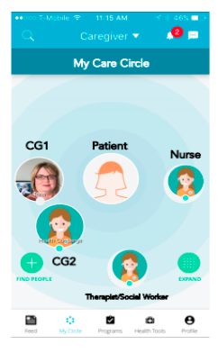 My Care Circle screen

|  |  |
| --- | --- |
| Term | Description |
| REQ ID | RQ03 |
| Purpose | Care -giver can view all the patients’ details. Care-giver can be any near or dear one. |
| Derived Requirement | NA |
| Access Restrictions | List of Care-giver |
| Input(s) | Invitation will be sent from patient to care-giver. |
| Output(s) | Upon accepting the invitation, registered care-giver can view patient’s data. If not registered, the care-giver is first registered and then can view patient’s data. |
| Process | All the associated care-giver can view the patients details |
| Mandatory Fields | First name, Last name, Phone number, emailID |
| Pre-Loaded Values | NA |
| Default Values | NA |
| Data Latency Period | NA |
| Data Retention Period | Data will be visible to user, until app is in foreground. |
| Data Rate/ <Daily> Number of transaction | NA |
| External Events | Adding the care-givers. |
| Temporal Events | Access code is generated or Care-givers are invited by email. |
| Validation Rules | NA |
| Constraints | NA |
| Effects on other systems/sub system | All the care-givers associated with the patients can view the patient’s data and can schedule their alarms. |
| Testability with respect to test environment  (Yes/No) | Yes |
| Acceptance Criteria | One or more care-giver can be associated to the patient.  Care-giver can view the patients’ medical data. |

### Patients health status

There will be a screen where there will be patients health related data like temperature, BP, respiratory rate etc. on daily, weekly and monthly basis. Each care-giver will have multiple patients associated with him/her. The list can be viewed in drop-down menu.

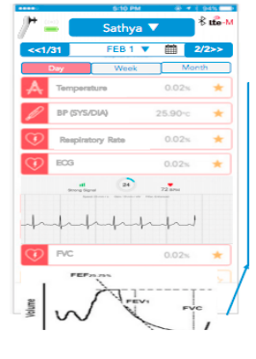

Health Status Screen

|  |  |
| --- | --- |
| Term | Description |
| REQ ID | RQ04 |
| Purpose | Here the patients and care-giver can see the graph of all the medical parameters like BP, Respiratory rate etc. on daily, weekly or monthly basis. |
| Derived Requirement | NA |
| Access Restrictions | The logged in user can view his/her own and all the other associated patients health statistics. If the logged in user is not a patient, he can view his/her associated patient’s health statistics. |
| Input(s) | Daily, weekly, monthly data with the scroll functionality(as in stock visualization app) |
| Output(s) | Graphical representation of data |
| Process | NA |
| Mandatory Fields | NA |
| Pre-Loaded Values | NA |
| Default Values | A plain empty graph |
| Data Latency Period | NA |
| Data Retention Period | Data will be visible to user, until app is in foreground. |
| Data Rate/ <Daily> Number of transaction | NA |
| External Events | NA |
| Temporal Events | NA |
| Validation Rules | NA |
| Constraints | Graphs can be view as: daily, weekly, monthly |
| Effects on other systems/sub system | NA |
| Testability with respect to test environment  (Yes/No) | Yes |
| Acceptance Criteria | Graphical representation of pre-defined health parameters.  Representation will be on daily, monthly or weekly basis. |

### Daily concerning symptoms

There will be a screen where the patients can enter their daily concerned symptoms like today’s weight, feeling tired etc. The care-provider and care-giver can view these symptoms and take necessary actions.

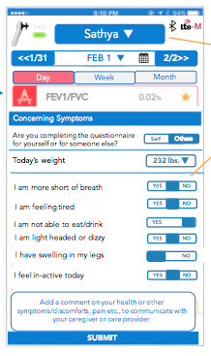 Daily symptoms screen

|  |  |
| --- | --- |
| Term | Description |
| REQ ID | RQ05 |
| Purpose | Here the patients can enter their daily concerned symptoms: with three options YES , NO or “No selection(default)” |
| Derived Requirement | NA |
| Access Restrictions | Patients or care-giver can enter the symptoms (patients') |
| Input(s) | This is a list of predefined general symptoms .like: “feeling dizzy”, “problem in breathing” etc. |
| Output(s) | Care-provider can take necessary actions. |
| Process | NA |
| Mandatory Fields | NA |
| Pre-Loaded Values | NA |
| Default Values | The actual default values of various parameters like weight, BPetc. |
| Data Latency Period | NA |
| Data Retention Period | Data will be visible to user, until app is in foreground. |
| Data Rate/ <Daily> Number of transaction | NA |
| External Events | NA |
| Temporal Events | NA |
| Validation Rules | NA |
| Constraints | User can add the comment if their symptoms is not specified in the list |
| Effects on other systems/sub system | NA |
| Testability with respect to test environment  (Yes/No) | Yes |
| Acceptance Criteria | Prelisted symptoms to be displayed. |

### Health statistics

Patients ECG, pulse Rate etc. will be graphically represented on daily, weekly and monthly basis.

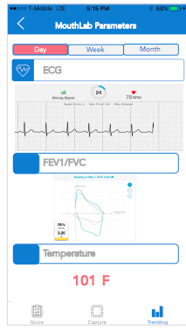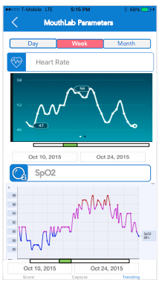

Health Statistics Screen (I) Health Statistics Screen (II)

|  |  |
| --- | --- |
| Term | Description |
| REQ ID | RQ06 |
| Purpose | Patients Temperature, respiratory rate, respiratory pattern, Spo2 are represented here. For graphical representation of a single day, only respiratory pattern will show a graph, Other will have a value representation. |
| Derived Requirement | NA |
| Access Restrictions | Patients and care-giver can view the graphs. |
| Input(s) | NA |
| Output(s) | Graphical representation of various parameters of the associated patients and self(if logged in user is a patient) |
| Process | NA |
| Mandatory Fields | NA |
| Pre-Loaded Values | NA |
| Default Values | The plain empty graph. |
| Data Latency Period | NA |
| Data Retention Period | Data will be visible to user, until app is in foreground. |
| Data Rate/ <Daily> Number of transaction | NA |
| External Events | NA |
| Temporal Events | NA |
| Validation Rules | NA |
| Constraints | Graphs will be on daily, weekly or monthly basis. |
| Effects on other systems/sub system | NA |
| Testability with respect to test environment  (Yes/No) | Yes |
| Acceptance Criteria | Graphical representation of various parameters.  Graphs will be on: daily, weekly, monthly. |

### Cloud, device and iOS app communication

The iOS app will send the raw data received from device to the cloud using HTTP protocol. The cloud will analyse this data.

When both LTE and BLE is available, user will be able to switch the preference from mobile app.If User selects LTE over BLE, data communication between device and cloud will be via. LTE. If user selects BLE over LTE, data communication between device and cloud will be using BLE.i.e. From device to app via. BLE and app to cloud via. LTE

When there is no internet connectivity, the iOS app will send scheduled alarms to handheld device via. BLE.

|  |  |
| --- | --- |
| Term | Description |
| REQ ID | RQ07 |
| Purpose | Internet Connectivity: Raw data from iOS app to cloud using HTTP protocol  Scheduled alarms from iOS app to cloud  No-Internet Connectivity: Raw data transfer from device to iOS via. BLE  Scheduled alarms from iOS app to handheld device. |
| Derived Requirement | NA |
| Access Restrictions | NA |
| Input(s) | NA |
| Output(s) | NA |
| Process | NA |
| Mandatory Fields | NA |
| Pre-Loaded Values | NA |
| Default Values | NA |
| Data Latency Period | NA |
| Data Retention Period | Data will be visible to user, until app is in foreground. |
| Data Rate/ <Daily> Number of transaction | NA |
| External Events | NA |
| Temporal Events | NA |
| Validation Rules | NA |
| Constraints | Internet connectivity status |
| Effects on other systems/sub system | NA |
| Testability with respect to test environment  (Yes/No) | Yes |
| Acceptance Criteria | Internet Connectivity: Raw data from iOS app to cloud using HTTP protocol  Scheduled alarms from iOS app to cloud  No-Internet Connectivity: Raw data transfer from device to iOS via. BLE  Scheduled alarms from iOS app to handheld device. |

### Alarm Scheduling

The care-provider can schedule the alarm in the app.The alarm is a remainder for the patient/care-giver.

The patients /care-giver can change / schedule the alarms.

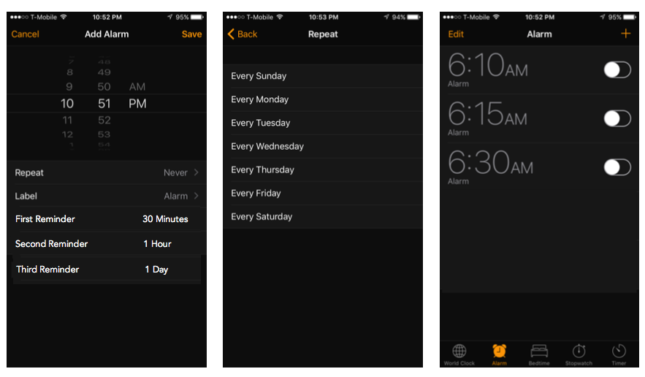

Alarm Schedule

|  |  |
| --- | --- |
| Term | Description |
| REQ ID | RQ08 |
| Purpose | The care-provider can schedule the alarms for patients via. IOS app.However, patients/care-giver can change or schedule the alarm. |
| Derived Requirement | NA |
| Access Restrictions | NA |
| Input(s) | NA |
| Output(s) | NA |
| Process | NA |
| Mandatory Fields | NA |
| Pre Loaded Values | NA |
| Default Values | NA |
| Data Latency Period | NA |
| Data Retention Period | Data will be visible to user, until app is in foreground. |
| Data Rate/ <Daily> Number of transaction | NA |
| External Events | NA |
| Temporal Events | NA |
| Validation Rules | NA |
| Constraints | Care-giver, Care-provider and patients can schedule the alarms. |
| Effects on other systems/sub system | NA |
| Testability with respect to test environment  (Yes/No) | Yes |
| Acceptance Criteria | The care-provider can be able to schedule the alarms for patients via. iOS app.And patients/care-giver can change or schedule the alarm. |

### Notification

Notification via text (SMS), push notification from server or call are sent to patients/ care-giver whenever required.

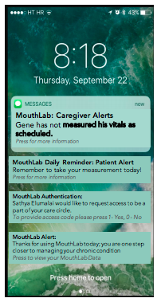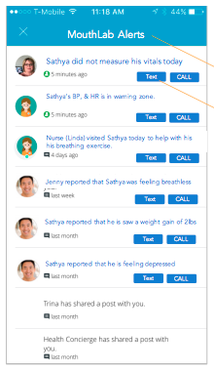 Notification screen Notification Screen

|  |  |
| --- | --- |
| Term | Description |
| REQ ID | RQ010 |
| Purpose | Patients/ Care-giver are notified via. Text or call or as provided by the server |
| Derived Requirement | NA |
| Access Restrictions | NA |
| Input(s) | NA |
| Output(s) | Text or call notification on registered number. |
| Process | NA |
| Mandatory Fields | Registered mobile number. |
| Pre Loaded Values | NA |
| Default Values | NA |
| Data Latency Period | NA |
| Data Retention Period | Data will be visible to user, until app is in foreground. |
| Data Rate/ <Daily> Number of transaction | NA |
| External Events | Notifications are send to care-giver /patients via. Text or call or as provided by the server |
| Temporal Events | NA |
| Validation Rules | NA |
| Constraints | NA |
| Effects on other systems/sub system | NA |
| Testability with respect to test environment  (Yes/No) | Yes |
| Acceptance Criteria | Text , push notification o Call to be send |

### Calibration Factor

The patient needs to enter systolic and diastolic BP manually once, to calculate the calibration factor of the patient.

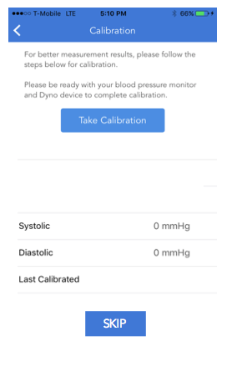

Calibration Screen

|  |  |
| --- | --- |
| Term | Description |
| REQ ID | RQ011 |
| Purpose | Patients calibration factor entered in App. |
| Derived Requirement | NA |
| Access Restrictions | NA |
| Input(s) | Systolic and Diastolic Pressure |
| Output(s) | Calibration Factor is displayed |
| Process | NA |
| Mandatory Fields | NA |
| Pre Loaded Values | NA |
| Default Values | NA |
| Data Latency Period | NA |
| Data Retention Period | Data will be visible to user, until app is in foreground. |
| Data Rate/ <Daily> Number of transaction | NA |
| External Events | NA |
| Temporal Events | NA |
| Validation Rules | NA |
| Constraints | NA |
| Effects on other systems/sub system | NA |
| Testability with respect to test environment  (Yes/No) | Yes |
| Acceptance Criteria | Calibration factor Systolic and Diastolic Pressure should be displayed |

### Care-giver Authentication

|  |  |
| --- | --- |
| Term | Description |
| REQ ID | RQ012 |
| Purpose | Care-giver can download the app and request access to a particular patient file. |
| Derived Requirement | NA |
| Access Restrictions | Care-giver |
| Input(s) | Patients authenticate care-givers by sending an invitation to their registered emailID. |
| Output(s) | View patients medical file |
| Process | For each patient data, we will allow any number of users to see the data and users can have read privileges. Anyone can download the app. The patient must authenticate. Patients sends invitation mail to the care-giver’s registered emailID. This will send a temporary password, which is used to authenticate for first time and can be changed later. |
| Mandatory Fields | NA |
| Pre Loaded Values | NA |
| Default Values | NA |
| Data Latency Period | NA |
| Data Retention Period | Data will be visible to user, until app is in foreground. |
| Data Rate/ <Daily> Number of transaction | NA |
| External Events | Care-giver wants to view the patients file |
| Temporal Events | NA |
| Validation Rules | NA |
| Constraints | NA |
| Effects on other systems/sub system | NA |
| Testability with respect to test environment  (Yes/No) | Yes |
| Acceptance Criteria | Patient must authenticate.  Care-giver can view patients file. |

## WebApp Requirements

### Login through WebApp

|  |  |
| --- | --- |
| Term | Description |
| REQ ID | RQ013 |
| Purpose | Login to web-app using credentials. |
| Derived Requirement | A access token will be provided from AWS incognito once successfully logged in. |
| Access Restrictions | Any registered user can login through the web application. |
| Input(s) | * Server URL/IP address * User name * Password |
| Output(s) | Login status: success or failure. |
| Process | * Open app by clicking icon. * Enter User Name, and password as an input, then click on Login button * If valid input, then it will redirect to Home page. * Otherwise it will indicate a login failure message and stay on the login page. |
| Mandatory Fields | * 1. Username   2. Password |
| Pre Loaded Values | NA |
| Default Values | NA |
| Data Latency Period | NA |
| Data Retention Period | Data will be visible to user, until app is in foreground. |
| Data Rate/ <Daily> Number of transaction | NA |
| External Events | When user clicks on login button, this event is triggered. |
| Temporal Events | * Call Login API (REST API) to server * Authenticate/Un-authenticate the User |
| Validation Rules | * + 1. Username and password entered by user will be validated against username and password data in AWS Cognito user pool. |
| Constraints | Restful API handling |
| Effects on other systems/sub system | NA |
| Testability with respect to test environment  (Yes/No) | Yes |
| Acceptance Criteria | * + - 1. User should be redirected to home page if login credentials are valid       2. If invalid credentials are provided by user, user should not be able to login. |

### Personal Signup through WebApp

|  |  |
| --- | --- |
| Term | Description |
| REQ ID | RQ014 |
| Purpose | Personal Registration for users. |
| Derived Requirement | A confirmation code is send to the user. Upon, verification user can access account. |
| Access Restrictions | User can register personal details through web application. |
| Input(s) | First name, Last name, , emailID, Password, Phone number, Gender |
| Output(s) | Registration status: success or failure. |
| Process | * Open app by clicking icon. * If not Registered, register new user * Code confirmation mail send. * Upon verification, redirected to home screen. |
| Mandatory Fields | First name, Last name, emailID, Password, Phone number, Gender |
| Pre Loaded Values | NA |
| Default Values | NA |
| Data Latency Period | NA |
| Data Retention Period | Data will be visible to user, until app is in foreground. |
| Data Rate/ <Daily> Number of transaction | NA |
| External Events | When user clicks on register button, this event is triggered. |
| Temporal Events | * Call register API (REST API) to server |
| Validation Rules | First name, last name, phone number, emailID and password are mandatory field. Standard phone number regex format is required. One emailID will be registered once. Password must be min. 8 characters and have one alphanumeric and one special character. |
| Constraints | Restful API handling |
| Effects on other systems/sub system | NA |
| Testability with respect to test environment  (Yes/No) | Yes |
| Acceptance Criteria | User should be able to register successfully upon email verification. |

### Professional Signup through WebApp

|  |  |
| --- | --- |
| Term | Description |
| REQ ID | RQ015 |
| Purpose | Professional Registration for users. |
| Derived Requirement | A confirmation code is send to the user. Upon, verification user can access account. |
| Access Restrictions | User can register professional details through web application. |
| Input(s) | Practice/Hospital/Organization, Speciality, Country of Practice, Zip Code, NPI Number/RN/NP Numbers, MouthLab Provider ID, License Number/Reg.Number, Expiration date |
| Output(s) | Registration status: success or failure. |
| Process | * Open app by clicking icon. * If not Registered, register new user * Code confirmation mail send. * Upon verification, redirected to home screen. |
| Mandatory Fields | Practice/Hospital/Organization, Speciality, Country of Practice, Zip Code, NPI Number/RN/NP Numbers, MouthLab Provider ID, License Number/Reg.Number, Expiration date |
| Pre Loaded Values | NA |
| Default Values | NA |
| Data Latency Period | NA |
| Data Retention Period | Data will be visible to user, until app is in foreground. |
| Data Rate/ <Daily> Number of transaction | NA |
| External Events | When user clicks on register button, this event is triggered. |
| Temporal Events | * Call register API (REST API) to server |
| Validation Rules | Practice/Hospital/Organization, Speciality, Country of Practice, Zip Code, NPI Number/RN/NP Numbers, MouthLab Provider ID, License Number/Reg.Number, Expiration date are mandatory field. Standard 6 digits of Zip Code is required |
| Constraints | Restful API handling |
| Effects on other systems/sub system | NA |
| Testability with respect to test environment  (Yes/No) | Yes |
| Acceptance Criteria | User should be able to register successfully upon email verification. |

### Team Signup through WebApp

|  |  |
| --- | --- |
| Term | Description |
| REQ ID | RQ016 |
| Purpose | Team Registration for users. |
| Derived Requirement | A confirmation code is send to the user. Upon, verification user can access account. |
| Access Restrictions | User can register team details through web application. |
| Input(s) | Email, Cell, Practice/Hospital, Speciality, NPI/license |
| Output(s) | Registration status: success or failure. |
| Process | * Open app by clicking icon. * If not Registered, register new user * Code confirmation mail send. * Upon verification, redirected to home screen. |
| Mandatory Fields | Email, Cell, Practice/Hospital, Speciality, NPI/license |
| Pre Loaded Values | NA |
| Default Values | NA |
| Data Latency Period | NA |
| Data Retention Period | Data will be visible to user, until app is in foreground. |
| Data Rate/ <Daily> Number of transaction | NA |
| External Events | When user clicks on register button, this event is triggered. |
| Temporal Events | * Call register API (REST API) to server |
| Validation Rules | Email, Cell, Practice/Hospital, Speciality, NPI/license are mandatory field. Standard phone number regex format is required |
| Constraints | Restful API handling |
| Effects on other systems/sub system | NA |
| Testability with respect to test environment  (Yes/No) | Yes |
| Acceptance Criteria | User should be able to register successfully upon email verification. |

### Add Team Members through Login>Create Account in WebApp

|  |  |
| --- | --- |
| Term | Description |
| REQ ID | RQ017 |
| Purpose | Add Team Members. |
| Derived Requirement | A confirmation code is send to the user. Upon, verification user can access account. |
| Access Restrictions | User can Add team members through add button in web application. |
| Input(s) | Email, Cell, Office Phone, Main Phone, Practice/Hospital, Speciality, NPI/license#, ML Provider ID, Privileges, send notification to Member |
| Output(s) | Registration status: success or failure. |
| Process | * Open app by clicking icon. * If not Registered, register new user * Code confirmation mail send. * Upon verification, redirected to home screen. |
| Mandatory Fields | Email, Cell, Office Phone, Main Phone, Practice/Hospital, Speciality, NPI/license#, ML Provider ID, Privileges, send notification to Member |
| Pre Loaded Values | NA |
| Default Values | NA |
| Data Latency Period | NA |
| Data Retention Period | Data will be visible to user, until app is in foreground. |
| Data Rate/ <Daily> Number of transaction | NA |
| External Events | When user clicks on register button, this event is triggered. |
| Temporal Events | * Call register API (REST API) to server |
| Validation Rules | Email, Cell, Office Phone, Main Phone, Practice/Hospital, Speciality, NPI/license#, ML Provider ID, Privileges, send notification to Member are mandatory field. Standard phone number regex format is required |
| Constraints | Restful API handling |
| Effects on other systems/sub system | NA |
| Testability with respect to test environment  (Yes/No) | Yes |
| Acceptance Criteria | User should be able to add team members successfully. |

### Home Page

|  |  |
| --- | --- |
| Term | Description |
| REQ ID | RQ018 |
| Purpose | View Home Page. |
| Derived Requirement | NA |
| Access Restrictions | User can view patient details through web application. |
| Input(s) | Med.Records#, Name, Age, Primary, Secondary, Tertiary Condition, Concerning Symptoms |
| Output(s) | User able to view patient details Successfully. |
| Process | * User can view patient details. |
| Mandatory Fields | Med, Records#, Name, Age, Pri, Sec, Ter Condition |
| Pre Loaded Values | NA |
| Default Values | NA |
| Data Latency Period | NA |
| Data Retention Period | Data will be visible to user, until app is in foreground. |
| Data Rate/ <Daily> Number of transaction | NA |
| External Events | When user clicks on Add button, this event is triggered. |
| Temporal Events | * Call register API (REST API) to server |
| Validation Rules | Med, Records#, Name, Age, Pri, Sec, Ter Condition are mandatory fields |
| Constraints | Restful API handling |
| Effects on other systems/sub system | NA |
| Testability with respect to test environment  (Yes/No) | Yes |
| Acceptance Criteria | User should be able to view Patient Details Successfully. |

### Add Patient Details

|  |  |
| --- | --- |
| Term | Description |
| REQ ID | RQ019 |
| Purpose | Add Patient Details |
| Derived Requirement | NA |
| Access Restrictions | User can add patient details through Add Button in web application. |
| Input(s) | Name, Primary Conditions |
| Output(s) | Added Patient details Successfully. |
| Process | * User can Add patient details. |
| Mandatory Fields | Name, Primary Conditions |
| Pre Loaded Values | NA |
| Default Values | NA |
| Data Latency Period | NA |
| Data Retention Period | Data will be visible to user, until app is in foreground. |
| Data Rate/ <Daily> Number of transaction | NA |
| External Events | When user clicks on Add button, this event is triggered. |
| Temporal Events | * Call register API (REST API) to server |
| Validation Rules | Name, Primary Conditions are mandatory fields |
| Constraints | Restful API handling |
| Effects on other systems/sub system | NA |
| Testability with respect to test environment  (Yes/No) | Yes |
| Acceptance Criteria | User should be able to Add Patient Details Successfully. |

### Doctor Profile through Home>Settings>My Profile in Web App

|  |  |
| --- | --- |
| Term | Description |
| REQ ID | RQ020 |
| Purpose | View Doctor Profile. |
| Derived Requirement | NA |
| Access Restrictions | User can save profile details through Save Button in web application. |
| Input(s) | Name, Display Pic, Speciality NPI #,Email, Cell, Office Phone, Main Phone, Teams |
| Output(s) | Save Profile Successfully. |
| Process | * User can view profile details. * Upon Click on Save Profile redirected to home screen. |
| Mandatory Fields | Name, Display Pic, Speciality, NPI #,Email, Cell,Office Phone,Main Phone,Teams |
| Pre Loaded Values | NA |
| Default Values | NA |
| Data Latency Period | NA |
| Data Retention Period | Data will be visible to user, until app is in foreground. |
| Data Rate/ <Daily> Number of transaction | NA |
| External Events | When user clicks on Save button, this event is triggered. |
| Temporal Events | * Call register API (REST API) to server |
| Validation Rules | Name, Display Pic, Speciality, NPI #,Email, Cell,Office, Phone, Main Phone, Teams are mandatory field. Standard phone number regex format is required. |
| Constraints | Restful API handling |
| Effects on other systems/sub system | NA |
| Testability with respect to test environment  (Yes/No) | Yes |
| Acceptance Criteria | User should be able to Save Profile Details Successfully. |

### Profile Patient About through Home>Day view>About in Web App

|  |  |
| --- | --- |
| Term | Description |
| REQ ID | RQ021 |
| Purpose | View Patient Profile. |
| Derived Requirement | NA |
| Access Restrictions | Patient can save about profile details through Save Button in web application. |
| Input(s) | ML #, DOB, Height, Weight, MR#,SSN |
| Output(s) | Save Profile Successfully. |
| Process | * User can view profile details. * Upon Click on Save Profile redirected to Day view page. |
| Mandatory Fields | ML #, DOB, Height, Weight, MR#,SSN |
| Pre Loaded Values | NA |
| Default Values | NA |
| Data Latency Period | NA |
| Data Retention Period | Data will be visible to user, until app is in foreground. |
| Data Rate/ <Daily> Number of transaction | NA |
| External Events | When user clicks on Save button, this event is triggered. |
| Temporal Events | * Call register API (REST API) to server |
| Validation Rules | ML #, DOB, Height, Weight, MR#, SSN are mandatory field. |
| Constraints | Restful API handling |
| Effects on other systems/sub system | NA |
| Testability with respect to test environment  (Yes/No) | Yes |
| Acceptance Criteria | User should be able to Save Profile Details Successfully. |
|  |  |

### Profile Patient Thresholds through Home>Day view>Thresholds in Web App

|  |  |
| --- | --- |
| Term | Description |
| REQ ID | RQ022 |
| Purpose | View Thresholds details |
| Derived Requirement | NA |
| Access Restrictions | User can save Thresholds details through Save Button in web application. |
| Input(s) | Temperature, SYS, DIA, Heart rate, Respiratory Rate, SpO2,FEV1,FEC,FEV1/FEV,PEF, Concerning Symptoms, Contact |
| Output(s) | Saved Thresholds Details Successfully. |
| Process | * User can view Thresholds details. * Upon Click on Save Button redirected to Day view page. |
| Mandatory Fields | Temperature, SYS, DIA, Heart rate, Respiratory Rate, SpO2,FEV1,FEC,FEV1/FEV,PEF, Concerning Symptoms, Contact |
| Pre Loaded Values | NA |
| Default Values | NA |
| Data Latency Period | NA |
| Data Retention Period | Data will be visible to user, until app is in foreground. |
| Data Rate/ <Daily> Number of transaction | NA |
| External Events | When user clicks on Save button, this event is triggered. |
| Temporal Events | * Call register API (REST API) to server |
| Validation Rules | Temperature, SYS, DIA, Heart rate, Respiratory Rate, SpO2,FEV1,FEC,FEV1/FEV,PEF, Concerning Symptoms, Contact are mandatory field. |
| Constraints | Restful API handling |
| Effects on other systems/sub system | NA |
| Testability with respect to test environment  (Yes/No) | Yes |
| Acceptance Criteria | User should be able to Save Thresholds Details Successfully. |

### Profile Patient Scheduled-Measurements through Home>Day view>Scheduled-Measurements in Web App

|  |  |
| --- | --- |
| Term | Description |
| REQ ID | RQ023 |
| Purpose | View Scheduled-Measurments details |
| Derived Requirement | NA |
| Access Restrictions | User can save Scheduled-Measurments details through Save Button in web application. |
| Input(s) | Measurment, Time/Frequency, Notify |
| Output(s) | Save Scheduled-Measurments Details Successfully. |
| Process | * User can view Scheduled-Measurements details. * Upon Click on Save Button redirected to Day view page. |
| Mandatory Fields | Measurements ,Time/ Frequency, Notify |
| Pre Loaded Values | NA |
| Default Values | NA |
| Data Latency Period | NA |
| Data Retention Period | Data will be visible to user, until app is in foreground. |
| Data Rate/ <Daily> Number of transaction | NA |
| External Events | When user clicks on Save button, this event is triggered. |
| Temporal Events | * Call register API (REST API) to server |
| Validation Rules | Measurement, Time/Frequency, Notify are mandatory field. |
| Constraints | Restful API handling |
| Effects on other systems/sub system | NA |
| Testability with respect to test environment  (Yes/No) | Yes |
| Acceptance Criteria | User should be able to Save scheduled-measurements Details Successfully. |

### Add Time and Frequency through Home>Day view>Scheduled Measurements in Web App

|  |  |
| --- | --- |
| Term | Description |
| REQ ID | RQ024 |
| Purpose | Add Time and Frequency details |
| Derived Requirement | NA |
| Access Restrictions | User can add time and frequency details in web application. |
| Input(s) | Time, Daily, weekdays, weekends, mon, tue, wed, thurs, fri, sat, sun |
| Output(s) | Add Time and Frequency details successfully |
| Process | * User can select frequency notification via daily or weekdays |
| Mandatory Fields | Time, Daily, weekdays, weekends, mon, tue, wed, thurs, fri, sat, sun |
| Pre Loaded Values | NA |
| Default Values | NA |
| Data Latency Period | NA |
| Data Retention Period | Data will be visible to user, until app is in foreground. |
| Data Rate/ <Daily> Number of transaction | NA |
| External Events | NA |
| Temporal Events | * Call register API (REST API) to server |
| Validation Rules | Time, Daily, weekdays, weekends, mon, tue, wed, thurs, fri, sat, sun are mandatory field. |
| Constraints | Restful API handling |
| Effects on other systems/sub system | NA |
| Testability with respect to test environment  (Yes/No) | Yes |
| Acceptance Criteria | User should be able to add Time and Frequency details.  User should be able to login web successfully. |

### Add Recipients through Home>Day view>Scheduled Measurments in Web App

|  |  |
| --- | --- |
| Term | Description |
| REQ ID | RQ025 |
| Purpose | Add Recipient details |
| Derived Requirement | NA |
| Access Restrictions | User can add Recipients details in web application. |
| Input(s) | Recipient |
| Output(s) | Recipients Added successfully |
| Process | * User can add Recipients details |
| Mandatory Fields | Recipients |
| Pre Loaded Values | NA |
| Default Values | NA |
| Data Latency Period | NA |
| Data Retention Period | Data will be visible to user, until app is in foreground. |
| Data Rate/ <Daily> Number of transaction | NA |
| External Events | NA |
| Temporal Events | * Call register API (REST API) to server |
| Validation Rules | Recipients |
| Constraints | Restful API handling |
| Effects on other systems/sub system | NA |
| Testability with respect to test environment  (Yes/No) | Yes |
| Acceptance Criteria | User should be able to add Recipients details.  User should be able to login web successfully. |

### Profile Patient Action Log through Home>Day view>Action Log in Web App

|  |  |
| --- | --- |
| Term | Description |
| REQ ID | RQ026 |
| Purpose | View Action Log details |
| Derived Requirement | NA |
| Access Restrictions | User can save Action Log details through Save Button in web application. |
| Input(s) | Log #,Date/Time, Action Required, Assign To, Action/To do, Action Performed, Phone |
| Output(s) | Save Action Log Successfully. |
| Process | * User can View Action Log. * Upon Click on Save Button redirected to Day view page. |
| Mandatory Fields | Log #,Date/Time, Action Required, Assign To, Action/To do, Action Performed, Phone |
| Pre Loaded Values | NA |
| Default Values | NA |
| Data Latency Period | NA |
| Data Retention Period | Data will be visible to user, until app is in foreground. |
| Data Rate/ <Daily> Number of transaction | NA |
| External Events | When user clicks on Save button, this event is triggered. |
| Temporal Events | * Call register API (REST API) to server |
| Validation Rules | Log #, Date/Time, Action Required, Assign To, Action/To do, Action Performed, Phone are mandatory field. Standard phone number regex format is required |
| Constraints | Restful API handling |
| Effects on other systems/sub system | NA |
| Testability with respect to test environment  (Yes/No) | Yes |
| Acceptance Criteria | User should be able to Save Action Log Successfully. |

### Add Action Log through Home>Day view>Action Log in Web App

|  |  |
| --- | --- |
| Term | Description |
| REQ ID | RQ027 |
| Purpose | Add Action Log details |
| Derived Requirement | NA |
| Access Restrictions | User can add Action Log details through Add Button in web application. |
| Input(s) | Log #,Action Initiated(Date/Time), Action Required, Assign To, Action/To do, Action Performed, Phone |
| Output(s) | Add Action Log Successfully. |
| Process | * User can add Action Log. |
| Mandatory Fields | Log #,Date/Time, Action Required, Assign To, Action/To do, Action Performed, Phone |
| Pre Loaded Values | NA |
| Default Values | NA |
| Data Latency Period | NA |
| Data Retention Period | Data will be visible to user, until app is in foreground. |
| Data Rate/ <Daily> Number of transaction | NA |
| External Events | When user clicks on Save button, this event is triggered. |
| Temporal Events | * Call register API (REST API) to server |
| Validation Rules | Log #, Date/Time, Action Required, Assign To, Action/To do, Action Performed, Phone are mandatory field. Standard phone number regex format is required |
| Constraints | Restful API handling |
| Effects on other systems/sub system | NA |
| Testability with respect to test environment  (Yes/No) | Yes |
| Acceptance Criteria | User should be able to add Action Log Successfully. |

### Profile Patient Insurance through Home>Day view>Insurance in Web App

|  |  |
| --- | --- |
| Term | Description |
| REQ ID | RQ028 |
| Purpose | View Insurance details |
| Derived Requirement | NA |
| Access Restrictions | User can save Insurance details through Save Button in web application. |
| Input(s) | Insurance Types, Individual Id, AuthClaim #, Effective Dates, Secondary Insurance |
| Output(s) | Save Insurance Details Successfully. |
| Process | * User can View Insurance details. * Upon Click on Save Button redirected to Day view page. |
| Mandatory Fields | Insurance Types, Individual Id, AuthClaim #, Effective Dates, Secondary Insurance |
| Pre Loaded Values | NA |
| Default Values | NA |
| Data Latency Period | NA |
| Data Retention Period | Data will be visible to user, until app is in foreground. |
| Data Rate/ <Daily> Number of transaction | NA |
| External Events | When user clicks on Save button, this event is triggered. |
| Temporal Events | * Call register API (REST API) to server |
| Validation Rules | Insurance Types, Individual Id, AuthClaim #, Effective Dates, Secondary Insurance are mandatory field. |
| Constraints | Restful API handling |
| Effects on other systems/sub system | NA |
| Testability with respect to test environment  (Yes/No) | Yes |
| Acceptance Criteria | User should be able to Save Insurance Details Successfully. |

### Profile Patient Risk Factor through Home>Day view>Risk Factor in Web App

|  |  |
| --- | --- |
| Term | Description |
| REQ ID | RQ029 |
| Purpose | View Risk Factor details |
| Derived Requirement | NA |
| Access Restrictions | User can save Risk Factor details through Save Button in web application. |
| Input(s) | Primary condition, Secondary, Tertiary, Co- morbidities, ICD-10 Codes |
| Output(s) | Save Risk Factor details Successfully. |
| Process | * User can View Risk Factor details. * Upon Click on Save Button redirected to Day view page. |
| Mandatory Fields | Primary condition, Secondary, Tertiary, Co- morbidities, ICD-10 Codes |
| Pre Loaded Values | NA |
| Default Values | NA |
| Data Latency Period | NA |
| Data Retention Period | Data will be visible to user, until app is in foreground. |
| Data Rate/ <Daily> Number of transaction | NA |
| External Events | When user clicks on Save button, this event is triggered. |
| Temporal Events | * Call register API (REST API) to server |
| Validation Rules | Primary condition, Secondary, Tertiary, Co- morbidities, ICD-10 Codes are mandatory fields. |
| Constraints | Restful API handling |
| Effects on other systems/sub system | NA |
| Testability with respect to test environment  (Yes/No) | Yes |
| Acceptance Criteria | User should be able to Save Risk Factor Details Successfully. |

### Profile Patient Contact through Home>Day view>Contact in Web App

|  |  |
| --- | --- |
| Term | Description |
| REQ ID | RQ030 |
| Purpose | View Contact details |
| Derived Requirement | NA |
| Access Restrictions | User can save Contact details through Save Button in web application. |
| Input(s) | Speciality, Name, Phone, Email |
| Output(s) | Save Contact Details Successfully. |
| Process | * User can view contact details. * Upon Click on Save Button redirected to Day view page. |
| Mandatory Fields | Speciality, Name, Phone, Email |
| Pre Loaded Values | NA |
| Default Values | NA |
| Data Latency Period | NA |
| Data Retention Period | Data will be visible to user, until app is in foreground. |
| Data Rate/ <Daily> Number of transaction | NA |
| External Events | When user clicks on Save button, this event is triggered. |
| Temporal Events | * Call register API (REST API) to server |
| Validation Rules | Speciality, Name, Phone, Email are mandatory field. |
| Constraints | Restful API handling |
| Effects on other systems/sub system | NA |
| Testability with respect to test environment  (Yes/No) | Yes |
| Acceptance Criteria | User should be able to Save Contact Details Successfully. |

### Add Contact through Home>Day view>Contact in Web App

|  |  |
| --- | --- |
| Term | Description |
| REQ ID | RQ031 |
| Purpose | Add Contact details |
| Derived Requirement | NA |
| Access Restrictions | User can Add Contact details through Add Button in web application. |
| Input(s) | Speciality, Name, Phone, Email |
| Output(s) | Add Contact Details Successfully. |
| Process | * User can add Contact details. |
| Mandatory Fields | Speciality, Name, Phone, Email |
| Pre Loaded Values | NA |
| Default Values | NA |
| Data Latency Period | NA |
| Data Retention Period | Data will be visible to user, until app is in foreground. |
| Data Rate/ <Daily> Number of transaction | NA |
| External Events | When user clicks on Add button, this event is triggered. |
| Temporal Events | * Call register API (REST API) to server |
| Validation Rules | Speciality, Name, Phone, Email are mandatory field. |
| Constraints | Restful API handling |
| Effects on other systems/sub system | NA |
| Testability with respect to test environment  (Yes/No) | Yes |
| Acceptance Criteria | User should be able to Add Contact Details Successfully. |

### Profile Patient Chronic Care Management through Home>Day view> Chronic Care Management in Web App

|  |  |
| --- | --- |
| Term | Description |
| REQ ID | RQ032 |
| Purpose | View Chronic Care Management details |
| Derived Requirement | NA |
| Access Restrictions | User can save Chronic Care Management details through Save Button in web application. |
| Input(s) | Status, Service Type, Provider Name, Enrollment date, Time Completed, SSN |
| Output(s) | Save Chronic Care Management Details Successfully. |
| Process | * User can View Chronic Care Management details. * Upon Click on Save Button user redirected to Day view page. |
| Mandatory Fields | Status, Service Type, Provider Name, Enrollment date, Time Completed, SSN |
| Pre Loaded Values | NA |
| Default Values | NA |
| Data Latency Period | NA |
| Data Retention Period | Data will be visible to user, until app is in foreground. |
| Data Rate/ <Daily> Number of transaction | NA |
| External Events | When user clicks on Save button, this event is triggered. |
| Temporal Events | * Call register API (REST API) to server |
| Validation Rules | Status, Service Type, Provider Name, Enrollment date, Time Completed, SSN are mandatory field. |
| Constraints | Restful API handling |
| Effects on other systems/sub system | NA |
| Testability with respect to test environment  (Yes/No) | Yes |
| Acceptance Criteria | User should be able to Save Chronic Care Management Details Successfully. |

### Profile Patient Medications through Home>Day view>Medications in Web App

|  |  |
| --- | --- |
| Term | Description |
| REQ ID | RQ033 |
| Purpose | View Medications details |
| Derived Requirement | NA |
| Access Restrictions | User can save Medications details through Save Button in web application. |
| Input(s) | Name, Dosage, Frequency |
| Output(s) | Save Medications Details Successfully. |
| Process | * User can View Medications details. * Upon Click on Save Button user redirected to Day view page. |
| Mandatory Fields | Name, Dosage, Frequency |
| Pre Loaded Values | NA |
| Default Values | NA |
| Data Latency Period | NA |
| Data Retention Period | Data will be visible to user, until app is in foreground. |
| Data Rate/ <Daily> Number of transaction | NA |
| External Events | When user clicks on Save button, this event is triggered. |
| Temporal Events | * Call register API (REST API) to server |
| Validation Rules | Name, Dosage, Frequency are mandatory field. |
| Constraints | Restful API handling |
| Effects on other systems/sub system | NA |
| Testability with respect to test environment  (Yes/No) | Yes |
| Acceptance Criteria | User should be able to Save Medications Details Successfully.  User Should be able to login web page successfully |

### Day View through Home>Day view in Web App

|  |  |
| --- | --- |
| Term | Description |
| REQ ID | RQ034 |
| Purpose | View Day Details |
| Derived Requirement | NA |
| Access Restrictions | NA |
| Input(s) | Date, Time,note,view profile |
| Output(s) | Display Values of Temperature, Blood Pressure, Heart rate, SpO2, Resp Rate, Weight, Date, Time, Volume, FEV1, FVC, FEV1/FVC, PEF.Patient Questionarire,EKG,Patient Profile  User able to see alert message i.e L,M,H |
| Process | * User can view day view details. * User can add note about disease |
| Mandatory Fields | Temperature, Blood Pressure, Heart rate, SpO2,Resp Rate, Weight, Date, Time, Volume, FEV1,FVC, FEV1/FVC, PEF,view profile |
| Pre Loaded Values | NA |
| Default Values | NA |
| Data Latency Period | NA |
| Data Retention Period | Data will be visible to user, until app is in foreground. |
| Data Rate/ <Daily> Number of transaction | NA |
| External Events | NA |
| Temporal Events | * Call register API (REST API) to server |
| Validation Rules | Date,time,note about disease(max 25 character) |
| Constraints | Restful API handling |
| Effects on other systems/sub system | NA |
| Testability with respect to test environment  (Yes/No) | Yes |
| Acceptance Criteria | User should be able to View Day Details Successfully. |

### Week View through Home>Week view in Web App

|  |  |
| --- | --- |
| Term | Description |
| REQ ID | RQ035 |
| Purpose | View Week View details |
| Derived Requirement | NA |
| Access Restrictions | User can View Weekly Chart details in web application. |
| Input(s) | Note about disease,view profile,select weekdays |
| Output(s) | View Chart on weekly basis |
| Process | * User can View chart details of Temperature, Blood Pressure and Heart rate. |
| Mandatory Fields | Temperature, Blood Pressure, Heart rate, WeekDay,view profile |
| Pre Loaded Values | NA |
| Default Values | NA |
| Data Latency Period | NA |
| Data Retention Period | Data will be visible to user, until app is in foreground. |
| Data Rate/ <Daily> Number of transaction | NA |
| External Events | NA |
| Temporal Events | * Call register API (REST API) to server |
| Validation Rules | Temperature, Blood Pressure, Heart rate, WeekDays ,view profile are mandatory field. |
| Constraints | Restful API handling |
| Effects on other systems/sub system | NA |
| Testability with respect to test environment  (Yes/No) | Yes |
| Acceptance Criteria | User should be able to view Chart of Temperature, Blood Pressure, Heart rate |

### Month View through Home>Month view in Web App

|  |  |
| --- | --- |
| Term | Description |
| REQ ID | RQ036 |
| Purpose | View Month details |
| Derived Requirement | NA |
| Access Restrictions | User can View Monthly Chart details in web application. |
| Input(s) | Temperature, Blood Pressure, Heart rate, WeekDays |
| Output(s) | View Chart on monthly basis |
| Process | * User can view chart details of Temperature, Blood Pressure and Heart rate. |
| Mandatory Fields | Temperature, Blood Pressure, Heart rate, WeekDays |
| Pre Loaded Values | NA |
| Default Values | NA |
| Data Latency Period | NA |
| Data Retention Period | Data will be visible to user, until app is in foreground. |
| Data Rate/ <Daily> Number of transaction | NA |
| External Events | NA |
| Temporal Events | * Call register API (REST API) to server |
| Validation Rules | Temperature, Blood Pressure, Heart rate, WeekDays are mandatory field. |
| Constraints | Restful API handling |
| Effects on other systems/sub system | NA |
| Testability with respect to test environment  (Yes/No) | Yes |
| Acceptance Criteria | User should be able to view chart of Temperature, Blood Pressure, Heart rate.  User should be able to login web successfully |

# External Interface

## User Interface

* All users should be able to register with the mobile app.
* All users should be able to navigate through the screens within 1 click.
* All users should be able to login and logout of the mobile app.
* All users should be able to associated patients and self(if patient) health statistics graphs.

## Hardware Interface

This will be an iPhone application, and as such will be designed to interface with the hardware present on the iPhone. As this is a mobile app, it will be using the network to connect to the internet. This means that it will be using the infrastructure, be it wireless communication points or physical lines, of the network in order to perform properly. There will have to be some sort of error checking for if the network is down or inaccessible.

## Software Interface

* This iPhone application will be able to receive and send data to cloud which will be setup by cloud team.
* Configuration of the device using mobile app via BLE module
* Also it will send/receive the data from microcontroller using BLE module

# Acceptance Criteria

## Overall Acceptance Criteria

* UI Matching with Wireframe provided by customer
* Functionality requested by customer functions as expected and there are zero critical issues reported by customer.

## Acceptance Test Scenarios

* Login

**Scenario**

1. Open app by clicking icon.
2. Enter User Name, and password as an input, then click on Login button
3. If valid input, then it will redirect to Home page.

**Expected Result**

User should able to login to app and redirect to home screen, view data as described in the Wire-frames and Requirements.

* Notification

**Scenario**

* 1. Text or ca ll notification on registered number.

**Expected Result**

Under any critical condition or if threshold is exceeded, the text or call notification should be send.

* Care-giver authenticate

**Scenario**

**1.** For each patient data, we will allow any number of users to see the data and users can have read privileges. Anyone can download the app. The patient must authenticate. Patients sends invitation mail to the care-giver’s registered emailID. This will send a temporary password, which is used to authenticate for first time and can be changed later.

**Expected Result**

Patient must authenticate.

Care-giver can view patients file.

# Special user requirements

## Performance Requirements

Application performance will be as per industry standards for iPhone applications.

## Security

Communication between the application and the backend system will be through Web Services. For all webs service calls, authentication is required. Login request shall provide one token number in case the user is authenticated and for all other web services calls, the token number shall be provided as one of the parameters.

All data transfer between mobile app and server/cloud should happen over an industry standard secure channel (encrypted).

## Portability

The application shall be developed using objective C and shall provide support for iOS 9 and above iPhones.

## Maintainability

Application design shall be flexible enough to accommodate future changes with less effort. Application design shall be based on standard iOS design patterns.

## Data Definition and Database

Any persistent data required in the project will be stored on cloud. The application may require to store some data locally till the app is running or till the app is installed on the device. All that data will be stored in local database.

## Backup and Recovery

The application shall not store any data locally. Backup and Recovery is not required for this application.

## Legal (Statutory Demand)

NA

## Regulatory Demand

NA

## Installation

The app will be uploaded to apple app store and can be downloaded from there itself.

## User Manual and Help

App will be quite simple and user friendly. Detailed User Manual will not be required

# Standards

Apple coding standards will be followed for iOS application.

# requirement Management

Any major changes in the requirement after SRS sign-off will undergo below Change Management Process.

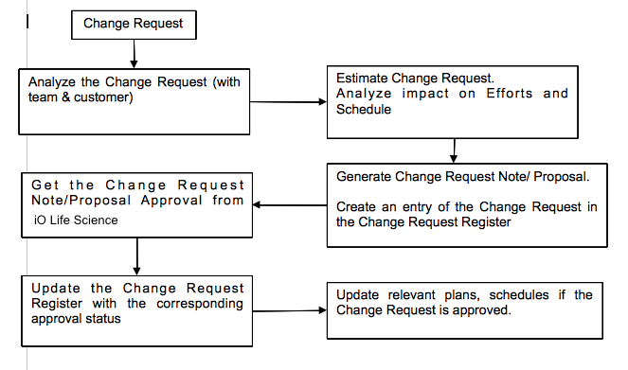

# ASsumptions

The application will only support mobile phones and tablets. The application will not support Smart watches and Smart-Tv

# Queries on requirement

Refer to ei_QueryTrackingSheet_MobileApp_MouthLab_Advanced.xls

# FMEA

NA

## Updated FMEA

NA

# Appendix

NA