U.S. Airline Performance & Delay Analysis – Final Project Report

1. Project Title
U.S. Airline Performance & Delay Analysis

2. Domain
Aviation Analytics / Transportation Management

3. Problem Statement
Flight delays and cancellations significantly impact passengers, airlines, airports, and the economy. This project analyzes historical U.S. flight data to identify delay and cancellation patterns, benchmark airline and airport performance, and generate actionable recommendations.

4. Business Objectives
• Analyze causes of delays and cancellations
• Benchmark airline performance
• Evaluate airport operations
• Study monthly, weekly and route trends
• Deliver stakeholder recommendations

5. Dataset Information
Dataset: 2015 U.S. Flight Delays and Cancellations
Files Used: flights.csv, airlines.csv, airports.csv
Source: Google Drive dataset provided in project brief.

6. Tools & Technologies
SQL, Power BI, Excel, Data Modeling, DAX, Data Cleaning, KPI Development, Data Visualization

7. Methodology
Phase 1: Data Ingestion
Phase 2: Data Cleaning & Transformation
Phase 3: EDA & KPI Development
Phase 4: Dashboard Development
Phase 5: Insights & Recommendations
Phase 6: Reporting

8. Data Preparation
Converted date/time fields, handled missing values, mapped cancellation codes (A,B,C,D), created flight date fields, joined airlines and airports lookup tables, created analytical dataset.

9. KPIs
Total Flights, Cancelled Flights, Cancellation Rate, Average Arrival Delay, Average Departure Delay, Delay Type Contribution, Airline Performance Metrics.

10. Dashboard Screenshot
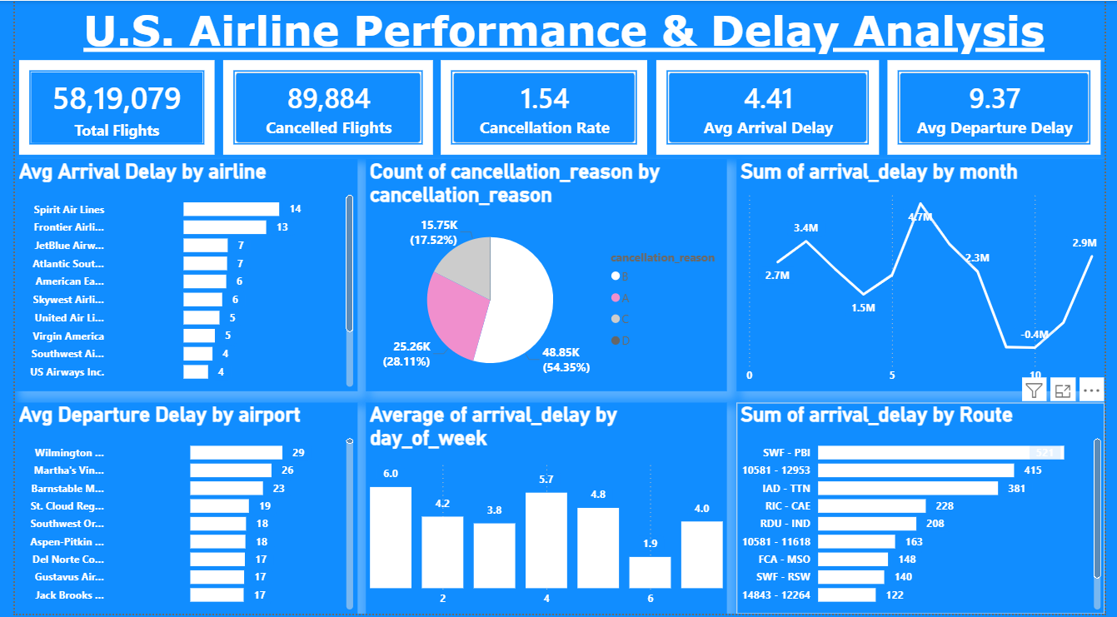

11. Dashboard Analysis & Findings
- 58,19,079 total flights were analyzed.
- 89,884 flights were cancelled, resulting in a 1.54% cancellation rate.
- Average arrival delay was 4.41 minutes.
- Average departure delay was 9.37 minutes.
- Spirit Airlines and Frontier Airlines recorded higher average arrival delays.
- Cancellation reason category B represented the largest share of cancellations.
- Arrival delays peaked during mid-year months and reduced toward year-end.
- Certain routes consistently generated the highest arrival delays.
- Several airports experienced significantly higher departure delays than the national average.

12. Business Recommendations
- Increase operational monitoring on high-delay routes.
- Improve scheduling and turnaround management during peak delay periods.
- Strengthen contingency planning for major cancellation causes.
- Focus airport-level process optimization for consistently delayed airports.
- Use predictive analytics to proactively manage disruption risks.

13. Project Deliverables
• SQL Scripts Package
• Interactive Power BI Dashboard
• Final Project Report
• Presentation Deck
• Recorded Video Demonstration

14. Conclusion
The project successfully analyzed U.S. airline performance and delay patterns using SQL and Power BI. The dashboard provides actionable insights into airline efficiency, airport operations, cancellations, and route performance.

