How to Launch AutoOptix Application

Prerequisites
Ensure you have Python 3.8 or higher installed on your system.

Installation Steps
- Extract the provided zip file to a folder on your computer
- Run this AutoOptix_Run file.
- After running AutoOptix_Run file, it will check whether the environment is created and dependencies are installed. If not, it will automatically do that and it will take 5 to 10 minutes.
Reference Screenshot Provided below: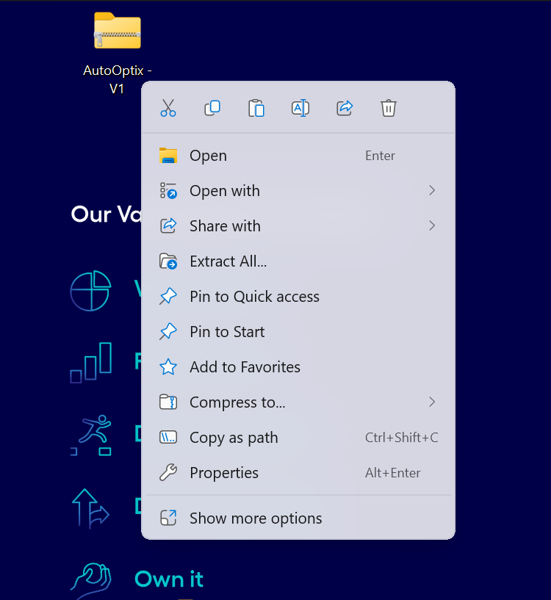
Run this AutoOptix_Run file 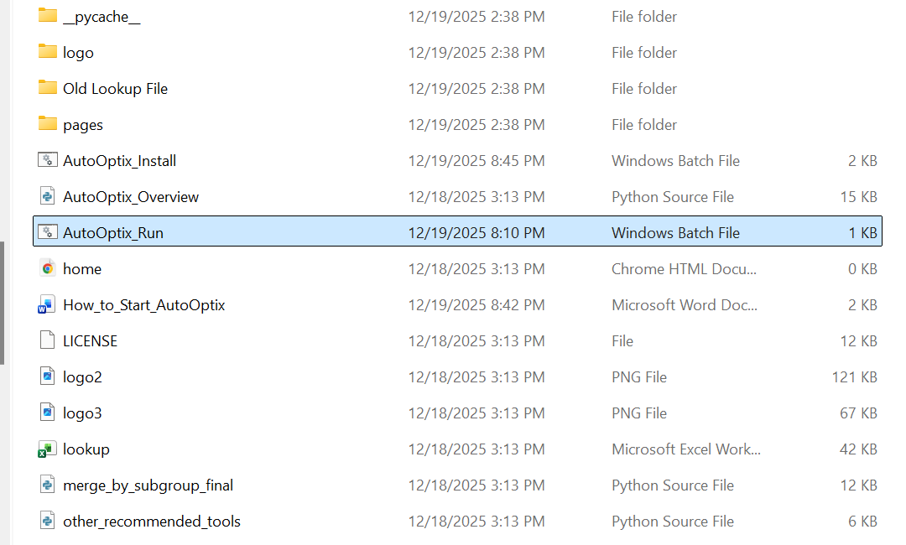

Automated Environment Setup:
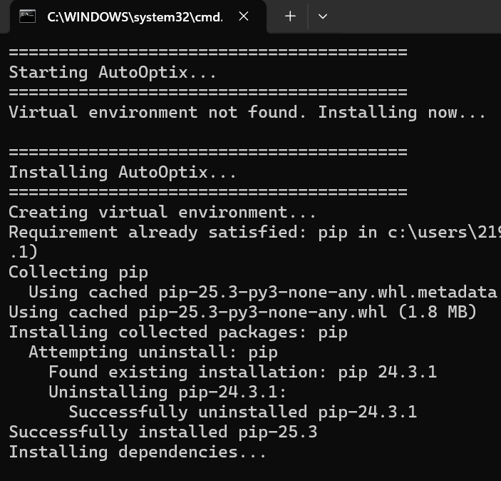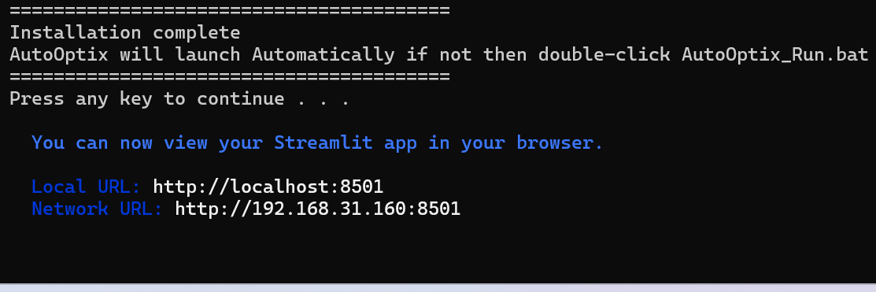
Once you see the above image on your terminal, it means installation is done.
Now you can press any key to continue; once pressed, the app will launch automatically in the browser.
Once you see Local URL and Network URL, the app is launching.
The tool will launch on this URL: https://localhost:8501

