Quiz-5 (AVL TREES) CompSci-535: Algorithm Design and Analysis
Email-id _________________@uwm.edu Name:__________________
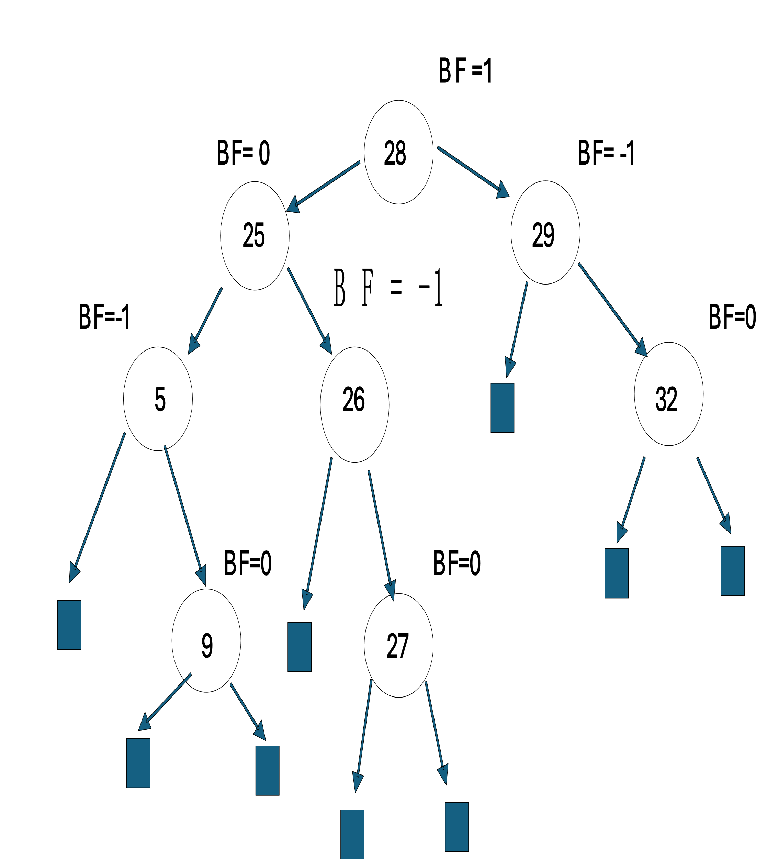
- Insert 41, 7, 43 and 2 in following AVL tree. Show final trees after each insertion.

- Delete 29 from the Resultant AVL tree in Question 1. Show the final tree after Deletion.

