Homework 1

Assigned: February 1, 2024 (Thursday)
Due: February 8, 2024 (in class, Thursday)

Problem 1 (2 points) Show that (n+1)²⁰ is O(n²⁰).
(Hint: don’t try to expand (n+1)²⁰! Think about (n+1) ≤ 2n for n ≥1, then use the Big-Oh definition.)

Problem 2 (2 points) Show that max{f(n), g(n)} is O(f(n) + g(n)), for f(n) ≥ 0, g(n) ≥ 0.
(Hint: use the Big-Oh definition.)

Problem 3 (3 points) Consider the following recurrence equation, defining a function T(n):
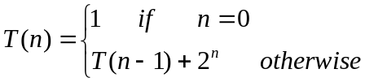

Show, by induction, that T(n) = 2^{n+1}-1.

Problem 4 (3 points) Consider an array A of size n. Each element is initially assigned either 0 or 1 (you don’t have to do that, it’s already done). Write a pseudo-code for each one of the following functions:
- AddOne (A, n): find the first “zero” and change it to “one”.
- RemoveOne(A, n): find the last “one” and change it to “zero”.
- ShrinkArray(A, n): Move all “ones” to the front of the array, such that all elements following the last “one” are “zero”.

