Homework 4

Assigned: February 22, 2024 (Thursday)
Due: February 29, 2024 (Thursday)

Problem 1 (3 points) AVL Trees

Given the following tree, draw the AVL tree resulting from:
- the insertion of an item with key 52 into the original tree below,
- the removal of the item with key 62 from the original tree below.

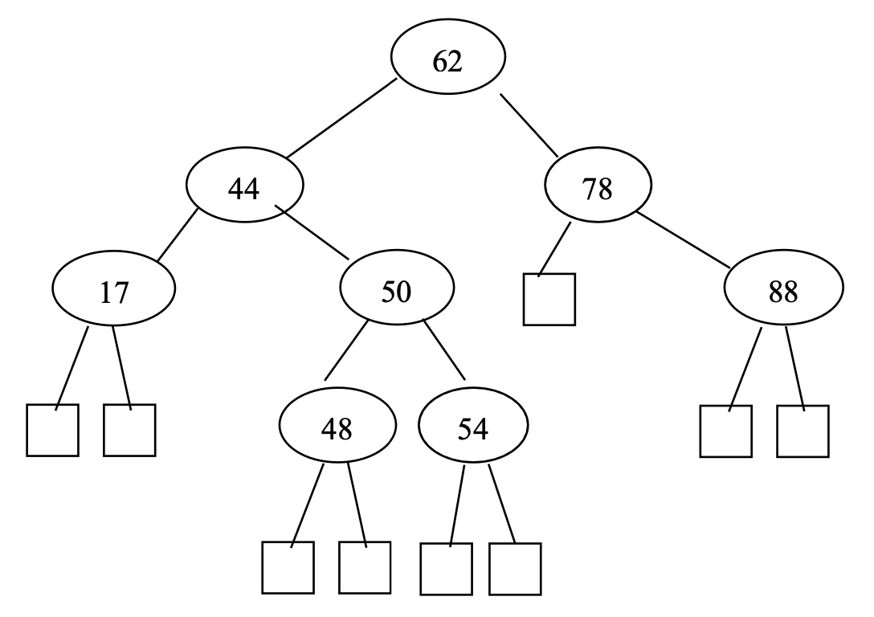

Problem 2 (3 points) Binary Search Trees

Describe how to perform the operation findAllElements(k) in an ordered dictionary implemented with a binary search tree T, and show that it runs in time O(h + s), where h is the height of T and s is the number of items returned.

Problem 3 (4 points) (2, 4) Trees

Let T and U be (2, 4) trees storing n and m items respectively, such that all the items in T have keys less than the keys of all the items in U. Describe an O(logn + logm) time method for joining T and U into a single tree that stores all the items in T and U (destroying the old versions of T and U).

