Homework 7

Assigned: April 17, 2024 (Wednesday)
Due: April 26, 2024 (Friday)

Problem 1 (4 points)
Let G be an undirected graph whose vertices are the integers 1 through 8, and let the adjacent vertices of each vertex be given by the table below:

vertex adjacent vertices
1 (2, 3, 4)
2 (1,3, 4)
3 (1, 2, 4)
4 (1, 2, 3, 6)
5 (6, 7, 8)
6 (4, 5, 7)
7 (5, 6, 8)
8 (5, 7)

Assume that, in a traversal of G, the adjacent vertices of a given vertex are returned in the same order as they are listed in the above table.
- Draw G.
- Order the vertices as they are visited in a DFS traversal starting at vertex 1.
- Order the vertices as they are visited in a BFS traversal starting at vertex 1.

Problem 2 (4 points)
Draw the transitive closure of the directed graph shown in the following figure.

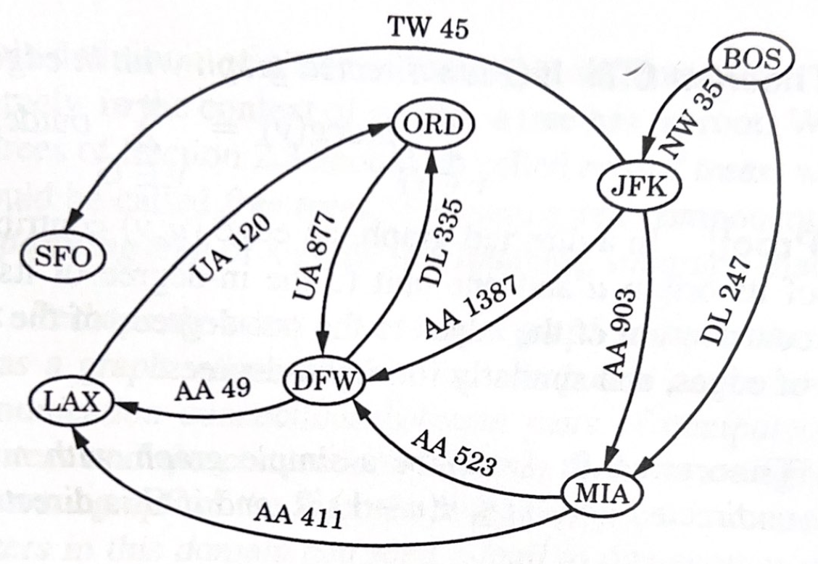

Problem 3 (4 points)
Compute a topological ordering for the directed graph drawn with solid edges in
The following figure.
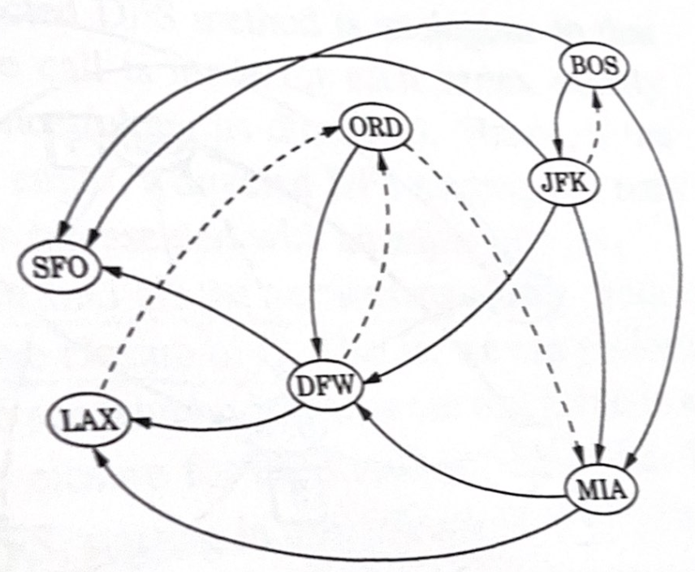

Problem 4 (8 points) [Textbook C-6.13]
A company has a network of n switching stations connected by m high-speed communication links. Each customer's phone is directly connected to one station in his or her area. The company has developed a prototype video-phone system that allows two customers to see each other during a phone call. In order to have acceptable image quality, however, the number of links used to transmit video signals between the two parties cannot exceed 4. Suppose that the company’s network is represented by a graph. Design an efficient algorithm that computes, for each station, the set of stations it can reach using no more than 4 links.

(Hint: Modify the DFS algorithm by considering the depth of each vertex being visited from the starting vertex.)

