Solution 1

Problem 1 (2 points) Show that (n+1)²⁰ is O(n²⁰).
Proof: Because 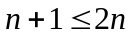 for all 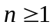, 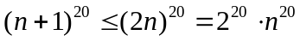.
Let c = 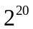 and 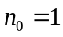, then 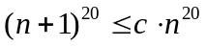, all 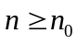.
By definition, 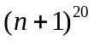 is 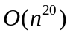.

Problem 2 (2 points) Show that max{f(n), g(n)} is O(f(n) + g(n)), for f(n) ≥ 0, g(n) ≥ 0.
Proof: Consider two cases:
- f(n) ≤ g(n). Then max{f(n), g(n)} = g(n).
Because f(n) ≥ 0, g(n) ≤ f(n) + g(n).
Let c = 1 and , then max{f(n), g(n)} = g(n) ≤ c×(f(n) + g(n)) for .
By definition, max{f(n), g(n)} is O(f(n) + g(n)).
- f(n) > g(n). Then max{f(n), g(n)} = f(n).
Because g(n) ≥ 0, f(n) ≤ f(n) + g(n).
Let c = 1 and , then max{f(n), g(n)} = f(n) ≤ c×(f(n) + g(n)) for .
By definition, max{f(n), g(n)} is O(f(n) + g(n)).

Problem 3 (3 points) Consider the following recurrence equation, defining a function T(n):
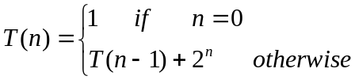
Show, by induction, that T(n) = 2^{n+1}-1.
Proof: (a) Base:
If n = 0, T(0) =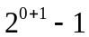 = 1. Therefore, T(n) = 2^{n+1}-1 is true for n=0.
(b) Induction step:
Let’s assume that T(i) = 2^{i+1}-1 is true for i < n for n ≥ 1. Then
T(n) = T(n-1) + 2^{n} = 2^{(n-1)+1}-1 + 2^{n} = 2^{n} + 2^{n} -1= 2^{n+1} -1.
Therefore, T(i) = 2^{i+1}-1 is true for i = n.
By induction rule, we conclude that T(n) = 2^{n+1}-1 for all n ≥ 0.

Problem 4 (3 points) Consider an array A of size n. Each element is initially assigned either 0 or 1 (you don’t have to do that, it’s already done). Write a pseudo-code for each one of the following functions:
- AddOne (A, n): find the first “zero” and change it to “one”.
- RemoveOne(A, n): find the last “one” and change it to “zero”.
- ShrinkArray(A, n): Move all “ones” to the front of the array, such that all elements following the last “one” are “zero”.
Pseudo-code:
(a) Algorithm AddOne(A, n)
Input array A of n integers (0 or 1)
Output array of A, where the first “zero” of A was changed to “one”.
for i ← 0 to n−1 do
if A[i] = 0 then
A[i] ← 1
Break
return A

(b) Algorithm RemoveOne(A, n)
Input array A of n integers (0 or 1)
Output array of A, where the last “one” of A was changed to “zero”.
for i ← n-1 to 0 do
if A[i] = 1 then
A[i] ← 0
Break
return A

(c) Algorithm ShrinkArray(A, n)
Input array A of n integers (0 or 1)
Output array of A, after shrinking.
j ← 0 // j is the first available entry to hold the next “one”.
for i ← 0 to n-1 do
if A[i] ≠ 0 then
if i ≠ j then
A[j] ← A[i]
A[i] ← 0
j ← j+1
return A

Note: This algorithm works for arbitrary values (replacing “one” above).

