Homework Solution 3

Problem 1 (2 points)
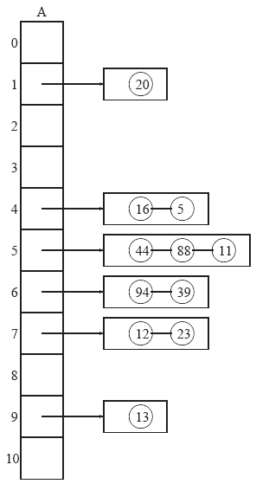

Problem 2 (3 points)
Call printKey(T, T.root, x) using the following algorithm:
Algorithm printKey(T, v, x)
if (v is external node)
return
else if (key(v) ≤ x)
print(key(v))
printKey(T, v.leftchild, x)
printKey(T, v.rightchild, x)
else
return
end

Problem 3 (5 points)
Let h(.) is the hash function and A is a “normal” (not circular) array storing the keys
Algorithm removeElement(A, k)
Find the slot (denoted by i) that stores k //this can be done using findElement(k)
//if not found, return NO_SUCH_KEY

j ← i+1 //check the next slot
while (A[j] is not empty) do //if empty, everything after j is correct
if (h(A[j]) ≤ i) //the key in A[j] was hashed before i,
//therefore needs to be shifted backward
A[i] ← A[j] //move the keys
i ← j //i always points to the slot to be filled
j ← j+1 //j always points to the next candidate slot
else
j ← j+1
end
end
Empty the bucket A[i] //You must do this, otherwise this key is //still alive and will be searchable later

