Solution 4

Problem 1 (3 points)

62
50
78
44
54
48
17
52
88

54
44
78
17
50
48
88

Problem 2 (3 points)

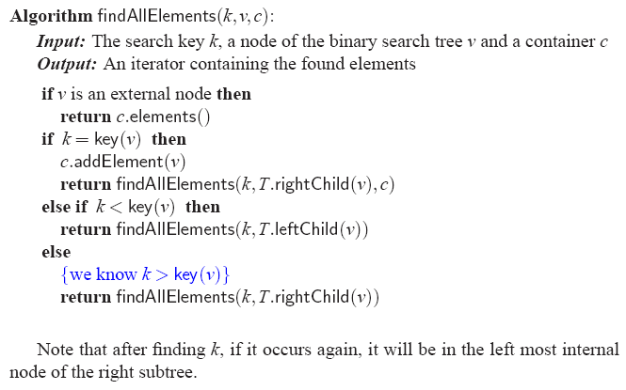

Problem 3 (4 points)

