Solution #7

Problem 1 (4 points)
(a)
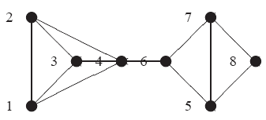

(b)
A DFS traversal starting at vertex 1 is: 1, 2, 3, 4, 6, 5, 7, 8

(c)
A BFS traversal starting at vertex 1 is: 1, 2, 3, 4, 6, 5, 7, 8.

Problem 2 (4 points)
Dashed edges below are newly added edges.

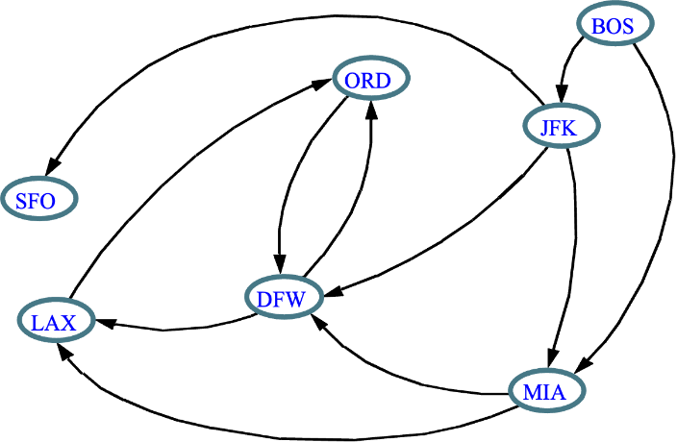

Problem 3 (4 points)

A topological ordering is: (BOS, JFK, MIA, ORD, DFW, SFO, LAX).

Problem 4 (8 points)
