**A PROJECT REPORT ON**

**“Smart Door Lock System”**

# Submitted

**In partial Fulfillment of the requirements For the Degree Of**

**MASTER OF COMPUTER APPLICATIONS**

# By

**ROHIT PANDEY**

**Under the supervision of Mss. AITIKA GUPTA**

**(Asst. Professor, GEHU)**



**To the Department of Computer Application Of**

**GRAPHIC ERA HILL UNIVERSITY DEHRADUN**

**(2019-2021)**

**CERTIFICATE**

I hereby declare that the work which is being presented in the project entitled, **Smart Door Lock System** has been carried out by **ROHIT PANDEY** for the partial fulfilment of the requirements for the award of the **MCA**, submitted in the department of computer application, **GRAPHIC ERA HILL UNIVERSITY** is an authentic record of our own **Mss. Atika**, Project Coordinator. I further declare that the matter embodied in this project has not been submitted by us for the award of any other degree.

## PROJECT INCHARGE

**MSS .ATIKA GUPTA**

**ACKNOWLEDGEMENT**

We take this precious opportunity to express my gratitude toward “**Smart Door Lock System”** to grant is permission for undergoing the project. Without its willingness to permit this project would not have been succeed.

First of all, we would like to thanks all those people who helped us directly or indirectly to complete our project whenever we found our self in problems. Our all faculties encourages us and due to their kindness and helpful nature and help we get very much confidence to complete this project.

We are deeply inherited who devoted his precious time in giving us the information about the various aspects and gave support and guidance at every point of time. We are really thankful to

Their kind and supportive nature. His/Her inspiring nature has always made me work

easy.

Last but not least, we would like to express our gratitude to **Mss. Atika Gupta**

who directly or indirectly helped in our project.

**ABSTRACT**

In this project, a specific domain is covered which proves to be a complementary aspect

to smart home automation. Smart security is the concept which is more emphasized

on in this project. The project **'Smart and Intelligent Door lock'** aims to enable

the basic activity a human could do, with technology.

The basic door lock can be made smart if it operates on its own. And intelligent as

it gathers the data and comes to draws a pattern through with some information can

be derived.

The project is appropriate to be embedded in business setup especially in the

'Hospitality Industry'.

Hotel business equipped with technology can allure the customers.

Eventually, profit generation would be high.

Therefore, it is a profitable project.

**TABLE OF CONTENTS**

1. Title Page 1
2. Certificate 2
3. Acknowledgment 3
4. Abstract 4
5. INTRODUCTION 1
   1. Odjective 1
   2. Summary of Invention 1
   3. Microcontroller Devices 2
   4. Computer to Microcontroller Communication 2
   5. Max232 to Microprocessor Wireless Data Transmission 3
   6. Controlling Multiple Motor Using By Microprocessors 4
   7. Arduino Device 4
   8. Computer to Arduino Communication 4
   9. Bluetooth communication 5
6. Technical Content 6
   1. Identification and Significance of Problem 6
      1. Microcontrollers Benefits 6
      2. Computer Serial Data Transfer Benefits 7
      3. MAX232’s Benefits 7
      4. Wireless Communication’s Benefits 7
      5. Using Motors’ Benefits 8

2.1.7 Using Arduino Benefits 9

2.1.7 Bluetooth’s Benefits 9

* 1. Technical Background 10
  2. Technical Objectives 35
     1. Wireless Communication and Serial Communication with Computer… 36
  3. Work Plan 37
     1. Computer to Microprocessor Connection Working Plan 38
     2. Wireless Communication Over Microprocessors Working Plan 38
     3. DC Motor Controlling Plan 37
     4. Arduino and Adafruit Motor Controlling Plan 38
     5. Bluetooth Communication Plan 38

2.5 Related Work 40

1. FACALITES AND EQUIPMENT 41

REFERENCES 43

# INTRODUCTION

**Objective**

It is the application of HOME AUTOMATION, Which can make the basic door lock, smarter and secure while operating it from our mobile phone.

The objective of the invention is to prevent you from the COVID-19.

The objective of the invention is to provide the best security.

The objective of the invention is home automation.

The product is appropriate to be embedded in business setup especially in the hospitality, Hotel business equipped with technology can allure customer eventually, profit generation would be high.

**Summary of Invention**

COVID-19 (Coronavirus) has affected day to day life and is slowing down the global economy. This pandemic has affected thousands of peoples, who are either sick or are being killed due to the spread of this disease. The most common symptoms of this viral infection are fever, cold, cough, bone pain and breathing problems, and ultimately leading to pneumonia. This, being a new viral disease affecting humans for the first time, vaccines are not yet available. Thus, the emphasis is on taking extensive precautions such as extensive hygiene protocol (e.g., regularly washing of hands, avoidance of face to face interaction etc.), social distancing, and wearing of masks, and so on.COVID-19 has rapidly affected our day to day life, businesses, disrupted the world trade and movements. Identification of the disease at an early stage is vital to control the spread of the virus because it very rapidly spreads from person to person. Most of the countries have slowed down their manufacturing of the products , The various industries and sectors are affected by the cause of this disease, these include the pharmaceuticals industry, solar power sector, tourism, Information and electronics industry. This virus creates significant knock-on effects on the daily life of citizens, as well as about the global economy.

There is no treatment of this disease till wet, but we can stop it by taking some precautions, which are regularly washing of hands, avoidance of face to face interaction, body sanitaization, regularly check your temperature, and avoid toching thing with our nacked hand. And these all things are not possible to follow in our daliy busy life,

So, we can use this product to stop the increasing rate od COVID-19, It is the application of HOME AUTOMATION, Which can make the basic door lock, smarter and secure while operating it from our mobile phone. It is a Smart Door Lock System, which enabled Bluetooth in it, for communication with a mobile phone and intelligent as it gathers the data and comes to draws a pattern through with some information can be derived. In this product, a specific domain is covered which proves to be a complementary aspect to smart home automation. Smart security is the concept which is more emphasized on in this product.The product Smart Door lock System aims to enable the basic activity a human could do, with technology.

As, we early discuss it also help in preventin from the COVID-19 because it come up with the following prtocols

## Microcontroller Devices

Microcontroller is an integrated chip and it’s also called as embedded system which includes CPU, RAM, ROM, I/O parts. Microcontrollers is like small computers but they are much simpler than the todays computers they can do simple specific tasks to control system. The advantage of the Microcontroller is, it is far cheaper than a complex controller. Microcontroller generally uses metal oxide semiconductor (CMOS) technology on the manufacturing process developers used less power and less resources. Generally microcontrollers’ uses 5V DC voltage to work but this can be change by the different microcontrollers. In this project WE used microcontroller to make the car and while doing this We have used microchip’s PIC 16F877A microcontroller. PIC 16F877A microcontroller has forty pin four of them for the feeding, two of them for oscillator. Oscillator is a simply clock with constant frequency in the project WE have tried two different oscillator one of them 4 Hz and the other were 8 Hz. For the programming PIC microcontroller there are many option PIC microcontroller does not interested complier or editor too much as long as code and configuration setting were true and hex file correctly complied. In our project WE used microchip’s MicroC editor and complier program. Codding is not so hard on these microcontrollers the hard part is setting true configuration settings for right hardware. To add hex files to the microcontroller there are many ways we can use debugger or an installer board can fix this problem but for different platforms we need to change our installer software too.

We used different ways first WE used boards that school gave to us but WE could not have successfully results from them on the capstone one….

## Computer to Microcontroller Communication

Computers have many output protocols and hardware like USB, HDMI, SD, Ethernet and VGA. Visual basic has its own connection tools for this kind of connection. Today most of applications about computer to microcontroller use VGA, USB or similar connections for PC (Personal Computer) to microcontroller or similar applications. Serial ports and VGAs use RS232 protocols to send serial information. PIC (Peripheral Interface Controller) has also its own connection protocols and libraries for this kind of communications. It has UART library which helps PIC to communicate with each other or other devices like PC.

## Max232 to Microprocessor Wireless Data Transmission

Wireless systems are very common in these days and WE want to make wireless a simple wireless receiver and transmitter to communicate speech recognition program with car. PIC is a microcontroller producing by Microchip Company and their microchips have a lot of application areas like wireless so WE want to make a wireless receiver and transmitter that use PIC microcontrollers. Due to this kind of communication applications PIC microcontrollers generally uses UART library to communicate with each other. After establish code there is necessary to have receiver and transmitter components. For the transmitter part WE have to take values from our computer to doing this WE have to use some component. MAX232 is a very useful solution for this connection; MAX232 uses RS232 serial port cable to communicate with PIC microcontroller. MAX232 converts computers signals coming from RS232 cable and sends converted signals to the PIC microcontroller. MAX232 component uses 5V DC as a input but it can also stands approximately 7.5V DC.

## Radio Frequency and Frequency Modulation

Radio Frequency is using very frequently in our live, it is on the air and because of radio frequency people can listen radio frequencies, watch television, communicate from long distance without cable and with using this people also can do various things. Radio frequency is a kind of electrical current that have some certain properties that allow it to broadcast with using an antenna. If an AC current generates an electromagnetic field or a wave at a frequency that is necessary to broadcast, then we can say this AC current is Radio frequency. These frequencies are not visible for human eyes these are infrared side of visible light. We have used an RF receiver and a RF transmitter WE have connected our RF transmitter to the MAX232 circuit to send values MAX232 converted comments to the RF receiver we connected PIC 16F877A circuit. Our RF components is very simply ones the only uses 433 MHz frequency and this is approximately equal to the 433 cycles per second. Importing thing is when we use these components our receiver and transmitter frequency should be equal if it is not than they cannot communicate with each other. There are two important radio modulation technique exist today they are Frequency Modulation (FM) and Amplitude Modulation (AM).

## Controlling Multiple Motor Using By Microprocessors

By using motor drivers PIC microcontrollers can control DC, AC or any other kind of motors. Drivers protect PIC and motor from burning problem. Motor drivers also provide bigger voltage for motors because PIC microcontrollers use five volt input and output. There are some drivers can help microcontroller to control two different motor those component called as dual h-bridge motor driver. WE have used a motor driver that can control two different motors but instead using one to control two motor we used two of them because these drivers get hot so quickly to avoid this situation I could use a metal panel but we had two motor drivers and we wanted to use both of them in our project that is why we used two motor controller in our car circuit.

## Arduino Device

Arduino is open source electronic prototyping platform based on flexible to use easy to use hardware and software tool. Arduino has a microcontroller inside its hardware it is different than WE used on the microcontroller part of the project part. Arduino uses ATmega series there is many type of Arduino exist today most popular ones are Arduino MEGA, Arduino UNO and many other type. We have used Arduino UNO it uses ATmega328 series of microcontroller has 28 ports inside it. Software of Arduino is very easy to use it does not requires too much configuration one you choose your dictionaries and wrote your code Arduino takes care of all other configuration settings and makes things much more easier. To installing code to Arduino is also very easy after code verified its complier than user just need to connect its cable to the PC than Arduino’s software finds its hardware and when user installs code to the hardware it is still easy to debug Arduino without using different hardware or software. If user defines serial communication with PC then user can check what Arduino does when it’s working.

## Computer to Arduino Communication

To communicate with Arduino we first need to install its free software on the internet and install. The software is very easy to use and install it creates just one .uno files on the

|  |  |  |
| --- | --- | --- |
| microprocessors these files are making user confuse because of there are many different file generating. After installing Arduino is ready to usage including dictionaries using dictionaries is very easy on the Arduino and Arduino does not requires any configuration setting when programming these setting madden by program itself on the background. User can use USB cable to connect Arduino and after that user can install his code to Arduino far more easily and quickly than microcontroller.  **1.9. Bluetooth communication**  Bluetooth is one of the popular devices to communicate in short range it is using on computers, cell phones, head phones and many other devices. Bluetooth devices use 2.4 to  2.5 GHz frequency to communicate with each other’s. Bluetooth standardized as IEEE  802.15.1 but then it changed that 802.15.1 Bluetooth’s range is 2400–2483.5 MHz approximately. Bluetooth devices generally use frequency-hopping spread spectrum communication technique to communicate each other. It can have approximately 40 channels and signals hops 1600 hop per second. Bluetooth devices firstly search each other once one find other it shows device to its user if user decides to communicate with device he paired those two devices and starts communication.  Hardware designs, Hardware connections, Hardware integrations,  Input voice,  Hardware errors  Computer programs,  Coding languages, Communication protocols, | |  |
| Coding errors key authentication  Design 1.1: Design level for Voice controlled car project | Output data,  Serial communication system, Wireless communication syste Motor controlling system,  Simple Cars, | m, |
| 5 | |  |

# Technical Content

## Identification and Significance of Problem

## Microcontrollers Benefits

Microcontrollers using in many different applications by now on the first computer developers used microcontrollers and in the basic daily life many device we see controlling by microcontrollers. Microcontrollers do specific jobs on the circuit they used in battery charges, printers, scanners, stereo systems, etc. there some different processors for embedded systems there are general purpose processors like intel and AMD, Micro- controller processors like PIC microchip and 8051, special processors like TMS320 series DSP and finally application specific instruction processors. In our case microcontroller processors have four main features one of them is on chip peripherals like timers, analog to digital converters, secondly on chip program and data memories, third direct programmer access to chips pins, and fourth is specialized instructions for bit manipulation and lower level operations. And their applications are reading sensor data, setting actuators, dealing with bits little amount of data, they can be using on the disk drive, digital camera, washing

machine or etc. microprocessor works with using hex files.

## Computer Serial Data Transfer Benefits

Today computers have varied usage area in the engineering society so connecting devices to computer and other similar devices is fundamental. Computers have many applications inside it and these applications can be easily changing by using keyboard and good algorithm so connecting devices to the computer provides user that improve his device and obtain new skills from them. Connecting computer property also provides user that control his equipment easily and enable user to check that device frequently. Another importance using area for serial port is data transfer, PC to SD, Flash, external memory, etc. people also using this communication for taking information or give information to their phones, cameras, tablets and other similar devices.

## Wireless Communication’s Benefits

Wireless systems is very importing in these days, these systems removes cables around and gives its users to ability connect internet and wireless networks for many different applications. With smart phones wireless technology using area increased these systems are very importing for community. Government use this wireless networks in the public areas like Istanbul metropolitan municipality use wireless technology to get location of their busses and via mobile applications they share this information with the Istanbul citizens. In these days communicating is very importing issue and with improvements in the

wireless technology systems communicating is being much easier and efficient. On the project we have used two type of wireless device these devices are radio frequency and Bluetooth.

## Using Motors’ Benefits

Motors are using in many industrial and daily application like cars, elevators, etc. to make our live more easy. Without of motors people could make many hard jobs with their body power and this is not so efficient for today’s industry. Motors are very popular and controlling them is very importing issue engineers and scientists still try to control motors more efficient. With efficient motor control industrial technology could be improve much faster and this affects other areas either. There is much kind of motors in the industrial area because their applications vary due to application it used.

## 2.1.7 Using Arduino Benefits

Arduino is open source electronic prototyping platform based on flexible to use easy to use hardware and software tool. Arduino has a microcontroller inside this microcontroller control its own hardware and while using given pins it help user to do different kind of applications. Today many artists, designers, engineers and hobbyists, who interested in creating interactive objects or environments on their systems, use this prototype to create new projects. Arduino has its own software it can be freely downloadable on the internet and it is just one file easily installing and there is no necessary configuration requires. Arduinos dictionaries are fairly easy to use, they have its own examples on the software and these examples are very tutoring.

## 2.1.7 Bluetooth’s Benefits

Connecting things is getting very complex thing because there is too many cables and too many port. With Bluetooth technology this problem could be solving and people could connect their devices more easily, more beautify. The main idea of this invention is cable-free computer connections, which means real freedom for working environment regardless wire availability and device restriction. This Bluetooth technology allows portable computers, notebooks, mobile phones, personal digital assistant and other helpful materials to use short range, low power radio technology to connect to each other very easily. Bluetooth is using 2.4 to 2.5 GHz frequency spectrum to communicate. While Bluetooth communication with other Bluetooth device its signals hops between channels and frequencies. It can communicate in the short range but its usage areas very varying, it can be used to data transmission between two devices like computer to computer, computer to cell phone, cell phone to computer, cell phone to cell phone. Bluetooth also using to head phones to connect musical device, computer or cell phone wirelessly, Bluetooth communication is pretty secure it hops between frequencies so jammers and similar devices getting hard time to restrict its communication. Bluetooth also can easily choose device that it will send its data, firstly Bluetooth device search device near it and second it ask user should WE get paired with this device to connect it securely and if user permits they starts to their

communications

#### BACKGROUND AND RELATED WORK

There are some factors that must to be considered when designing a smart home system. The system is invented to be low-priced, scalable so that new devices can be simply integrated into the system, and it should be user friendly. A variety of smart systems have been considered where the control is via Bluetooth, internet, short message service (SMS), smart card based, wifi etc

Shiu Kumar proposed smart home design application that allows owner to manage their home through internet. Its need a PC tend the information to the internet, so a PC is used as a server that increases the price and power consumption while others need web page hosting that need extra cost also.In his paper, said that the use of PC can require considerable cost and can be reduced by using a microcontroller [6].

Deepali recommends the use of the android platform version 2.3.4 Gingerbread and 3.1 Honeycomb using the Java programming language for smart home security system for the disabled and senior citizens [7]. In his research , the connection between android platform and the home device using wired conection, so It will be more efficient to support various wired as well as wireless technologies such as Bluetooth, Zigbee, Wi-Fi, World Wide Web. The implementation of Bluetooth for home security systems using the ARM9 processor were introduced by Naresh [8]. Hao Shi, in his research on home lighting settings implemented an open-source.

Android Development Tools (ADT), the Android SDK (Software Development Kit) and Java Development Kit (JDK) [9]. Manasee Patil had examined home automation system using RFID, Wireless Sensor Network (ZigBee) technology and GSM. ZigBee is low power wireless technology used for monitoring and controlling various devices [10]. R. Piyare [11] has introduced design and implementation of a low cost, flexible and wireless solution for home automation, especially or on/off the lamp and to on/off the television automatically. However, this is a basic system without advanced features like integration of RTOS, and also not has light sensors that are used to intelligently control the home appliances without human intervention.

All research that mention above, inspired our research to make a research about the device that providing a safe and efficient solution for controlling home automation. The first step to build a smart home is about the security and the door is the mayor device for security system.

The device is a system to lock and unlock the door. Rather than using a key, it uses a command that is delivered digitally via Bluetooth on Smartphone and other mobile devices. The use of electronic lock using Bluetooth on Android smart phones in addition to providing ease of use, also provide better security than conventional key.

The system designed to simulate an electronic key, which is controlled through a Bluetooth-enabled smart phone. Controlling conducted by sending a command via Bluetooth to the Arduino circuit that acts as a connection between Android smart phone and solenoid.

Solenoid door lock is the electronic device that made for door lock and often use for automatic door locks. Solenoid will operate if the system has a voltage. The average of the solenoid door lock is 12 volt. In normal condition, the lever will be Normally Closed. If there is any voltage through the solenoid, it will unlock the door. Usually the solenoids combine with electric key lock system with RFID and password. In our research we combine solenoid door lock with Bluetooth-based smart phone.

#### HARDWARE ARCHITECTURE AND IMPLEMENTATION

There are several step in hardware design, i.e.

* The design of Arduino Uno circuit
* The design of Bluetooth circuit
* The design of Solenoid door lock circuit
* The design of LED circuit
* The design of power supply circuit
* The design of driver relay circuit

Arduino microcontroller serves as the brain of the whole series. [12] The microcontroller can be linked with other circuits to perform certain functions. The Arduino microcontroller using IC ATMega328P-PU and works by entering the program that has been created and ready for instantly use. Bluetooth module used in this circuit is the

type of HC-05, which requires a 3.3 V DC power drawn from the Arduino microcontroller circuit (pin 3.3 V), Pin (TX 1) is a pathway transmit / send data on the Bluetooth module HC-05 with microcontroller and Pin (Rx 0) as the receive path / receiver data on the HC-05 Bluetooth module with microcontroller while the path GND (Ground) is a path connecting the data between HC-05 Bluetooth module with microcontroller circuit.

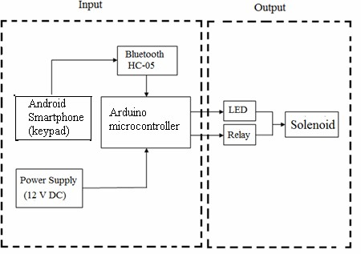

**Figure-1.** Block diagram of door automation system using android.

The block diagram in Figure-1 describes the system overall. This system has input from android Smartphone using Andruino software (v0.11), the overall system is controlled automatically and the output is a solenoid that connected to the Arduino microcontroller circuit. The function of each block can be seen in Table-1.

**Table-1.** The function of each System Block.

|  |  |  |
| --- | --- | --- |
| **No** | **System Block** | **Function** |
| 1 | Arduino Microcontroller | As data processing  center |
| 2 | Android Smartphone  (Andruino v0.11) | As data input |
| 3 | Bluetooth Module Hc-05 | As data receiver |
| 4 | Battery and Adaptor (12V) | As the power supply |
| 5 | Driver Relay | As switch |
| 6 | LED | As indicator |
| 7 | Solenoid | As system output |

The system required a program that must be implemented to the microcontroller. Programming language for the Arduino microcontroller is C language. To run the the program and incorporate the program to the microcontroller needed software i.e. Arduino.

The mechanism of device is to input a digital keypad on the software on android Smartphone first, if there is a command that is controlled by the user, the data will be instantly sent via a Bluetooth network then the input received by the Hc-05 Bluetooth module that connected to Arduino microcontroller. Arduino microcontroller circuit serves as a data processor that controls the solenoid that previously connected to a relay that functions as an on / off switch.

Microcontroller is the central data in processing system. Microcontroller Arduino has been equipped with an internal EEPROM, Flash memory, etc. This section will examine the input password, and give orders to the LED and relay, to fill out his program with the principle of ISP (In System Programming) so that the program can be done without removing control.

Power supply circuit is used to supply power throughout the series; the power needed for the whole series is equal to 12 Volts DC. There are several components in the power supply circuit, such as transformers that serve for lowering the voltage. Capacitors are used as filters. And the last is the type LM7812 regulator IC that functions as a regulator of the power output by 12 Volt

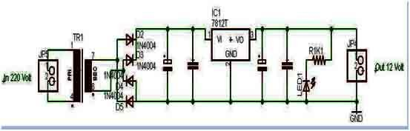

**Figure-2.** Power supply circuit.

Relay has a function as an electronic switch. Relay will be active when given input from the microcontroller, and serves as a switch for the solenoid system. In this research, we use the electro mechanical solenoid 12 V with supply voltage to 12V from Adaptor. Solenoid connected to the Relay, Relay connected to the 5V pin of the Arduino Uno for supplying coil voltage and ground Relay to ground Arduino Uno pin.

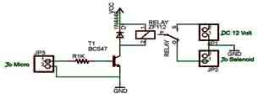

**Figure-3.** Relay driver circuit with solenoid

LED circuit serves as indicator for electric current. LED will turn on when current is passed from 12V DC solenoid in open-door condition, so the LED will be off when the system / solenoid current is not passed in the locked state.

#### SOFTWARE DEVELOPMENT

We use C language as programming language for Arduino (1.0.5) to run Arduino microcontroller. Relay as a switch to move the solenoid is set in pin 6 in Arduino microcontroller. Output pin 6 in relay will be in high condition and 1 s delay after user gives an order. [13]

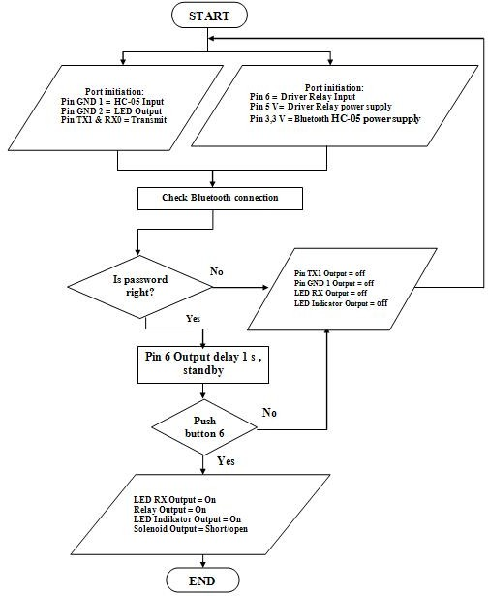

**Figure-4.** Flowchart for solenoid door lock programming.

#### EXPERIMENTAL RESULTS

After the implementation phase, the testing process performed. The results of the test series shows the minimum system of the Arduino microcontroller circuit system has a minimum value 9600 Bits per second, with 8 data bits and 1 Stop Bits. The whole series in this study operate the power of 12 volts. The power drawn from an adapter with a 7812 regulator IC. A function of this IC is to make the input voltage 220 volts of electricity into the main 12 volt DC, so it is safe and does not damage the circuit. Testing is done by ensuring the circuit has been installed correctly. With LED indicator that turn on in the microcontroller circuit and make sure there is no damaged component.

Relay and solenoid used to open and lock the output. The relay driver receives input data from Pin 6 on the microcontroller. Pin 6 on the microcontroller has function as input keypad on smart phone. Voltage measurements performed on output of the microcontroller Pin 6 using Volt-Ohm meter. Testing was conducted to determine the changes or differences in voltage solenoid.

Further testing is to examine the connectivity between Bluetooth on android Smartphone with Bluetooth module series HC-05 and the connection between keypad with Microcontroller. All of these tests show that all goes according to design connections. Final testing is testing the connection System to lock/unlock the door automatically. The test is performed to test the Arduino output in giving output on the LED and Relay for opening and closing the systems. Positive cable from the 12V supply adapter connected to a COM port on the relay, and the other connected to a port on the relay NO. This condition make the voltage supply of the adapter can not flow because normally Open positions in the state. When the relay is active, the relay was originally connected to the COM port and port NC will be connected to the COM port and port NO. These conditions make voltage supply 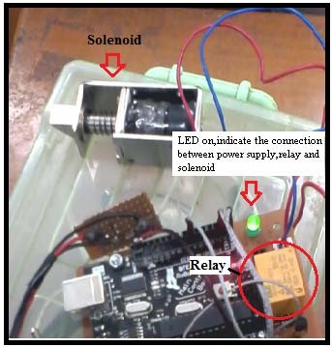passed the solenoid adapter and make solenoid open the door system.

**Figure-5.** LED on indicate the connection between power supply, relay and solenoid.

#### CONCLUSIONS

This is a ongoing project. This paper gives basic idea of how to control home security for smart home, especially for door key locks. We use solenoid door lock system as a prototype for indoor and outdoor key lock system. It also provide a security and easy for Android phone/tab users. This project based on Android and Arduino platform both of which are Free Open Source Software. So the implementation rate is inexpensive and it is reasonable by a common person. Accomplishment of wireless Bluetooth connection in microcontroller permits the system installation in more easy way. The system has been successfully designed and prototyped to control the door condition using an Android Bluetooth-enabled phone and Bluetooth modules via Bluetooth HC-05. We have discussed a simple prototype in this paper but in future it can be extended to many other regions.

Today, most mobile phones are a 'smart phone', which offers more advanced capabilities in connectivity issues than regular cell phones. According to an investigate by ABI Research, at the end of 2013, 1.4 billion smart phones has been in use: 798 million of them run Android, 294 million run Apple’s iOS, and 45 million run Windows Phone [1]. Smart phone usually support one or more short range wireless technologies such as Bluetooth and infrared, making it possible to transfer data via these wireless connections. Smart phone can provide computer mobility, ubiquitous data access, and pervasive intelligence for almost every aspect of business processes and people’s daily lives [2].

One of the smart phone applications that have been developed is smart homes technology [3]. Smart home technology is the technologies that are used in homes with various apparatus converse over a local network. According to the Smart Homes Association the best definition of smart home technology is: the combination of technology and services through home networking for a better value of living. This technology can be used to monitor, alert and execute, according to the desired functions. Smart homes technology makes automatic connection with environment via Internet, telephone or regular fixed phones. Smart homes actually have the ability to make life easier and more proper. Home networking can also offer peace of mind. Whether you're at job or on holiday, the smart home will aware you to what's going on, and security system can be built to offer some help in emergency situations. For example, not only would a house owner be woken with warning of a fire alarm, the smart home would also release doors, call the fire department and light the pathway to safety [4].

The use of Bluetooth technology in a smart phone today is not just for the transfer of data and files only. In recent years, smart home automation is one of the

applications of Bluetooth technology. Bluetooth technology operate over unlicensed, its available at 2.4GHz frequency, it also can link digital devices within a range of 10m to 100m at the speed of up to 3Mbps but it depending on the Bluetooth device class [5]. With these qualifications of Bluetooth; we offer a door automation system based on Bluetooth technology, especially in door automation system.

The design of the microcontroller-based controller, the Infrared temperature sensor directly to the collected signal for internal amplification and data processing and send it into the microcontroller, the microcontroller is to achieve LCD display and over-temperature alarm. The system diagram is shown in Fig. 1.

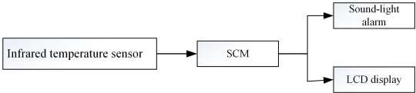

# Hardware Circuit Design

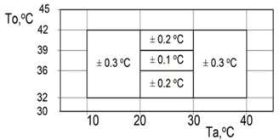**Temperature Measurement Circuit Design.** MLX90614 is a non-contact infrared temperature measurement device, it uses low-noise amplifier, 17 b A/D converter and powerful DSP processing unit with high temperature resolution and measurement accuracy. The thermometer temperature range is -40~+125℃, calculate and store in RAM ambient temperature and object temperature can achieve data with 0.01˚C resolution. In addition, the sensor outputs digital signals that are accurate and linearly correlated with temperature, which simplifies the design. For the MLX90614, the accuracy is shown in Fig. 2 within the range of 10ºC-40ºC ambient temperature and 32ºC-42ºC tested object temperature [3,4]. Ta is the ambient temperature and To is the measured temperature. Since the thermometer is generally used indoors, the temperature usually ranges from 20 to 30 °C and the human body temperature ranges from 35 to 42 °C. As shown in the Fig. 2, the accuracy of the MLX90614 is 0.1℃ ~ 0.2℃, so the design uses MLX90614 infrared temperature sensor to meet the design requirements.

Figure 2. The accuracy of MLX90614 medicine

The working principle of infrared sensor MLX90614 is to transform the infrared radiation signal collected from objects and bodies into electrical signals, send the electrical signal into converter after noise amplification processing by amplifier, then the electrical signal is converted to digital signals and store the processed signals into the internal memory, finally send the signals into the SCM control system for further processing [5].

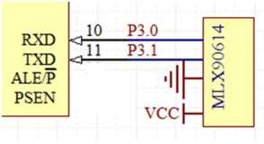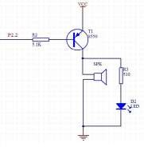MLX90614 infrared temperature sensor uses the SPI bus, when connected to the microcontroller, SCL termination microcontroller serial input port RXD, serial output pulse signals of sensor are provided by the microcontroller, it is used to transmit temperature information, SDA serial output port TXD is used to provide temperature information for the microcontroller, in the specific operation, the microcontroller transfer data through the serial port mode 0. Infrared temperature measurement circuit is shown in Fig. 3.

Figure 3. Infrared temperature measurement circuit Figure 4. Alarm circuit

**SCM.** STC89C52RC microcontroller is adopted because it is a low-power, high-performance microcontroller. With flexible 8-bit CPU and in-system programmable Flash, it provides a highly flexible and efficient solution for a wide range of embedded control applications. The download.

**Alarm Circuit.** Alarm circuit will make alarm when the body temperature exceeds the set value. The design uses active buzzer DC5V. When the system is powered on, the current drives the transistor T1 8550 to amplify to trigger the buzzer alarm through the current limiting resistor R2. The circuit is shown in Fig. 4.

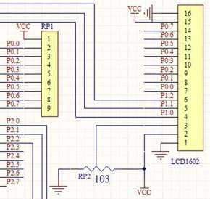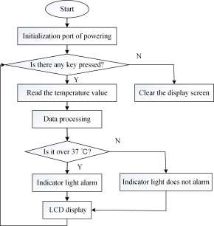**Design of Display Circuit.** The commonly used LCD1602 is adopted in this design, it can display two lines, there are 16 characters in each line, using a single +5 V power supply, and its peripheral circuit configuration is simple, cheap, with a high cost performance[7]. The display circuit is shown in Fig. 5.

Figure 5. Display circuit Figure 6. Main program flow chart

# Software Design

The design of software program uses Keil uVsion4 compiler software, and the programming has four main parts, namely the main program, infrared temperature measurement program, the display program and alarm program. The main program work process is that the system is normally powered, start the initialization, when a key is pressed, the sensor will detect the signal transmitted to the microcontroller, the microcontroller is to process the data, send to the display and alarm, if there is no key press, the liquid crystal display is clear. The main program flow chart is shown in Fig. 6.

# Production and Commissioning

The main design temperature measurement circuit, clock circuit, power circuit, reset circuit, display circuit, alarm circuit. Therefore, before the production of its overall layout of the first circuit layout, wiring, reduce cross-connection, the production is carefully carried out, after the completion of the production, with a multimeter to detect the connectivity of welding circuit. When circuit check is completed, debug the object, supply the power, press the start button to observe and record the ambient temperature value on LCD display, and then repeatedly measure the body temperature in different parts to compare and analyze the error. Fig. 7 is a figure of welded object.

Finally, to test different parts of the human body using the design of the infrared thermometer and the traditional thermometer, the statistical measurement results are shown in Table 1

Table 1 Temperature Test Comparison Table

|  |  |  |
| --- | --- | --- |
|  | Infrared thermometer[℃] | Mercury thermometer[℃] |
| Armpit | 36.7 | 36.9 |
| Oral | 36.9 | 37 |
| Ear | 36.5 | - |
| Forehead | 36.5 | - |

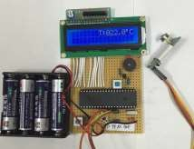

Figure 7. Infrared Thermometer

After comparison, through the temperature tests on different parts of the body measured by infrared thermometer and mercury thermometer, we can see that the results of infrared thermometer is small different with mercury thermometer, at the same time, temperature values of different parts of body are different. The general oral temperature is close to the body's temperature [8]. As can be seen from the table, the mercury thermometer is inconvenient to measure the temperature of ear, forehead and other external temperature. At the same time, in the testing process, there is a temperature difference in the infrared thermometer measurement, so it is recommended to use multiple measurements in the specific use and to take the average value, infrared thermometer is generally used for ear measurement.

# Analysis and Processing of System Error

The developed infrared thermometer will cause some measurement error due to the following interferences, and the interferences are as follows [9,10]:

Interference light. The system measures body temperature mainly by measuring the infrared radiation emitted by the object, so that all light outside the system may interfere with the system.

Ambient temperature. The higher the ambient temperature, the greater the impact on the system. Measuring distance.

Measuring objects and time. The design is mainly aimed at the human body, the wavelength range of body’s radiation is 7 ~ 14um, the measured wavelength of system is close to the real value, but can not rule out the interference of other light or objects.

In order to avoid large errors, the following measures can be taken:

Multiple measurements to take the average value; Select the best measuring distance between 2 ~ 4cm;

When measuring, select the site where the temperature is closest to human body and measure it under suitable environment;

# Conclusion

Physiological parameter of body temperature is the most important and basic human life indicator, and infrared thermometer is a new type of non-contact thermometer. It has the fast response, safety and other characteristics compared with the mercury thermometer. At the same time, the over-temperature alarm, LCD display and other functions are designed to make it more perfect.

.

Microsoft windows is an operating system which includes many software, derivers, configuration that manages computers hardware systems and manages their resources for its and users profits. Today

nearly all applications systems require an operating system to process on the computer or similar device. Most popular operating systems in the word are Microsoft windows, MAC and Linux open source operating systems like Ubuntu. Microsoft Windows uses IBM’s DOS (Disk Operating system), IBM generated this system to usage of the personal computers but after it gained graphical user interface (GUI) ability then it is start to being importing for Microsoft. DOS’s Kernel type is Monolithic its mean it is defines high level virtual interface over the computer or devices hardware system. Figure 2.13 shows application to hardware flow diagram.

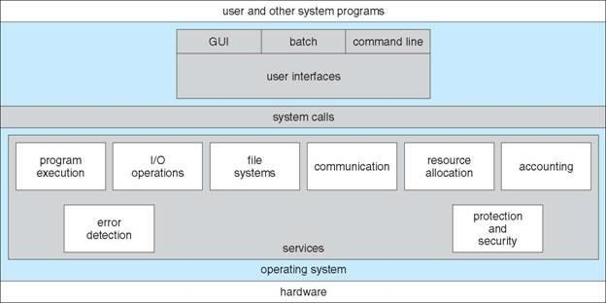

Figure 2.13: Application to hardware Microsoft Windows operating system.

Operating systems also provide communication between different systems like Arduino, microcontroller, internet, head phone, Bluetooth, etc. systems. The communication usually exchange information between other systems the information divided into packets by operating system and its also moved those packets to the receiver device or system. Computers do many process while its user does not notified these quests that are madden by operating systems. While operating systems does these quest, communicate and process data it also make errors and it detect errors also. Operating system also does protection and security quests it protects system resources and ensures it is secured. Security system requires user authentication and defends system to outsides attacks.

Microsoft also uses HMM model and other speech recognition algorithms to for

instance in the acoustic modelling Microsoft uses HMM(most common), segment models, super-segmental models, hidden dynamic models, Neural-Network HMMs, maximal entropy models and hidden conditional random fields, etc

Microsoft speech recognizing is very good application for making speech recognizing they uses and researches many algorithms and techniques to make this speech recognition application. In the early 1940 IBM and its partners tried to make an automatic speech recognizing tool and Microsoft’s speech recognizing tool began with this working. Microsoft firstly used its speech recognizing tool on the ease of access part. Now Microsoft speech recognizing toll is a part of Microsoft Windows operating system Microsoft is using it in the Microsoft office, Microsoft Agent, Microsoft Speech Server. Microsoft also allows software developer to write their own software’s while using windows speech recognizing tool on Microsoft’s supplied engines. Microsoft speech API is controlled by Microsoft applications and speech engines for recognition and synthesis. Microsoft names their speech recognizing tool to speech application programming interface or SAPI. They have five different versions SAPI 1, SAPI 2, SAPI 3, SAPI 4, SAPI 5 and its extensions.

SAPI 1 was came for Windows 95 and Windows NT 3.51 on year 1995 it was used for low level speech recognition and it was spotted by Microsoft’s control engines. SAPI 2 was very close to the SAPI 1 and it is come in the year 1996. It was more accurate than first one it is also used Microsoft’s control systems and engines. SAPI 3 released one year later the SAPI 2 released. Microsoft made their speech recognizer a supporter group and made discrete speech recognition and added some application for the speech recognizer they made. SAPI 4 was released on the 1998 and this version was included COM communication between devices. This version also gives users to chance to use this ability with using C++ programming language. Microsoft visual studio and visual basic are capable to use this language, C++ is considered as intermediate level language and it has both high and low level properties on itself. SAPI 4 has many applications on itself like Voice Command, Voice Dictation, Voice Talk, Voice Telephony, Direct Speech Recognition, Direct Text To Speech, and many other applications with using C++ language its application number varied. SAPI 5 is released on the 2000 and it is ability cooperate with lower versions of speech recognizer tools of Microsoft Windows created. When Microsoft published its speech recognizing they changed their design. Their new design is better than past versions it is cooperative with Windows system, drivers and its applications all this configurations are

managed and routed by using sapi.dll. this sapi made speech recognizing tool more engine independent so this speech recognizing tool not any more being requires specific engine to speech recognize and other applications. This new version of SAPI also used COM port and C++ language but with this version Microsoft added C language too and Microsoft supported its speech recognizing tool by adding it to visual basic and .NET applications. This version of SAPI included new skills and also supported and developed old ones these skills are shared recognizer, in-proc recognizer, grammar objects, voice object, audio interfaces, user lexicon object, object tokens. On the extensions of the SAPI 5 Microsoft added new languages like Jscript, C#, and similar languages, they supported their speech recognizer tools. They supported new languages on their speech analyzer dictionary and they made their grammar tools increased. They updated it to adapt new windows versions and their new update versions on the visual studio program Microsoft added new configuration, driver and made communication between speech recognition search engine.

Microprocessors are ultra-large-scale integrated electronic circuits that providing computational control. They process as the central processing unit (CPU) in the computers and they can also be used as microchips or chips. These microchips and chips have extremely tiny components with semiconductor material around them places inside it. Modern microprocessors have approximately ten million transistors for working as amplifiers, oscillators, switches and they also has resistors, diodes, capacitors and wires all those components packaged in the little microchip. Most of microprocessors has been created by using Von Neumann Architecture so they can make three different job these jobs are fetch, decode and execute. Fetch meaning is storing data which is binary format and this data can also be stored in a read only memory (ROM) or random access memory (RAM). Figure

2.14 indicates an Intel microprocessor close up shot.

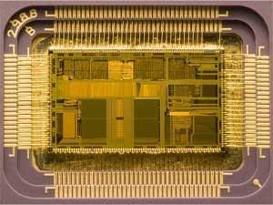

Figure 2.14: A close up shot of an Intel microprocessor, released in 1992..

Microprocessors has also Arithmetic Logic Unit (ALU) unit inside and this unit makes execution mission on the microprocessors. ALU has two main operations these operations are logic and arithmetic. Microprocessors also has clock component and this component generates clock signal with using this clock cycle microprocessor implements its applications.

Microprocessors are can communicate with LCD, other microcontrollers, computers and other similar electronic devices. Microcontrollers can take analog and digital inputs and while process it they can make new electronic applications. Microcontrollers requires an oscillator to count time so they can process their work correctly in time, embedded systems generally works with machine cycles and this cycles considered as their working timer. Microprocessors have different types and applications all of the applications should be depending on the timer if user of the embedded system should be consider its oscillator to get true process. Microprocessors should be minimal sized, minimal cost, increased reliability and maximize performance and they should be portable device, they could work with different networks and systems these microcontroller systems are very complex systems and their usage area it vary as written below. On the communication systems microcontrollers used very frequently this systems are telephone switches, routers and network bridges to communicate with different devices and different peoples. Microcontroller systems also used for motor controlling and other different applications it can drive a motor by itself but it would be harm microcontroller because this kind of control

does requires more protection to controller device instead of using microcontroller users should use a simple motor driver.

A motor deriver is a device group of devices that control a motor give a motor current to work control current to set its velocity and it also controls its torque. A motor controller protects motor and microcontrollers to sudden currents and overloads. These devices are easy to getting hot and it can break if user does not put a cooler metal component near it. There are many types of motor controllers some controllers are much more complex they can more accurately control the speed and the torque which connected to the motor these systems named as closed loop control system. Today using a motor controller has a many ways frequently used methods are automatic, manually or remotely controlled systems. Motor controllers are using with a power source like battery or power supply. This source should connect directly to the motors. Motor controllers are classified by their drive motors types these motors can be permanent magnet, servo, direct current, alternative current many other all those motor drives as different systems.

DC motors has a coil of wire and this wire rotates with respect to magnetic field around it. Split rings moves with effect of two different brushes magnetic load. Coil stand in the magnetic fields without moving this creates current over the coil and this current carrying wires creates torque over the coil itself. Coil’s position is vertical in the magnetic field and this vertical situation creates two opposite force over the coil, coil does not move with these forces because all forces are equal but these forces exert torque. Figure 2.15 shows magnetic field, coil and effect over the coil and magnetic field.

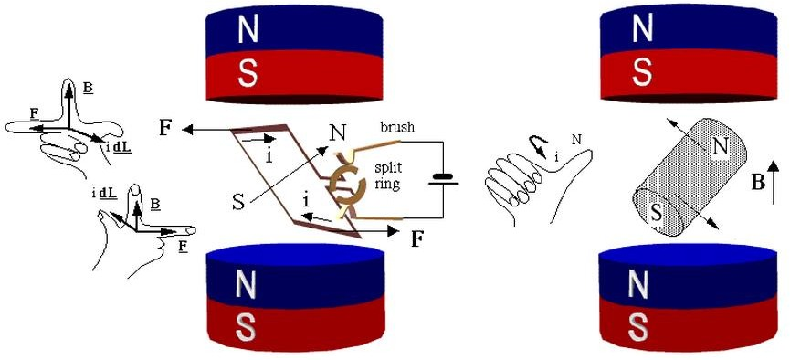

Figure 2.15: magnetic field and coil inside it rotates DC motor.

With using Lorentz force rule magnetic force affected coil can be found. Electromagnetic forces over the coil have a direction and this direction can be finding by using right hand rule. Equation 2.16 shows Lorentz forge law.

𝐹→ = 𝑞 ∗ 𝑣→ ∗ 𝐵→ = 𝑖 ∗ 𝑑𝐿→ ∗ 𝐵→

Figure 2.16: Lorentz forges law

Figure 2.15 is basic schematic of a motor but in the real electric motor case things get complicated. For example DC motors speeds depend dc current gave on it. Dc motors can be run both forward and backward depending current direction passes over it this direction can be changing by using H-bridges. DC motors has very high speed but they do not have that much torque. To gain much torque power, with using gears and transmissions motors speed power can be converting to torque. Other example is servo motors these motors has always same current inside it but size of the pulse determines direction of turning for typical servo motors large pulses means forward and smaller pulses mean backward. Servo also allows turning with an angle its typical movement is one or two degree for per pulse. Figure

2.17 shows a dc motors inside and above side of the figure is wound stator motor, below side permanent stators.

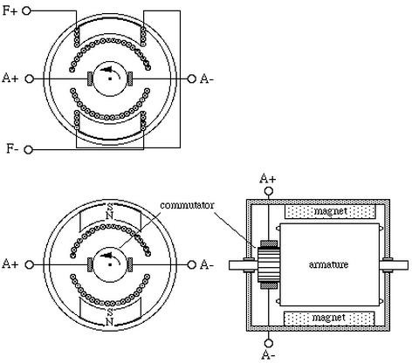

Figure 2.17: dc motors inside’s schematic.

MAX232 component is an integrated circuit, it first created by Maxim Integrated products. MAX232’s simple job was converting computers and similar devices RS232 cable communication signals to understandable signals for ıntegrated circuits like microprocessors and many other processors. MAX232 has dual receiver and driver on the inside and typically converts the RX, TX, CTS and RTS signals. MAX232 circuit also protects microprocessors from high voltages come from computer via RS232 cable. Computer send approximately 25 volt via using RS232 cable but this current is too much for the microprocessor so MAX232 simply took 15V DC and convert it to 5V dc voltage to do this it uses some on-chip charge pumps and some external capacitors. MAX232 component name could be changes due to its manufacturers but pin numbers and connection pins are nearly equal. RS232 has a logic output and input it process when it takes voltage from input, if input about +3V to +15V then it will give logic 0V for the (Rx) receiver and (Tx) transmitter output and for RTS/ CTS/ DTR/ DSR type of logic MAX232 gives 5V output. If MAX232 receives -3V to -15V for

the (Tx) transmitter and (Rx) receiver output circuit gives 5V and for the RTS/ CTS/ DTR/ DSR logic it gives 0V output.

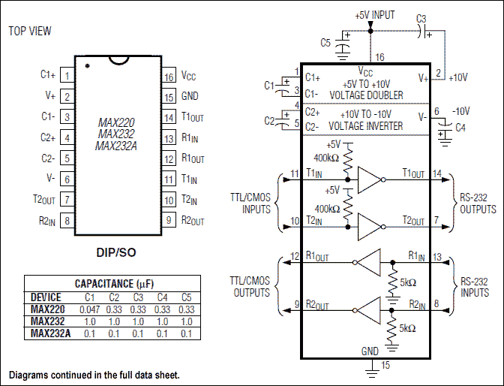

Figure 2.18: MAX232 Pin Configuration and Typical Operating Circuit diagram.

Wireless communication systems transmit data between to device or more than one device and while doing this it does not using wires. World’s first wireless telephone conversion had maddened in 1880 by Alexander Graham Bell who invented telephone. Alexander Graham Bell and Charles Sumner Tainter patented this new technology as photo phone that carries audio conventions wirelessly via using modulated light beams. In these days’ wireless technologies mostly using radio and less common method of using wireless technology is an electromagnetic wireless technology like light, sound, electric or magnetic fields. Figure 2.19 indicates fist wireless device photo phone demonstration.

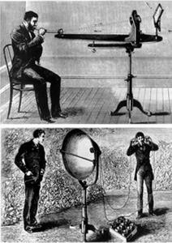

Figure 2.19: indicates fist wireless device photo phone demonstration.

In wireless systems sending data to one device to another there are many ways; one of them is radio frequency RF communication. To make a wireless data transmission RF is very efficient and common solution. Due to transmit data, transmitter needs to make modulation to carry data which we transmitted. This carrier usually is a cosine or sinus wave and this signal modulated with transmitter’s data after receiver receives this modulated signal it demodulates to use its data. Figure 2.20 contains three situation one of them, (a) indicate that sine wave modulation with frequency, (b) indicates resulting waveform’s spectrum, (c) spectrum after modulated continuous baseband signal has been shown.

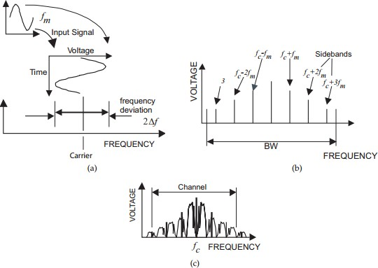

Figure 2.20: Frequency modulation.

The starting point for any 3D printing process is a 3D digital model, which can be created using a variety of 3D software programmes — in industry this is 3D CAD, for Makers and Consumers there are simpler, more accessible programmes available — or scanned with a 3D scanner. The model is then ‘sliced’ into layers, thereby converting the design into a file readable by the 3D printer. The material processed by the 3D printer is then layered according to the design and the process. As stated, there are a number of different types of 3D printing technologies, which process different materials in different ways to create the final object. Functional plastics, metals, ceramics and sand are, now, all routinely used for industrial prototyping and production applications. Research is also being conducted for 3D printing bio materials and different types of food. Generally speaking though, at the entry level of the market, materials are much more limited. Plastic is currently the only widely used material — usually ABS or PLA, but there are a growing number of alternatives, including Nylon. There is also a growing number of entry level machines that have been adapted for foodstuffs, such as sugar and chocolate.

Arduino’s specifications it is about 75x54x15 mm size and its weight 25 gram. Figure

2.24 shows a picture of Arduino UNO and USB connector cable with it. Arduino can be connecting computer with using USB cable. When user put computer its cable Arduino starts working uses power which took from computer and starts working. Arduino also permits users to debugging on their hardware and also software while computer connected to the computer if user defines serial communication with his board then he can easily see what Arduino does when it is working. Arduino allows fast transfer rates and there is no requirement for any drivers when using it and Arduino also have ability to connect some external hardware like Bluetooth, receiver, transmitter, mouse, keyboard, LCD screen and etc. when user connected external device all he needs to do indicate its dictionary on the code part and start codding and Arduino itself makes every changing, configurations, setting on its background engines.

The different types of 3D printers each employ a different technology that processes different materials in different ways. It is important to understand that one of the most basic limitations of 3D printing — in terms of materials and applications — is that there is no ‘one solution fits all’. For example some 3D printers process powdered materials (nylon, plastic, ceramic, metal),



Start with a 3D CAD file either by creating the 3D model or scanned with a 3D scanner

which utilize a light/heat source to sinter/melt/fuse layers of the powder together in the defined shape. Others process polymer resin materials and again utilize a light/laser to solidify the resin in ultra thin layers. Jetting of fine droplets is another 3D printing process, reminiscent of 2D inkjet printing, but with superior materials to ink and a binder to fix the layers. Perhaps the most common and easily recognized process is deposition, and this is the process employed by the majority of entry-level 3D printers. This process extrudes plastics, commonly PLA or ABS,

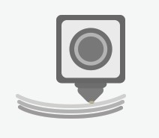

Layer by layer the printer will create the predetermined shape

heated extruder to form layers and create the predetermined shape.

Because parts can be printed directly, it is possible to produce very detailed and intricate objects, often with functionality built in and

negating the need for assembly.

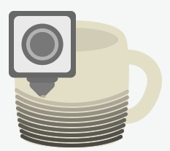However, another important point to stress is that none of the 3D printing processes come as plug and play options as of today. There are many steps prior to pressing print and more once the part comes oﬀ the printer — these are often overlooked. Apart from the realities of designing for 3D printing, which can be demanding, ﬁle preparation and conversion can also prove time-consuming and complicated, particularly for parts that demand intricate supports during the build process. However there are continual updates and upgrades of software for these functions and the situation is improving. Furthermore, once oﬀ the printer, many parts will need to undergo ﬁnishing operations. Support removal is an obvious one for processes that demand support, but others include sanding, lacquer, paint or other types of traditional ﬁnishing touches, which all typically need to be done by hand and require skill and/or time and patience.



At the end of the print process you will have your finalized object

You will soon start to see the object become more recognizable

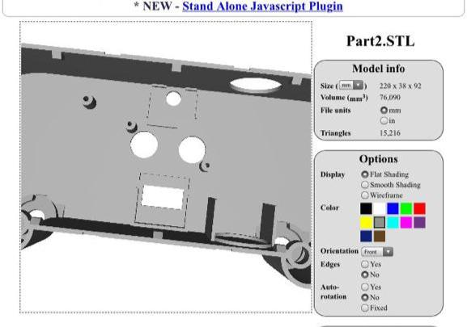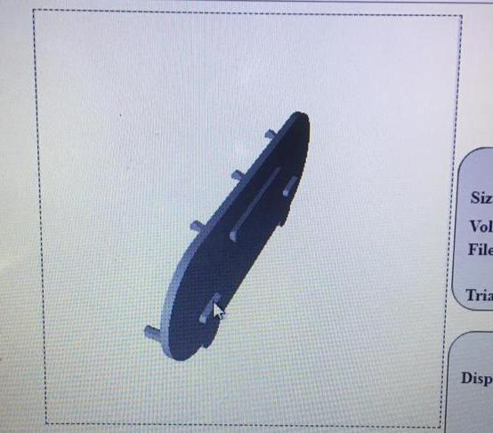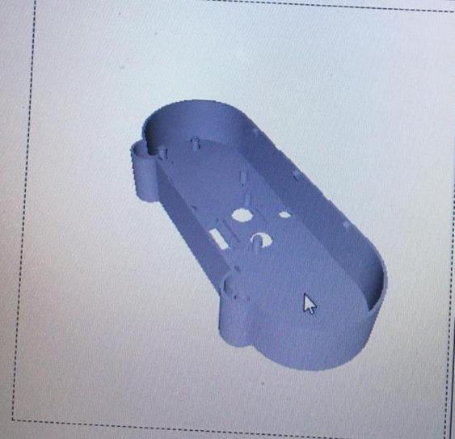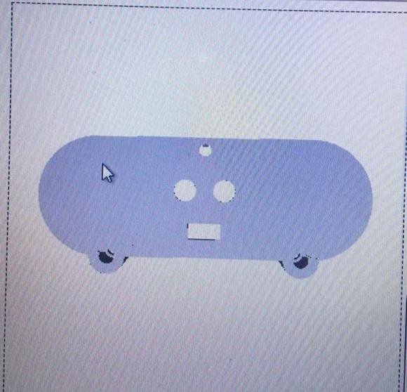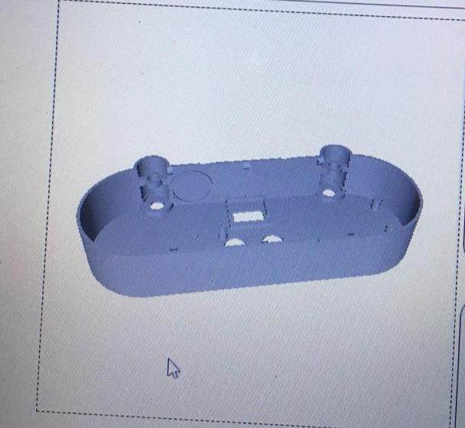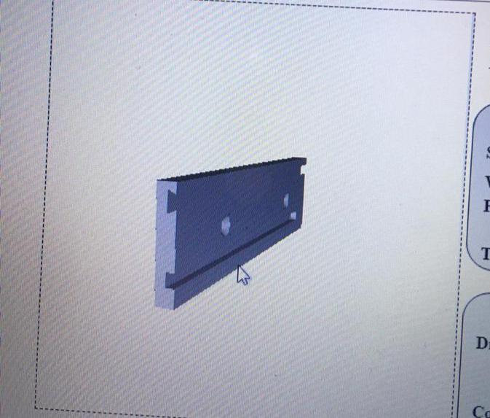

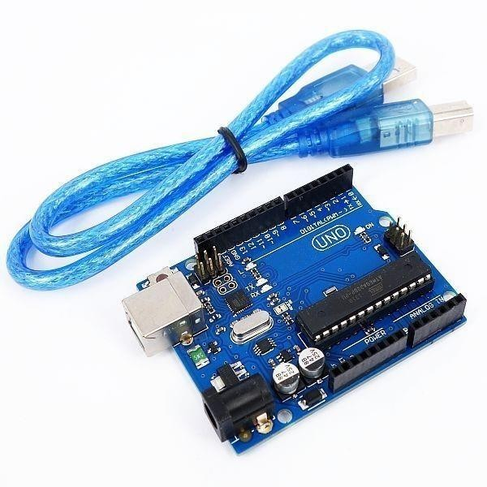

Figure 2.25: Arduino UNO board and its USB connection cable.

Arduino has it is own software and this software can be freely downloadable on the Arduinos own web side. This software of Arduino is very easy to use it does not requires too much configuration one you choose your dictionaries and wrote your code Arduino takes care of all other configuration settings and makes things much more easier. To installing code to Arduino is also very easy after code verified its complier than user just need to connect its cable to the PC than Arduino’s software finds its hardware and when user installs code to the hardware it is still easy to debug Arduino without using different hardware or software. If user defines serial communication with PC then user can check what Arduino does when it’s working. When software fist opened an empty space opening this pages name became today’s history and it called sketch_history and alphabetical count for number of new document. Arduinos option bar include five different menus these are file, edit, sketch, tools and help these menus help user to find user’s required applications. On the file menu examples are very tutoring for the beginners and they are also shows user how to use dictionaries on their applications. And second option bar includes verify, upload serial monitor, new, open, save functions. Figure 2.26 indicates an empty Arduino page on our computer.

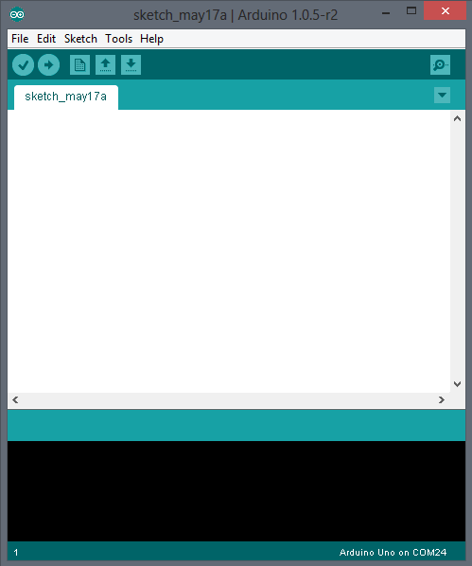

Figure 2.26 Arduino software an empty page screen shoot.

Arduino can be using with another hardware while installing and using its dictionary. In this project Arduino should control two different motor and to control these Adafruit motor shield has been used. This shield could control 4 different DC motor, 2 servo motor and 1 stepper motor. This shield provided 4H-Bridges on its L293D chipset and per bridge can stand and have self-shutdown opportunity for more than 0.6A or 1.2A peak. 4 directional DC motor have 8 bit speed control option this devices can stand hot and when something goes wrong they have protection diodes on their self. It also comes with its own dictionary to help users; users can directly write direction of rotation setting speed easily and manage motors torque. These shields also provide user to use six analog input pin of the Arduino so user could add another external hardware on his system. Figure 2.27 shows an Adafruit motor shield circuit.

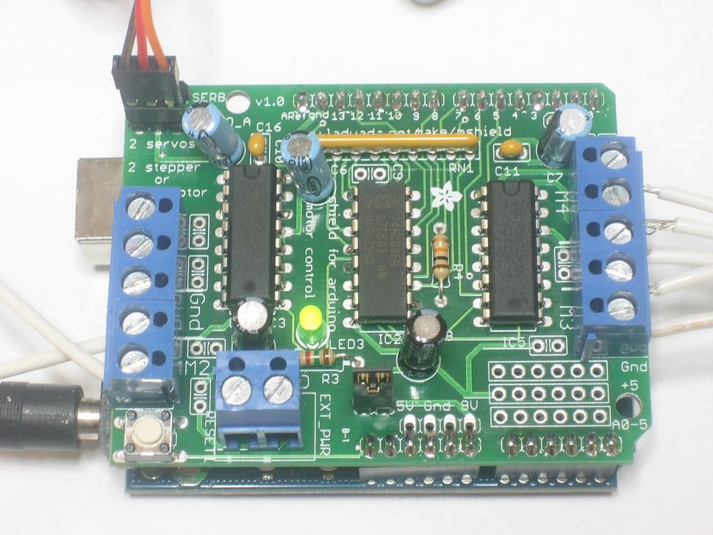

Figure 2.27: Adafruit’s motor shield circuit.

Bluetooth is one of the popular devices to communicate in short range it is using on computers, cell phones, head phones and many other devices. Bluetooth has been invented by Ericsson Company in the 1994. Bluetooth devices use 2.4 to 2.5 GHz frequency to communicate with each other’s. Bluetooth standardized as IEEE 802.15.1 but then it changed that 802.15.1 Bluetooth’s range is about 2400–2483.5 MHz approximately. Bluetooth devices generally use frequency-hopping spread spectrum communication technique to communicate each other. It can have approximately 40 channels and signals hops 1600 hop per second. Bluetooth devices firstly search each other once one find other it shows device to its user if user decides to communicate with device he paired those two devices and starts communication. Bluetooth has several versions such as Bluetooth 2.0, Bluetooth 2.1, Bluetooth 3.0 and Bluetooth 4.0 which is used today. Bluetooth is gained new technologies after first released some of them are Enhanced Data Rate (EDR), Alternate MAC/PHY, low energy protocols etc. has been added and used on the newer versions of Bluetooth devices. The protocols name can be varying in case of security, max speed, and bandwidth. Bluetooth’s data transfer rate is about 25mbps after new update 4.0 this data rate directly related on hopping frequency earlier versions old Bluetooth could hops 800 per

second. Connection with Bluetooth fairly easy as indicated before it is simply uses key matching process to connect each other and it requires and pair code between devices after it given devices connects each other. Security over Bluetooth is pretty good early versions of Bluetooth were encrypted to stop any attack coming from the outside and now they added key matching and pairing code. Bluetooth devices have a good search mechanism they can find other devices on the 30m range and they can connect with them. Bluetooth’s power requirement is very low but it is range is low and it is not so fast connection. Maximum range of Bluetooth is like 30m and it can connect with 7 different devices it is called piconet. Bluetooth can make slave and master connection with different devices on this network Master waits for its slaves when a slave connect its network and paired with it master send data to them and waits for answer, master also make those device synchronal and communicate between them. Figure 2.28 shows a Bluetooth slave and master connection.

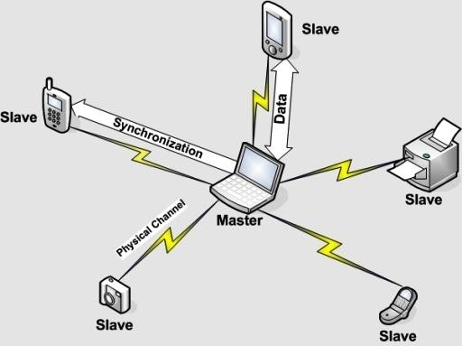

Figure 2.28: Bluetooth master and slave network.

## Technical Objectives

## Wireless Communication and Serial Communication with Computer

Peripheral Interface Controller (PIC) microprocessors are very common microprocessors. Their shape is different due to applications and version of them. PIC16F877A PIC pin diagrams can be seen in figure 2.30.

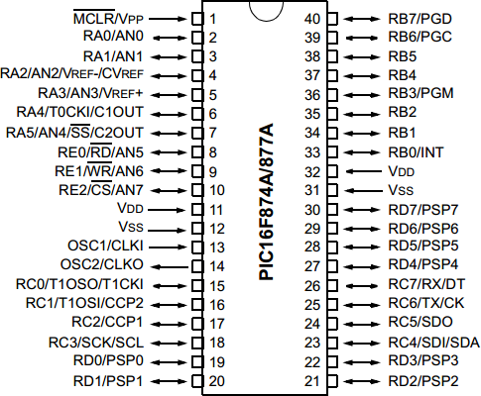

Figure 2.30: PIC16F877A PIC pin diagrams.

Due to programming this PIC microprocessor one of the best compiler is MicroC compiler developed by Microchip Company which also makes this PIC microprocessors. PIC microprocessors uses assembly and C programming languages but for programming them the easiest one C. C programing language is a basic level programming language founded for programming basic managing and controlling basic hardware. Screens shoot

## Computer to Microprocessor Connection Working Plan

We have found some Visual Studio protocols to connecting program to a different hardware via using USB and RS232 interfaces. We could use this interfaces with MAX232 component this component protect Microprocessor and converts computers signals to the understandable form for the microcontroller. Our computer does not have a RS232 port so we brought a USB to RS232 cable and another cable to make this male cable female because our cables should connect with RS232’s pins. We made a simulation to control if it is working and saw it is working finely and I implemented the circuit we designed.

After hardware we wrote a serial communication protocol on the visual studio program, the code simply used serial communication to connect microprocessor. program should send output numbers to MAX232 correctly.

## Wireless Communication Over Microprocessors Working Plan

We brought receiver and transmitter components to communicate MAX232 with microcontroller. We connected MAX232 with the transmitter and we connected receiver with the microcontroller. Duty was communicate between them but that does not worked. We tried oscilloscope to understand error but we could not successfully connect them yet.

But on the software level we planned a addressing and security protocol we add two numbers before main control number came, this two numbers were protecting any other connection to our circuit and also protect noises provided mistakes. It is also provide a good addressing option to send data right device.

## DC Motor Controlling Plan

We used motor controller component on this circuit. We used our microcontroller to control motor driver We choose a motor driver and programmed our microprocessor with it. We also added an H bridge to this motor driver circuit, this H bridge provides more control and also it protect our motor and motor controller components. We tried to control four dc motor but we controlled two of them other two directly connected to the other motors pins to do same rotation.

## Arduino and Adafruit Motor Controlling Plan

We brought an Arduino board and a motor controller board for four motor but we just used two motor. We downloaded Arduino’s program on the internet and made some exercises to learn it and we also installed and learned how to use motor controlling with looking its exercises and its forums. We have learned how to connect Arduino with our computer and how to install program inside it. We have learned how to control motor how many motor can we control which pins are never used and which are used. We learned how to supply Arduino without of connecting computer.

## Bluetooth Communication Plan

We fist decided to communicate over something more accurate than RF communication than we came up with Bluetooth idea. Bluetooth is a short range communication technology, it is very accurate and works with less problem than RF. We brought Bluetooth device we firstly working something more useful than serial communication but Arduino did not support it and we used serial communication. we used

serial communication dictionary for this work and defined two analog ports to transmitter and receiver. We read HC-06 Bluetooth device’s data sheet and decided to give 3.3V to input but that was absolutely mistake for a long time we could not communicated with Arduino. We tried different techniques to solve problems but after a while we solved the problem. The problem was voltage; it was not enough we had to use 5V to communicate with Arduino. After solved problem we finished android part of the project.

* 1. Speech Recognizing Program.
  2. Making Speech Recognition.
  3. Correcting Results.
  4. Car Word Filter.
  5. Computer to microprocessor communication.
  6. Making a fine Working Design
  7. Understanding of USART Interface.
  8. Connecting PIC to the computer.
  9. Implementing Visual Studio Codes for Sending Results.
  10. Implementing MAX232 circuit
  11. Connection PIC to Visual Studio
  12. Wireless Communication.
  13. Making Fine Working Design
  14. Programming PIC
  15. Fixing Wireless Circuit’s Problems.
  16. Choose right pin to get data.
  17. DC Motor Controlling.
  18. Building H Bridge.
  19. Finding enough space on the circuit board
  20. Implementation motor control circuit
  21. Integrating Motor Circuits with Receiver Circuit.
  22. Arduino and Adafruit Car Circuit.
  23. Learning motor controlling with Adafruit motor controller shield.
  24. Learning Adafruit motor controller shield dictionary.
  25. Implementation Arduino circuit
  26. Bluetooth Communication.
  27. Learning HC-06 Bluetooth devices properties.
  28. Defining serial communication with HC-06 Bluetooth devices on Arduino.
  29. Sending data to C-06 Bluetooth device.
  30. Get data from computer

## Related Work

It work on the basic principal of IOT, it is the powerful product which is combination of two powerful technology Android and IOT.

* Arduino:

It control all the module, which all the program in it

* Android Application:

Which allow to communicate with the system

* Bluetooth Module:

Bluetooth hc05, allow to connect with the system and transfer the data from phone to system.

* Latch:

It carry 3 sub part 1. Electromagnet 2. Screw 3.Protection

* automatic opening/close mechanism:

open door automatic and even close it without user touch the door so that we can prevent form virus to spread.

The ssaa is the only system which can be use in anywhere, here we have the 3 main scenario :

**At the main door :** it can be use in the main door of the hotel, hospital, factory and other public places, here we can use the two feature like

scheduling: we set the schedule like our office open from 9-5 so we can schedule it form 9am - 5pm and befor and after from this time slote the door will not be able to use, one can only use it after conntecting it with the application, in between this time, it can be use by the gernal public without the appliction, but they have to follow the sanitaizer procdure

and turring onn and off, or he can turrn manually onn and off the system, like the onwer can turn it in the mornning at 9am and off it manually at 5pm.

**At the hotel room :** it system also be use in the hotel room or in any of your personal room to make it more secure and covid free, here the user can use the key feature like key sharing, changing of key, and hotel own can schedule the validaty of the key accordingly the room book by the user.

**At home :** here we use all the feature that we have discuss above.

100 : Android application (App) : **It is the appliction which is use for communicating from the door lock system, it is the only way of communication from the door lock system, communication like - turring onn and off the system, exchanging key, setting the configration, and change of the key.**

101 : Door lock system The android application can be connect with the lock system using Bluetooth connection and can be use as, to operate the system like turning on and off, key sharing, scheduling and lots more feature as we discussed above.

102 : a ultrasonic sensor : **which is used for the sensing the person, if he/she come near to door that means he/she want to access the door, and the following producer will follow.**

104 : a temperature sensor : **is used to check the temperature of the person,**

(105)(106): Led bulbs : **use for indicating the following- green it is ready to use, red alert for high temperature or the system is off**

107 : a Sanitizer block(107) : **here we are using the concepts of induction to convert the liqued sanitaizer into the fog, to sanitize the person without making him/her unconfortable. and by using the fog we can sanitaiz him/her full body, very eassly and fast.**

108 : a lock latch : **it is the block of mattel which is used of lock and unlocking the door, if the latch is comptelety inside the system that means the door is open and if the lactch is in between the door and the system that means the door is lock.**

109 : a automatic opening/close mechanism: **it is the mechanism of gare and pully which allow us the automatic open and close of the door without touch by the person. it can be fited in any commanly used door in our home, hospital and other places**

Main electronic components use are Arduino UNO, DC-Motor Bridge, dc motor, Bluetooth device.

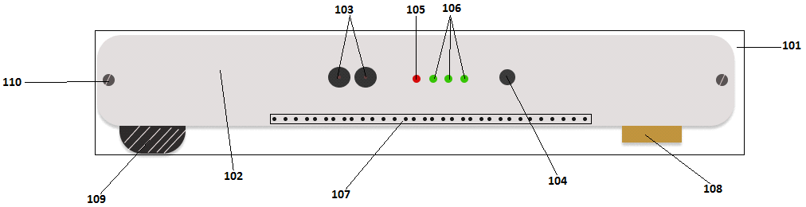

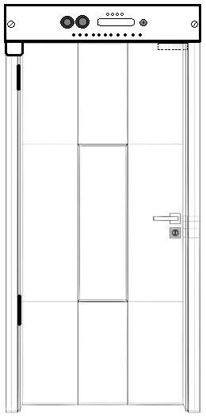

**Circuit Digram :**

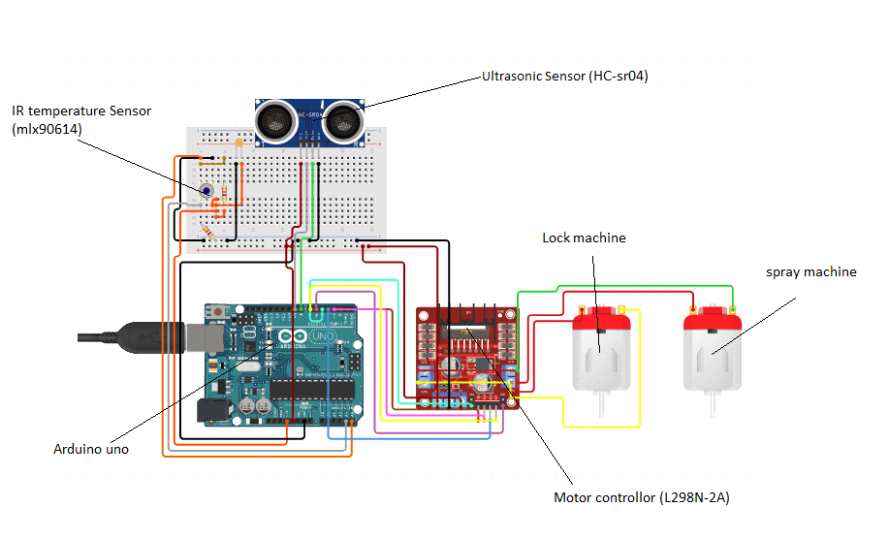

**Unique Points :**

* **It is the first covid-19 compatible door lock**
* **Multi-key feature:** one can create, change, and share there key with any one they like.
* **Full body sanitization:** In the other sanitizer system they use sanitizer sprinkler which maken the user wet and uncomfortable, and it sanitise only in limited area. So we are using a fog sanitization, In which it spread in all the body without making them uncomfortable.
* **Automatic opening and closing:** It also provide automatic opening and closing mechanism, Which also helps in preventing from corona virus
* **Time scheduling:** User can also set the temporary key for other users like (friends, family, servant and any other source) he/she can set the time period also for the key.
* **Can be use as domestic and commercial purpose:** It can be use in our home, hospital, hotels, and any other public place.
* **It can be easily installed and configured:** It is very easy to use, You just have to install it in the door and connect it to the phone using our application, and you are good to go
* **User-friendly:** It is use user friendly, because of the above points
* **No battery is use:** In the other IOT door lock they use battery, Which set some limitation to the system, but here we are using it with the direct power supply. and also providing some battery for the back-up.
* **Fully key less:** It is fully key less, One should not have to carry, and now there do not have to worry about the key losing or duplication or exchanging of the key, now they can do it very easily using the multi-key feature.
* **Compatible with any door:** it can be easily installed in any door used in our house, hotels and hospitals. We just have to attached it in the upper side of the door-frame using the nail holes(110), and open/close machine properly goes inside the door.

# FACALITES AND EQUIPMENT

Computer programs;

Microsoft Visual Studio, MicroC for PIC, MicroProg Suite,

PROTEUS for circuit design and simulation, Office programs for reporting and documentations, BlueSoleil Bluetooth communication program, Arduino software to programming Arduino,

USB to RS232 cable drivers to open new COM port, Bluetooth drivers to open seven new COM port, USBburn111a5 to send codes to microcontroller, winPICPgm to PIC debugger,

Microsoft windows 8 for speech recognition engine,

Hardware;

Computer,

Microphone for taking input speech, Bluetooth device for PC,

Bluetooth device for Arduino, Arduino UNO,

Adafruit motor controller shield, USB to RS232 cable,

RS232 male to RS232 female cable; PIC microprocessor 16F877A, Transmitter 433MHz,

Receiver 433MHz, 2xAntenna, 2xBreadboards,

Multimeter,

Batteries, 6xDC Motor,

Motor shield Adafruit, Oscilloscope,

3x 7805 regulator,

8x diode for H bridge, Punched board.

Components;

This part depend design of the wireless devices.

Resistors, Capacitors, Cables, Diodes,

And other components.

# REFERENCES

1. “Understanding How Voice is Produced” internet: <http://www.voiceproblem.org/anatomy/understanding.php>Dec. 19, 2013.
2. Dr. Joseph Picone, (1999, MAY, 15-17). Fundamentals of speech recognition: a short course. (1nd edition). [Online]. Available: <http://speech.tifr.res.in/tutorials/fundamentalOfASR_picone96.pdf>[OCTOBER 28, 2013]
3. B. York. ECE 2C Lab “Microphone Circuit” Department of Electrical and Computer Engineering. University of California, Santa Barbara. UC Santa Barbara, Santa Barbara. 2007.
4. Lawrence Rabier, Biing-Hwang Juang.(1993). Fundamentals of speech recognition. (1nd edition).[ On-line ] Available: [http://www.cin.ufpe.br/~lheva/voz,%20video%20e%20pds/Rabiner%20&%20Juang%20-](http://www.cin.ufpe.br/~lheva/voz%2C%20video%20e%20pds/Rabiner%20%26%20Juang%20-%20Fundamentals%20of%20Speech%20Recognition.pdf)

[%20Fundamentals%20of%20Speech%20Recognition.pdf](http://www.cin.ufpe.br/~lheva/voz%2C%20video%20e%20pds/Rabiner%20%26%20Juang%20-%20Fundamentals%20of%20Speech%20Recognition.pdf) [OCTOBER 28, 2013]

1. Kim Xu. Speech Detection in Noisy Environments. Internet: [http://www.cc.gatech.edu/~kweaver3/projects/MSU/csann.html,](http://www.cc.gatech.edu/~kweaver3/projects/MSU/csann.html) [ Nov. 6, 2013]
2. Cecilia CARUNCHO LLAGUNO (April 2008). cepstral analysis synthesis on the mel frequency scale, and an adaptative algorithm for it. 1(1), pp. 1-6. Available: [http://www2.spsc.tugraz.at/www-archive/AdvancedSignalProcessing/SS08- SpeechSynthesis/cepstral_analysis.pdf](http://www2.spsc.tugraz.at/www-archive/AdvancedSignalProcessing/SS08-SpeechSynthesis/cepstral_analysis.pdf) [Nov. 7,2013]
3. D.L. Barron, W.C. Yip. “Speech recognition using polynomial expansion and hidden markov model”. U.S. Patent 6,928,409 B2 , Aug 9, 2005.
4. Ibrahim Patel, Dr. Y. Srinivas Rao. 2010 December. speech recognition using hmm with MFCC- an analysis using frequency specral decomposion technique. [On-line]. Vol.1, No.2, pp 1- 10 Available: <http://airccse.org/journal/sipij/papers/1210sipij09.pdf> [Nov. 5, 2013]
5. Chadawan Ittichaichareon, Siwat Suksri and Thaweesak Yingthawornsuk. nternational Conference on Computer Graphics, Simulation and Modeling (ICGSM'2012), Pattaya (Thailand ), 2012.
6. D.Yu, L. Deng, J.Droppo, J.Wu, Y. Gong, A Acero. “A MINIMUM-MEAN- SQUARE-ERROR NOISE REDUCTION ALGORITHM ON MELFREQUENCY CEPSTRA FOR ROBUST SPEECH RECOGNITION”. Microsoft Corporation, One Microsoft Way, Redmond, WA 98052. Internet:

<http://research.microsoft.com/pubs/78296/2008-dongyu-icassp.pdf>

1. D.Yu, L. Deng, J.Droppo, M.Seltzer, G. Zweig. “Acoustic Modeling”. Microsoft Corporation, One Microsoft Way, Redmond, WA 98052. Internet: <http://research.microsoft.com/en-us/projects/acoustic-modeling/>
2. M. Michihara.(2013,Dec). “Microprocessors: The Silicon Revolution”. Volume XIV Issue III. [On-line] Available: [https://illumin.usc.edu/printer/123/microprocessors-the- silicon-revolution/](https://illumin.usc.edu/printer/123/microprocessors-the-silicon-revolution/)
3. Gary H. Bernstein, B.S.E.E., M.S.E.E., Ph.D. "Microprocessor,". Microsoft Corporation, One Microsoft Way, Redmond, WA 98052. Internet: [http://autocww.colorado.edu/~toldy2/E64ContentFiles/ComputersElectronics/Microproces sor.html](http://autocww.colorado.edu/~toldy2/E64ContentFiles/ComputersElectronics/Microprocessor.html)
4. Elizabeth Flock. “Alexander Graham Bell sketches his electrical speech machine”. Internet: [http://www.washingtonpost.com/blogs/blogpost/post/alexander-graham-bell- sketches-his-electrical-speech-machine-photos/2011/05/20/AFo0qn7G_blog.html](http://www.washingtonpost.com/blogs/blogpost/post/alexander-graham-bell-sketches-his-electrical-speech-machine-photos/2011/05/20/AFo0qn7G_blog.html) , June. 20, 2011 [Nov. 5, 2013]
5. P. Yue. L. Sun. UCSB ECE 219 “Modulation, Transmitters and Receivers”. High-Speed Silicon Lab (HS2L). Harald Frank Hall 4162. 2013 available: <http://www.ece.ucsb.edu/yuegroup/Teaching/ECE594BB/Lectures/steer_rf_chapter1.pdf>
6. J. Wolfe. 2011 Oct- Mar “Electric motors and generators” University of New South Wales or of the School of Physics. 61-2-9385 4954. Avaliable: [http://www.animations.physics.unsw.edu.au//jw/electricmotors.html#DCmotors](http://www.animations.physics.unsw.edu.au/jw/electricmotors.html#DCmotors)
7. M. Ilyas. “Visual Studio 2005 Window Application Project”. Internet: [http://myprogrammingzone.blogspot.com/2012/09/visual-studio-2005-window- application.html#.Ur6ea9JjdWY](http://myprogrammingzone.blogspot.com/2012/09/visual-studio-2005-window-application.html#.Ur6ea9JjdWY) Sep. 2012. [Sep. 8, 2013].
8. Microchip. “28/40/44-Pin Enhanced Flash Microcontrollers”. PIC16F87XA Data Sheet, Jul. 2003.

[19]H. Şahin, A.Dayanık, C.Altınbaşak. PIC PROGRAMLAMA TEKNİKLERİ ve PIC16F877A. İstanbul, Maltepe: Altaş yayıncılık ve Elektronik Tic. Ltd. Şti. 2010, pp. 1- 547.