Q1. Basic Filtering – High-Value Products
Find all event records where the base_price is greater than 1,000.
Display:
- event_id
- store_id
- product_code
- base_price
- promo_type
Concepts:
SELECT, WHERE, comparison operators.
Ans 1 –
SELECT f.event_id,f.store_id,f.product_code,f.base_price,f.promo_type
FROM retail_events_db.fact_events as f
WHERE f.base_price>1000;
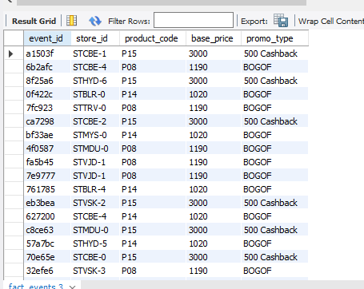
------------------------------------------------------------------------------------------------------
Q2. Sorting Promotional Events
Display all events where quantity sold after the promotion was greater than 100.
Display:
- event_id
- product_code
- promo_type
- quantity_sold(before_promo)
- quantity_sold(after_promo)
Sort by quantity_sold(after_promo) in descending order.
Concepts:
WHERE, ORDER BY, DESC.
Ans 2 –
SELECT event_id,product_code,promo_type,`quantity_sold(before_promo)`,`quantity_sold(after_promo)`
FROM retail_events_db.fact_events
ORDER BY `quantity_sold(after_promo)` DESC
WHERE quantity_sold(after_promo) > 100;
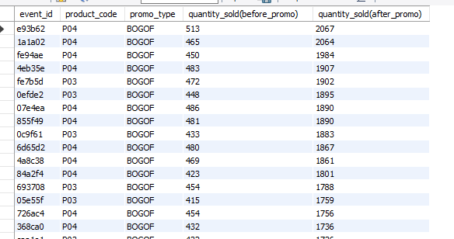

---------------------------------------------------------------------------------------------------------
Q3. DISTINCT Promotion Types
Find all unique promotion types used in the dataset.
Display only the unique promo_type values.
Concepts: DISTINCT.
Ans 3 –
SELECT DISTINCT promo_type
FROM retail_events_db.fact_events;
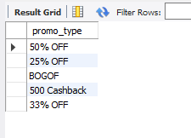
--------------------------------------------------------------------------------------------------------
Q4. Basic Aggregation
Calculate the following for the complete fact_events table:
- Total number of events
- Total quantity sold before promotion
- Total quantity sold after promotion
- Average base price
- Maximum base price
- Minimum base price
Return all metrics in one row.

Concepts:
COUNT, SUM, AVG, MAX, MIN.
Ans 4 –
SELECT COUNT(event_id),SUM(`quantity_sold(before_promo)`),SUM(`quantity_sold(after_promo)`),
AVG(base_price),MAX(base_price),MIN(base_price)
FROM retail_events_db.fact_events;

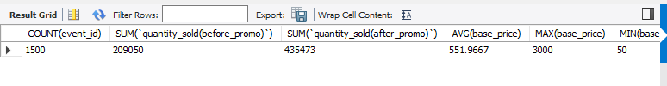
---------------------------------------------------------------------------------------------
Q5. Sales Volume by Promotion Type
For each promo_type, calculate:
- Number of events
- Total quantity sold before promotion
- Total quantity sold after promotion
Sort by total quantity sold after promotion in descending order.
Ans 5 –
SELECT promo_type,COUNT(event_id),
SUM(`quantity_sold(before_promo)`),
SUM(`quantity_sold(after_promo)`)
FROM retail_events_db.fact_events
GROUP BY promo_type
ORDER BY SUM(`quantity_sold(after_promo)`) DESC;
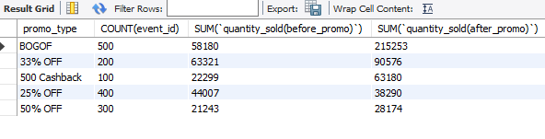
------------------------------------------------------------------------------
Q6. Promotion Uplift
For every promotion type, calculate:
- Total quantity before promotion
- Total quantity after promotion
- Quantity increase/decrease
Use: Quantity Change = After Promo Quantity - Before Promo Quantity
Display:
- promo_type
- total_before
- total_after
- quantity_change
Sort by quantity_change descending.
Ans 6 –
SELECT promo_type,
SUM(`quantity_sold(before_promo)`) as total_before,
SUM(`quantity_sold(after_promo)`) as total_after,
SUM(`quantity_sold(after_promo)`)-SUM(`quantity_sold(before_promo)`) AS Quantity_Change
FROM retail_events_db.fact_events
GROUP BY promo_type
ORDER BY Quantity_Change DESC;
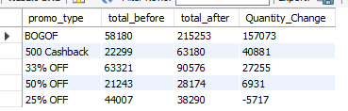
--------------------------------------------------------------------
Q7. Product Performance
Using fact_events and dim_products, calculate total quantity sold after promotion for every product.
Display:
- product_code
- product_name
- category
- total quantity after promotion
Sort by total quantity after promotion descending.
Ans 7 –
SELECT d.product_code,d.product_name,d.category,SUM(f.`quantity_sold(after_promo)`) AS total_quantity_after_promotion
FROM retail_events_db.fact_events as f
JOIN retail_events_db.dim_products as d
ON f.product_code=d.product_code
GROUP BY d.product_code,d.product_name,d.category
ORDER BY total_quantity_after_promotion DESC;
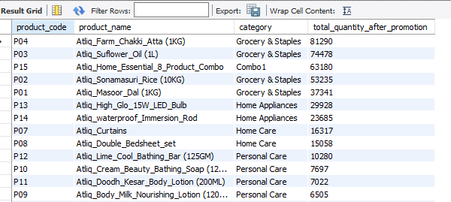
--------------------------------------------------------------------------------
Q8. Category-Level Performance
Using fact_events and dim_products, calculate for every product category:
- Number of events
- Total quantity before promotion
- Total quantity after promotion
- Quantity change
Sort categories by total quantity after promotion descending.
Ans 8 –
SELECT d.category,COUNT(event_id),SUM(`quantity_sold(before_promo)`) as total_quantity_before_promotion
,SUM(`quantity_sold(after_promo)`) as total_quantity_after_promotion,
(SUM(`quantity_sold(after_promo)`)-SUM(`quantity_sold(before_promo)`)) as quantity_change
FROM retail_events_db.fact_events as f
JOIN retail_events_db.dim_products as d
ON f.product_code=d.product_code
GROUP BY d.category
ORDER BY total_quantity_after_promotion DESC;
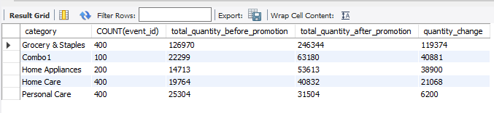
-----------------------------------------------------------------------------------
Q9. Store Performance
Using fact_events and dim_stores, calculate for every city:
- Number of promotional events
- Total quantity before promotion
- Total quantity after promotion
Display:
- city
- event_count
- total_before
- total_after
Sort cities by total_after descending.
Ans 9 –
SELECT d.city,COUNT(f.event_id) as event_count,
SUM(f.`quantity_sold(before_promo)`) as total_before,
SUM(f.`quantity_sold(after_promo)`) as total_after
FROM retail_events_db.fact_events as f
LEFT JOIN retail_events_db.dim_stores as d
ON f.store_id=d.store_id
GROUP BY d.city
ORDER BY total_after DESC;
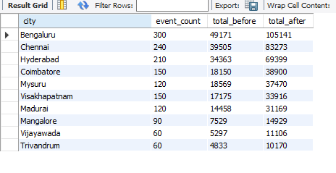
_-------------------------------________-------------------------------------------------
Q10. Campaign Performance
Using fact_events and dim_campaigns, calculate for each campaign:
- Campaign name
- Start date
- End date
- Number of events
- Total quantity before promotion
- Total quantity after promotion
Sort by total quantity after promotion descending.
Ans 10 –
SELECT d.campaign_name,d.start_date,d.end_date,COUNT(f.event_id),
SUM(f.`quantity_sold(before_promo)`) as total_quantity_before_promotion,
SUM(f.`quantity_sold(after_promo)`) as total_quantity_after_promotion
FROM retail_events_db.fact_events as f
LEFT JOIN retail_events_db.dim_campaigns as d
ON f.campaign_id=d.campaign_id
GROUP BY d.campaign_name,d.start_date,d.end_date
ORDER BY total_quantity_after_promotion DESC;
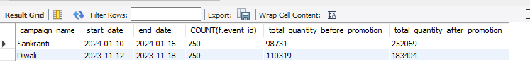

----------------------------------------------xx-------------------------------------xx-----------------
Q11. Product Category with HAVING
Find product categories where the total quantity sold after promotion is greater than 1,000.
Display:
- category
- total quantity after promotion
- average base price
Sort by total quantity after promotion descending.
Ans 11 –
SELECT d.category,
SUM(f.`quantity_sold(after_promo)`) as total_quantity_after_promotion
,AVG(f.base_price) as average_base_price
FROM retail_events_db.fact_events as f
LEFT JOIN retail_events_db.dim_products as d
ON d.product_code=f.product_code
GROUP BY d.category
HAVING total_quantity_after_promotion>1000
ORDER BY total_quantity_after_promotion DESC;
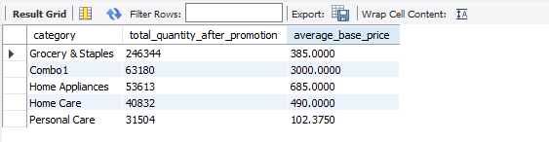
----------------------------------------XX--------------------------------------------------------------
Q12. Store + Category Analysis
Using fact_events, dim_stores and dim_products, calculate total quantity sold after promotion for every combination of:
- City
- Product category
Display:
- city
- category
- total quantity after promotion
Sort first by city and then by total quantity descending.
Ans 12 –

SELECT d.city,p.category,SUM(f.`quantity_sold(after_promo)`) as total_quantity_after_promotion
FROM retail_events_db.fact_events as f
LEFT JOIN retail_events_db.dim_stores as d
ON f.store_id=d.store_id
LEFT JOIN retail_events_db.dim_products as p
ON f.product_code=p.product_code
GROUP BY d.city,p.category
ORDER BY d.city,total_quantity_after_promotion DESC;

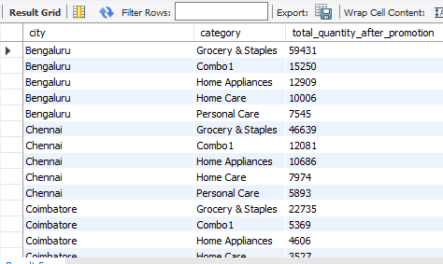
-------------------------xxx----------------------------xxxx----------------------------------------------xxx----------
Q13. Promotion Effectiveness by Product
For each product, calculate:
- Product name
- Category
- Total quantity before promotion
- Total quantity after promotion
- Quantity change
- Percentage change
Use:
Percentage Change = ((After Promo - Before Promo) / Before Promo) * 100
Handle division by zero appropriately.
Sort by percentage change descending.
Ans 13 –
SELECT d.product_name,d.category,
SUM(f.`quantity_sold(before_promo)`) as total_quantity_before_promotion,
SUM(f.`quantity_sold(after_promo)`) as total_quantity_after_promotion,
(SUM(f.`quantity_sold(after_promo)`)-SUM(f.`quantity_sold(before_promo)`)) as quantity_change,
(((SUM(f.`quantity_sold(after_promo)`)-SUM(f.`quantity_sold(before_promo)`))/NULLIF(SUM(f.`quantity_sold(before_promo)`),0))*100.0) as percentage_change
FROM retail_events_db.fact_events as f
LEFT JOIN retail_events_db.dim_products as d
ON d.product_code=f.product_code
GROUP BY d.product_name,d.category
ORDER BY percentage_change DESC;
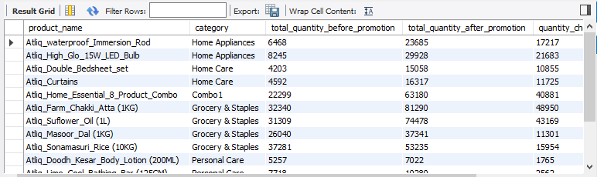
--------------------------XX----------------------XX-------------------------------XX----------
Q14. Campaign and Promotion Type Analysis
For each campaign and promo_type combination, calculate:
- Number of events
- Total quantity before promotion
- Total quantity after promotion
- Quantity change
Display:
- campaign_name
- promo_type
- event_count
- total_before
- total_after
- quantity_change
Sort by campaign_name and quantity_change descending.

Ans 14 –
SELECT d.campaign_name as campaign_name,
f.promo_type as promo_type,
COUNT(f.event_id) as event_count,
SUM(f.`quantity_sold(before_promo)`) as total_quantity_before_promotion,
SUM(f.`quantity_sold(after_promo)`) as total_quantity_after_promotion,
SUM(f.`quantity_sold(after_promo)`)-SUM(f.`quantity_sold(before_promo)`) as quantity_change
FROM retail_events_db.fact_events as f
LEFT JOIN retail_events_db.dim_campaigns as d
ON d.campaign_id=f.campaign_id
GROUP BY d.campaign_name,f.promo_type
ORDER BY d.campaign_name,quantity_change DESC;

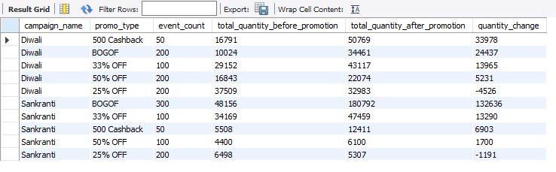
------------------------------------xxx-----------------------------------------------xxxx-----------------------------------xxx----------
Q15. Product Revenue Before and After Promotion
For each product, calculate:
1. Revenue before promotion =
base_price × quantity_sold(before_promo)
2. Revenue after promotion =
base_price × quantity_sold(after_promo)
3. Revenue difference =
Revenue after - Revenue before
Display:
- product_name ,- category ,- revenue_before,- revenue_after ,- revenue_difference
Sort by revenue_difference descending.

Ans 15 –
SELECT d.product_name,d.category,
SUM(f.`quantity_sold(before_promo)`*f.base_price) as revenue_before,
SUM(f.`quantity_sold(after_promo)`*f.base_price) as revenue_after,
(SUM(f.`quantity_sold(after_promo)`)*f.base_price -SUM(f.`quantity_sold(before_promo)`)*f.base_price) as revenue_difference
FROM retail_events_db.fact_events as f
LEFT JOIN retail_events_db.dim_products as d
ON d.product_code=f.product_code
GROUP BY d.product_name,d.category,f.base_price
ORDER BY revenue_difference DESC;

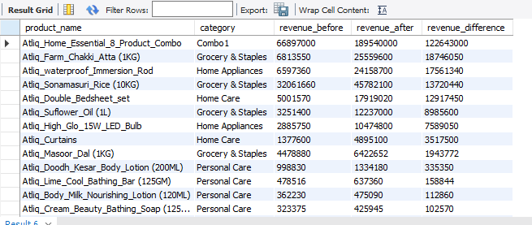
----------------------xxx---------------------------xxx---------------------------------xxx------------------------------
Q 16.
Classify Promotion Performance
For every promotion type, calculate total quantity before and after promotion.
Then classify the promotion using CASE:
- Percentage change >= 50% → "High Impact"
- Percentage change >= 20% → "Medium Impact"
- Percentage change < 20% → "Low Impact"
Display:
- promo_type
- total_before
- total_after
- percentage_change
- performance_category
Sort by percentage_change descending.
Ans 16 –
SELECT fe.promo_type,
SUM(fe.`quantity_sold(before_promo)`) as total_before,
SUM(fe.`quantity_sold(after_promo)`) as total_after,
((SUM(fe.`quantity_sold(after_promo)`)-SUM(fe.`quantity_sold(before_promo)`))/(NULLIF(SUM(fe.`quantity_sold(before_promo)`),0)))*100.0 as percentage_change,
(CASE
WHEN ((SUM(fe.`quantity_sold(after_promo)`)-SUM(fe.`quantity_sold(before_promo)`))/(NULLIF(SUM(fe.`quantity_sold(before_promo)`),0)))*100.0 >= 50.00 THEN 'High Impact'
WHEN ((SUM(fe.`quantity_sold(after_promo)`)-SUM(fe.`quantity_sold(before_promo)`))/(NULLIF(SUM(fe.`quantity_sold(before_promo)`),0)))*100.0 >= 20.00 THEN 'Medium Impact'
ELSE 'Low Impact'
END) as performance_category
FROM retail_events_db.fact_events as fe
LEFT JOIN retail_events_db.dim_products as dp
ON fe.product_code=dp.product_code
GROUP BY fe.promo_type;
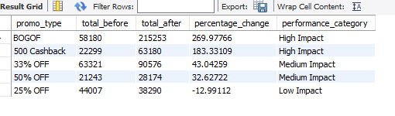
------------------------xxx-----------------------------------------xxx-----------------------------------------------xxx-----
Q 17. Top Products Within Each Category
Using a CTE:
1. Calculate total quantity sold after promotion for every product.
2. Rank products within each category based on total quantity sold after promotion.
3. Return only the top 2 products from every category.
Display:
- category
- product_name
- total_quantity_after
- category_rank
Ans 17 –
WITH table1 as (SELECT dp.category, dp.product_name,
SUM(fe.`quantity_sold(after_promo)`) as total_quantity_after,
ROW_NUMBER() OVER( PARTITION BY dp.category ORDER BY SUM(fe.`quantity_sold(after_promo)`) DESC) as city_rank
FROM retail_events_db.fact_events as fe
LEFT JOIN retail_events_db.dim_products as dp
ON fe.product_code=dp.product_code
GROUP BY dp.category,dp.product_name)
SELECT *
FROM table1
WHERE city_rank<=2;

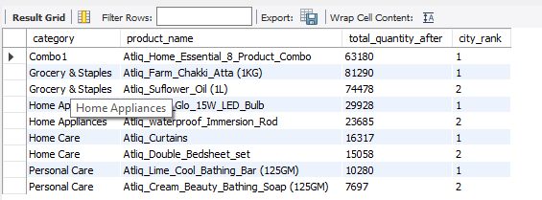
-------------------------xx----------------------------------------xx---------------------------------------------------
Q18 . Best-Performing Stores Within Each City
Calculate total quantity sold after promotion for each store.

Join dim_stores to obtain the city.
Then rank stores within each city based on total quantity sold after promotion.
Return the top 2 stores from each city.
Display:
- city
- store_id
- total_quantity_after
- city_rank
Ans 18 –
WITH table1 as (SELECT ds.city,ds.store_id,SUM(fe.`quantity_sold(after_promo)`) as total_quantity_after,
DENSE_RANK() OVER( PARTITION BY ds.city ORDER BY SUM(fe.`quantity_sold(after_promo)`) DESC) as city_rank
FROM retail_events_db.fact_events as fe
LEFT JOIN retail_events_db.dim_stores as ds
ON fe.store_id=ds.store_id
GROUP BY ds.city,ds.store_id)
SELECT *
FROM table1
WHERE city_rank<=2;

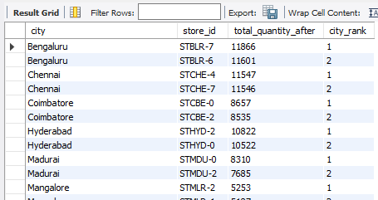
------------------------------xx-------------------------------xxx--------------------------------------xx---------------------------------
Q19. Campaign-Level Product Performance
For every campaign and product:
Calculate:
- Total quantity before promotion
- Total quantity after promotion
- Quantity change
- Percentage change
Then rank products within each campaign based on percentage change.
Return the top 3 products for every campaign.
Display:
- campaign_name
- product_name
- total_before
- total_after
- quantity_change
- percentage_change
- campaign_rank
Ans 19 –
WITH table1 as (SELECT dc.campaign_name,
dp.product_name,
SUM(fe.`quantity_sold(before_promo)`) as total_before,
SUM(fe.`quantity_sold(after_promo)`) as total_after,
(SUM(fe.`quantity_sold(after_promo)`)-SUM(fe.`quantity_sold(before_promo)`)) as quantity_change,
(SUM(fe.`quantity_sold(after_promo)`)-SUM(fe.`quantity_sold(before_promo)`))/NULLIF(SUM(fe.`quantity_sold(before_promo)`),0)*100.0 as percentage_change,
ROW_NUMBER() OVER(PARTITION BY dc.campaign_name ORDER BY (SUM(fe.`quantity_sold(after_promo)`)-SUM(fe.`quantity_sold(before_promo)`))/NULLIF(SUM(fe.`quantity_sold(before_promo)`),0)*100.0 DESC) as ranking
FROM retail_events_db.fact_events as fe
LEFT JOIN retail_events_db.dim_products as dp
ON fe.product_code=dp.product_code
LEFT JOIN retail_events_db.dim_campaigns as dc
ON fe.campaign_id=dc.campaign_id
GROUP BY dc.campaign_name,dp.product_name)
SELECT *
FROM table1
WHERE ranking<=3;
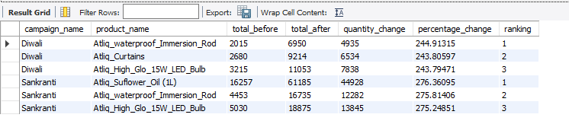
-----------------------xx----------------------------xx-------------------------xx----------------------------xx------------------------
Q20. Complete Promotional Performance Analysis
Create a complete analytical report at the product-category level.
For every product, calculate:
- Product name
- Category
- Number of promotional events
- Total quantity before promotion
- Total quantity after promotion
- Quantity change
- Percentage change
- Revenue before promotion
- Revenue after promotion
- Revenue change
- Average base price
- Product rank within its category
Use:
Quantity Change =Total After - Total Before
Percentage Change =((Total After - Total Before) / Total Before) * 100
Revenue Before =SUM(base_price × quantity_before)
Revenue After =SUM(base_price × quantity_after)
Revenue Change =Revenue After - Revenue Before
Then:
1. Rank products within each category by Revenue Change.
2. Return only the top 2 products from each category.
3. Use appropriate handling for division by zero.
Ans 20 –
WITH table_1 as (SELECT dp.product_name,dp.category,
COUNT(fe.event_id) as number_of_promotional_events,
SUM(fe.`quantity_sold(before_promo)`) as total_quantity_before_promotion,
SUM(fe.`quantity_sold(after_promo)`) as total_quantity_after_promotion,
(SUM(fe.`quantity_sold(after_promo)`)-SUM(fe.`quantity_sold(before_promo)`)) as quantity_change,
((SUM(fe.`quantity_sold(after_promo)`)-SUM(fe.`quantity_sold(before_promo)`))/NULLIF(SUM(fe.`quantity_sold(before_promo)`),0)*100.0) as percentage_change,
SUM(fe.base_price*fe.`quantity_sold(before_promo)`) as revenue_before_promotion,
SUM(fe.base_price*fe.`quantity_sold(after_promo)`) as revenue_after_promotion,
(SUM(fe.base_price*fe.`quantity_sold(after_promo)`)-SUM(fe.base_price*fe.`quantity_sold(before_promo)`)) as revenue_change,
AVG(fe.base_price) as average_base_price,
RANK() OVER( PARTITION BY dp.category ORDER BY (SUM(fe.base_price*fe.`quantity_sold(after_promo)`)-SUM(fe.base_price*fe.`quantity_sold(before_promo)`)) DESC ) as product_rank_within_its_category
FROM retail_events_db.fact_events as fe
LEFT JOIN retail_events_db.dim_products as dp
ON fe.product_code=dp.product_code
LEFT JOIN retail_events_db.dim_campaigns as dc
ON fe.campaign_id=dc.campaign_id
GROUP BY dp.product_name,dp.category)
SELECT *
FROM table_1
WHERE product_rank_within_its_category <=2;

