BUILD 2 · WEEK 6 · TEAM PLAYBOOK
How does Build 2 work?
One client, one decision, four documents, and the rules that let a team of four work without stepping on each other.
Read the Client Brief first. Fill in the Templates pack. Everything here also sits in your starter repository under docs/.

How does the week run, and what do we open when?
Build 2, Week 6. Your team is a revenue-science squad at RateGain, and a two-hotel group in Portugal has asked you one question, in BRIEF.md. Everything your team builds, decides and records lives in this repository. The last commit before Friday's deadline is the one that is graded.
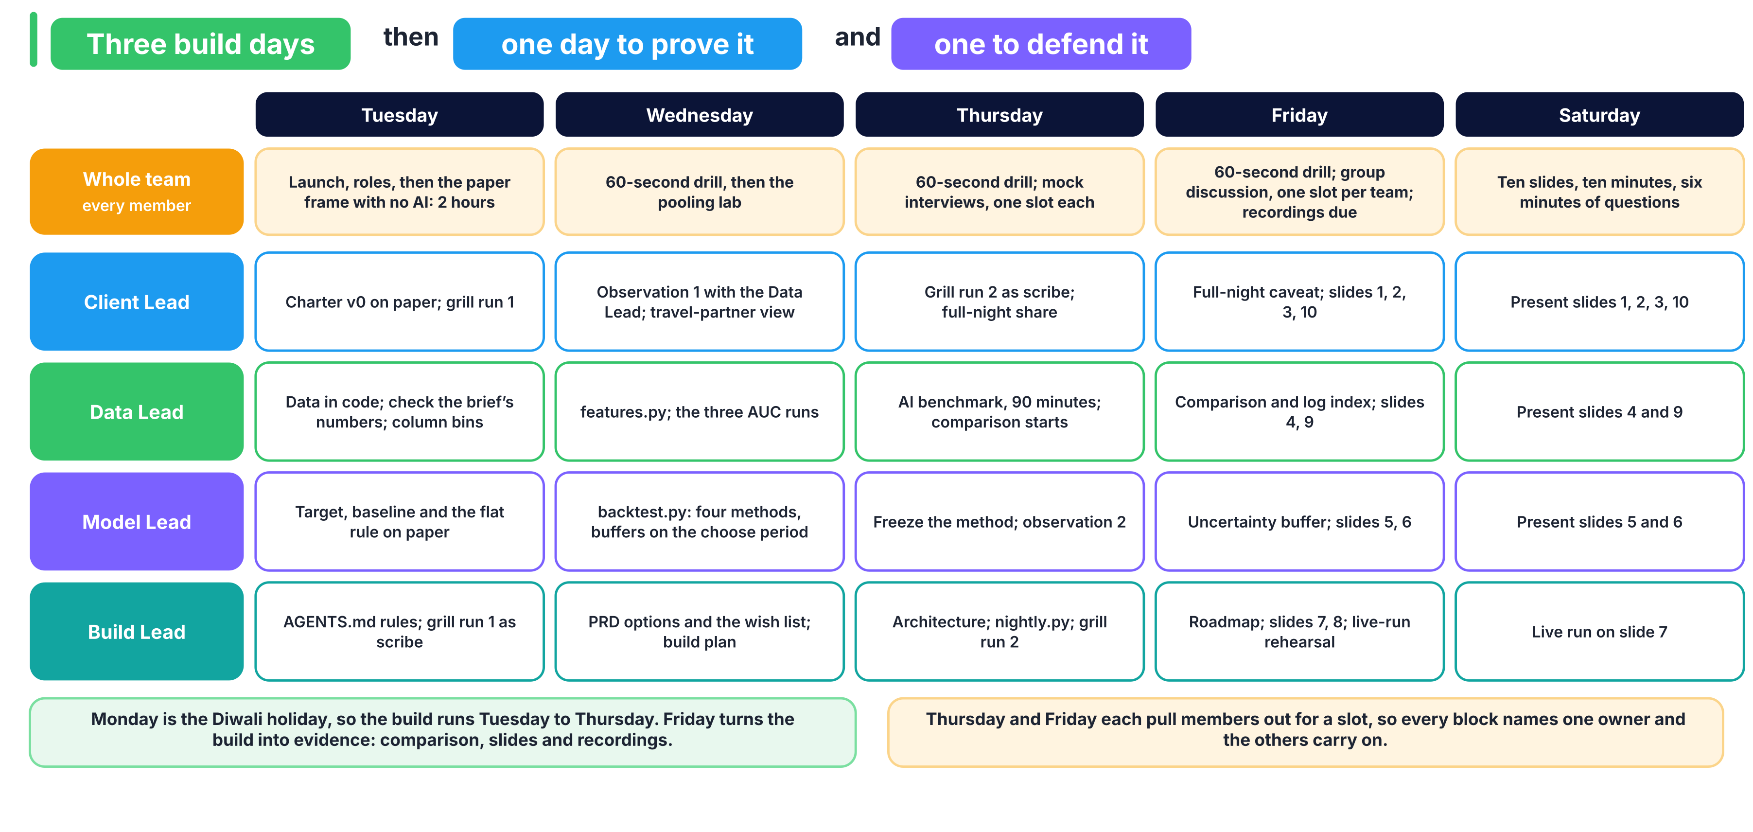

What do we open, and when?
When | Open | Why
Tuesday, first hour | BRIEF.md in full, docs/ROLES.md (your row and the disagreement rule), docs/LADDER.md (stages 0 to 2), docs/EVALUATION_CONTRACT.md | The ask, your role, the stages and the scoring rule
Tuesday, paper frame, no AI | docs/CHARTER.md, docs/RFP.md, docs/DOMAIN.md | Ladder stages 0 to 2
Tuesday, data | notebooks/00_start_here.ipynb, docs/COLUMNS.md, docs/DECISIONS.md | Check the brief's numbers and start the column audit
Tuesday, grill run 1 | docs/AI_WORKFLOW.md, AGENTS.md | Agent rules and the first grilling
Wednesday | docs/PRD.md, docs/BUILD_PLAN.md, src/contract.py | Options, then the POC method table
Thursday | docs/AI_WORKFLOW.md, ai_benchmark/README.md | The MVP, the AI benchmark and grill run 2
Friday | docs/COMPARISON.md, docs/ROADMAP.md, docs/PRESENTATION.md, docs/RECORDING.md | The comparison, the roadmap, the slides and your recording
Any time | docs/RUBRIC.md | How the 40 marks are given

Which two commands must work by Friday?
python src/backtest.py
python src/nightly.py --from 2017-08-18 --nights 14

The first prints every method you tried on the proof period and saves the chosen one to models/, which you commit. The second writes the table the revenue manager reads each morning. pytest -q checks the client's scoring rule at any time.

Who owns each artifact, and who has signed it?
A challenger signs by writing the commit hash they checked. An artifact counts as done only once it is signed.
Artifact | Owner | Challenger | Signed at commit
docs/CHARTER.md and docs/RFP.md
docs/COLUMNS.md and src/features.py
src/backtest.py
docs/PRD.md, docs/BUILD_PLAN.md and src/nightly.py
docs/COMPARISON.md

Where are our recordings?
Member | Role | Recording link on the LMS
 | Client Lead
 | Data Lead
 | Model Lead
 | Build Lead

Where does the data come from?
Antonio, N., de Almeida, A. and Nunes, L. (2019). Hotel booking demand datasets. Data in Brief, 22, 41 to 49. CC BY 4.0. src/data.py downloads it; see data/README.md.

Who owns what, and how do we disagree without fighting?
Four roles, one owner per artifact. The owner decides on their own artifact, a named challenger checks it, and every member can still explain every number.
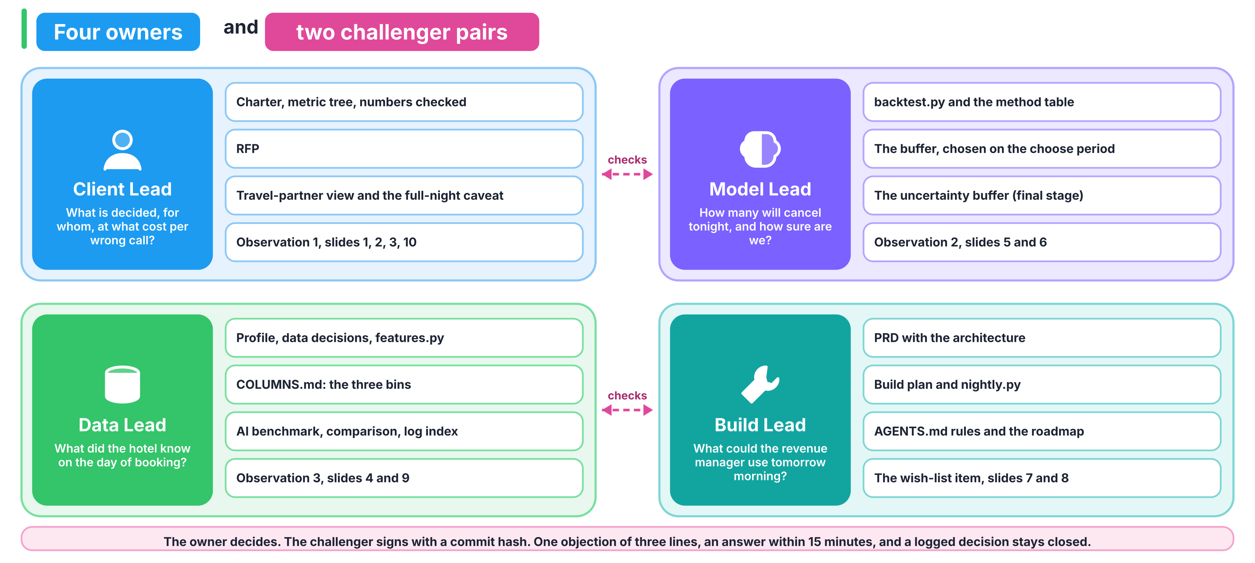

What does each role own?
Role | Owns these artifacts | Owns this question | Owns this observation from the brief | Challenges
Client Lead | docs/CHARTER.md with the metric tree and the numbers-checked table, docs/RFP.md, the travel-partner view (rate against volume), the full-night caveat, slides 1, 2, 3 and 10 | What is decided, for whom, at what cost per wrong call? | Checking every number in the brief, and observation 1 (with the Data Lead) | Model Lead
Data Lead | The profiling notebook, the data decisions in docs/DECISIONS.md, docs/COLUMNS.md, src/features.py, the AI benchmark and docs/COMPARISON.md, ai_logs/INDEX.md, slides 4 and 9 | What did the hotel know on the day of booking? | Observation 3 | Build Lead
Model Lead | src/backtest.py, the method table, the buffer chosen on the choose period, the uncertainty buffer (final stage), slides 5 and 6 | How many will cancel tonight, and how sure are we? | Observation 2 | Client Lead
Build Lead | docs/PRD.md with the architecture diagram, docs/BUILD_PLAN.md, src/nightly.py, the project rules in AGENTS.md, docs/ROADMAP.md, slides 7 and 8 | What could the revenue manager use tomorrow morning? | The wish-list item | Data Lead

The grill logs belong to the owner of the document being grilled: docs/grill_01_charter.md to the Client Lead, docs/grill_02_prd.md to the Build Lead.

How does a challenger work?
- The Client Lead and the Model Lead check each other: does the method serve the money, and does the money rule match what the method outputs?
- The Data Lead and the Build Lead check each other: does the MVP read only columns from the first bin, and does the pipeline produce what the MVP reads?
- A challenger signs the partner's artifact in the README table, with the commit hash they checked. An artifact counts as done only once it is signed.

What happens when we disagree?
- The owner decides on their own artifact.
- A challenger may file one written objection of three lines in docs/DECISIONS.md: what I object to, why, what I propose.
- The owner answers in writing within 15 minutes.
- If it is still open, a frame or money question goes to the Client Lead and a scope or time question goes to the Build Lead. A TA breaks a true tie, and the result is logged.
- A logged decision is not reopened. New evidence opens a new entry.

How are roles assigned?
In the first 20 minutes on Tuesday, each member writes a first and a second choice. A first choice nobody else wants is granted. A contested role goes to a coin toss run by a TA. The assignment is logged and does not change after the first hour. The role that worries you is usually the one that teaches you most.

What changes in the team of three?
There is no Build Lead, so every Build Lead item has a named owner below. The team is excused from the uncertainty buffer, so its final stage is the full-night caveat and the roadmap, and it may hand-draw the architecture diagram. Three recordings, the same rubric.
Role | Owns, in the team of three | Is challenged by
Client Lead | Charter, RFP, PRD with the wish-list answer, docs/grill_01_charter.md and docs/grill_02_prd.md, the travel-partner view, the full-night caveat, slides 1, 2, 3, 8 and 10 | Data Lead
Data Lead | Profiling notebook, data decisions, docs/COLUMNS.md, src/features.py, the project rules in AGENTS.md and ai_logs/karpathy_effect.md, the AI benchmark, docs/COMPARISON.md, docs/ROADMAP.md, ai_logs/INDEX.md, slides 4 and 9 | Model Lead
Model Lead | src/backtest.py, the buffer, docs/BUILD_PLAN.md, the architecture, src/nightly.py, slides 5, 6 and 7 | Client Lead

What must every member be able to explain, whatever their role?
- The one sentence the client acts on.
- Why the unit is the night.
- The two costs and the ceiling.
- The three column bins, with one example each.
- Which method won under which measure, and why the rankings disagree.
- What the MVP reads and what it writes.
- The gaps the AI build exposed in your build, or the evidence that it exposed none.

How do we get from the brief to a number the client acts on?
You already know this ladder: eight stages, from the business as a black box to a defended answer. This week every stage has one question per role and one line that says when the stage is done. The four documents you write (charter, RFP, PRD, build plan) are the ladder written down, so there is no second framework to learn.
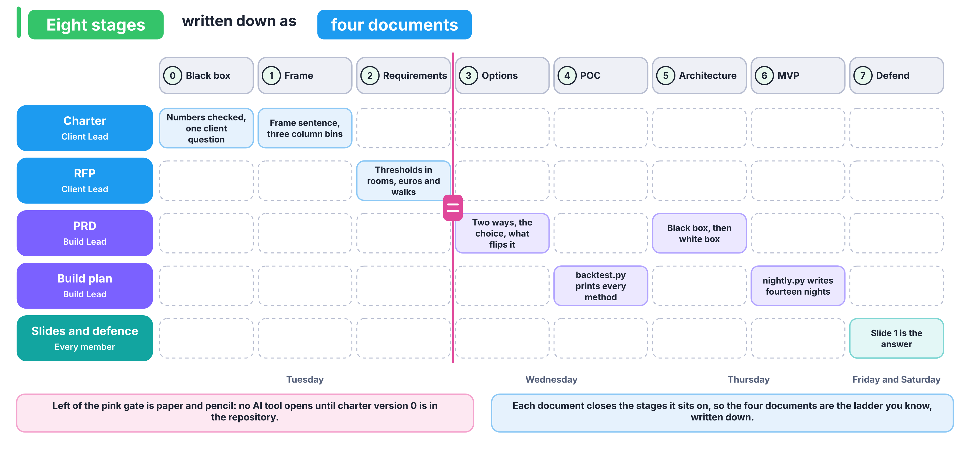

Work down the stages in order. When a later stage shows that an earlier answer was wrong, go back, fix the earlier document, and log the change in docs/DECISIONS.md.

Stage 0: What is the business, seen as a black box?
Role | Asks
Client Lead | Who pays RateGain, who at the hotel decides each night, and what does one wrong call cost in each direction?
Data Lead | Which of the client's numbers can I check today, and which need a question back to the client?
Model Lead | Which number would the revenue manager change tomorrow if we were right?
Build Lead | Who uses our output, in which room, and at what point in their day?

Done when the charter's black-box answers are written, every number in the brief has the value you checked beside it, and one question to the client is written down.

Stage 1: What exactly is being decided?
Role | Asks
Client Lead | What is decided, from what is known when, about which outcome? Is the unit the booking or the night, and why?
Data Lead | Which columns exist on the day of booking, which can change before arrival, and which are written after the outcome?
Model Lead | Which column is the target, and does every column mean what its name says?
Build Lead | What is the smallest table the client could act on each morning?

Done when the frame sentence is in the charter, every column sits in one of three bins in docs/COLUMNS.md by when the hotel learns its value, and any bookings that follow different rules from the rest are named, with the number that shows it.

Stage 2: How good must the answer be, and within which limits?
Role | Asks
Client Lead | How good, in rooms, euros and walks per 1,000, and on which period?
Data Lead | What must the input file look like for a nightly run?
Model Lead | What is the proof rule (train, choose, prove), and which baseline must we beat?
Build Lead | Which limits bind: inputs, run time, explanation, guest data?

Done when the RFP fits on one or two pages, with acceptance thresholds in business units and the three periods named.

Stage 3: Which ways could we decide, and which do we choose?
Role | Asks
Client Lead | Which two ways could we decide, what does each cost to build and to run, which do we choose, and what would flip the choice?
Data Lead | Where does each way get its numbers from?
Model Lead | Is a lookup table already a model, and when does a learned model earn its place?
Build Lead | Which method would the wish-list item need, and would its output change any number the client acts on?

Done when the PRD's options section names two ways, the choice, the flip condition, and an answer to the wish-list item backed by a number.

Stage 4 (POC): Does the idea survive a first test?
Role | Asks
Client Lead | Does our way beat the client's flat rule in euros with the ceiling met?
Data Lead | Is every column the method uses one the hotel knew on the day of booking?
Model Lead | Do the client's flat rule, a lookup table and at least two learned models sit in one table, scored by src/contract.py on the same nights? Which choose-period nights set each method's buffer?
Build Lead | Can a teammate reproduce that table with one command?

Done when python src/backtest.py prints every method on the proof period, with AUC, nightly error in rooms and cost in euros under the ceiling, and the numbers match the slides.

Stage 5: What does the system look like inside?
Role | Asks
Client Lead | Where does a person overrule the number, and how is that recorded?
Data Lead | What flows from the bookings file to the nightly table, box by box?
Model Lead | Where is the buffer chosen, and where is it frozen?
Build Lead | What would production add that the MVP leaves out?

Done when the PRD holds the diagram, from black box to white box, with the production additions listed.

Stage 6 (MVP): Could the revenue manager use it tomorrow?
Role | Asks
Client Lead | Would the revenue manager trust this table tomorrow morning, and what would they ask first?
Data Lead | Does the nightly run read only the bookings file and the saved model?
Model Lead | Is the buffer the one chosen on the choose period, untouched?
Build Lead | Does one command produce the table for the next fourteen nights?

Done when python src/nightly.py --from 2017-08-18 --nights 14 writes the nightly table using only columns the hotel knew at booking, and the challenger has signed it in the README.

Stage 7: Can every one of us defend every number?
Role | Asks
Client Lead | What is the one sentence the client acts on?
Data Lead | Which screenshot proves each number?
Model Lead | Which method won under which measure, and why do the rankings disagree?
Build Lead | Which gaps did the AI build expose in ours, and which mistakes did it make?

Done when every member can defend every number, and slide 1 is the answer.

What do we do when we are stuck?
- After 25 minutes without progress, the owner writes a stuck note in your team's GitHub Discussion thread, in three lines: what we tried, what we expected, what we saw.
- A TA answers within 30 minutes with a first clue, which is a question.
- After another 25 minutes you may ask for a second clue, which points at the evidence. After a further 25 minutes you may ask for a third, which shows the computation.
- Clues carry no penalty. They are logged, and if a clue changed a decision, you say so on the slide where that decision appears.

What is the 60-second card?
Every build morning starts with a 10-minute drill on a different business. You get one card and 60 seconds, alone, to answer five questions. This is the shape an interviewer expects when they say "what would you measure?"
- Who pays, and who decides?
- What is the one decision?
- What is the unit of that decision?
- Which three metrics would you track, ranked? Mark the north star and the guardrail.
- Rule, lookup table or model, and why?
Run the same five questions on the hotel brief before you open any template.

Where do Weeks 1 to 5 show up this week?
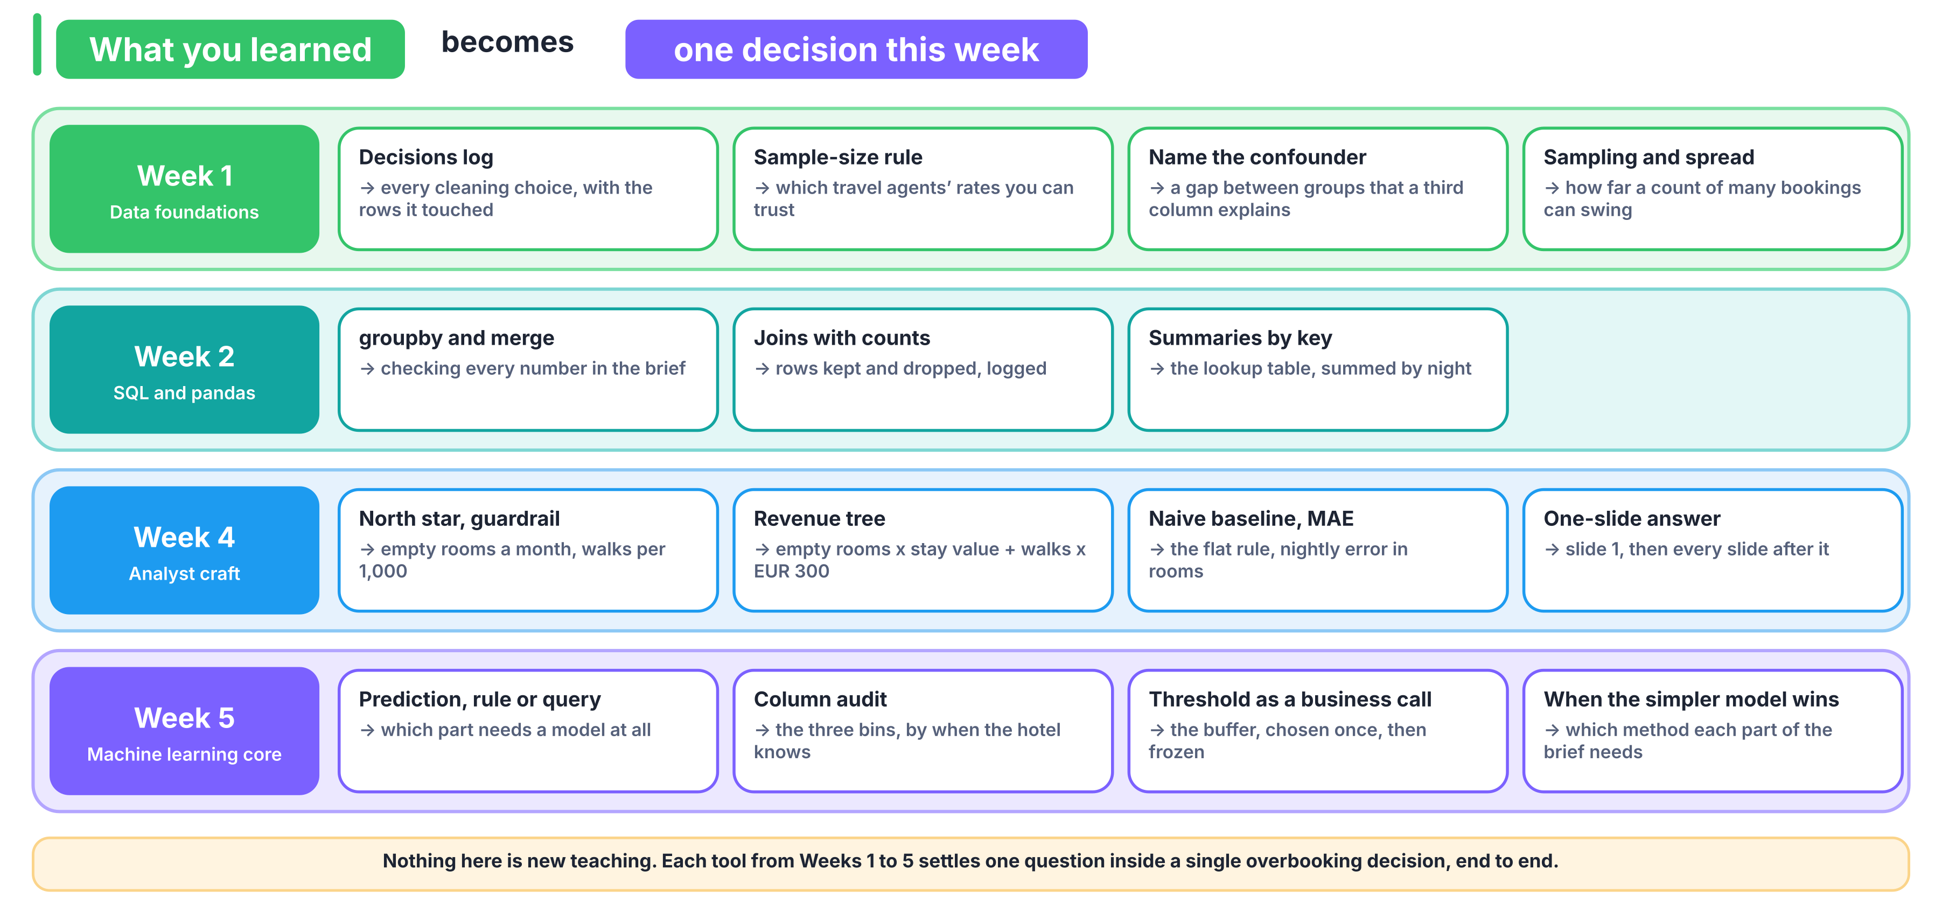

Week | What you learned | Where it decides something this week
1 | Profiling and cleaning with a decisions log | Every cleaning choice, its reason and the rows it touched, in docs/DECISIONS.md
1 | The sample-size rule | Which travel agents' cancellation rates you can trust
1 | Correlation against causation: name the confounder | A gap between two groups of bookings that a third column explains
1 | Sampling and spread | How much a count of many uncertain bookings swings (Wednesday's pooling lab)
2 | groupby, merge, joins with before-and-after counts | Checking the brief's numbers, the lookup table, summing by night
4 | North star and guardrail, each with numerator, denominator, window and exclusions | Empty rooms per month, and walks per 1,000 arrivals
4 | The revenue tree | The cost of a night: empty rooms times stay value, plus walks times EUR 300
4 | Naive baselines, and MAE in business units | The client's flat rule, and nightly error in rooms
4 | The one-slide answer: claim, evidence, caveat, action | Slide 1 and every slide after it
5 | Prediction, rule or query | Which part of the problem needs a model, which a rule and which a groupby
5 | The prediction-time question and the column audit | The three bins in docs/COLUMNS.md
5 | Train, validation, test, and the baseline | Train, choose, prove
5 | Threshold selection as a business decision | The buffer, chosen once on the choose period
5 | The error bill in money | Euros and rooms on the proof period
5 | Clustering compared, and when the simpler model wins | Deciding which method each part of the brief needs, simplest first

Nothing on this page is new teaching. The project asks you to use what you have, on one decision, end to end.

How will the client score any rule we propose?
The client scores every proposal the same way, whichever method produced it. src/contract.py holds this rule as code. Read it, use it, and do not change it. Everything the rule leaves open is your team's decision.

What is the unit?
One hotel on one arrival night. A night's book is every booking your team scores whose arrival date is that night.

What does a rule decide?
The oversell count k for each night: how many rooms beyond capacity to keep selling. It is a whole number, zero or more.

What does one night cost?
Let A be the number of that night's bookings that cancelled (is_canceled = 1, which includes no-shows).
Quantity | Formula
Empty rooms | max(A − k, 0)
Walked guests | max(k − A, 0)
Stay value V | the mean of adr × nights over the night's bookings, where nights = stays_in_weekend_nights + stays_in_week_nights
Walk cost W | EUR 300 per walked guest
Cost of the night | empty rooms × V + walked guests × W

When is a rule acceptable?
Walks per 1,000 arrivals = 1,000 × walked guests ÷ arrivals, over the whole period, where arrivals are the scored bookings that did not cancel. A rule is acceptable only at 10 or fewer. A rule that saves more euros but breaks the ceiling is rejected.

Which data may we use, and when?
Period | Arrival dates | What it is for
Train | before 1 July 2016 | Fit your methods
Choose | 1 July 2016 to 31 December 2016 | Pick settings and the buffer, and check the ceiling here
Proof | 1 January 2017 to 31 August 2017 | Run once, at the end, and report what happens, walks included

You may refit on train and choose together before the proof run, as long as you keep every setting you picked. If you change anything after seeing proof results, say so on slide 5 and report both runs.

What does `src/contract.py` give us?
Function | What it returns
split_periods(df) | The train, choose and proof bookings, by arrival date
nightly_table(bookings, prob) | One row per hotel and night: book (bookings due), cancelled (what happened), expected (the sum of your probabilities), spread (the standard deviation of that sum if bookings cancel independently) and stay_value (V)
night_cost(nights, oversell) | The cost in euros, empty rooms, walked guests, walks per 1,000, whether the ceiling was met, and the number of nights

It does not choose which bookings you score, which columns you use, where your probabilities come from, how you turn them into k, or your buffer.

What is the client's current rule?
The flat rule: each hotel's cancellation rate, times the night's bookings, less a fixed number of rooms for safety. Formalise it exactly that way, with its rate taken from the train period and its safety margin chosen on the choose period under the ceiling, the same way you choose your own. Every saving you report is a saving against this rule, never against selling nothing extra.

What does the client want to read each morning?
One row per hotel and arrival night, for the next fourteen nights: the hotel, the night, the bookings on the book, the expected cancellations, the buffer, and the oversell count. Your PRD may add columns if the revenue manager would use them.
The rule scores each night's final book, meaning every booking ever made for that night, so the fourteen-night run treats every booking as already on the book. Fourteen days before arrival only about half of a night's final book is actually there, so a run that uses only the bookings known on the morning it runs is the natural next step, and your roadmap may name it.

What must every result report?
Euros, rooms and walks per 1,000, side by side, on the proof period. A euro figure without its rooms and walks is not accepted.

Which hotel words do we need this week?
These are standard hospitality revenue-management terms. Where the dataset defines a term its own way, the third column says so.
Term | What it means | How it is counted
Occupancy | The share of the hotel's rooms that were sold for a night | rooms sold ÷ rooms available
ADR (average daily rate) | The average price paid per occupied room night | room revenue ÷ room nights sold; in the data, adr is per booking
RevPAR | Room revenue per room the hotel could have sold | room revenue ÷ rooms available, which equals occupancy × ADR
Lead time | How far ahead the booking was made | arrival date minus booking date, in days (lead_time)
Length of stay | The nights booked | stays_in_weekend_nights + stays_in_week_nights
Cancellation rate | The share of bookings that never become a stay | cancelled bookings ÷ bookings, for a stated set of bookings and period
No-show | A guest who neither cancels nor arrives | counted as a cancellation in is_canceled
Overbooking | Selling more rooms than exist, expecting some bookings not to arrive | rooms sold minus rooms available
Walking a guest | Sending a guest with a confirmed booking to another hotel because the hotel is full | the hotel pays for the other room, the transport and usually a goodwill gesture
Allotment or block | Rooms held for a tour operator or a group under contract | unsold rooms go back on sale at an agreed cut-off date
OTA | An online travel agency that sells the hotel's rooms to guests for a commission | Booking.com and Expedia are examples
Tour operator | A business that packages rooms with flights or tours and sells the package | usually holds allotments
GDS | The global distribution system that travel agents and corporate travel desks book through | Amadeus, Sabre and Travelport are examples
Market segment and channel | The segment says who the customer is; the channel says how the booking arrived | market_segment and distribution_channel; a group can arrive through a travel-agent channel

Who are the two sides of this business?
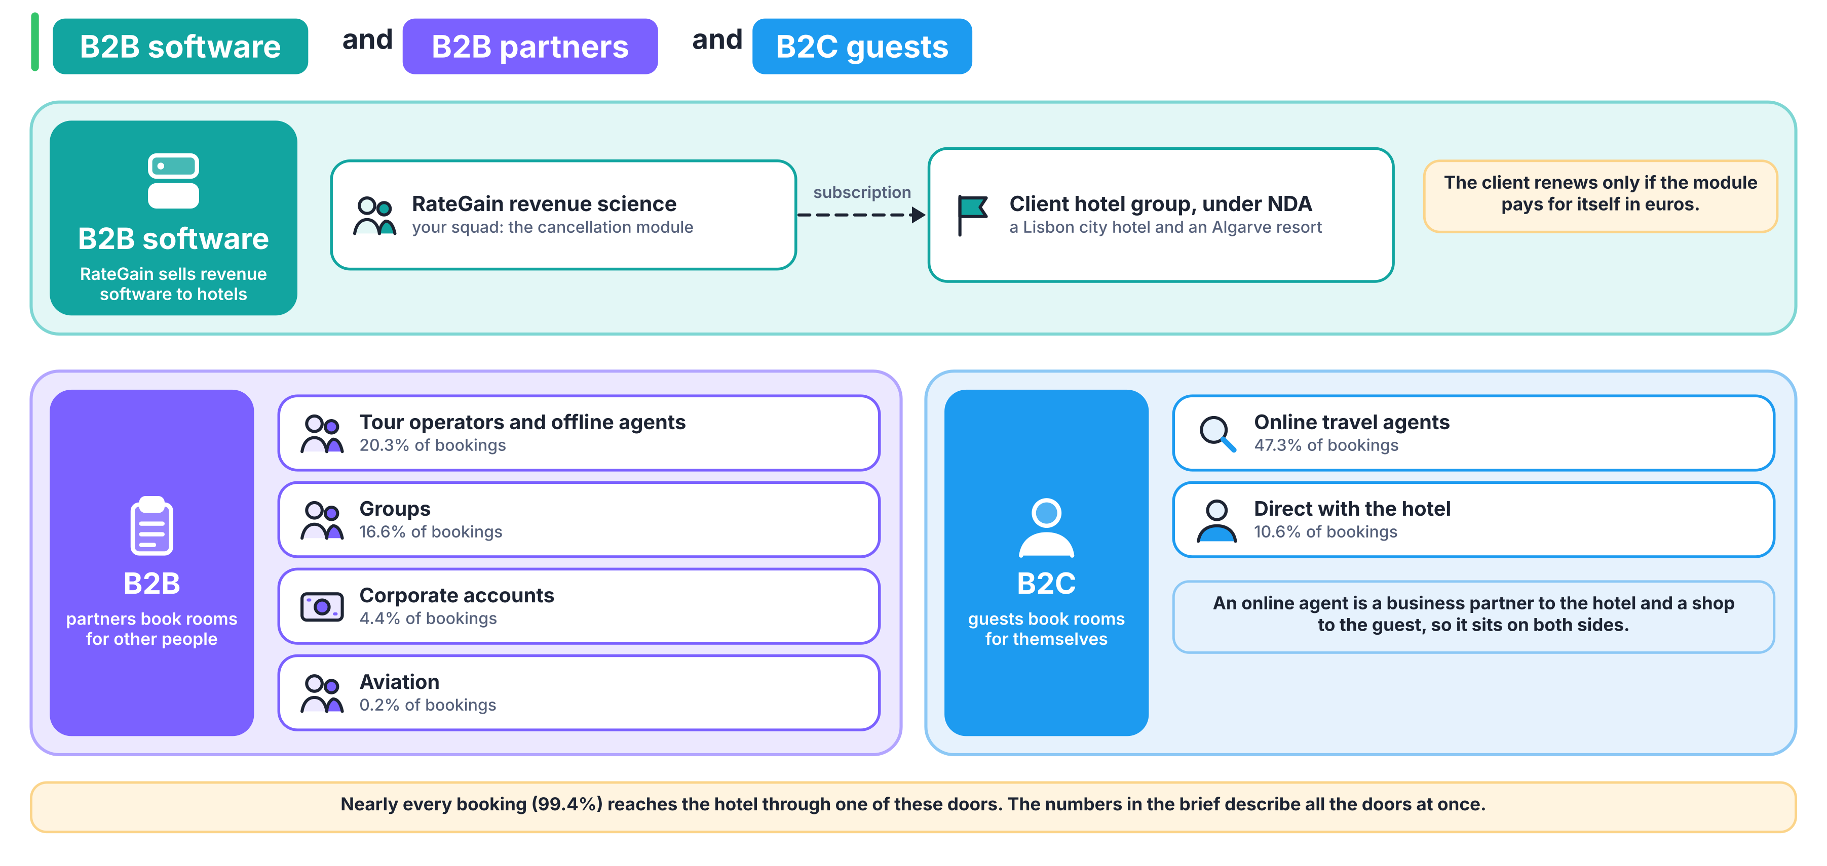

- Business customers (B2B). Tour operators and offline travel agents, groups, corporate travel desks and airlines buy rooms in volume, often under contract. In the data they appear through market_segment, agent and company.
- Guests (B2C). Individual travellers book directly with the hotel or through an online travel agency. An OTA sits on both sides: a business partner to the hotel, a shop to the guest.
- The software vendor. RateGain sells revenue software to the hotel group. It is paid by the hotel, so its work has to pay for itself in the hotel's euros.
In agent and company, an empty value means "booked without one", which is a category of its own and not a missing value.

How do we use AI this week, and how do we prove what it did?
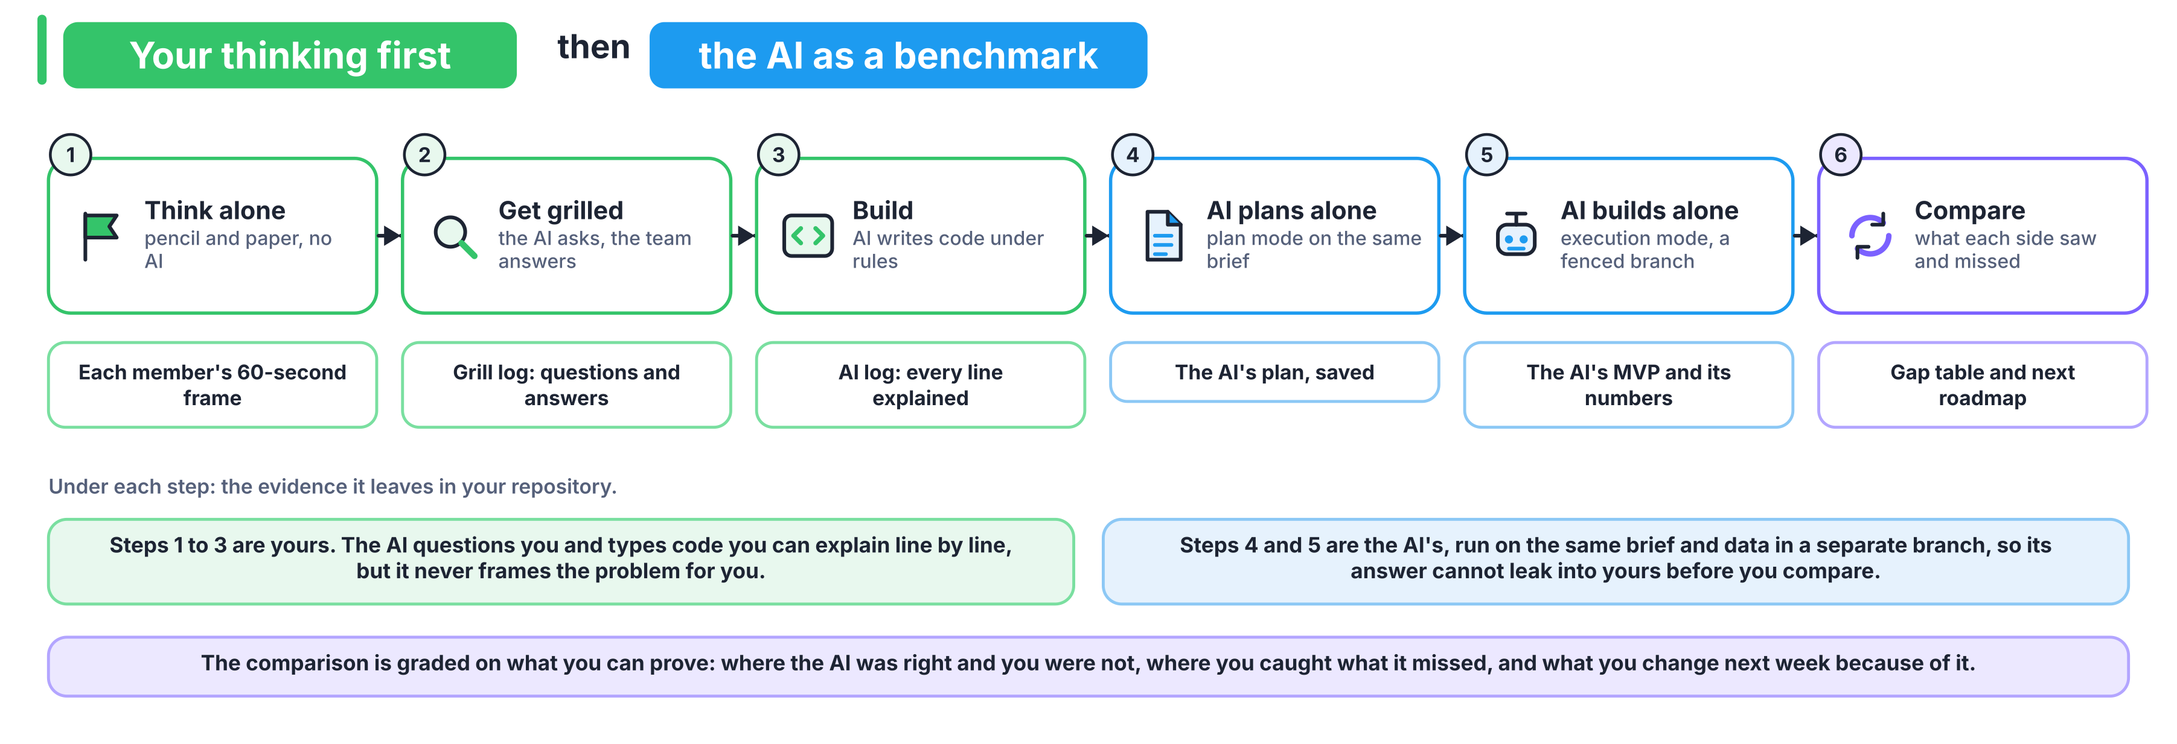

Which work happens without AI?
- Tuesday's paper frame, ladder stages 0 to 2. Type or photograph charter version 0 into the repository before anyone opens an AI tool.
- Saturday's defence, and any viva.
Everything else may use AI, and every chat is logged. Whoever commits an AI-written line must be able to explain it.

Which tools can we use?
A free ChatGPT, Claude or Gemini chat is enough for every step below. Claude Code and GitHub Copilot help where you have them; do not assume every member does.

How do we give a coding agent our rules?
Who and when: the Build Lead, on Tuesday, in 15 minutes.
- Write at least five project rules under the first heading of AGENTS.md, each taken from a decision in your charter or docs/DECISIONS.md.
- Append Andrej Karpathy's coding guidelines (collected in forrestchang/andrej-karpathy-skills) and copy the file to where each tool looks for it. Run the second line again whenever AGENTS.md changes.
curl -sL https://raw.githubusercontent.com/forrestchang/andrej-karpathy-skills/main/CLAUDE.md >> AGENTS.md
cp AGENTS.md CLAUDE.md && mkdir -p .github && cp AGENTS.md .github/copilot-instructions.md

- In a plain chat, paste AGENTS.md as the first message before you ask for code.
The guidelines come down to four principles: think before coding, simplicity first, surgical changes, and goal-driven execution. Capture one screenshot where the agent stated an assumption or pushed back on you, save it in ai_logs/, and embed it in ai_logs/karpathy_effect.md with one line on what it changed.

How do we get grilled?
Matt Pocock's grill-me skill (repository mattpocock/skills) makes the AI interview you about a plan in rounds of numbered questions, each with a recommended answer, until every branch of the plan is settled.
Tool | How to start it
Claude Code | claude plugin install mattpocock-skills@claude-plugins-official, then type /grill-me
Copilot CLI | copilot plugin marketplace add mattpocock/skills, then copilot plugin install mattpocock-skills@mattpocock
Gemini CLI | gemini skills install https://github.com/mattpocock/skills.git --path skills/productivity, then the same command with --path skills/engineering
Any plain chat | Paste the grilling skill's text as the first message, then your document

Run | When | Document | Opening line | Log
1 | Tuesday, after the paper frame and the first data pass: 45 minutes, then the edits before the day ends | Charter v0 and the RFP skeleton | "Grill me on this charter until we share an understanding of what is being decided, for whom, from what is known when, and what one wrong call costs in each direction." | docs/grill_01_charter.md
2 | Thursday, after the POC: 45 minutes | PRD and build plan | "Grill me on this PRD and build plan until every branch of the design tree is settled." | docs/grill_02_prd.md

Write your own answer before you read the recommended one. Every "yes" is a decision you will defend on Saturday.
Three more skills from the same repository, used only when a question calls for one: research when a claim about hotels needs a primary source, prototype for throwaway code that answers one question, and diagnosing-bugs when the back-test disagrees with a count you made by hand.

How do we benchmark an AI build against ours?
Who and when: the Data Lead, on Thursday, in a box of 90 minutes.
- Commit everything on main, then branch from the repository's first commit, so the AI starts from what you had on Tuesday morning:
git switch -c ai-benchmark $(git rev-list --max-parents=0 HEAD)

- Switch to plan mode: Shift+Tab in Claude Code until it shows plan mode, the Plan agent in Copilot, or a request for a plan only in a chat. Give this prompt, word for word:
You are the vendor's engineering team. Read only BRIEF.md, docs/EVALUATION_CONTRACT.md, src/data.py and src/contract.py. The data is at data/hotels.csv; download nothing else. Produce a plan only, no code: what you will predict, which columns you will use and why, which bookings you will score, how you will split the data, what you will compare against, how you will turn predictions into the number of rooms to oversell each night, and what you will report. Stop and wait for approval.

- Save the plan as ai_benchmark/PLAN_AI.md, then approve it as written. If the AI asks a question, answer only from BRIEF.md.
- Give the execution prompt:
Execute the approved plan. Write aibenchmark/run.py so that `python aibenchmark/run.py` prints the proof-period results and writes the oversell table for 18 to 31 August 2017. Stop when it runs end to end.

- Edit nothing the AI wrote, except to fix an environment error such as a missing package. In a plain chat you may paste an error message back and run what the AI returns, but you may not change its logic yourself. The box closes at 90 minutes, whatever state it is in.
- Save and leave the branch, which is never merged: git add -A && git commit -m "AI benchmark" && git push -u origin ai-benchmark && git switch main.
On Friday, docs/COMPARISON.md sets the AI build beside yours.

How do we log every chat?
One file per session in ai_logs/, named YYYYMMDD_role_tool_purpose.md, for example 20261110_client-lead_claude_grill-charter.md. Each holds the chat's share link and the pasted text; in VS Code, Copilot's Chat: Export Chat command saves it. Then add a row to ai_logs/INDEX.md.

What goes on the ten slides, and what does the panel ask?
Ten minutes, ten slides, then six minutes of questions on Saturday.

Which rules apply to every slide?
- Slide 1 is the answer. The panel has read the brief, so no slide restates it; a slide that does scores zero for evidence discipline.
- Every number on a slide has a screenshot beside it showing the line of code and the output that produced it. Save them in evidence/.
- Each slide's title is the question it answers, and its owner's name is on it.
- A clue that changed a decision is named on the slide where the decision appears.
- Slide 7 runs python src/nightly.py --from 2017-08-18 --nights 14 live from your frozen commit, reading the method saved in models/, so nothing retrains on stage.

Which slides, owned by whom, with which evidence?
Slide | Owner | Seconds | Title | Evidence that must appear
1 | Client Lead | 45 | What should the revenue manager do tomorrow night? | The nightly table for the next fourteen nights, with one sentence above it
2 | Client Lead | 45 | What is decided, and what do the two wrong calls cost? | The frame sentence and the metric tree, with the north star and the ceiling
3 | Client Lead and Data Lead | 75 | What did the data say that the brief did not? | The check of the brief's numbers, your answer to observation 1 with the question you sent the client, and the travel-partner view of rate against volume
4 | Data Lead | 60 | Which columns did the hotel know on the day of booking? | The three-bin audit, and the three AUCs from docs/COLUMNS.md
5 | Model Lead | 75 | Which method wins, and under which measure? | The method table from python src/backtest.py on the proof period
6 | Model Lead | 45 | What would flip the choice? | Buffer against walks on the choose period, and one changed condition
7 | Build Lead | 90 | Does it run? | A live run of the MVP command, and the architecture diagram
8 | Build Lead | 60 | Which three grilling questions changed our plan? | Three rows from the grill logs: question, answer, change
9 | Data Lead | 60 | What did the AI build get wrong, and what did it expose in ours? | The comparison table and one screenshot of the branch
10 | Client Lead | 45 | What is the honest range, and what comes next? | The full-night caveat by hotel, and the three-week roadmap

The seconds add up to 600.

Which questions should we expect?
The panel picks who answers, never the team.
- Why the night and not the booking?
- Which column would you drop if you learned it is set at check-in, and how much AUC would you lose?
- Which of your methods won on AUC, which won on money, and why are they not the same one?
- What happens in January, when the resort is not full?
- Which number in the brief was wrong, and how did you find it?
- Show me the line that sets the buffer.
- If walking a guest cost EUR 1,000, what would change?
- What did the AI build do that you would never ship?
- How many walks per 1,000 did your rule produce on the proof period?

What goes in my recording?
Every member records one screen-share of 15 to 20 minutes about their own work. Camera is optional and no editing is needed. It is due on Friday, before the end of the build day.

Which five parts, in which order?
Part | Minutes | What you show
1. My artifacts and the question I owned | 2 | The files you own, opened, and your role's question in your own words
2. The number I own | 5 | The line of code that produces it, a run that prints it, and what it means for the client
3. Where I was stuck | 4 | What you tried, what you expected, what you saw, and how you got out, with the commit or log that shows it
4. My research, with proof | 3 | The source or chat you used, its file in ai_logs/ or its link, and the commit hash where it changed the work
5. What I would do differently | 2 | One decision you would remake, and why

Where does the link go?
Upload the recording to the LMS and paste the link next to your name in the README.

What will the TA check?
The TA opens your recording at three points, confirms that you are the one speaking, and checks that the commit hash and the chat-log file you cite exist in the repository under your name. Under ten minutes, or narrated without the screen, scores zero.

How are the 40 marks given?
The mini-project carries 40 of the build week's 100 marks: 24 for the team and 16 for each member. Every line below is scored by counting what is present, so two scorers reach the same mark. The panel and the TAs score on the same sheet.

Which team marks are there, out of 24?
Code | Criterion | Marks | One mark for each of these
T1 | Frame and metrics | 5 | (1) The unit is the night, with the reason. (2) The walk ceiling sits inside the money rule. (3) The wrong number in the brief is caught, with its checked value in the charter. (4) The north star and the guardrail each have a numerator, a denominator, a window and exclusions. (5) The euro figures carry the full-night caveat, with the share of nights near full at each hotel.
T2 | Honest evidence | 5 | (1) A time split, with the proof period run once. (2) Every column binned in docs/COLUMNS.md. (3) The client's flat rule, a lookup table and at least two learned models, all scored by src/contract.py on the same nights. (4) Every number on the slides reproduced by one command. (5) No late column and no random split anywhere in the chosen rule.
T3 | The client's three observations | 4 | (1, 2, 3) One mark per observation answered with its witness: the number that explains it. (4) All three answers changed something in the build, and the slides name what.
T4 | The MVP | 4 | (1) The MVP command runs live on Saturday. (2) It writes the nightly table for the fourteen nights. (3) It reads only first-bin columns, signed by the challenger. (4) The architecture diagram matches the code.
T5 | Evidence discipline and the AI storyline | 6 | (1) No slide restates the brief. (2) Every number on every slide has its screenshot. (3) The grilling slide shows three rows that changed a document. (4) The comparison names up to three gaps and up to three AI mistakes, each with a file reference, or says "none found" and names the file that shows it. (5) The roadmap has three weeks, each with an owner and hours. (6) ai_logs/INDEX.md lists every log, including the four required rows.

Which individual marks are there, out of 16?
Code | Criterion | Marks | How it is counted
I1 | The recording | 6 | One mark for each of the five parts present and specific, and one mark when the cited commit hash and chat log verify. Missing, under ten minutes, or narrated without the screen scores 0.
I2 | Defence in questions | 6 | Two questions: one on your own number, one on a teammate's. Each scores 3 for a right answer with the mechanism, unaided; 2 after one prompt; 1 for the right number without the mechanism, or with a teammate's help; 0 for no answer.
I3 | The trail | 4 | (1) Commits under your name on your artifacts. (2) Your chat logs indexed. (3) Every AI-written line the panel points to, explained. (4) Your challenger signature given on your partner's artifact.

What is never scored?
Which method wins. Two teams with opposite winners can both take full marks for evidence, because the marks go to the discipline of the comparison. Clues taken from a TA cost nothing.

