Report
Of
Frontend Web Development

Submitted
To
School of Computer Science and Engineering
IILM University, Greater Noida, U.P.
In partial fulfilment of the requirement of degree of
B.Tech CSE
By
Roll Number of Student: CS-2341877
Name of Student: ROHIT PANWAR
Section: 4CSE8
Batch: 2023-27

CANDIDATE'S DECLARATION
I, ROHIT PANWAR, do hereby declare that the internship report titled "Frontend Web Development" has been completed by me to fulfil the requirement for the award of the degree of Bachelor of Technology in Computer Science and Engineering. All the references have been quoted and I have not taken as such any material from any other source. I affirm that this report is my own work and has not been submitted to any other institute for any degree/diploma requirement, and I shall be solely responsible for any kind of copyright violation in this regard.
Signature: ______________________
Student Name: ROHIT PANWAR
Roll No.: CS-2341877
i

ACKNOWLEDGEMENT
I am using this opportunity to express my gratitude to everyone who supported me throughout the Internship Program at YuvaIntern. I am thankful for their aspiring guidance, invaluably constructive criticism and friendly advice during this work. I am sincerely grateful to my mentors and to Mr. Kounal Gupta, Founder of YuvaIntern.com, for the opportunity and support extended to me during the internship. I would also like to thank my faculty at IILM University for their continuous guidance and encouragement throughout this internship.
I express my gratitude to my parents for their blessings.
Signature: ______________________
Student Name: ROHIT PANWAR
Roll No.: CS-2341877
ii

INTERNSHIP COMPLETION CERTIFICATE
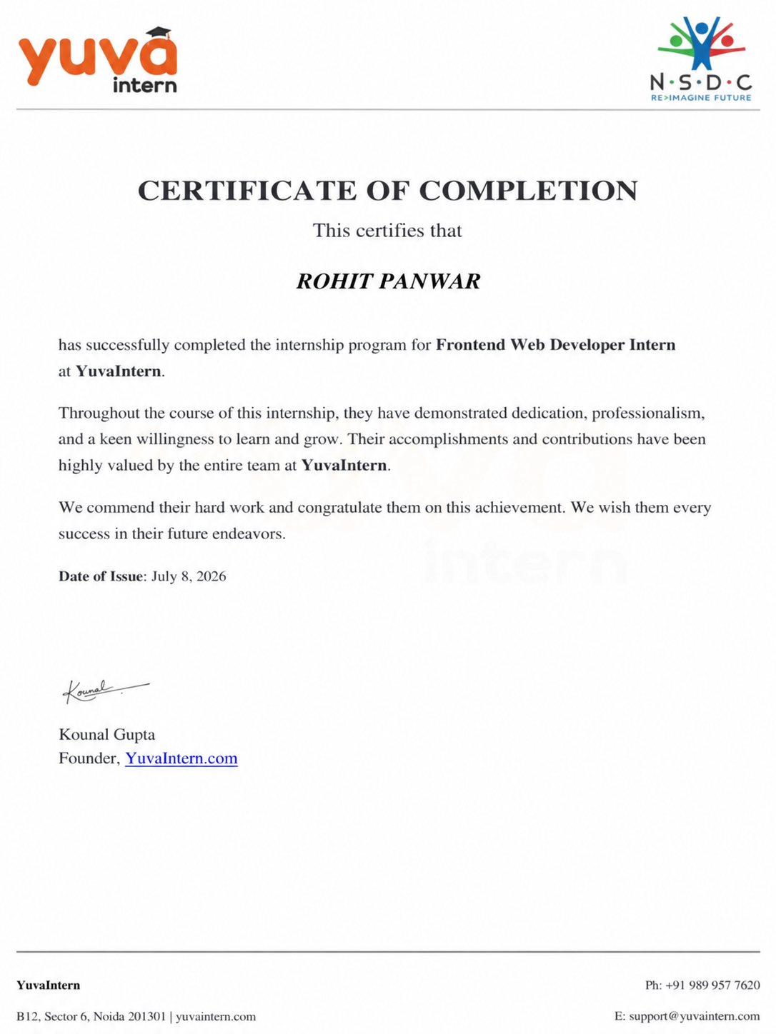
Internship Completion Certificate issued by YuvaIntern
iii

TABLE OF CONTENTS
Chapter No. | Chapter Name | Page Nos.
Cover Page |  | —
1. | Candidate's Declaration | i
2. | Acknowledgement | ii
3. | Internship Completion Certificate | iii
4. | Project Description | 1
 | 4.1 Introduction | 1
 | 4.2 Organization Profile | 1
 | 4.3 Problem Statement | 1
 | 4.4 Project Objectives | 2
 | 4.5 Scope of the Project | 2
 | 4.6 Technologies and Tools Used | 2
 | 4.7 System Architecture | 3
 | 4.8 Methodology | 3
 | 4.9 Expected Outcomes | 3
 | 4.10 Certificates of Completion / Experience Proof | 4
5. | Bibliography / References | 5
iv

Chapter 4: Project Description
4.1 Introduction
This report presents an account of the internship undertaken at YuvaIntern as a Frontend Web Developer Intern, over a structured duration (Remote). The internship provided hands-on exposure to modern frontend web development, working alongside industry mentors on real project tasks combined with technical execution. Program highlights included hands-on experience in HTML, CSS, JavaScript, responsive UI components, user accessibility, cross-browser compatibility, project tasks with regular assessments, and performance-based evaluation. This chapter describes the organization, the problem addressed, the objectives pursued, the technologies used, and the methodology followed during the internship.
4.2 Organization Profile
YuvaIntern (in collaboration with NSDC) is a technology and skill development organization that emphasizes hands-on, real-world work for its interns. Every internship at YuvaIntern is structured around practical frontend project tasks, dedicated mentorship, and a clear framework of milestones and feedback, with the objective of building both technical competence and professional discipline in its interns. The organization is led by Mr. Kounal Gupta, Founder of YuvaIntern.com, and offers remote internship tracks across core technology domains, including frontend web development.
4.3 Problem Statement
Modern web applications require highly intuitive, fast, and responsive user interfaces that adapt seamlessly across a variety of screen sizes and device viewports. Inconsistent layout structures, poorly managed CSS frameworks, and non-optimized UI components lead to poor user experience, slow loading times, and reduced engagement. The project undertaken during this internship addressed the need for a responsive, clean, and accessible frontend interface that delivers smooth navigation, optimal layout rendering, and well-structured code components, thereby enhancing user engagement and overall front-end reliability.
4.4 Project Objectives
- To gain practical exposure to modern frontend web development in a professional, project-driven environment.
- To design, construct, and refine the client-side user interfaces using standard web technologies.
- To apply structured software engineering practices, including clean component separation, modular styling, cross-browser testing, and Git version control under mentor guidance.
- To implement responsive design principles, smooth layout transitions, and intuitive navigation flows across devices.
- To evaluate and validate the developed frontend solution against target UI/UX design benchmarks.
4.5 Scope of the Project
The scope of the project covers the frontend interface design, client-side interactions, responsive styling, and layout implementation within the internship period. The project focused on building end-to-end user interfaces, dynamic visual elements, and scalable markup architecture. Back-end server logic, complex persistent database configurations, and enterprise-grade cloud deployments were outside the primary scope of this frontend-focused internship project.
4.6 Technologies and Tools Used
- Programming & Markup Languages: HTML5, CSS3, JavaScript (ES6+)
- Styling & Layout: Responsive Web Design, Flexbox, CSS Grid, Modern UI Libraries
- Version Control: Git, GitHub (rohitpanwarcs27-hue/2023-27_RohitPanwar_CS-2341877_4CSE-8)
- Development Environment & Tools: Visual Studio Code, Chrome Developer Tools
4.7 System Architecture
The application follows a modular client-side frontend architecture. The interface layer consists of semantic HTML markup combined with structured CSS styling rules (Flexbox/Grid) to ensure fluid presentation. JavaScript handles dynamic UI events, state updates, DOM manipulation, and asynchronous interaction triggers.
[ User / Browser ]
│
▼
┌─────────────────────────────────────────────────────────────┐
│ Frontend UI Presentation │
│ ┌──────────────────┐ ┌───────────────┐ ┌────────────┐ │
│ │ Semantic HTML5 │ │ CSS3 / Flex / │ │ JavaScript │ │
│ │ DOM │ │ Grid Layout │ │ Logic/DOM │ │
│ └──────────────────┘ └───────────────┘ └────────────┘ │
└─────────────────────────────────────────────────────────────┘
Figure 4.1: High-level architectural structure of the Frontend Web Application
4.8 Methodology
The internship followed a structured methodology consisting of onboarding, task orientation, project development, and periodic reviews. During the onboarding phase, the intern was introduced to project goals and given guidelines on project milestones. Development proceeded through requirement analysis, component-wise UI design, incremental coding of pages and components, mobile responsiveness optimization, and functional testing across multiple viewports. Code iterations were uploaded and tracked on GitHub. Regular feedback was provided by mentors to optimize performance, clean up code structure, and adhere to best web standards.
4.9 Expected Outcomes
Through this internship, the following outcomes were achieved:
- Practical mastery of core frontend web development principles, including HTML5 layout structuring, CSS3 styling, and JavaScript client-side interactions.
- Experience in creating fully responsive, cross-browser compatible user interfaces tailored for web and mobile devices.
- Professional growth through mentor check-ins, task reviews, and version control workflows on GitHub.
Successful completion of the program demonstrates practical internship experience in frontend web development at YuvaIntern.
4.10 Certificates of Completion and Experience Proof
The Internship Completion Certificate issued by YuvaIntern is provided in the front matter of this report (page iii) [cite: 5]. The official Certificate of Experience issued by YuvaIntern is embedded below as supporting proof [cite: 5].
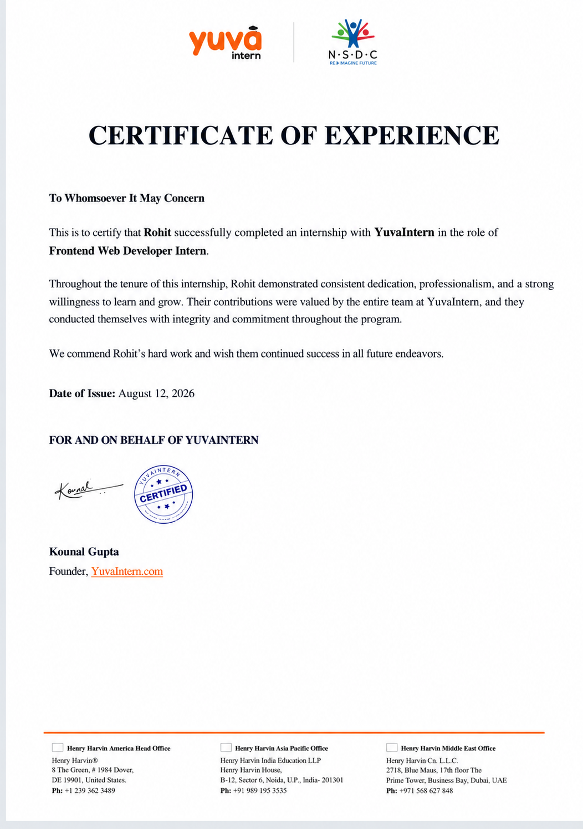
Certificate of Experience issued by YuvaIntern

Chapter 5: Bibliography / References
[1] W3C, "HTML5 & CSS3 Standard Specifications," World Wide Web Consortium, 2026.
[2] Mozilla Developer Network (MDN), "JavaScript, HTML, and CSS Web Docs," developer.mozilla.org, 2026.
[3] GitHub, "Repository: 2023-27_RohitPanwar_CS-2341877_4CSE-8," github.com/rohitpanwarcs27-hue, 2026.
[4] YuvaIntern, "Frontend Web Developer Internship Guidelines and Documentation," YuvaIntern.com, 2026.
[5] YuvaIntern, "Certificate of Experience & Completion - Rohit Panwar," YuvaIntern.com, 2026.

