TECHNICAL DESIGN DOCUMENT
Voice-Based Minutes of Meeting (MoM) Pipeline
Architecture • Technology • Processing Flow • Implementation

1. Executive Summary & Objective
The Voice-Based Minutes of Meeting (MoM) Processing Pipeline is an end-to-end intelligent audio/video processing system designed to convert recorded meeting conversations into structured, actionable meeting records. The pipeline supports English, Hindi, and Odia, including multilingual code-switched meetings. It segments speakers, assigns persistent Person 1/Person 2/Person 3 labels, transcribes speech with timestamps, calculates speaker conversation statistics, and generates concise MoM documents with summaries, key discussion points, decisions and action items.
Strict Open-Source & Zero External API Key Policy: the voice processing, diarization, speech-to-text, analytics and summarization pipeline runs locally using open-source models and libraries, without paid external LLM APIs.

2. Technology Stack & Component Specifications
Pipeline Layer | Selected Model / Library | Technical Specification | Rationale & Capabilities
Audio Preprocessing | FFmpeg 8.0 + Librosa + Scipy | 16kHz 16-bit Mono PCM WAV | Converts multi-format video/audio files; normalizes sample rates and channels for ML inference.
Multilingual ASR | OpenAI Whisper (base/small) | Transformer Encoder-Decoder | Provides speech-to-text with segment timestamps for English, Hindi (hi), and Odia (or) with code-switching.
Speaker Diarization | Spectral Clustering + Frame VAD | MFCC / Spectral Centroid + K-Means | Segments audio turns into consistent Person 1, Person 2, Person 3 labels without external HF token requirements.
Timestamp Alignment | Custom Overlap Matrix Engine | Temporal Overlap Maximization | Aligns diarization speaker turns with ASR word/segment boundaries to assign speaker labels to text.
Conversation Analytics | NumPy + Scipy Math Engine | Duration & Proportion Matrix | Computes total speaking time, segment count, speaking percentage proportion, and primary language per speaker.
MoM Intelligence | Local Transformers + Rule NLP | DistilBART / Extractive Heuristics | Extracts executive summary, key discussion points by topic, consensus decisions, and action item assignments.
Web Backend API | Python 3.12 + FastAPI + SQLite | SQLAlchemy 2.0 + Pydantic v2 | Asynchronous job orchestrator handling upload, background tasks, status polling, and structured JSON delivery.
Frontend & Sync Player | HTML5 + CSS3 + Vanilla JS | Glassmorphism UI + Audio Sync | Modern dark-mode dashboard with interactive media player timestamp synchronization.
Document Exporter | ReportLab + python-docx | PDF & DOCX Render Engines | Generates formal styled PDF and DOCX Minutes of Meeting reports for enterprise distribution.

3. Key System Features & Functional Requirements
- Multi-Format Media Ingestion: Supports audio (.wav, .mp3, .m4a, .flac, .ogg) and video (.mp4, .mkv, .avi, .webm) uploads up to 500 MB.
- File Integrity & Validation: Validates file formats, MIME types, duration, and rejects corrupted or 0-byte files with clear error diagnostics.
- Speaker Diarization & Consistency: Identifies distinct speaker turns and maintains stable persistent speaker labels (Person 1, Person 2...) throughout the recording.
- Multilingual Speech Recognition: Transcribes English, Hindi, and Odia speech accurately with segment-level timestamps and language tagging.
- Speaker-Wise Analytics: Calculates total speaking time in HH:MM:SS, proportion percentage (%), total segment counts, and primary language per participant.
- MoM Intelligence Extraction: Generates Executive Summaries, Key Discussion Points categorized by topic, Decisions Made, and Action Items with assignees.
- Synchronized Audio/Video Player: Clicking any transcript segment in the Web UI immediately seeks audio playback to that exact timestamp and plays.
- Multi-Format Export: Exports complete meeting results to formal PDF, DOCX, and JSON formats at the click of a button.

4. System Architecture & Diagrams
The diagrams below use a presentation-style architecture view with technology badges, clear processing layers, and explicit data/control flow.

4.1 High-Level System Architecture
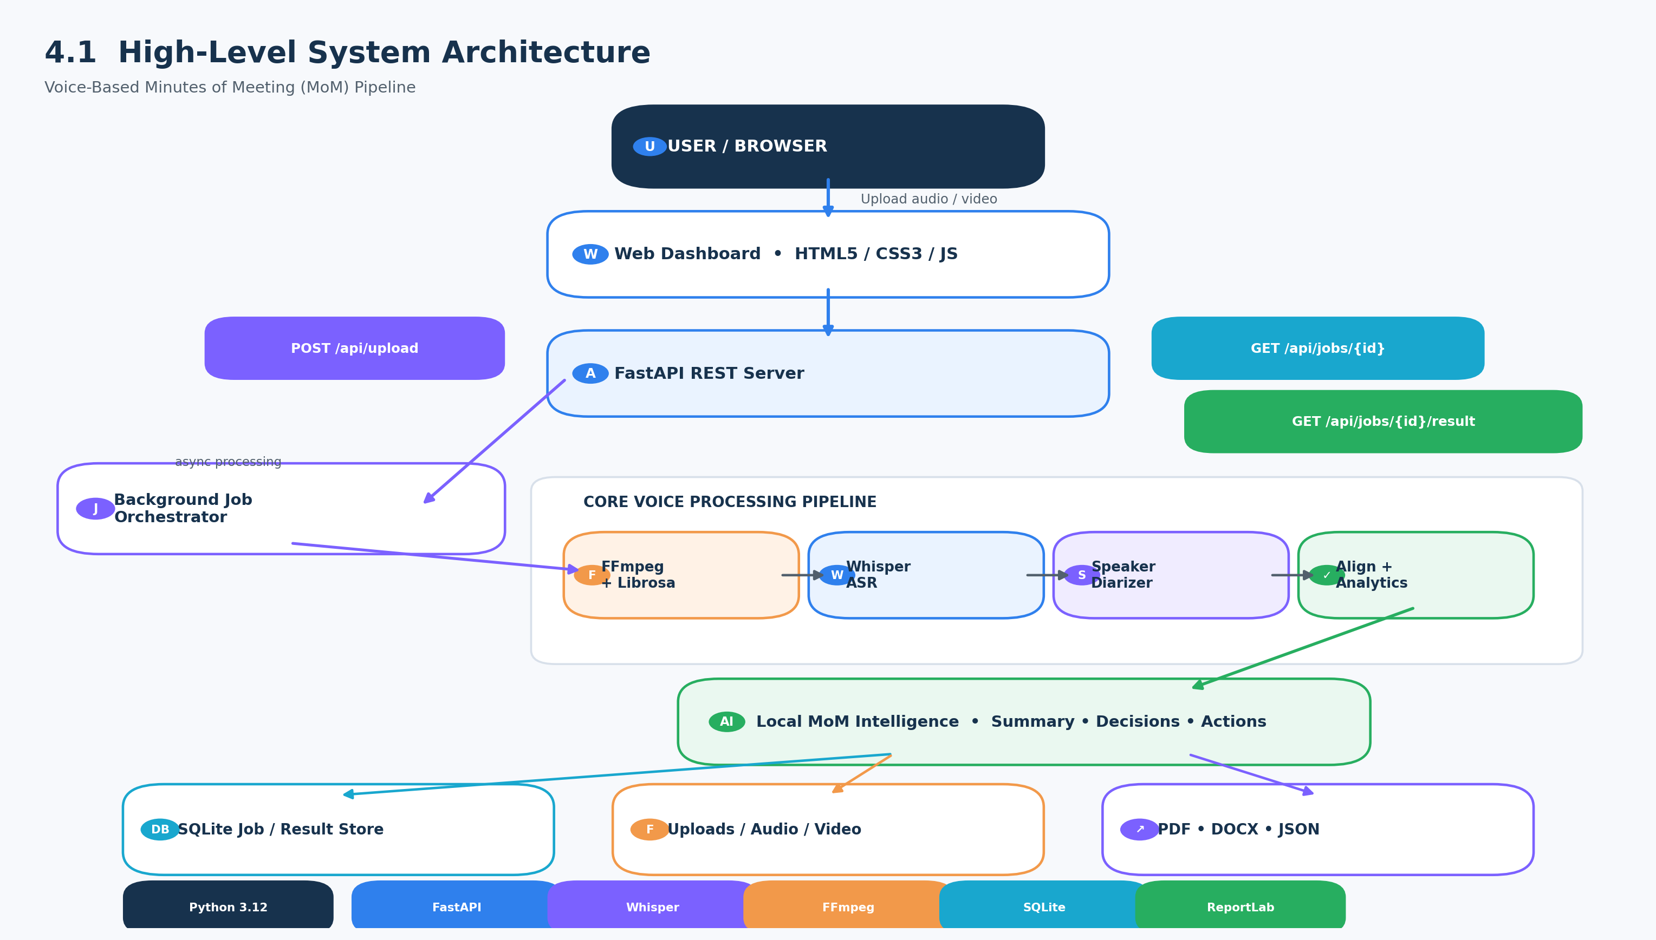

4.2 Pipeline Processing & Backend Architecture
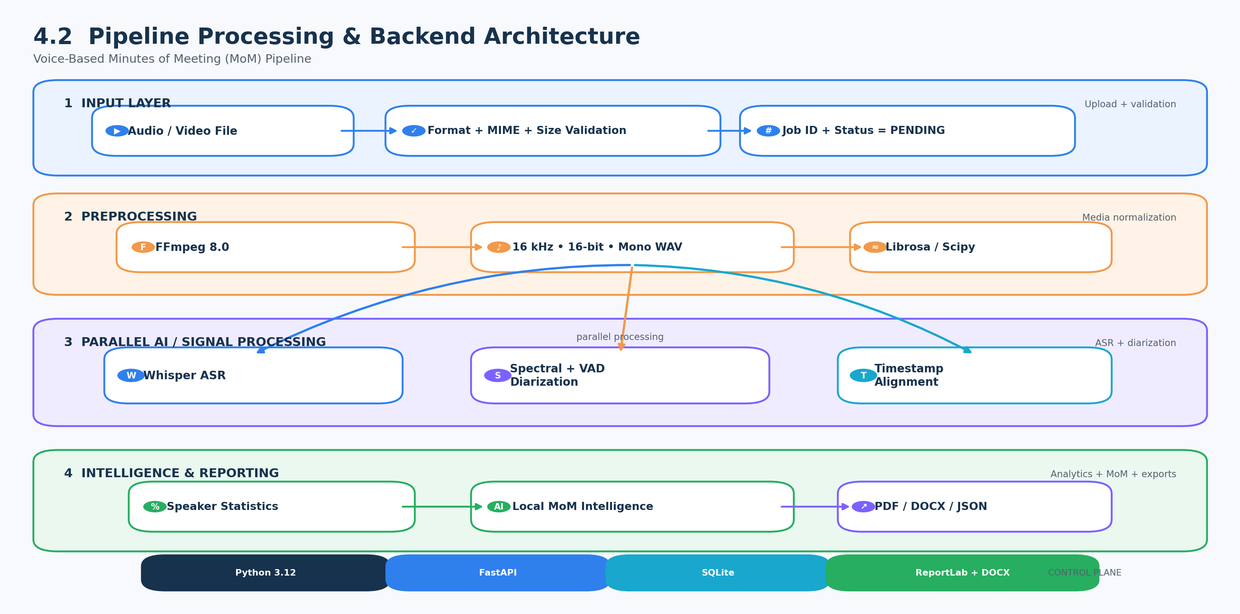

4.3 User Flow Diagram
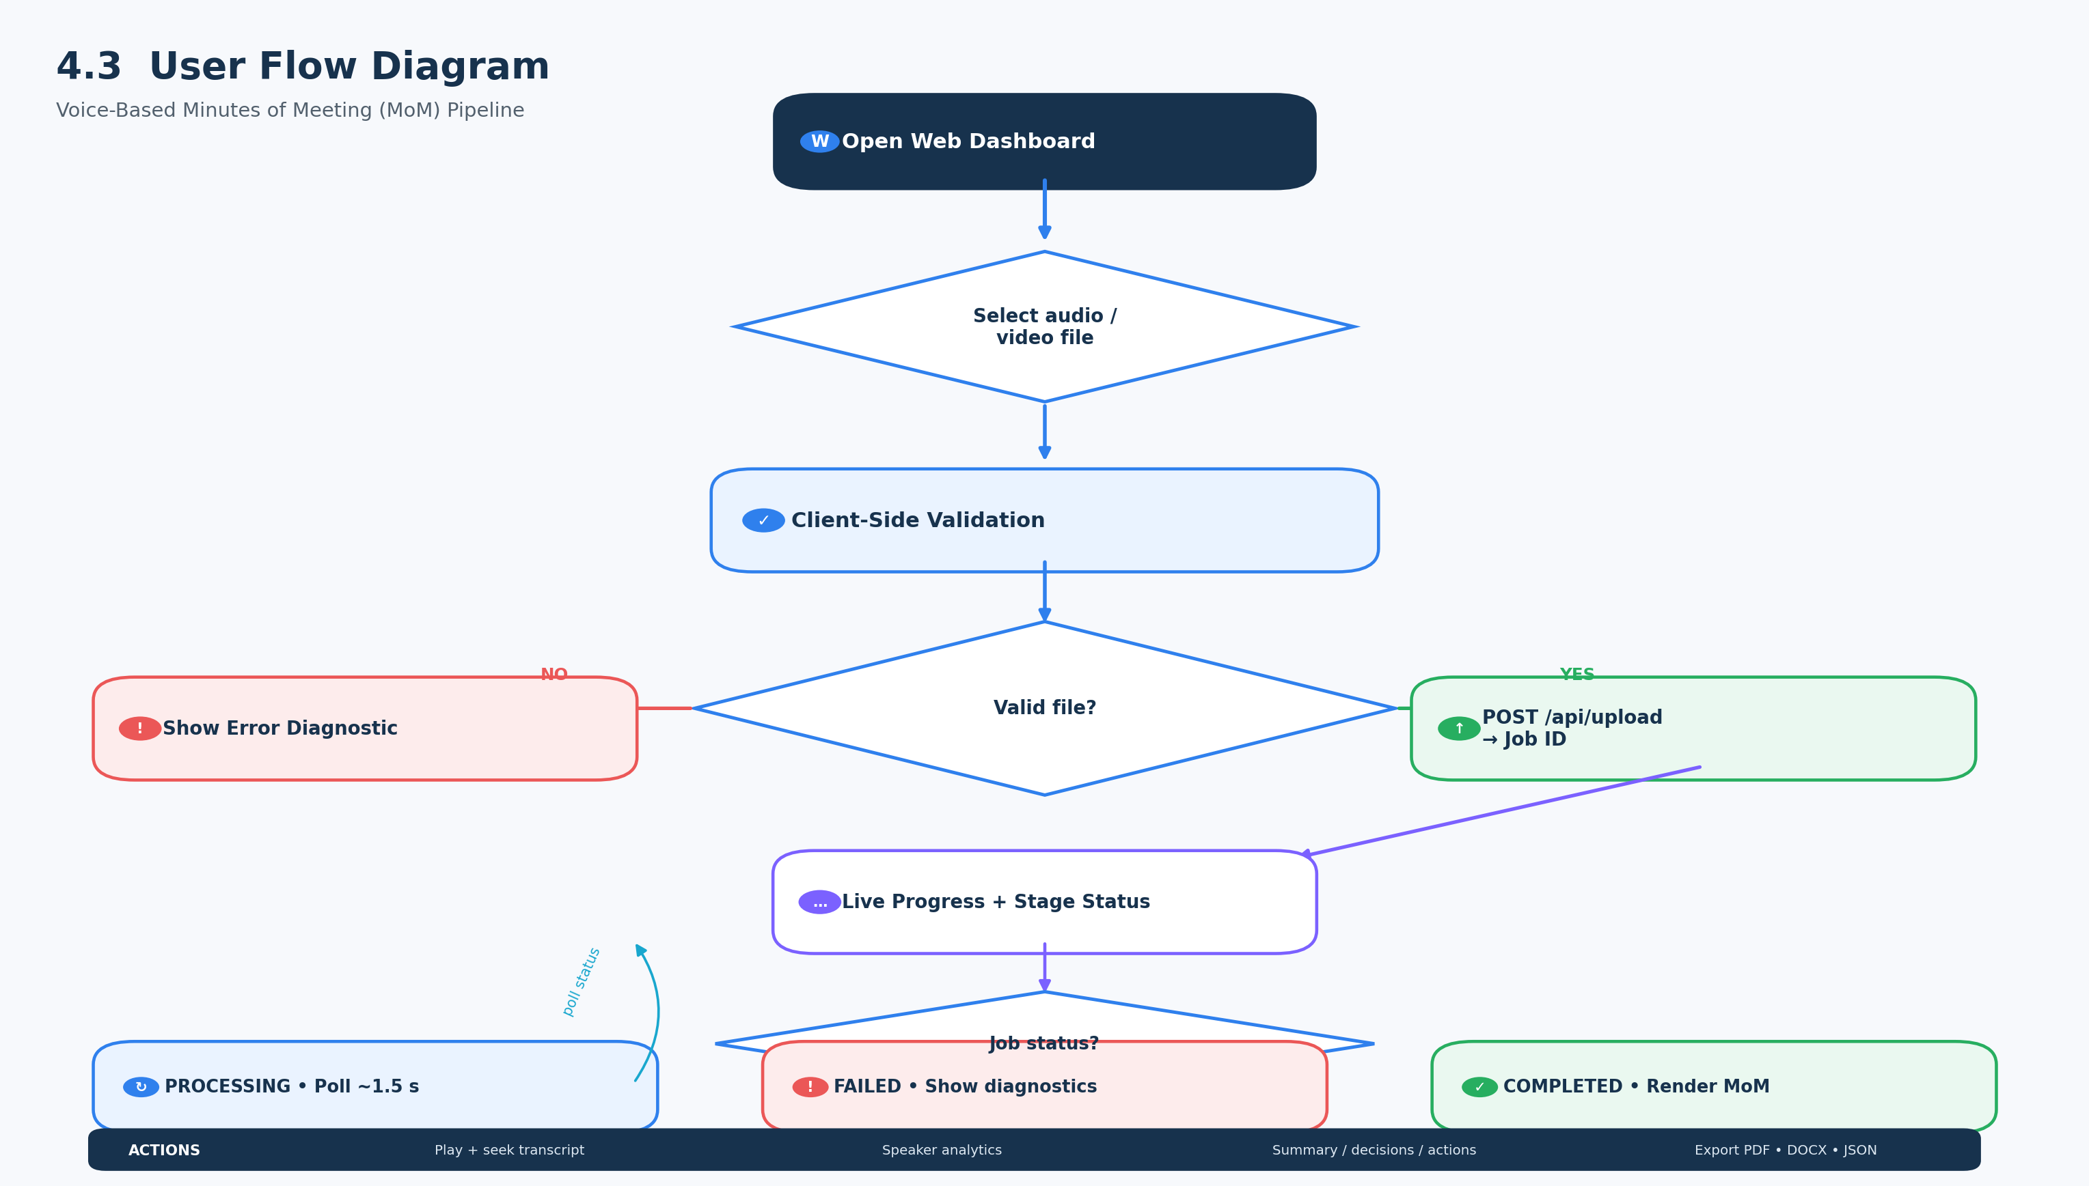

4.4 End-to-End Sequence Diagram
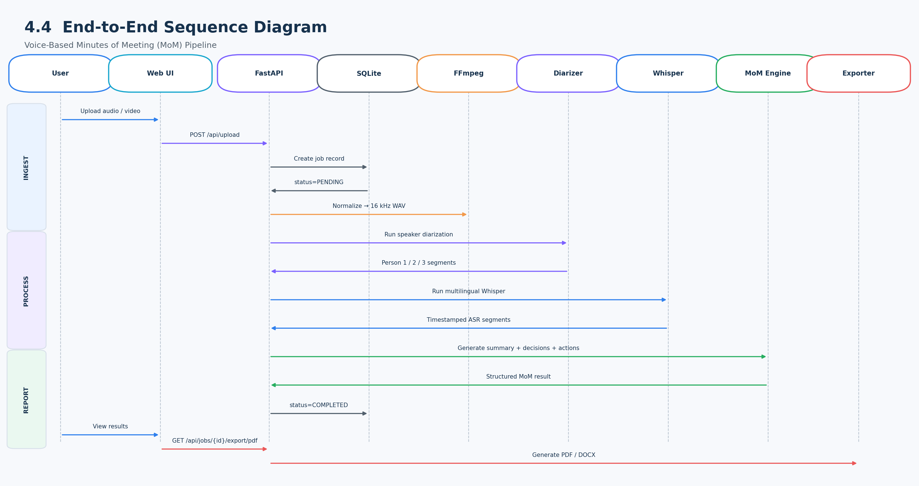

5. Processing Approach
- 1. Upload & Validation: FastAPI receives the meeting file, validates it, creates a processing job and stores the input.
- 2. Audio Preprocessing: FFmpeg converts the source into normalized 16kHz 16-bit mono PCM WAV.
- 3. Speaker Diarization: Frame VAD and audio features are used with clustering to identify distinct speaker turns and maintain persistent Person X labels.
- 4. Multilingual ASR: Whisper transcribes English, Hindi and Odia speech and returns timestamped speech segments.
- 5. Timestamp Alignment: The custom overlap matrix matches speaker intervals with ASR word/segment boundaries.
- 6. Conversation Analytics: NumPy/SciPy calculations produce speaking duration, proportion, segment count and primary-language statistics.
- 7. MoM Intelligence: Local Transformers and rule-based/extractive NLP generate summary, discussion points, decisions and action items.
- 8. Storage & Export: The structured MoM result is stored and returned as JSON; PDF and DOCX reports are generated when requested.

6. API Design
Endpoint | Purpose
POST /api/upload | Upload meeting file and create processing job.
GET /api/jobs/{job_id} | Return processing status, progress and current stage.
GET /api/jobs/{job_id}/result | Return completed structured MoM JSON.
GET /api/jobs/{job_id}/export/pdf | Generate formal PDF MoM.
GET /api/jobs/{job_id}/export/docx | Generate formal DOCX MoM.

7. Final MoM Result Structure
{
"job_id": "...",
"filename": "...",
"meeting_title": "...",
"summary": "...",
"statistics": {
"total_audio_duration_seconds": 120.5,
"total_speakers_count": 2,
"speaker_statistics": [
{
"speaker": "Person 1",
"speaking_duration_seconds": 65.2,
"speaking_proportion_percent": 59.2,
"segment_count": 3,
"primary_language": "English"
}
]
},
"key_discussion_points": [],
"decisions": [],
"action_items": [],
"transcript": [
{
"speaker": "Person 1",
"start": 0.0,
"end": 12.5,
"text": "...",
"language": "English",
"confidence": 0.95
}
]
}

8. Error Handling & Reliability
- Reject unsupported, empty or corrupted files with clear diagnostics.
- Keep ASR, diarization, alignment and NLP stages modular and independently testable.
- Persist job status and progress so long recordings can be monitored.
- Log processing failures and preserve job metadata for debugging.
- Document limitations caused by noisy audio, overlapping speakers, accents and multilingual code-switching.

9. Step-by-Step Instructions to Run the Project
Here are the step-by-step instructions to run the project on your machine:

Step 1: Open PowerShell / Terminal in your Project Folder
Open your terminal and make sure you are in the project folder:

cd "c:\Users\adity\OneDrive\Desktop\template editor\Project"

Step 2: Install Project Dependencies
Run the following command to install all required libraries from requirements.txt:

pip install -r requirements.txt

(Note: We already pre-installed these dependencies during setup, so running this command will quickly confirm everything is ready).

Step 3: Generate Sample Meeting Recordings (Optional)
To create sample audio files in English, Hindi, and Odia for quick testing, run:

python -m scripts.generate_samples

This creates demo files in the samples/ folder (sample_english_meeting.mp3, sample_hindi_meeting.mp3, sample_odia_meeting.wav, sample_multilingual_meeting.mp3).

Step 4: Start the Application Server
Run the startup script:

python -m scripts.run

You will see output indicating the server is running:

Starting Voice-Based Minutes of Meeting Pipeline Server...

Access Web UI at: http://localhost:8000
Access API Docs at: http://localhost:8000/docs

Step 5: Open the Web UI Dashboard
Open your web browser (Chrome, Edge, Firefox) and go to: http://localhost:8000

What you can do in the Web UI:

• Drag & Drop any recorded meeting audio (.mp3, .wav, .m4a, .flac) or video file (.mp4, .mkv, .webm).
• Watch the live progress bar as it performs Speaker Diarization, Multilingual ASR (English, Hindi, Odia), Analytics, and MoM Intelligence.
• View Speaker Statistics (speaking duration in HH:MM:SS, percentage contribution, and segment counts).
• View the Executive Summary, Key Discussion Points, Decisions, and Action Items.
• Use the Interactive Audio Player: Click any transcript row to jump the audio directly to that exact timestamp!
• Click the PDF, DOCX, or JSON buttons to export formatted Minutes of Meeting documents.

10. Source Basis
This updated document is based on the uploaded Technical Design Document and the exact technology/component specifications and run instructions supplied for this revision.

