# Exercise 4: Download Zip File

1. In the address window enter the below URL and hit the Enter key. This will download the class files (in a .zip format) needed for the remaining labs. **Note that the link is case sensitive.**

https://www.dropbox.com/s/pdhuouv2mn8gnze/Student%20Files.zip?dl=0

1. You will be prompted about what you want to do with the file. Select **Save**.

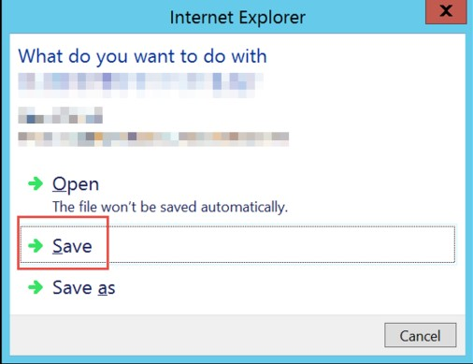

1. Download progress is shown at the bottom of the browser window. When the download is complete, click **Open folder**.



1. The **Downloads** folder opens. **Right-click** the zip file and click **Extract All**.In the **Extract Compressed (Zipped) Folders** window enter **C:\AzureVMData** in the **Files will be extracted to this folder** dialog. Click the **Extract** button.

# Exercise 5: Configure the Azure PowerShell cmdlets for your Subscription

Note: The lab VM you created already has the Azure PowerShell cmdlets installed but we will update the version to ensure the labs work well.

1. In Internet Explorer navigate to <https://azure.microsoft.com/en-us/downloads/>. Click the link for the **Windows install** in the **PowerShell** section of the page and choose **Run.**

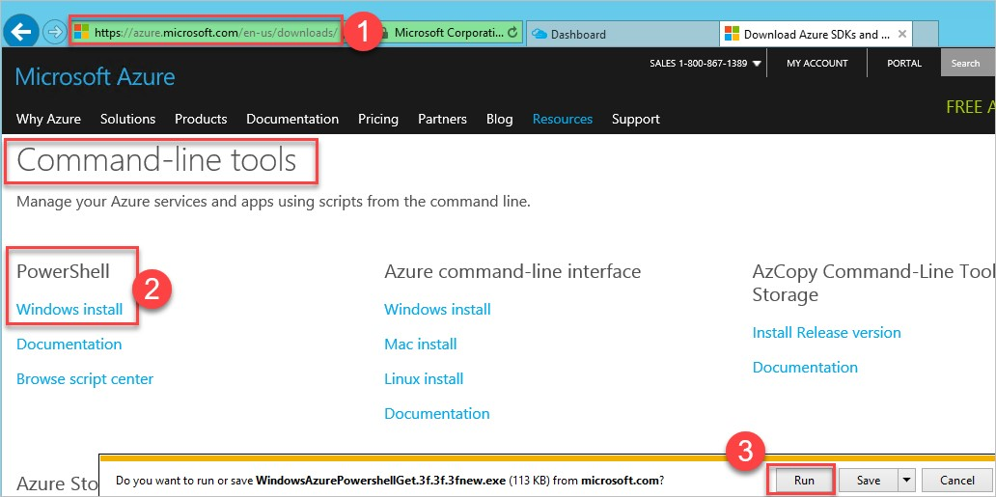

1. A Web Platform Installer dialog box will open. Click **Install** to install the latest version of the Azure PowerShell module.

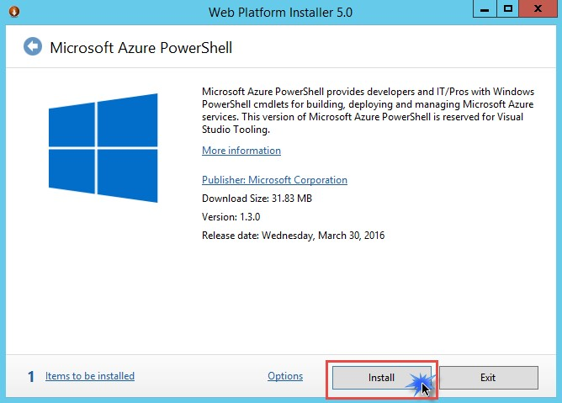

1. On the next dialog, click **I Accept** to accept the license terms for Azure PowerShell.

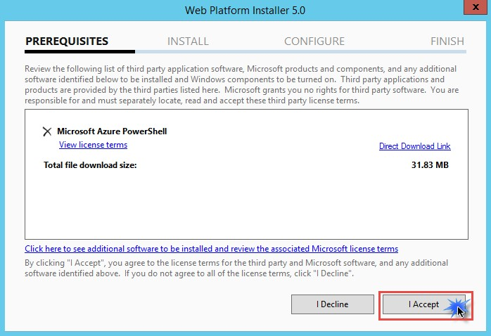

1. When the install is completed, click **Finish**.

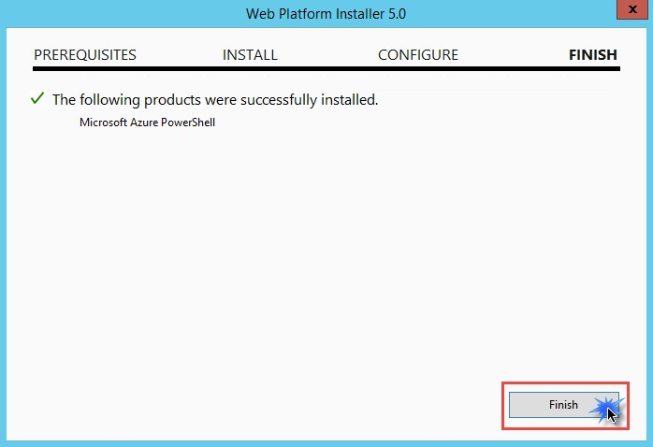

1. Within the Web Platform Installer screen, click **Add** to also install the Microsoft Azure Cross-platform Command Line Tools.

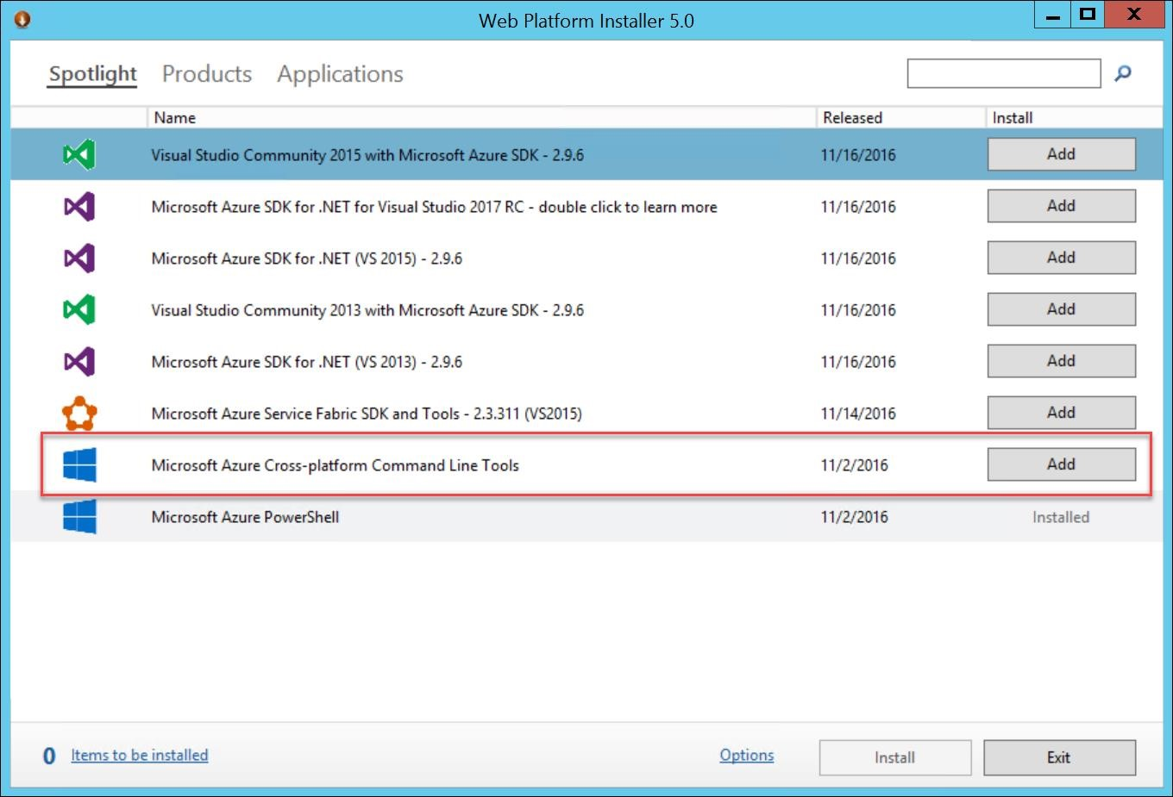

1. Click **Install** and accept the license agreement for this item as well.
2. Once the installations for both the Azure PowerShell and Command line tools are complete,

**restart the HardikLABVM and reconnect after it has been restarted and continue.**

1. Launch the PowerShell Integrated System Environment (ISE), by opening a Windows run prompt.

To do this, **Right-click** on the **Start** button and choose **Run**

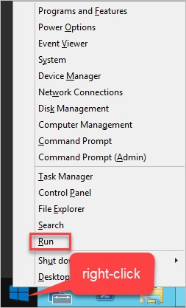

1. Launch the PowerShell Integrated System Environment (ISE) by typing in **PowerShell_ISE** in the Windows run prompt.

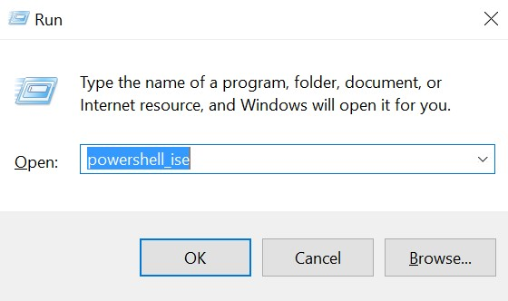

The ISE consists of two windows, the Script Pane and the Console Pane. If the Script Pane is not visible click the **^** icon towards the top right of the window. The Console Pane is where you can execute individual commands with immediate results and the script pane is designed for authoring complete scripts.

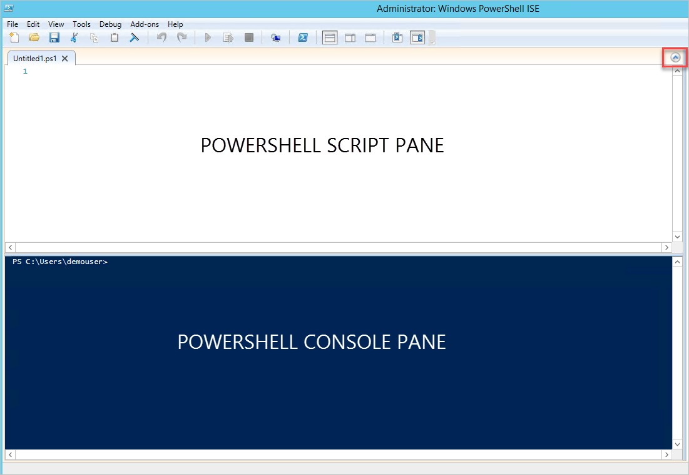

1. In the console pane execute the following command:

**Set-ExecutionPolicy –ExecutionPolicy ByPass –Scope CurrentUser**

**Note**: This is a security change to your system in order to execute local scripts. To reset the permissions back to default run the following:

**Set-ExecutionPolicy –ExecutionPolicy Default –Scope CurrentUser**

1. Click Yes at the Execution Policy Change Prompt

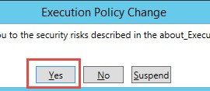

# Exercise 6: Configure the Azure Command Line Interface (CLI)

1. Click Windows button and search for **Windows PowerShell**. Launch a PowerShell prompt in Administrator mode by first right-clicking on the PowerShell icon on the task bar choosing **Run as Administrator**.

|  |  |
| --- | --- |
| C:\Users\ranpu\AppData\Local\Microsoft\Windows\INetCache\Content.Word\vm010.png | C:\Users\ranpu\AppData\Local\Microsoft\Windows\INetCache\Content.Word\vm011.png |

1. Confirm that the Azure CLI was installed by simply typing ‘azure’ and choosing ‘y’ for data collection.

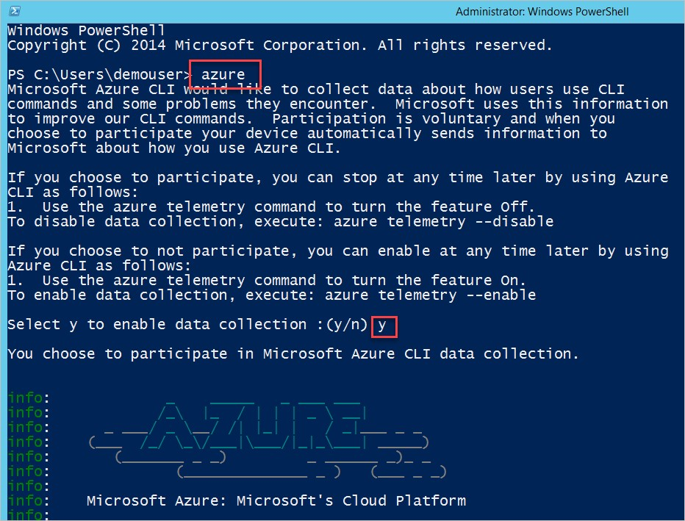

1. Type the following command to login

azure login

The Command will return with devicelogin url and authentication code for your device.

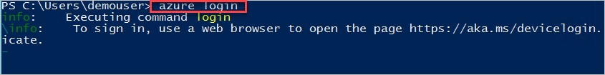

1. Browse to Device login URL https://aka.ms/devicelogin and Enter code into textbox. The Portal would identify the application publisher as Microsoft Azure CLI. Click **Continue**.

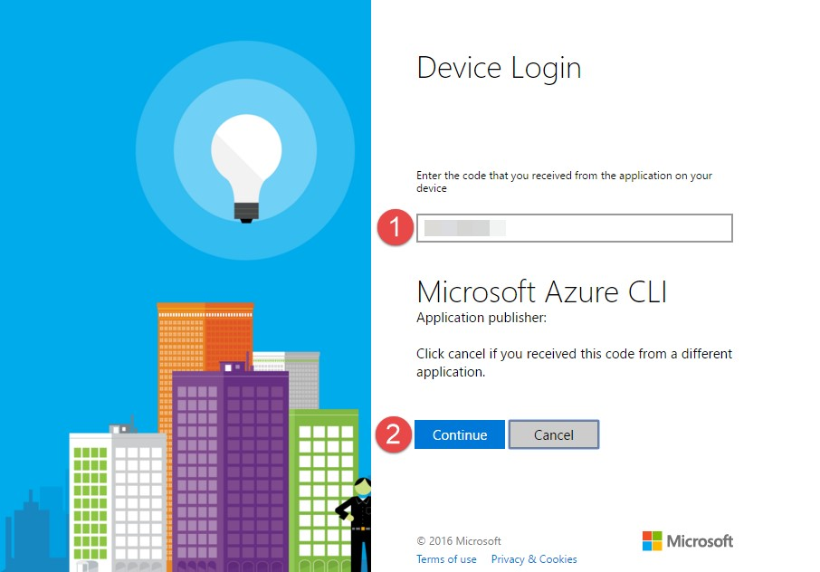

1. Login with your Microsoft Azure account credentials. After a successful authentication, the device login portal would return as below:

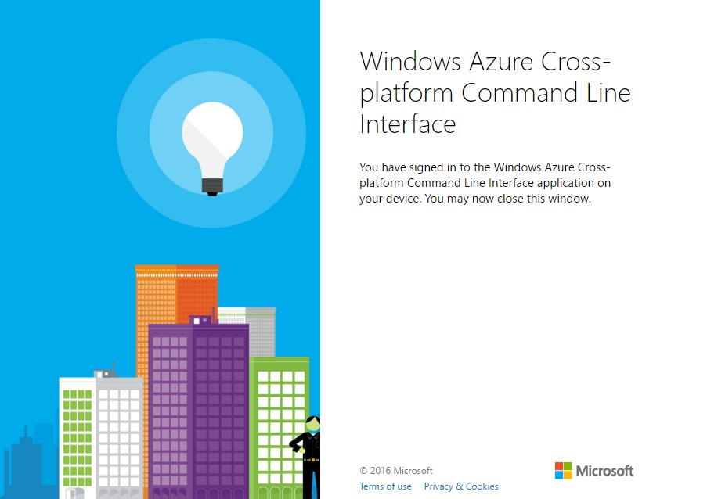

1. Also, the Azure CLI console returns with message **login command OK**.

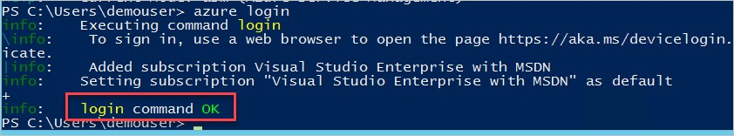

1. To list all the subscriptions associated with your account, enter command

**azure account list**

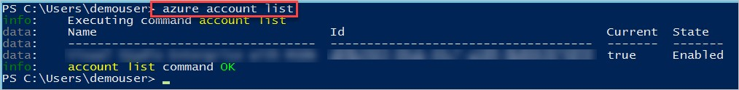

1. Select the subscription that you will use throughout this course. Enter the command (the quotes are required), where the “[subscription_name/id]” is the name of the subscription you would like to use.

azure account set "[subscription_name/id]"

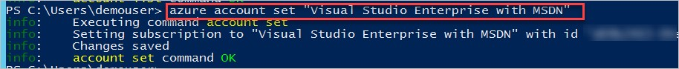

1. To select azure mode (classic/arm) for your session, enter the command

azure config mode arm

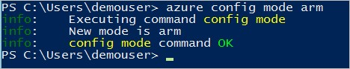

1. Refer to the following URL for the Azure CLI commands in Resource Manager mode https://azure.microsoft.com/en-us/documentation/articles/azure-cli-arm-commands/