# Creating an Azure VM in a Virtual Network

## Lab Overview

In this lab, you will create a virtual network that will be used for several of the hands-on labs in this course. You will then create a virtual machine and specify the virtual network configuration and the availability set configuration along with storage for the virtual machine.

## Exercise 1: Login to the Azure Management Portal

1. From within the RDP session (**HardikLabVM**), open Internet Explorer and navigate to https://portal.azure.com and authenticate with your Organization or Microsoft Account by selected the correct link.

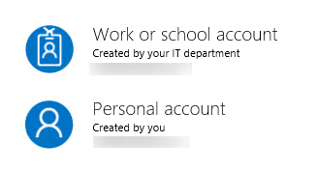

## Exercise 2: Create an Azure Virtual Network

1. Click **New**, **Networking**, and then click **Virtual Network**.

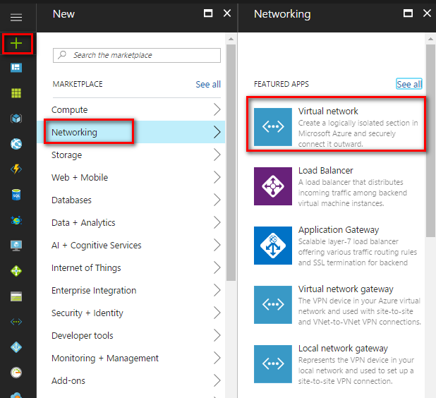

1. Leave the deployment model at **Resource Manager** and click **Create**.

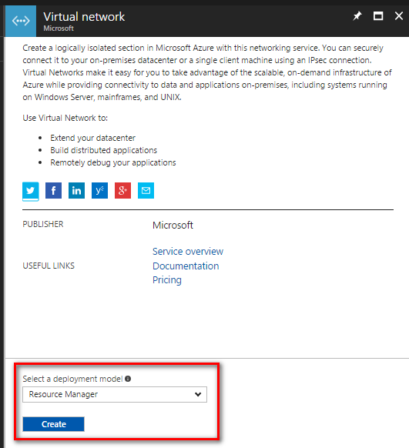

1. Specify the following configuration:
   * Name: **MyLabVNet**
   * Address space: **10.0.0.0/16**
   * Subnet name: **Apps**
   * Subnet address range: **10.0.0.0/24**
   * Resource Group: **rgMyLabVNet**
   * Location: **Select a region different than the one you used for the lab virtual machine.** (Location: Central India)

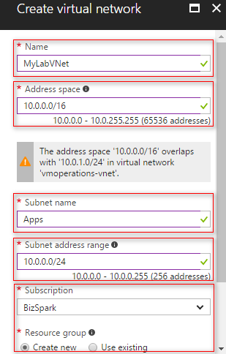

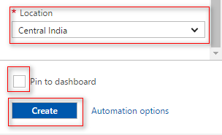

You may see a warning like this when creating the virtual network. This is just letting you know that you cannot connect these two virtual networks later using a site-to-site or ExpressRoute connection because the address range overlaps. You can ignore this warning.

1. 4. Check the box **Pin to dashboard** and click **Create** to create the virtual network.

