## Exercise 3: Update the Virtual Network (Add subnet)

1. Click the **MyLabVNet** tile to open the virtual network.

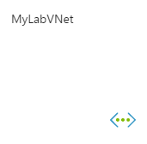

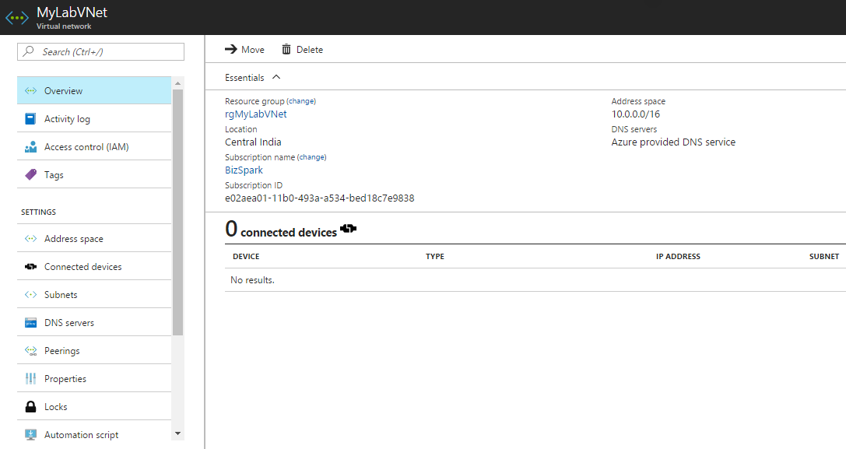

1. Click the **Subnets** tile on the virtual network configuration blade.

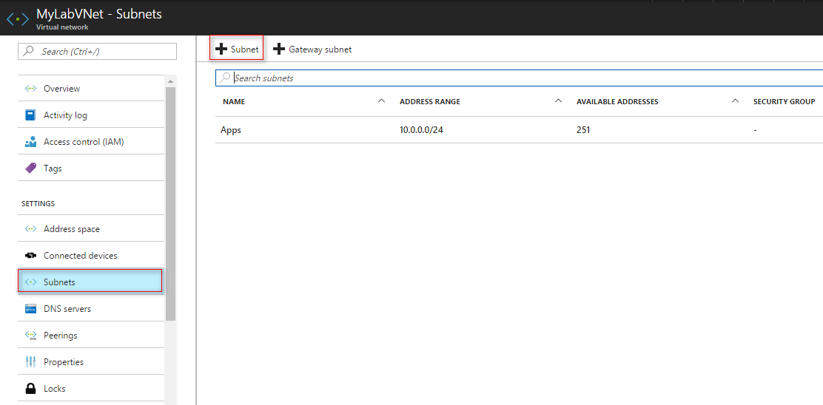

1. Specify the following configuration on the new subnet and click **OK**.
   * Name: **Datas**
   * Address Space: **10.0.1.0/24**

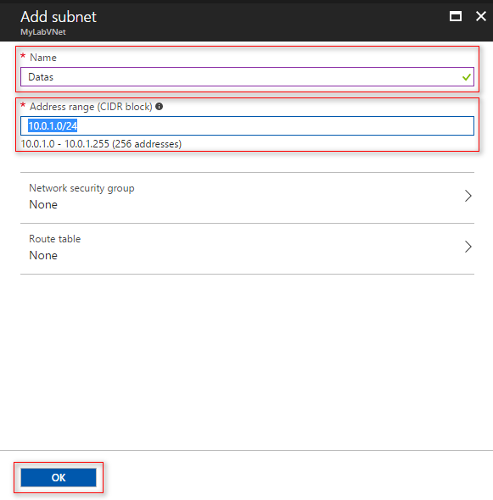

You should have two subnets with following address ranges:

