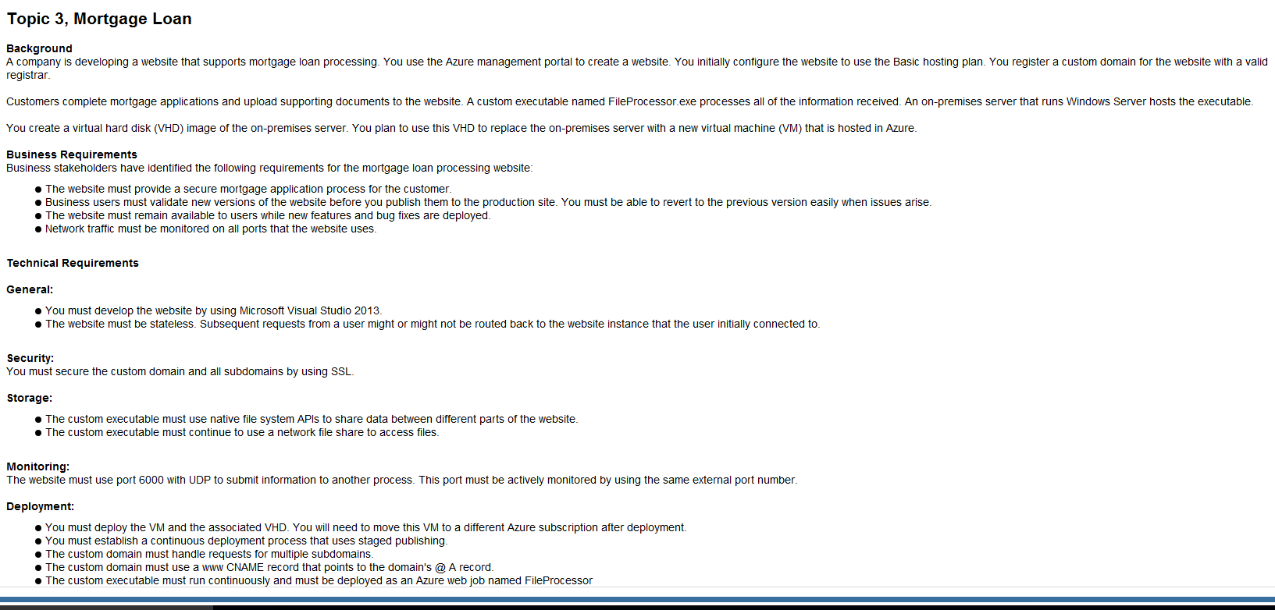

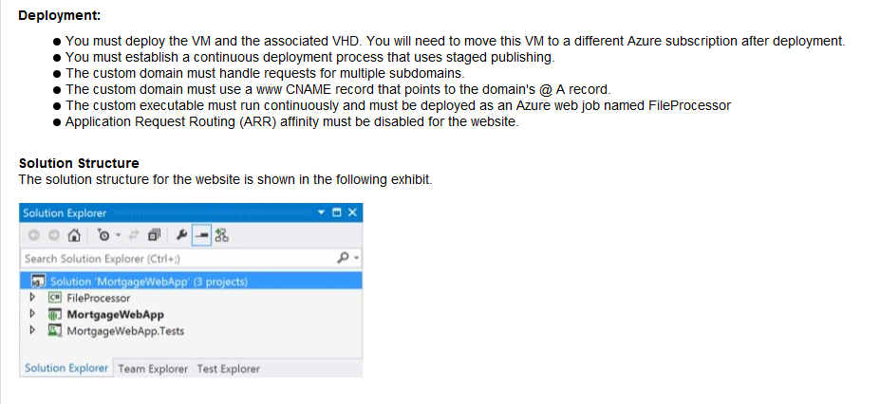

1)

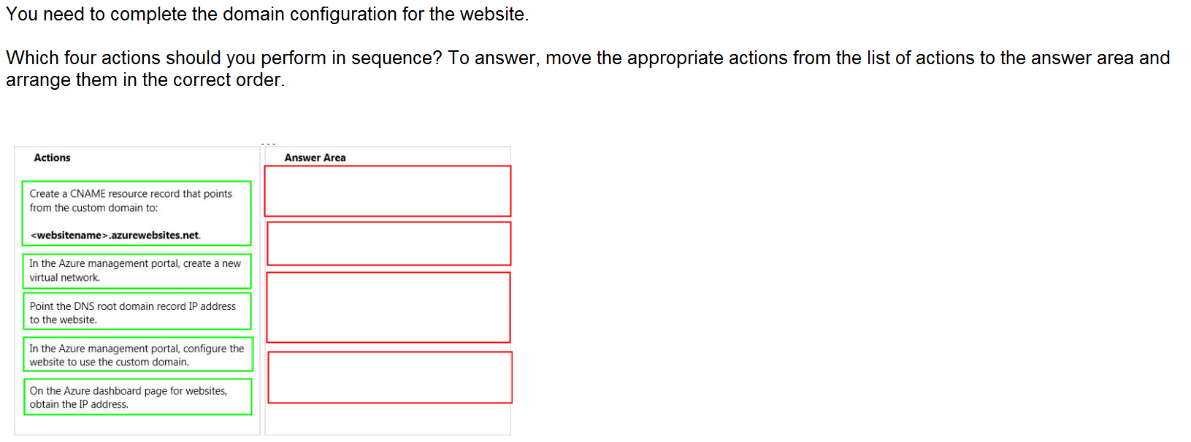

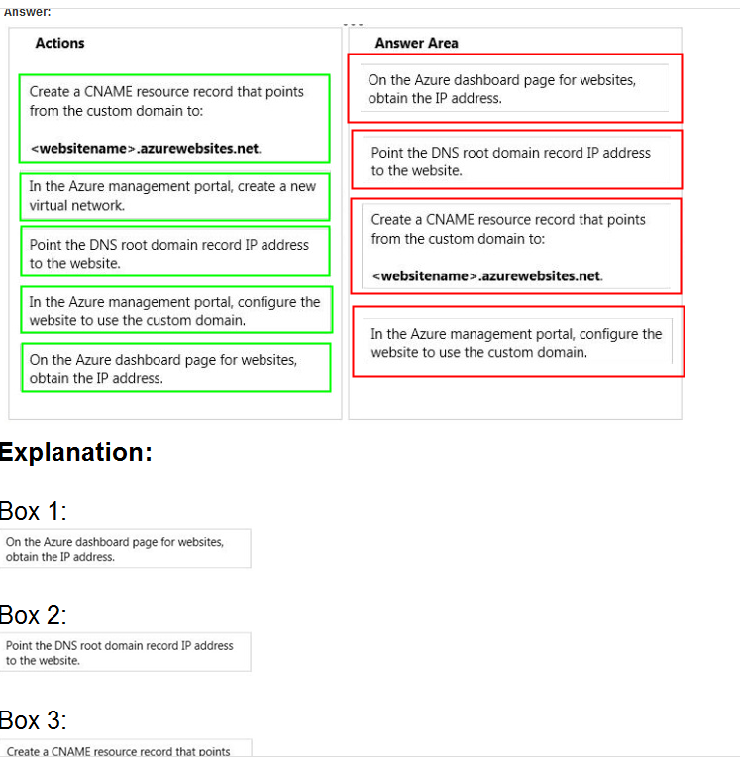

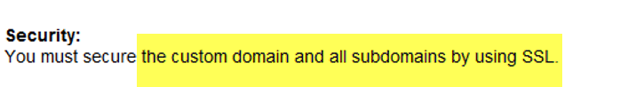

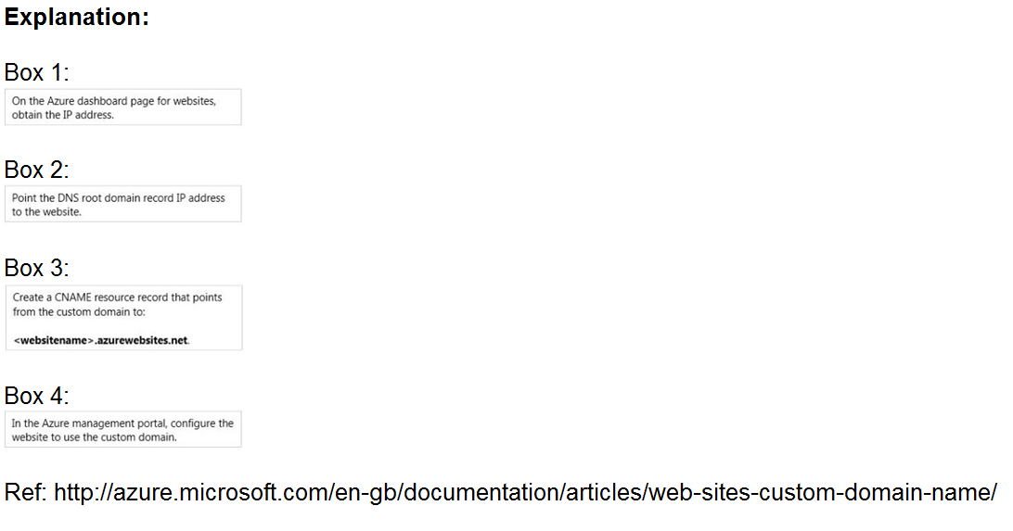

2)

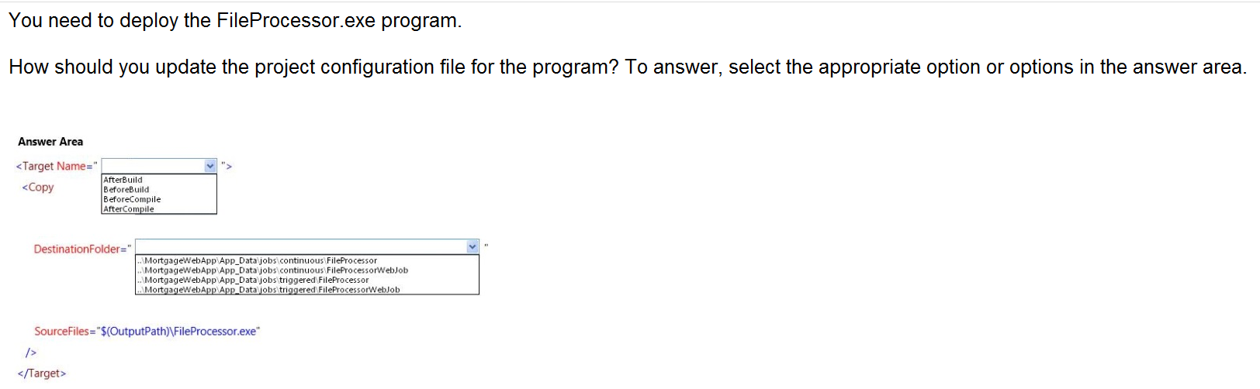

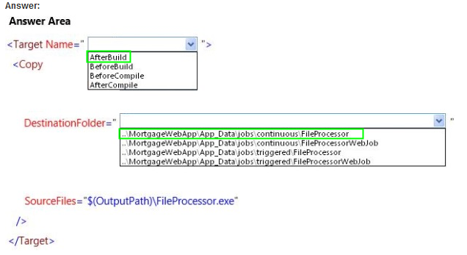

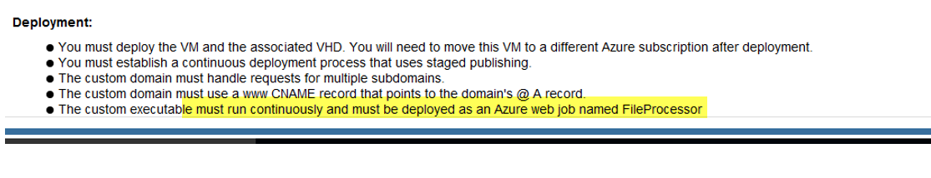

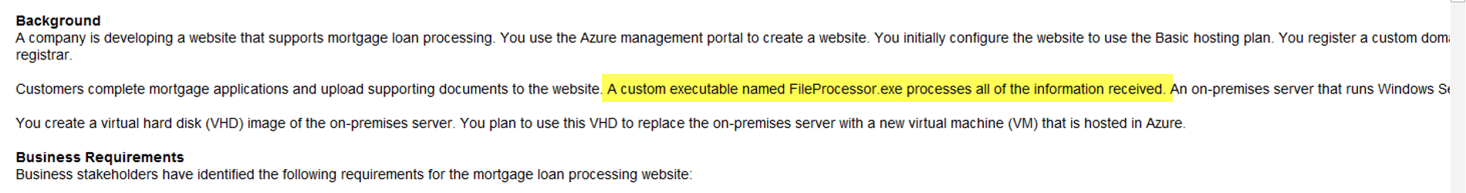

When Visual Studio deploys a WebJobs-enabled Console Application project, it performs two tasks:

* Copies runtime files to the appropriate folder in the web app (*App_Data/jobs/continuous* for continuous WebJobs, *App_Data/jobs/triggered* for scheduled and on-demand WebJobs).
* Sets up [Azure Scheduler jobs](https://docs.microsoft.com/en-us/azure/app-service-web/websites-dotnet-deploy-webjobs#scheduler) for WebJobs that are scheduled to run at particular times. (This is not needed for continuous WebJobs.)

+

A WebJobs-enabled project has the following items added to it:

* The [Microsoft.Web.WebJobs.Publish](http://www.nuget.org/packages/Microsoft.Web.WebJobs.Publish/) NuGet package.
* A [webjob-publish-settings.json](https://docs.microsoft.com/en-us/azure/app-service-web/websites-dotnet-deploy-webjobs" \l "publishsettings) file that contains deployment and scheduler settings.

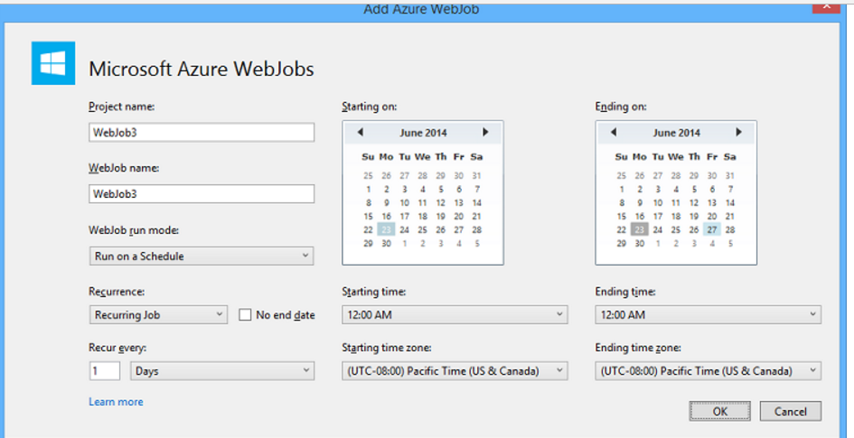

3)

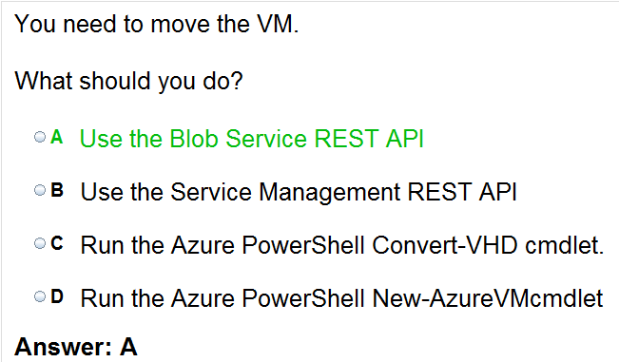

VM hard disk ( I mean the .vhd files are stored in the Page blob only )

4)

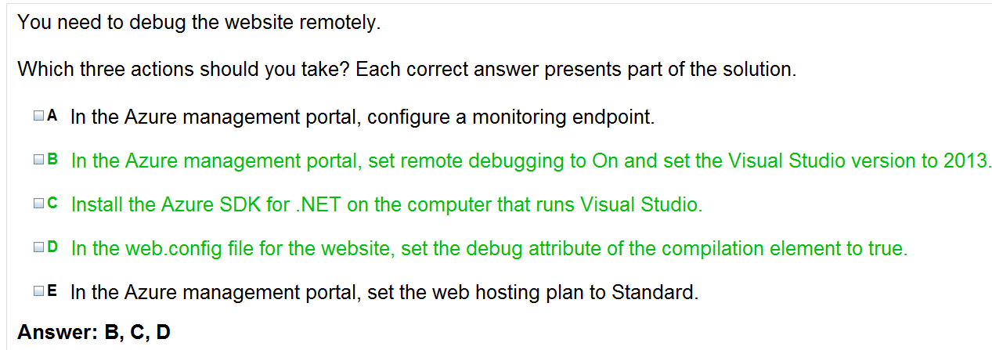



5)



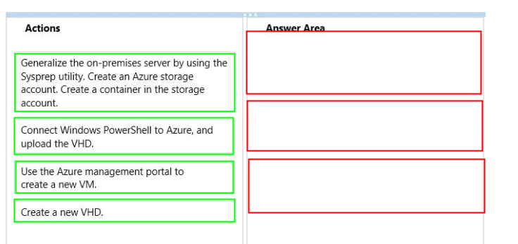

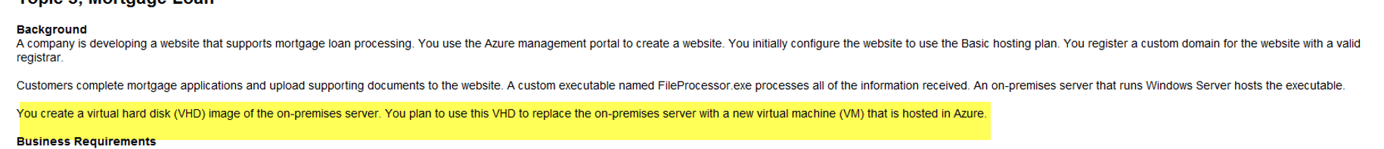

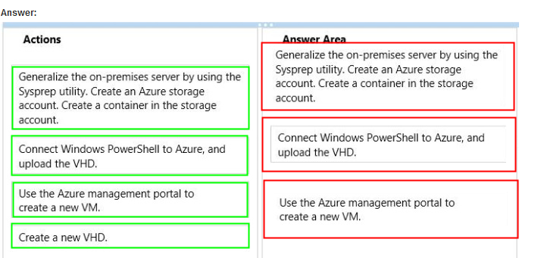

6)

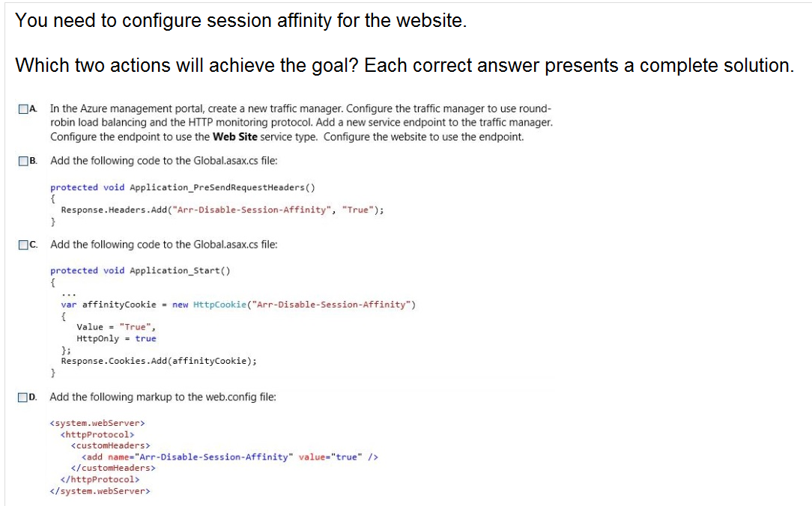

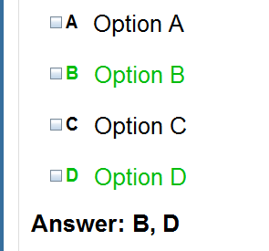



7)

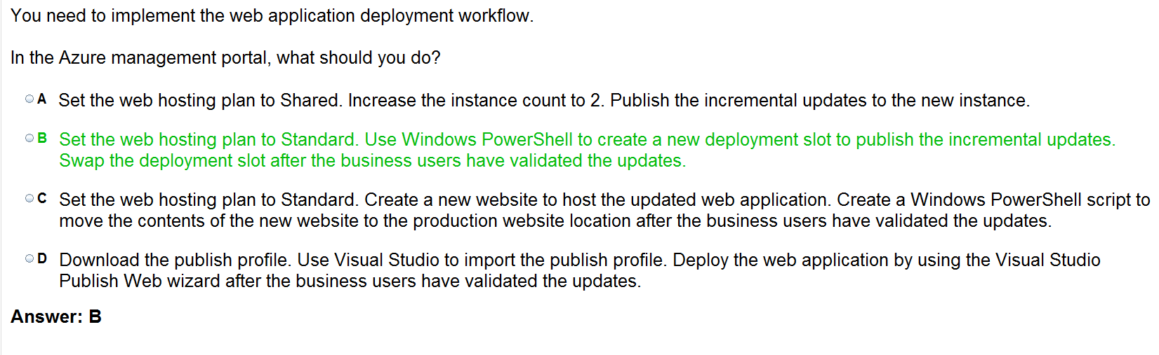

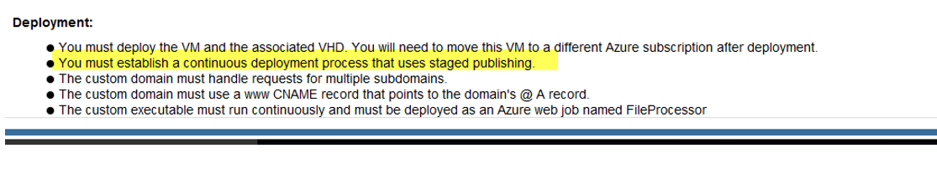

8)

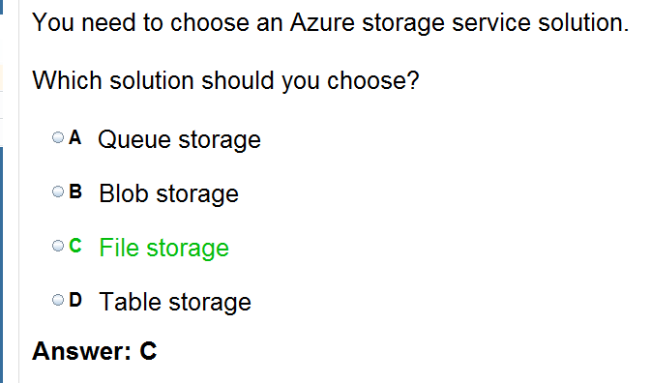

With SMB protocol for sharing the data files for working of custom exe file

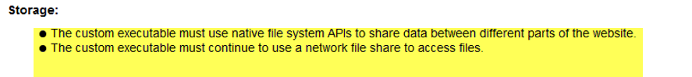

9)



