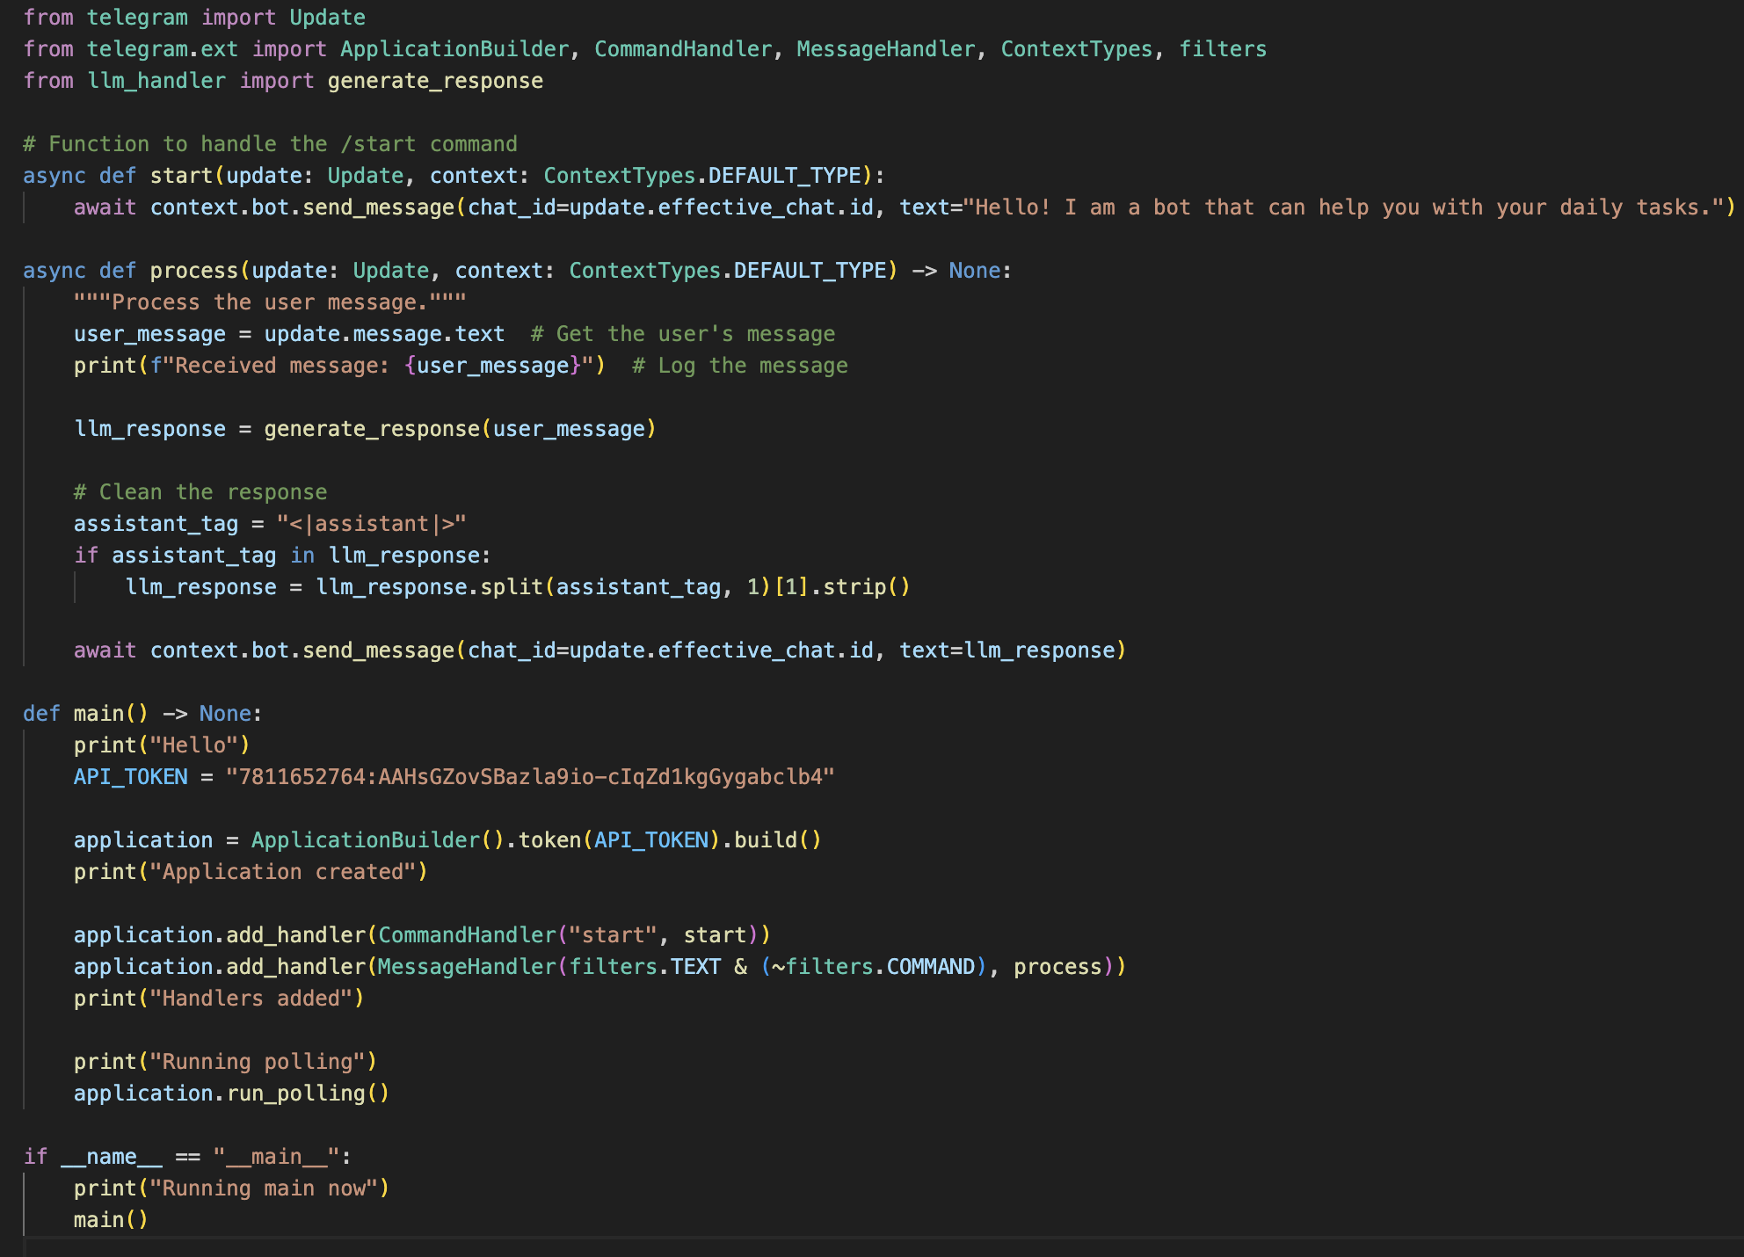Task 1: Task 2:

**Rohit Potdukhe, M. N.: 22985091, IdM: yx49uxym**

Guthub link : https://github.com/rohitpotdukhe01/HW9

Bot link : t.me/ropo_ai_bot