RESULTS :

COMPARISION OF SEARCHING ALGORITHMS :
FUNCTION USED:

F(x,y) = (∑(i*cos((i+1)*x+i)))*( ∑(i*cos((i+1)*x+i)))
+(x+1.42513)^2+(y+0.80032)^2

OPTIMISATION ALGORITHM | VALUE OF FITNESS FUNCTION | XMIN YMIN
BFO | -186.7222 | -1.4757 -0.7886
GA | -186.7187 | -1.4230 -0.7990
ACO | -186.7278 | -1.4257 -0.7993
PSO | -186.7309 | -1.4251 -0.8003

INFERENCE :
The performance of PSO was observed as the most efficient among the above four algorithms.
Hence we will train our ANN using PSO algorithm.

TRAINING PSO WITH ANN :
In each epoch, all the particles update their position by calculating the new velocity, which they use to move to the new position. The new position is a set of new weights used to obtain the new MSE. In MPPSO, if the new MSE does not decrease, the particle will not move to the new position and thus the new weights are discarded. For PSO, the new weights are adapted even though no improvement is observed. This process is repeated for all the particles.The particle with the lowest MSE is considered the global best particle discovered so far. The training process continues until satisfactory error is achieved by the best particle or computational limits are exceeded. When the training process ends, the weights are used to calculate the classification error for the training pattems.

ANN BACKPROPAGATION OUTPUT :

Data set : IRIS

ON training data :
CLASS | MISCLASSIFIED
Iris setosa = 0 0 1 | 0
Iris versicolor = 0 1 0 | 10
Iris virginica | 12

Accuracy on training data = ( 128/150 ) * 100 = 85.33 %

Accuracy on test data = 70.00%

Epochs :
10000

PSO - ANN OUTPUT :

Data set : IRIS

Fitness Value :

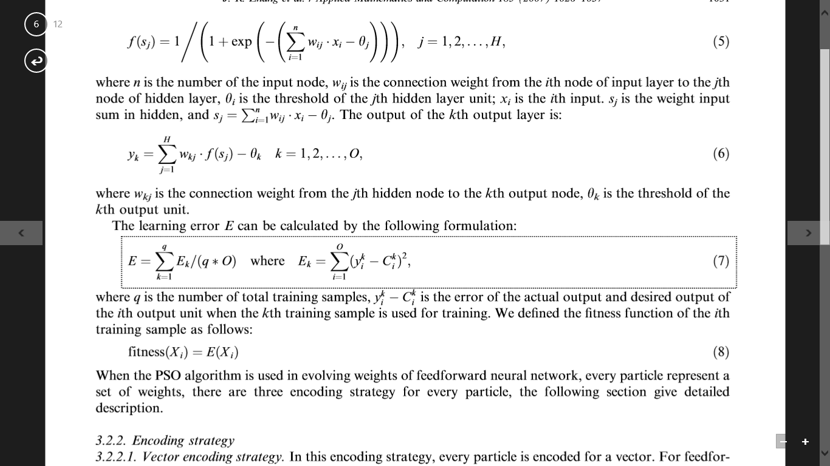

Data is a 30-item subset of the famous Iris flower set
Data is sepal length, width, petal length, width -> iris species
Iris setosa = 0 0 1, Iris versicolor = 0 1 0, Iris virginica = 1 0 0
Predicting species from sepal length & width, petal length & width

The training data is:
0: 6.3 2.9 5.6 1.8 1.0 0.0 0.0
1: 6.9 3.1 4.9 1.5 0.0 1.0 0.0
2: 4.6 3.4 1.4 0.3 0.0 0.0 1.0
3: 7.2 3.6 6.1 2.5 1.0 0.0 0.0
4: 4.7 3.2 1.3 0.2 0.0 0.0 1.0
5: 4.9 3.0 1.4 0.2 0.0 0.0 1.0
6: 7.6 3.0 6.6 2.1 1.0 0.0 0.0
7: 4.9 2.4 3.3 1.0 0.0 1.0 0.0
8: 5.4 3.9 1.7 0.4 0.0 0.0 1.0
9: 4.9 3.1 1.5 0.1 0.0 0.0 1.0
10: 5.0 3.6 1.4 0.2 0.0 0.0 1.0
11: 6.4 3.2 4.5 1.5 0.0 1.0 0.0
12: 4.4 2.9 1.4 0.2 0.0 0.0 1.0
13: 5.8 2.7 5.1 1.9 1.0 0.0 0.0
14: 6.3 3.3 6.0 2.5 1.0 0.0 0.0
15: 5.2 2.7 3.9 1.4 0.0 1.0 0.0
16: 7.0 3.2 4.7 1.4 0.0 1.0 0.0
17: 6.5 2.8 4.6 1.5 0.0 1.0 0.0
18: 4.9 2.5 4.5 1.7 1.0 0.0 0.0
19: 5.7 2.8 4.5 1.3 0.0 1.0 0.0
20: 5.0 3.4 1.5 0.2 0.0 0.0 1.0
21: 6.5 3.0 5.8 2.2 1.0 0.0 0.0
22: 5.5 2.3 4.0 1.3 0.0 1.0 0.0
23: 6.7 2.5 5.8 1.8 1.0 0.0 0.0

The test data is:

0: 4.6 3.1 1.5 0.2 0.0 0.0 1.0
1: 7.1 3.0 5.9 2.1 1.0 0.0 0.0
2: 5.1 3.5 1.4 0.2 0.0 0.0 1.0
3: 6.3 3.3 4.7 1.6 0.0 1.0 0.0
4: 6.6 2.9 4.6 1.3 0.0 1.0 0.0
5: 7.3 2.9 6.3 1.8 1.0 0.0 0.0

Creating a 4-input, 6-hidden, 3-output neural network
Using tanh and softmax activations
Setting numParticles = 12
Setting maxEpochs = 700
Setting early exit MSE error = 0.050
Setting probDeath = 0.005

Beginning training using a particle swarm

rand =System.Random
error = 0.0491198866768581
EPOCH = 131
length = 24
Training complete
Final neural network weights and bias values:

3.593 3.685 10.000 -10.000 10.000 -10.000 4.899 -9.153 -1.171 8.530
-6.360 2.523 -10.000 10.000 2.025 9.822 -9.285 6.353 -10.000 8.825
7.962 10.000 -10.000 9.465 -4.782 -7.976 -6.597 8.123 -8.307 7.143
-10.000 -6.934 -9.056 2.621 -2.295 -8.452 5.024 -6.821 1.129 7.932
8.456 10.000 -3.747 -9.420 The thread 0x27b8 has exited with code 259 (0x103).
The thread 0x1ff4 has exited with code 259 (0x103).
The program '[12932] WindowsFormsApplication1.vshost.exe' has exited with code 0 (0x0).
The program '[12932] WindowsFormsApplication1.vshost.exe: Program Trace' has exited with code 0 (0x0).
9.990 6.627 -10.000 -10.000 -7.322 4.828
7.151

Accuracy on training data = 0.9583

Accuracy on test data = 0.8333

End neural network training with particle swarm optimization demo

COMPARISON :

ANN- BP :
Accuracy on training data = ( 128/150 ) * 100 = 85.33 %
Accuracy on test data = 70.00%
Epochs :
10000

ANN-PSO :
Accuracy on training data = 0.9583

Accuracy on test data = 0.8333
EPOCH = 131

