Report

1. Berkeley
In my implementation of berkeley algorithm, a node acts as the master. All other processes spawed wait to read the data from the master. As the master process is initialized it prints out the time on its logical clock and sends request to each of the slave process to request for their logical clock.

The slave process will receive the request and parse it. The slave process sends its logical clock back to the master. Subsequently, the master calculates the average on these logical clock times. Using this average a drift value is calculated which is the offset by which the slave has to update its value. After the master node adjusts its time based on the average. The drift is calculated by the master and sent to the slaves. Finally, the slaves update and adjust their logical clock as per the drift value.

At the end, we see that all the clocks including the master are now syncronized to the same logical time. They print out their clocks and on the output we see that all clocks are now syncronized as seen in the screenshot below.

Syncronizing the messages was a challenge in this task. The master sends the data while the slave waits in the read blocking call, then the slave sends the data to master and the slave waits in the blocking call, designing this in the code was a bit challenging.

In the screenshot below, the logical time of slave 1 is updated to a value.
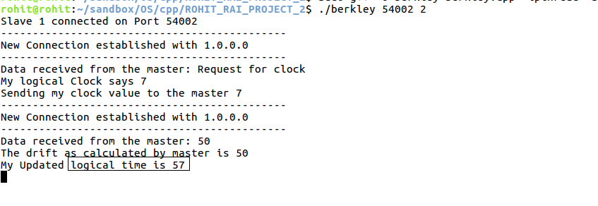

The logical time of slave 2 is also updated to the same value.

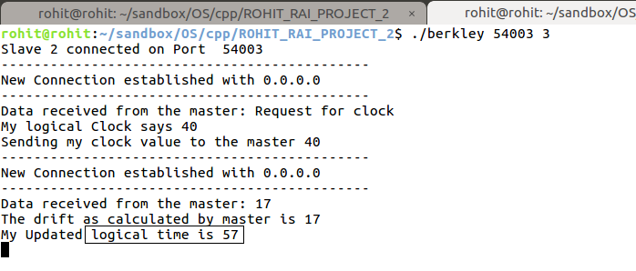

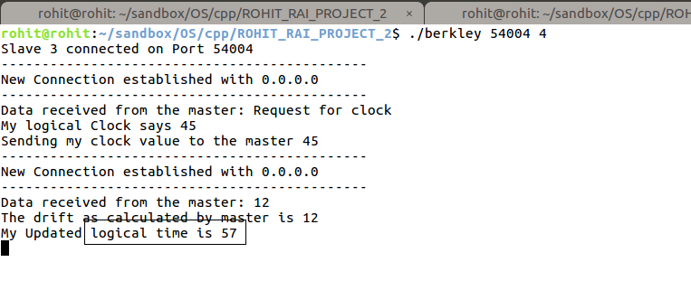
The logical time of the slave 3 is also updated to the same value.

And the master has also adjuste its logical clock, this output also has the final clock value received by master from each slave.

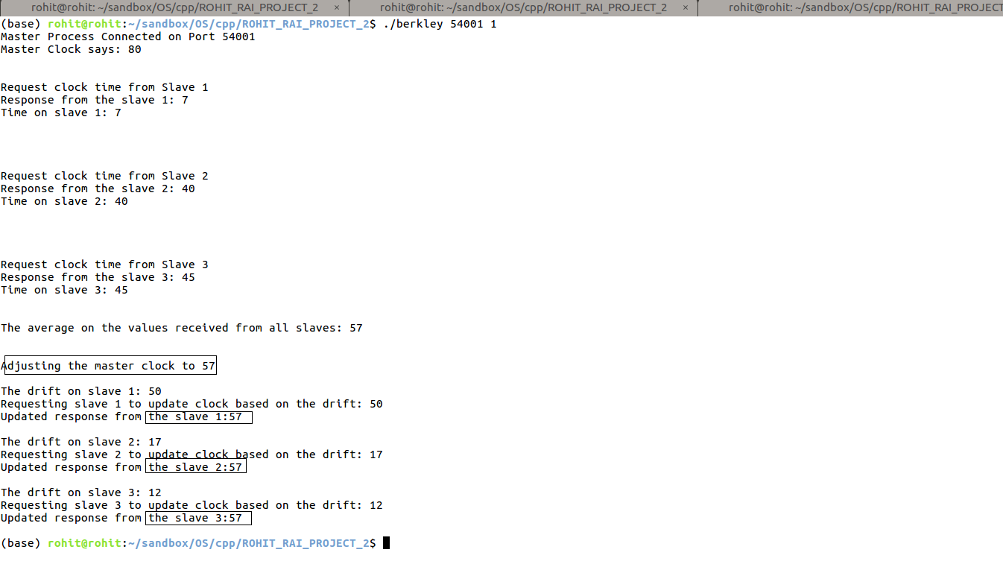
2. Causal Ordering & Non Causal Ordering
As per my implemention, as you run each multicast processes, each process spawns two different threads sender and the receiver. There are 3 processes, therefore total threads spawned will be 6. Each process keeps on sending multicast messages to all the other processes including itself.

When the process sends a message, its vector element is incremented by 1. When the vector is received on the reciver thread, the sequence number is verified. For instance, if process 1 sends a message to process 2 with vector 1, 0, 0. The first element of the current vector on the process 2 is checked and if the value of first element if incremented by 1 is equivalent to the sequence number of the received vector the message is delivered otherwise it is buffered.

Therefore, I have implemented the following rule for the Causal Ordering,

- Send multicast from processe Pi and update Pi[i] = P[i]i + 1
- Include the Pi[i] in the multicast message as sequence number
- Receive multicast from Pi to Pj
- Check if the sequence number, Pj[i] + 1, is equal to the sequence number of Pi
- If equal, deliver the message if not buffer the message.

This task was especially challenging, it was easy to design the sender thread, but a lot of thought process went into designing the receiver thread. Everytime a message was received the message had to be checked if it has to be delivered or buffered.

For the Non Causal Ordering, the above-mentioned implementation is true as well. Except that there is one more additional condition that has to be fullfilled. When the message is received at any process, with the sequence number it is also checked wheather the other values of the current vector on the process are greater than the delivered message.

The rules for non causal are as follows,
- Send multicast from processe Pi and update Pi[i] = P[i]i + 1
- Include the Pi[i] in the multicast message as sequence number
- Receive multicast from Pi to Pj
- Check if the sequence number, Pj[i] + 1, is equal to the sequence number of Pi
- If equal, then check if M[k] <= P[j]k, where k is not equal to i
deliver the message if not buffer the message.

The below ss is for causal ordering, the last message delivered on process 2 was from process 3 and its vector value was 0, 1, 1. The next message delivered was from process 1 with a value 2, 0, 0. Since the sequence number criteria is not maintained here, 0+1 is not equal to 2, this message is buffered.

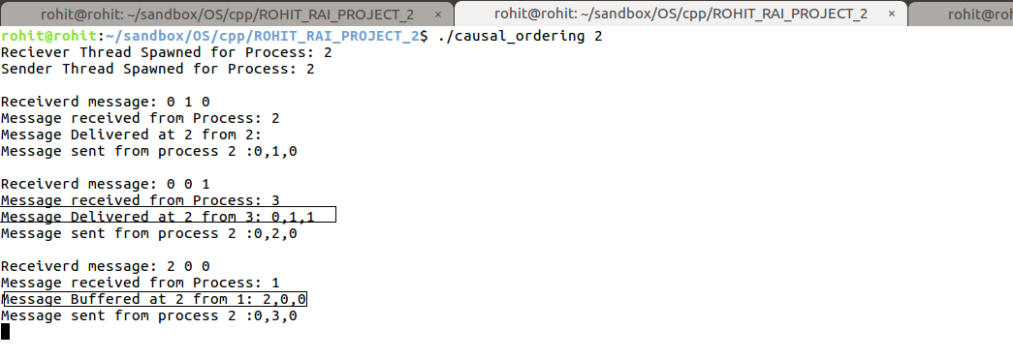

The similar condition is satified for the non causal ordering as can be seen in the below screenshot, however, in causal an additional condition to compare the other elements of the message with the current vector elements also needs to be satified.

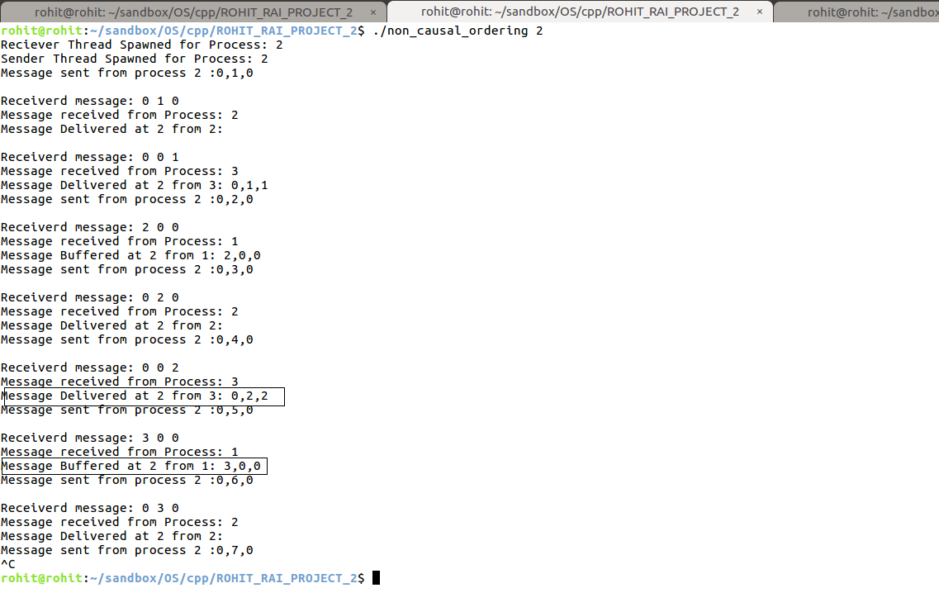

Here, the last message delivered at process 2 was 0,2,2 and the next was 3,0,0 since the sequence number criteria is not satisfied it was buffered. Also, in this case the elements other than sequence number of the received message are also compared with corresponding elements of current vector on the receving process.

It was really hard to implement multicast communication between all the process in a syncronized manner. Also, since the program has to identify what process is sending message to what other processes, program logic gets complex and gets divided into multiple section. Furthermore, when the vector array was introduced in the logic to handle the multicast messages delivery, it got even more complex to comprehend. I overcame this issue by making a program design on the paper just so it was not easy to get lost in what is going on.

Locking
For this one, I have implemented the centralized distributed algoritham that was discussed in the class from the text book. There are three slaves and a coordinator, the slaves are executed first. Once they are executed they wait for the response from the coordinator. Once the coordinator is executed which is the process with process id 1, it sends a message to all the slave process to inform that it is now active.
The slave process once informed of this, they start requesting for the resource from the coordinator. The coordinator checks the queue and the locking variable and makes a decision if this process can be given the resource or not. If the queue is empty the coordinator will send an ‘OK’ message to the requesting process and add its process id to its queue. In case any other process requests for the file, while some other process is already using it the requesting process will be denied and no response will be sent to it from the coordinator, in this case the coordinator will check its queue and see that the queue is not empty.

The coordinator keeps on adding processes in the queue and serves them one by one. Once the process is done using the resource they may send back “DONE” message to the coordinator and the coordinator now knows that the resource is now ready to be allocated to a different process now.

The algorithm guarantees mutual exclusion, the coordinator lets only one process at a time to use the resource. It is also a fair algorithm as the processes are given the resources in the order which they request them, no process will ever wait forever for the resource. This process also has its short commings as it is prone to a single point of failure where if the coordinator fails the whole system distrupts.

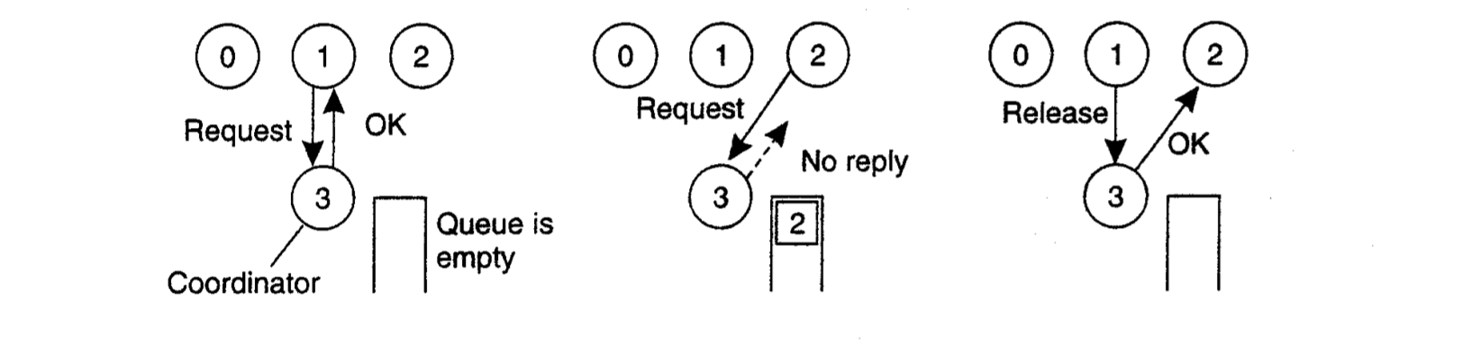

The figure demostrate how my implementation works.

