STep-1
Install
https://ollama.com/download/windows
ollama in loca
tinyllama:latestl

STEp-2 Install n8n in local
Step-3
npm install -g n8n
n8n --version
n8n
- URL: http://localhost:5678

Step-4
Created workflow

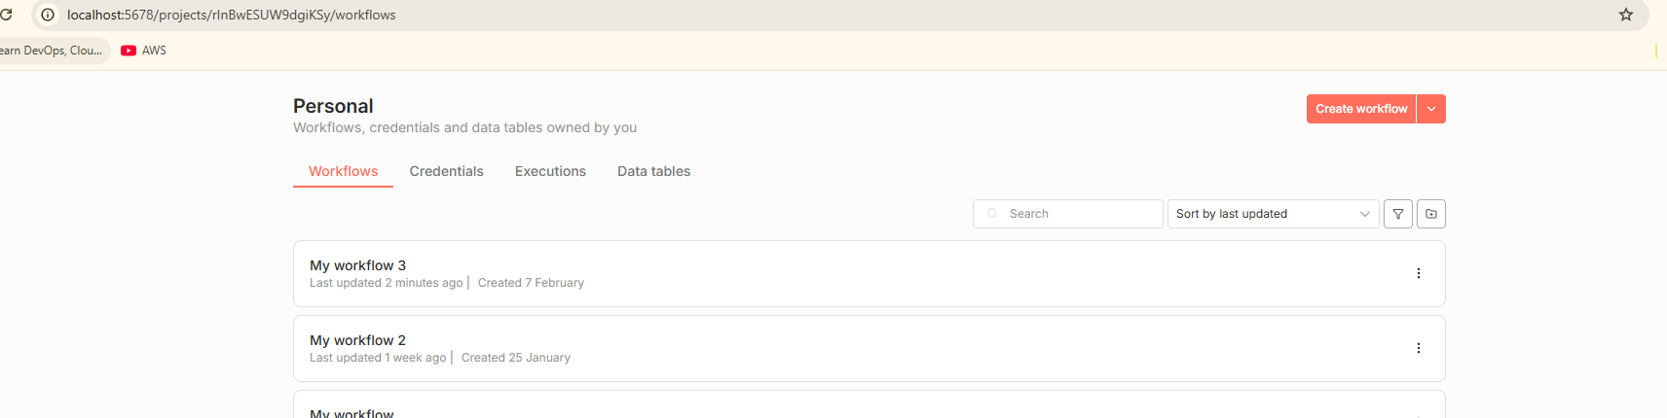

Added chat

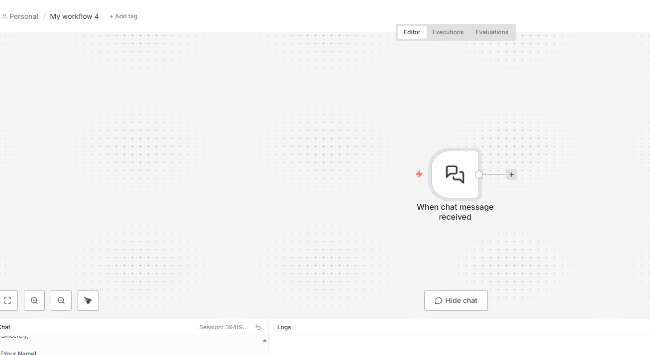

Step-5 AI agent
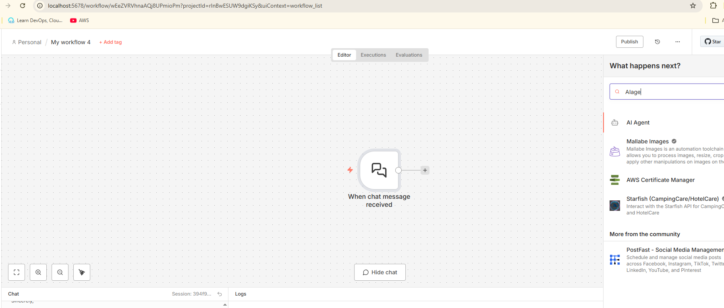

Step-6 Ollama chat model

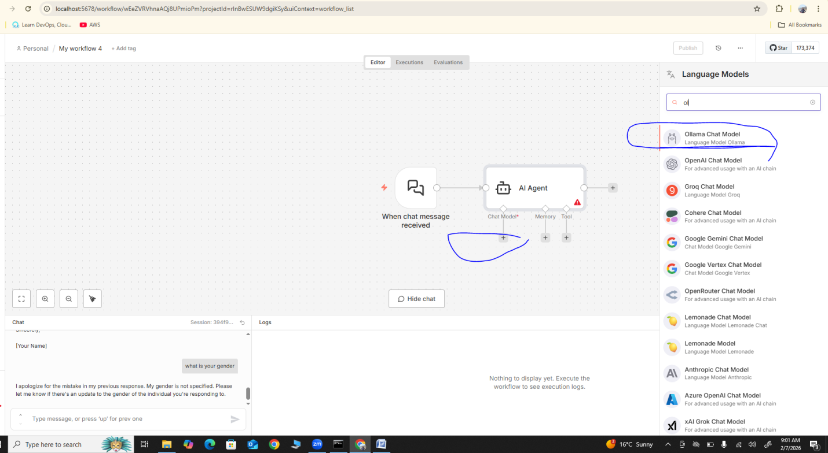

Step7

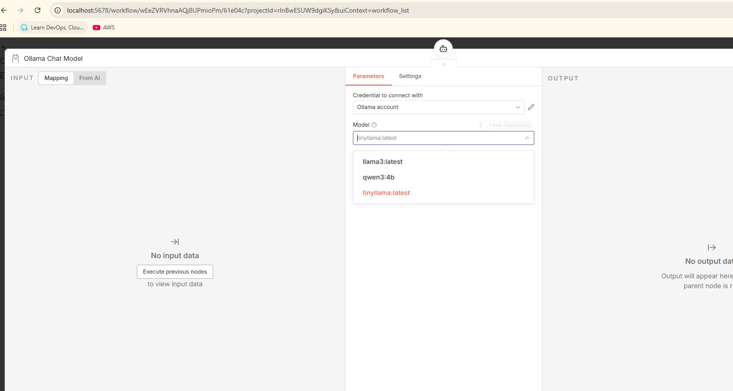

Step-8

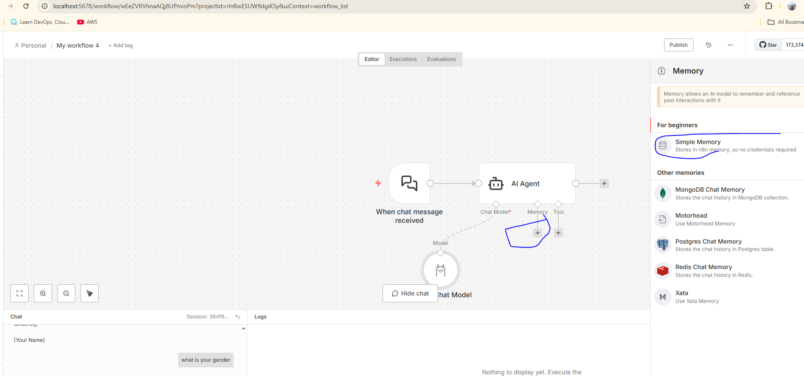

STEp-9 in-progess

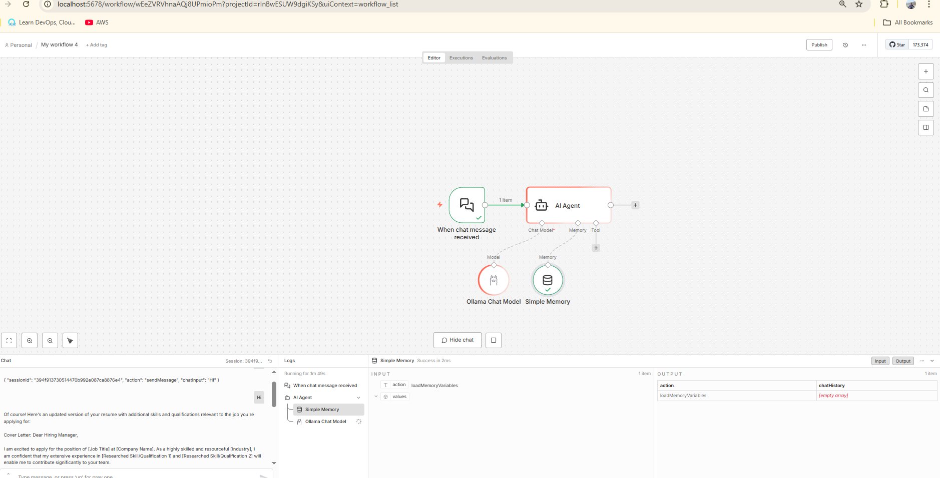

Step-10 Successfully connected

