SIMATS ENGINEERING (SAVEETHA SCHOOL OF ENGINEERING)
Department of Computer Science and Engineering
CO1 ASSESSMENT TOOL 1 – Case Study Analysis
Course Code: | CSA10 / CSA1005 | Course Title: | Software Engineering
CO Assessed: | CO1 | Assessment: | Assessment Tool 1 – Case Study Analysis
Weightage: | 20% | Total Marks: | 25
CO1 Statement: | Apply advanced methodologies and agile project management techniques to manage software projects effectively
Student Name: | S. Rohit Ram | Reg. No.: | 1922260146
Date: | 20/10/2026 | Duration: | 60 minutes

Code of Conduct
I __________________________ (Name / Reg No) certify that this submission is my original work and that I have adhered to the guidelines specified for this assessment. I understand that any violation of academic integrity rules will result in disciplinary action.
Signature of the Student: _________________________

Annexure A – Case Study Analysis
Case Study Title: Intelligent Agricultural Equipment Sharing Platform

1. Understand the Problem Statement
Problem in my own words: Small and medium-scale farmers often cannot afford to purchase tractors, harvesters, seeders, and irrigation equipment that may be needed only during particular farming periods. At the same time, equipment owned by other farmers or rental providers can remain unused for long periods. The Intelligent Agricultural Equipment Sharing Platform connects farmers who need machinery with equipment owners through a single digital system. Users can find equipment, check availability, book rentals, arrange delivery, make payments, and maintain usage records.
Objectives of the proposed system:
Register farmers, equipment owners, and rental providers.
Create equipment listings with type, location, rental charge, availability, and usage conditions.
Allow farmers to search and compare equipment and view available dates.
Manage booking requests, confirmation, cancellations, and rental periods.
Calculate rental charges and record payments and receipts.
Coordinate equipment delivery and return arrangements.
Maintain equipment usage history, rental history, ratings, and reviews.
Scope: The system covers user registration, equipment listing and discovery, availability management, booking, rental-charge calculation, payment records, delivery coordination, usage tracking, reviews, and rental history. It can be developed as a mobile-friendly website or application. Physical maintenance, transport, and disputes still require cooperation between users and service providers.

2. Identify Key Stakeholders and Challenges
Farmers / equipment renters: Search for suitable machinery, compare rental charges, book equipment, make payments, use equipment responsibly, and return it on time. Challenges include limited budgets, uncertain availability during peak seasons, travel distance, and lack of trustworthy rental information.
Equipment owners / rental providers: Add accurate listings, update availability and charges, approve requests, arrange handover and collection, and maintain equipment condition. Challenges include idle equipment, double bookings, late returns, damage risk, and payment disputes.
Platform administrator: Manages user accounts, reviews listings where appropriate, handles reports and complaints, monitors platform activity, and maintains records. The administrator must protect user data and prevent fake accounts or misleading listings.
Delivery / transport partners: Coordinate machinery movement to and from farms when delivery is offered. They need accurate addresses, schedules, contact information, and clear delivery charges.
Payment service provider: Processes electronic payments and communicates transaction status securely. It must support reliable transaction records and protect sensitive payment information.
Major shared challenges include seasonal demand peaks, rural network limitations, inaccurate availability, location and transport coordination, trust between unfamiliar users, equipment damage, cancellations, and secure payment handling.

3. Analyze the Current Approach
Existing process: Farmers commonly find machinery through personal contacts, local dealers, village groups, telephone calls, or visits to equipment owners. Availability and rental rates may be shared informally. Booking details, payments, delivery arrangements, and rental history may be recorded on paper or in separate messages.
Strengths of the current approach:
Personal relationships can create trust and allow direct discussion.
Local owners may understand nearby farming needs and field conditions.
The process can work without advanced digital infrastructure.
Limitations and gaps:
Farmers may not know all available equipment providers in nearby areas.
Availability and rental prices are difficult to compare in one place.
Telephone-based coordination can lead to missed messages or double bookings.
Paper records make it difficult to track rentals, usage, payments, and disputes.
Transport and delivery arrangements may be unclear or delayed.
There may be limited feedback about reliability, equipment condition, or service.
A shared platform is needed to centralize listings and booking information while keeping the process simple for users with different levels of digital experience.

4. Propose a Suitable Solution Using Software Engineering Principles
Proposed solution: Develop a secure, mobile-friendly platform with separate views for farmers, equipment owners, and administrators. Users can create accounts, list or search for machinery, check availability, request bookings, view rental charges, record payments, coordinate delivery, and submit reviews after a rental.
Major functional modules:
User Registration and Profiles: Stores basic user details, role, contact information, and preferred location.
Equipment Listing: Records equipment name, category, description, location, rental rate, photographs, and usage conditions.
Search and Availability: Filters equipment by type, location, rental period, and price; shows available dates.
Booking Management: Handles booking requests, approval, confirmation, cancellation, and rental status.
Rental Charges and Payments: Calculates charges using the rental period and agreed rate; stores transaction status and receipts.
Delivery Coordination: Records delivery or collection preference, address, schedule, and delivery charges where applicable.
Usage and Rental History: Maintains booking dates, equipment used, payment records, and return status.
Ratings, Reviews, and Support: Allows users to provide feedback and report issues.
Administration: Supports account management, listing review, complaint handling, and activity monitoring.
Functional requirements: The system shall allow users to register and sign in; owners to add, edit, and remove listings; farmers to search and view availability; users to request and manage bookings; the system to calculate rental charges; payment status to be recorded; delivery arrangements to be saved; and completed rentals to be stored with ratings and reviews.
Non-functional requirements: Usability—clear screens and simple navigation; reliability—booking and payment records must remain consistent; security—authenticated access and protection of personal information; performance—search results should load within a reasonable time; scalability—the system should support more users, equipment, and regions; maintainability—modules should be independently tested and updated; accessibility—interfaces should work on common mobile devices and low-bandwidth connections where possible.
Application of software engineering principles: Modularity separates accounts, listings, bookings, payments, delivery, and reviews. Scalability can be supported through a structured database and service-based design. Maintainability is improved by clear documentation, coding standards, and automated tests. Reliability is supported by validating availability before confirming bookings and keeping consistent transaction records. Usability is improved through simple forms, readable language, and clear booking status. Security is supported by role-based access, secure authentication, input validation, and restricted access to private information.

5. Justify the Chosen Methodology / Framework
Selected methodology: Agile development using short iterations, with Scrum practices for planning and review.
Justification: The platform contains several connected modules and requirements may change after feedback from farmers, equipment owners, and rental providers. Agile allows the team to deliver a small working version first and improve it in repeated cycles. The first iteration can provide registration and equipment listings; the next can add search and booking; later iterations can introduce payments, delivery coordination, and reviews.
How it supports development and maintenance: The team can maintain a prioritized product backlog, plan work in short sprints, demonstrate completed features, gather stakeholder feedback, and test each increment. Regular reviews help discover usability issues early, while continuous testing and version control reduce regression risks. After launch, the same approach can fix defects, improve performance, and add features based on user needs.

6. Discuss Expected Outcomes and Limitations
Expected outcomes:
Improved access to agricultural machinery for farmers who cannot afford to buy it.
Better utilization of equipment that might otherwise remain idle.
Reduced time spent contacting multiple owners to find available machinery.
Clearer rental charges, booking status, and rental history.
Additional rental opportunities and income for equipment owners.
Improved coordination of bookings, delivery, returns, and feedback.
How the solution addresses challenges: Centralized listings improve equipment discovery; availability calendars reduce booking conflicts; recorded rental charges and payment status improve transparency; delivery details improve coordination; and rental history and reviews help users make informed choices.
Potential risks and limitations: Some rural users may have limited internet access or digital skills. Incorrect listings can mislead renters. Owners may fail to update availability. Transport costs can make distant rentals impractical. Equipment damage, late returns, payment failures, and disagreements may still occur. The platform cannot guarantee equipment quality or replace rental agreements, safety checks, and human dispute resolution.
Risk mitigation: Provide a simple mobile interface, allow owners to update availability easily, use booking confirmations and reminders, display clear rental terms, maintain support and complaint procedures, and keep secure transaction logs. Pilot the system in a small area before expanding.
Future enhancements: Add local-language interfaces, SMS notifications for low-connectivity areas, map-based distance estimation, seasonal demand insights, verified owner profiles, maintenance reminders, digital rental agreements, insurance or damage-report workflows, and recommendations based on equipment type, location, and farming season.

Conclusion
The Intelligent Agricultural Equipment Sharing Platform offers a practical software-based approach to connecting farmers with underused agricultural machinery. By bringing equipment discovery, availability, bookings, rental charges, delivery coordination, usage history, and reviews into one system, it can improve access and utilization. Agile development is suitable because the platform can be delivered incrementally and refined through feedback from its users.
Rubrics for Calculation
Criteria | Excellent (5 Marks) | Good (3 Marks) | Satisfactory (2 Marks) | Needs Improvement (1 Mark)
Problem Understanding (30%) | Clearly explains the problem, objectives, and scope with complete understanding. | Explains the problem with minor omissions. | Basic understanding with limited explanation. | Poor understanding; objectives and scope are unclear or missing.
Stakeholder & Challenge Analysis (25%) | Identifies all stakeholders, their roles, and challenges with clear analysis. | Identifies most stakeholders and challenges with adequate analysis. | Identifies only a few stakeholders or challenges. | Stakeholders and system analysis are incomplete or inaccurate.
Current System Analysis (20%) | Thoroughly analyzes the existing system, strengths, weaknesses, and identifies all gaps. | Good analysis with most strengths and weaknesses identified. | Limited analysis with partial identification of issues. | Proposed solution is unclear or inappropriate; requirements are largely missing.
Proposed Software Solution & Software Engineering Principles (15%) | Proposes an innovative, feasible solution applying appropriate software engineering principles (modularity, scalability, maintainability, security, etc.). | Suitable solution with good application of software engineering principles. | Basic solution with limited application of software engineering principles. | Methodology is inappropriate, poorly justified, or not discussed.
Methodology/ Framework Justification (10%) | Selects the most suitable SDLC/model/framework and provides strong technical justification. | Suitable methodology selected with adequate justification. | Methodology selected but justification is weak. | Outcomes, limitations, or future enhancements are missing; report lacks organization and clarity.

Criteria | Mark
Problem Understanding (30%) | /5
Stakeholder & Challenge Analysis (25%) | /5
Current System Analysis (20%) | /5
Proposed Software Solution & Software Engineering Principles (15%) | /5
Methodology/ Framework Justification (10%) | /5
TOTAL | /25

JIRA TASK BOARD – PROJECT PROGRESS
Intelligent Agricultural Equipment Sharing Platform
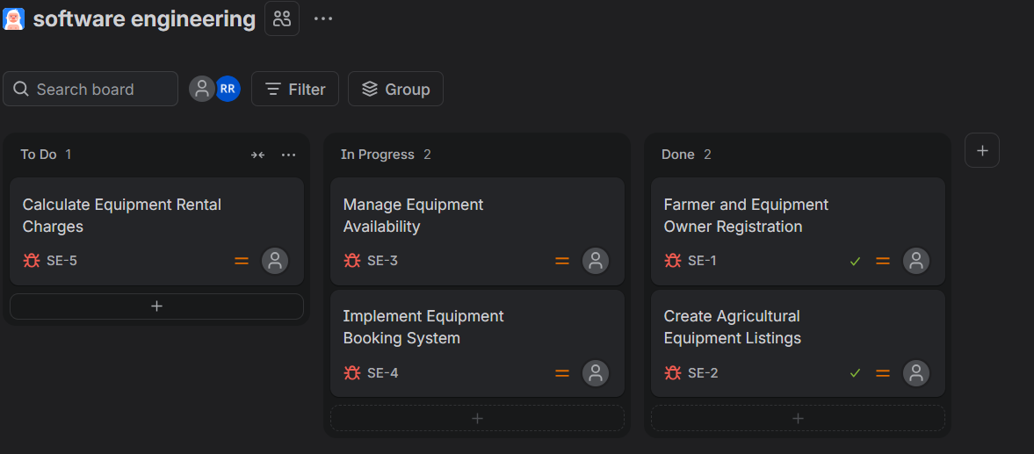
Figure: Jira board showing project tasks in To Do, In Progress, and Done.

