**Code Explanation**

Your script uses **OpenCV, Media pipe, and screen-brightness-control** to adjust screen brightness with hand gestures.

* **Import Required Modules**
* cv2 → Captures webcam feed
* mediapipe → Detects hand landmarks
* screen_brightness_control → Adjusts laptop brightness
* NumPy → Computes distance between fingers

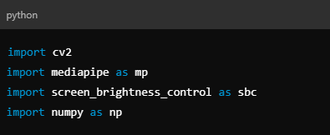

* **Initialize Mediapipe for Hand Detection**
* Hands() → Detects and tracks hand landmarks
* drawing_utils → Draws hand landmarks on the video feed

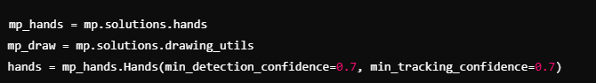

* **Capture Webcam Feed**
* Opens the default webcam (index 0).



* **Process Each Frame**
* Reads each frame
* Mirrors the image (for natural feel)
* Converts it to RGB (needed for Mediapipe)
* Processes the frame to detect hands

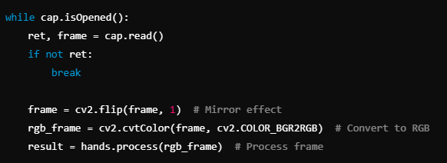

* **Detect Hand and Measure Thumb-Index Distance**
* Extracts thumb and index finger positions
* Calculates the distance between them

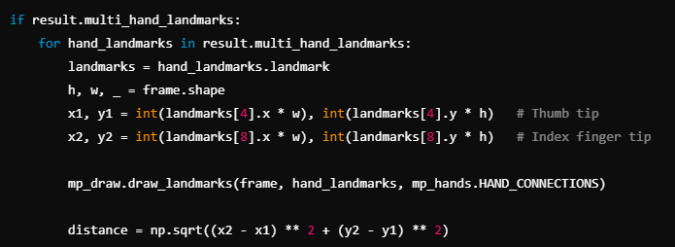

* **Adjust Brightness Based on Distance**
* Maps the hand distance (20 to 200 px) to brightness levels (10% to 100%).
* Updates brightness using sbc.set_brightness().



* **Display Information**
* Displays brightness level on screen
* Draws a line between thumb and index finger

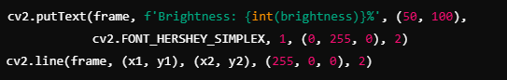

* **Exit Condition**
* Displays the video feed
* Press 'q' to exit

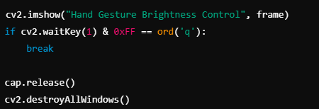

**Future Enhancements**

✅ Add **GUI** for manual control

✅ Improve **gesture detection**

✅ Make an **auto-start feature**