Lab 1
Roll number: 150050061

1. (a) I went to /proc/cpuinfo and wrote the command ‘lscpu’ to find out the information about the CPU.
Number of sockets = 1
Number of cores = 4
Number of threads per core = 1
Number of CPUs = No. of cores*No. of threads per core = 4*1 = 4

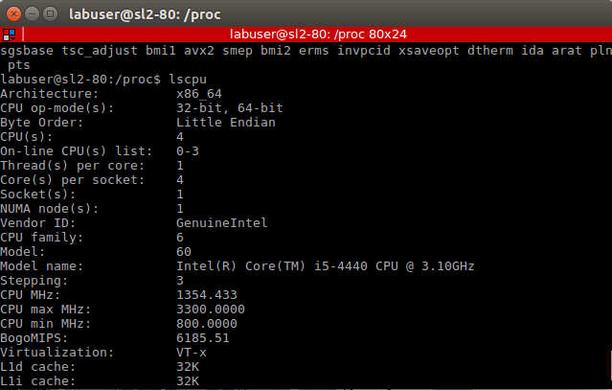
(b) I did ‘less /proc/cpuinfo’ to find out the current CPU frequency.
CPU0 freq: 3082.804 Mhz
CPU1 freq: 1592.261 Mhz
CPU2 freq: 2493.925 Mhz
CPU3 freq: 2990.046 Mhz
The text file is too big, I have saved it in dump1b.txt

(c) Did a ‘less /proc/meminfo’ to find out the total memory. Total memory is 7825944 kB.
Dump saved at dump1c.txt

(d) The above command also had the free and available memory details. Check dump1c.txt
MemFree: 4252596 kB
MemAvailable: 6064192 kB
The difference is that MemFree gives the physical amount of RAM that is free, but MemAvailable is the actual amount of memory that can be used by applications and processes.

(e) Did ‘cat stat’ inside /proc and saw value of ‘processes’. Here is the screenshot (next page)
Number of forks: 143603

(f) Same command and saw the value of ‘ctxt’. Number of context switches: 102794231
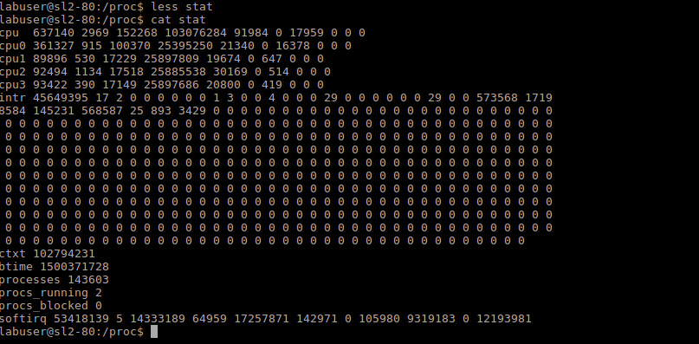

2. I copied the VmRSS and VmSize from /proc/[pid]/status (dumps are present as 1.txt, 2.txt, 3.txt, 4.txt)
memory_1.c :
VmRSS: 688 kB
VmSize: 8140 kB

memory_2.c :
VmRSS: 692 kB
VmSize: 12052 kB

memory_3.c :
VmRSS: 4676 kB
VmSize: 8144 kB

memory_4.c :
VmRSS: 6932 kB
VmSize: 12052 kB

VmSize is the size of the virtual memory allocated to the process. VmRSS is the part of the virtual memory that is present in physical memory. For the 3rd and 4th processes, half of the array elements are initialized to some values, hence consuming more RAM to hold the values, and hence the high VmRSS as compared to 1st and 2nd processes. It is mostly resource management applied to consume as much RAM that is necessary while holding the array elements.

3. I sent the program to the background by issuing the command - ‘./subprocesses 150050061 &’ and then dumped the file from ‘ps’ into dump.txt inside the folder answer-3. There is an alternate command, open a new terminal and issue the command ‘ps aux | grep ./subprocess’

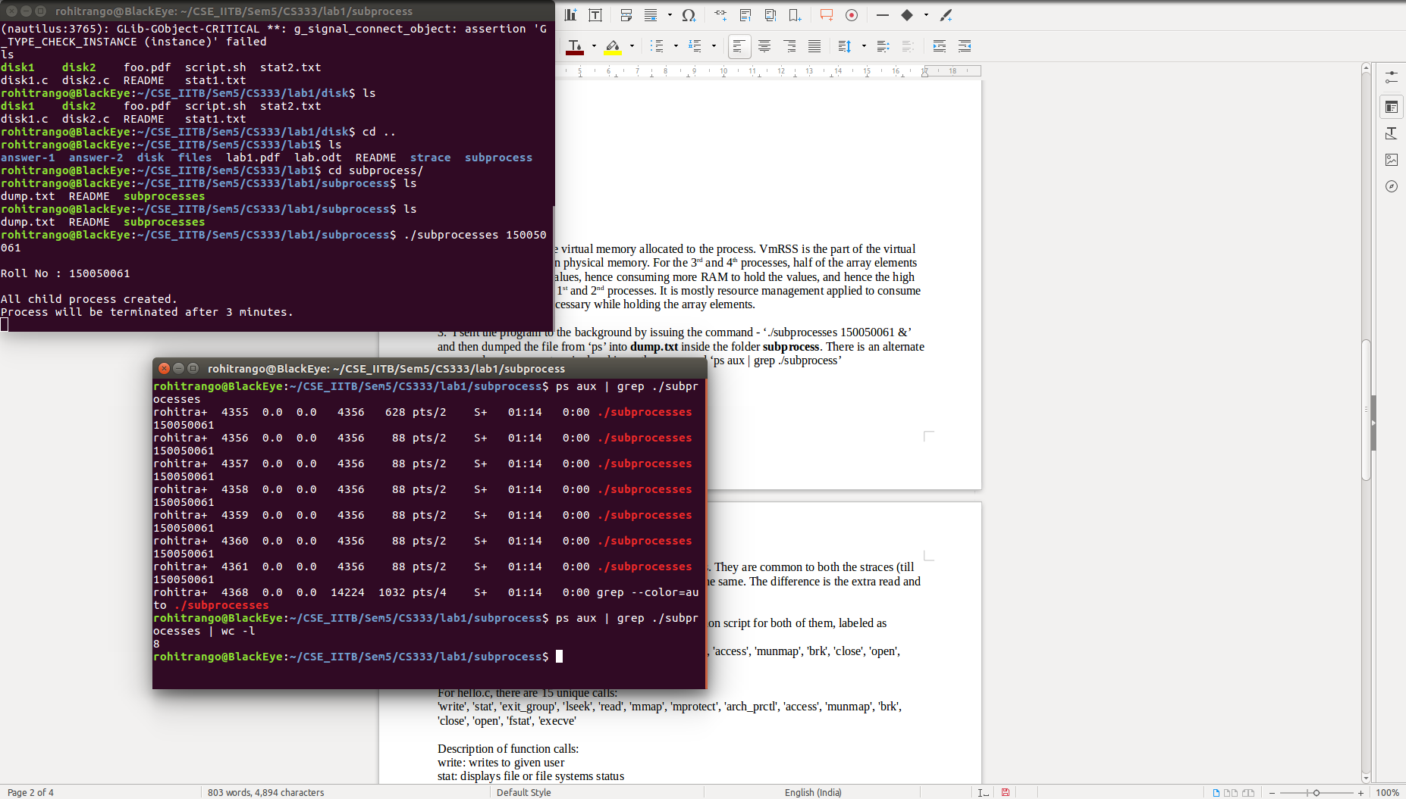

4. Ran both and emptied the dump.
Note: Got some additional system calls to other libraries when I ran from my laptop.

(a) There are some ‘stat’ and ‘open’ calls to the libraries. They are common to both the straces (till line 38). The last line which makes an exit call is also the same. The difference is the extra read and write calls made by the hello.c file.

(b) There are 13 unique calls in empty.c file (ran a python script for both of them, labeled as script.py inside the folder strace) :
'stat', 'exit_group', 'read', 'mmap', 'mprotect', 'arch_prctl', 'access', 'munmap', 'brk', 'close', 'open', 'fstat', 'execve'

For hello.c, there are 15 unique calls:
'write', 'stat', 'exit_group', 'lseek', 'read', 'mmap', 'mprotect', 'arch_prctl', 'access', 'munmap', 'brk', 'close', 'open', 'fstat', 'execve'

Description of function calls:
write: writes to given user
stat: displays file or file systems status
exit_group: exits all threads in a process
lseek: repositions the read and write offset
read: reads from a file descriptor
mmap: maps/unmaps files or devices into memory
mprotect: sets protection for a memory region. If some program tries to violate the access rules, it gets a SIGSEGV signal
arch_prctl: sets architecture-specific process and thread states
access: checks whether a process can access the given file path
munmap: similar to mmap
brk: change the location of the program’s break
close: close a file descriptor
open: start the program on a virtual terminal
fstat: return the details of the file
execve: executes the program given its filename

5. First, I did an ‘strace’ and stored the dump in dump.txt. Now all the files passed in the open function are the one that the program opened. A simple python script present in the folder does the job. Here are the files it opened (on my laptop):

/usr/local/cuda-8.0/lib64/tls/x86_64/libc.so.6
/usr/local/cuda-8.0/lib64/tls/libc.so.6
/usr/local/cuda-8.0/lib64/x86_64/libc.so.6
/usr/local/cuda-8.0/lib64/libc.so.6
tls/x86_64/libc.so.6
tls/libc.so.6
x86_64/libc.so.6
libc.so.6
/etc/ld.so.cache
/lib/x86_64-linux-gnu/libc.so.6
/tmp/welocme to OS
/tmp/CS333
/tmp/CS347

6. Here are the block devices, their mountpoints, and the file system types of the block devices.
I used the command ‘lsblk -f’ to display this information.

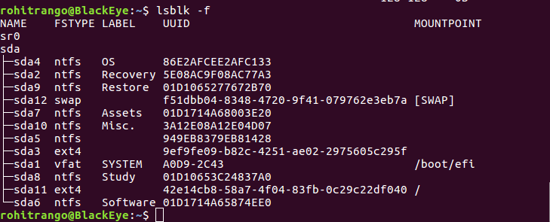

7. I did the following in a different terminal before running the program ./disk1 : iostat -x 1 > stat1.txt

The %util shows the disk utilization at every 1 second. There is ~100% disk utilization while the program is running, because it has to fetch every file. It took around 167.058476 seconds to run.

Before running ./disk2, I did iostat -x 1 > stat2.txt in another terminal. There is a maximum of 1.2% disk utilization since the file is already cached. It also took around 1.412285 seconds to run.

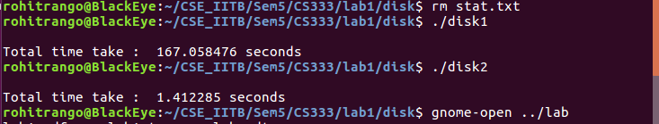
The executables and stat files are present inside the directory answer-7.

