**1) Check employee is check in or check out**

URL :mysita.com/acilselfdeclaration/api/index.php/CheckEmployeeInOrOut

Method: GET

Parameter: emp_code

complete url: mysita.com/acilselfdeclaration/api/index.php/CheckEmployeeInOrOut/ACL004

**Screen : 1**

**2)** **Update Temperature by security guard**

URL: http://mysita.com/acilselfdeclaration/api/index.php/UpdateTempBySecurityGuard

Method:POST

Parameter:emp_code,office_location, security_guard_id, temperature_by_security_guard, flag,remark

**Screen : 2**

**3) Employee attendance (Punch out)**

URL:mysita.com/acilselfdeclaration/api/index.php/EmployeeAttendance

Method:POST

Parameter:emp_id

**Screen : 3**

**4) Check visitor is in or out**

URL:mysita.com/acilselfdeclaration/api/index.php/CheckVisitorInOrOut

Method:GET

Parameter: visitor_id

5) **Record visitor temperature and check in**

URL:mysita.com/acilselfdeclaration/api/index.php/VisitorTempRecord

Method:POST,

Parameter:visitor_id,temperature

**Screen: 4**

**6) Visitor exit or checkout**

URL:mysita.com/acilselfdeclaration/api/index.php/CheckOutVisitor

Method:POST

Parameter:visitor_id

**Screen: 4**

**7) Extend visiting time (Visitor)**

URL:mysita.com/acilselfdeclaration/api/index.php/ExtendVisitingTime

Method:POST

Parameter:visitor_id, time

**Screen: 5**

**8) KYC for employee**

URL:mysita.com/acilselfdeclaration/api/index.php/SaveEmployeeKYC

Method:POST

Parameter:emp_id,name,father_name,pan,age,designation,department,office_location,current_address,permanent_address, domicile_state,reporting_to

**Add new parameter in KYC form**

Parameter: aadhar_no

**Screen:6**

{

"referred_associate": [{

"name": "Rohit",

"relation": "Brother",

"position": "cce",

"department": "1"

}, {

"name": "Rohit",

"relation": "Brother",

"position": "cce",

"department": "1"

}]

}

{

"business_activity": [{

"agent_name": "Sandeep",

"vendor_name": "Raju",

"project": "1",

},

{

"agent_name": "Sandeep",

"vendor_name": "Raju",

"project": "1",

},

]

}

**9) Employee list by office location**

URL:http://mysita.com/acilselfdeclaration/api/index.php/EmpBylocationID

Method: GET

Parameter: location_id

Complete <url:http://mysita.com/acilselfdeclaration/api/index.php/EmpBylocationID/8>

**10) Save office duty**

Url: mysita.com/acilselfdeclaration/api/index.php/SaveOfficeDuty

Method:POST

Parameter: emp_id, name, designation, department, off_date, from_time, to_time, place_of_visit, pusrpose, reporting_person

**Screen:7**

**11) Reporting person man no. list**

URL:http://mysita.com/acilselfdeclaration/api/index.php/EmpReportingPerson

Method:GET

Parameter:emp_id

Complete <Url:http://mysita.com/acilselfdeclaration/api/index.php/EmpReportingPerson/1253>

**12) Office duty response list**

Url:http://mysita.com/acilselfdeclaration/api/index.php/EmpOfficeDutyResponse

Method:GET

Parameter:emp_id,page

Complete Url:http://mysita.com/acilselfdeclaration/api/index.php/EmpOfficeDutyResponse/1254&1

**13) Office duty request list**

Url: mysita.com/acilselfdeclaration/api/index.php/OfficeDutyRequest

Method:GET

Parameter: emp_id, page

**14) Update KYC for employee**

url:mysita.com/acilselfdeclaration/api/index.php/SaveEmployeeKYC

Method:POST

Parameter:emp_id,name,father_name,pan,age,designation,department,office_location,current_address,permanent_address, domicile_state,aadhar_no

{

"referred_associate": [{

"name": "Rohit",

"relation": "Brother",

"position": "cce",

"department": "1"

}, {

"name": "Rohit",

"relation": "Brother",

"position": "cce",

"department": "1"

}]

}

{

"business_activity": [{

"agent_name": "Sandeep",

"vendor_name": "Raju",

"project": "1",

},

{

"agent_name": "Sandeep",

"vendor_name": "Raju",

"project": "1",

},

]

}

**Screen : 6**

**15) Employee Kyc**

URL:http://mysita.com/acilselfdeclaration/api/index.php/KycByEmployeeID

Method:GET

Parameter:emp_id

Complete url:http://mysita.com/acilselfdeclaration/api/index.php/KycByEmployeeID/1256

**16) Attendance list by employee id**

Url:http://mysita.com/acilselfdeclaration/api/index.php/AttendanceByEmployee

Method:Get

Parameter:emp_id, page

Complete url:http://mysita.com/acilselfdeclaration/api/index.php/AttendanceByEmployee/1253&1

**17) Web URL to generate visitor request for testing**

[**http://sdf.mysita.com/home/visitor**](http://sdf.mysita.com/home/visitor)

**18) Format of datetime to be passed in OD form or a sample JSON request**

**for saving office duty form data (Rohit from team, had mentioned that he**

**will be sharing it)**

**format will be dd-mm-YYYY h:I a (ex. 10-12-2020 1:30 pm)**

**19) MR Dashboard**

**Employee daily report count**

URL:mysita.com/acilselfdeclaration/api/index.php/MrDashboardDailyReport

Method:GET

Parameter:emp_id

Complete <URL:mysita.com/acilselfdeclaration/api/index.php/MrDashboardDailyReport/1260>

Screen:10

**20) Employee daily report list**

URL:mysita.com/acilselfdeclaration/api/index.php/EmployeeReport

Method:GET

Parameter: emp_id, date(in dd-mm-YYYY format),flag(1=Present, 2=assessed, 3=Pending),page

Complete URL:http://mysita.com/acilselfdeclaration/api/index.php/EmployeeReport/1260&28-10-2020&1&1

Screen: 11

**21) Office duty approve or disapprove**

Url: mysita.com/acilselfdeclaration/api/index.php/OfficeDutyUpdateStatus

Method:POST

Parameter: emp_id, status (1=approved, 2=disapproved), office_request_id

**22) Visitor QR Code List**

URL:mysita.com/acilselfdeclaration/api/index.php/VisitorQRCodeByEmp

Method:GET

Parameter:emp_id

Complete URL:mysita.com/acilselfdeclaration/api/index.php/VisitorQRCodeByEmp/1254

**Screen : 1**

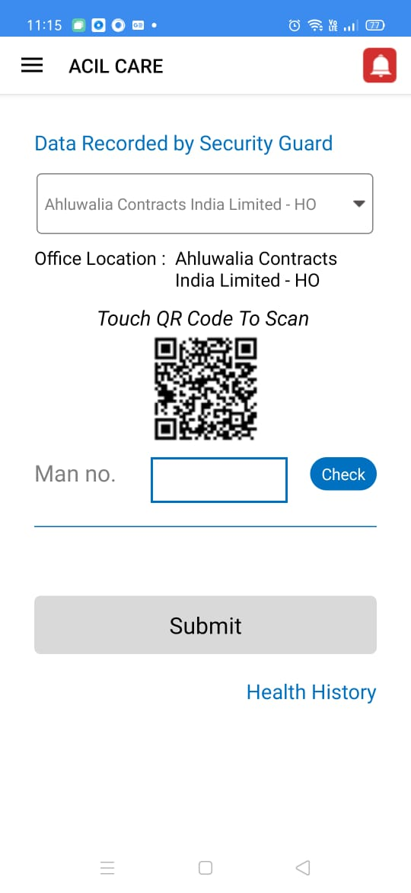

**Screen : 2**

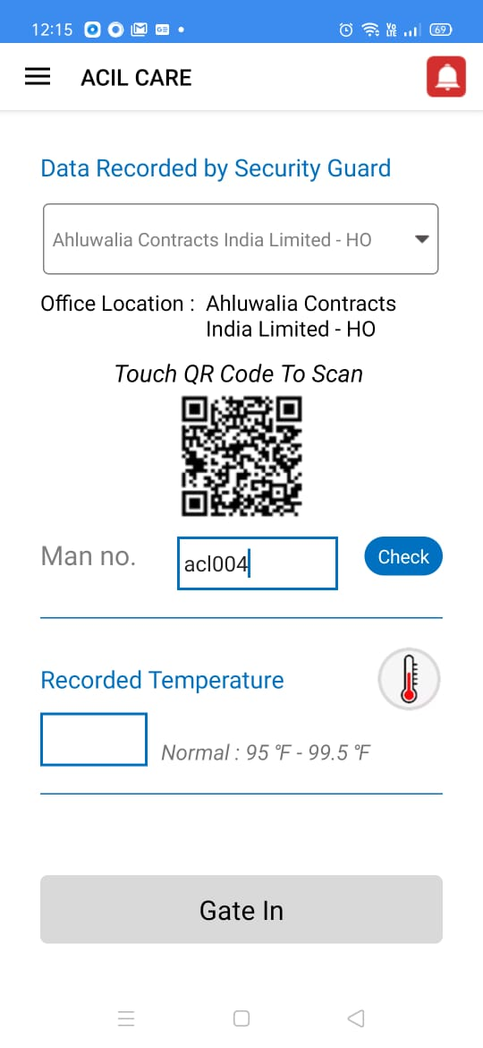

**Screen:3**

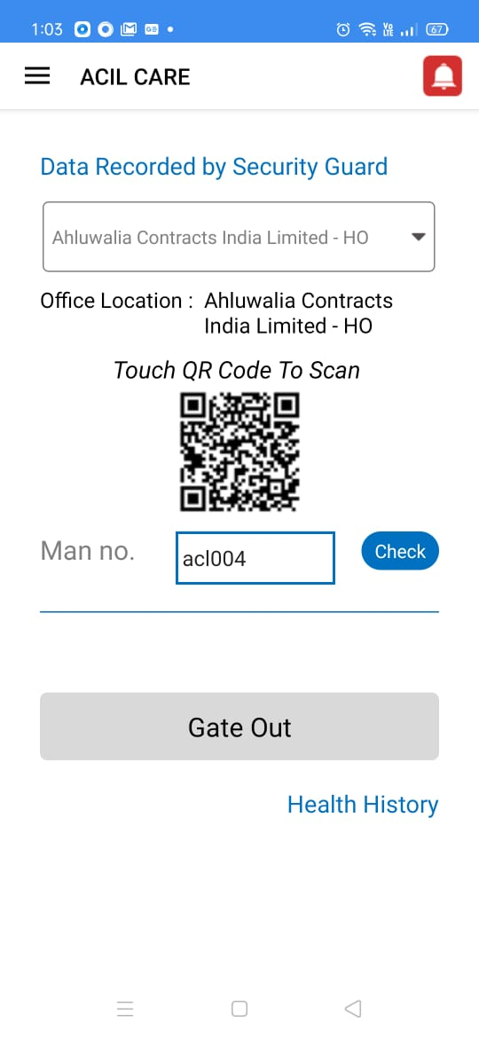

**Screen: 4**

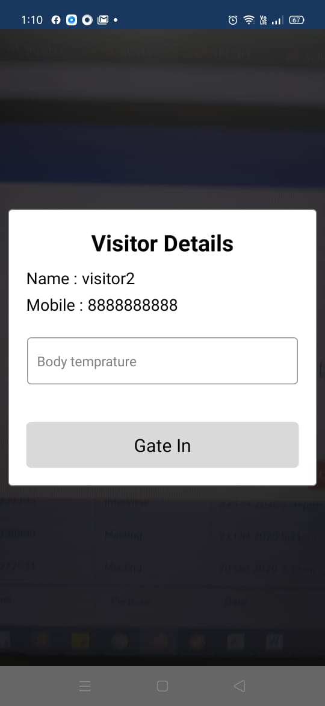

**Screen: 5**

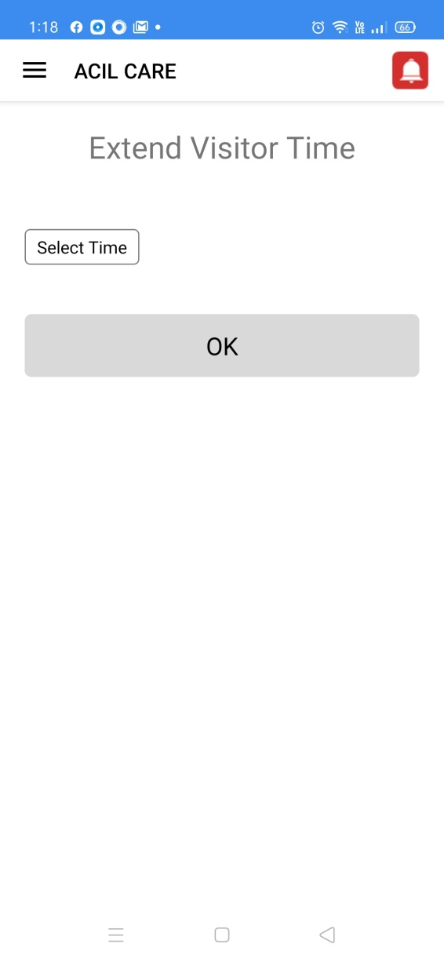

**Screen:6**

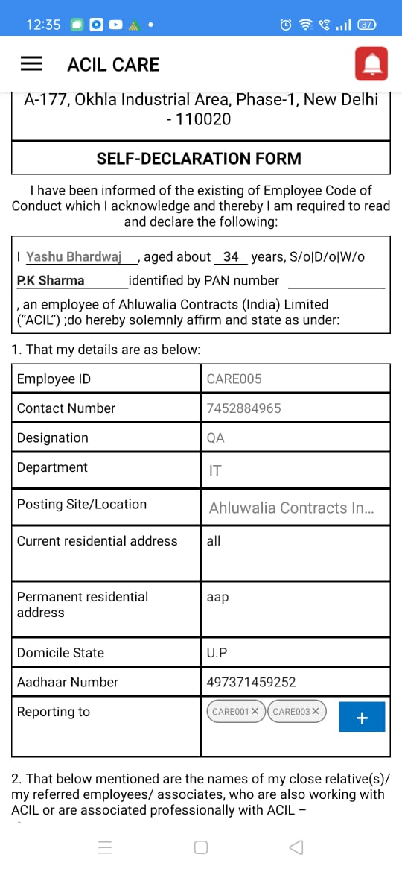

**Screen:7**

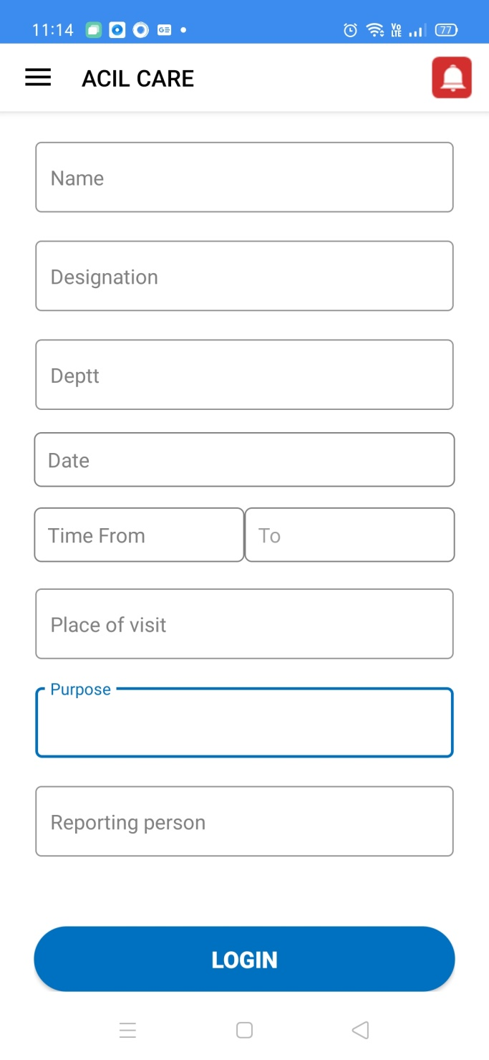

**Screen:8**

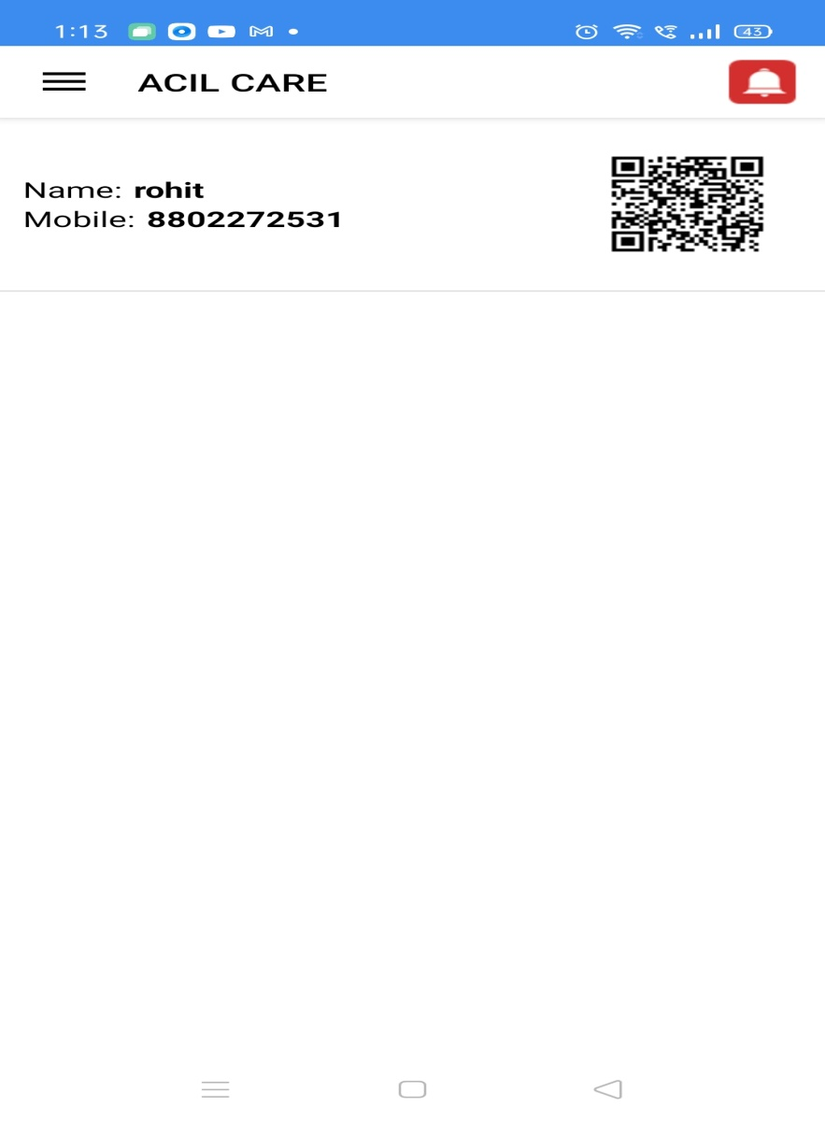

**Screen:9**

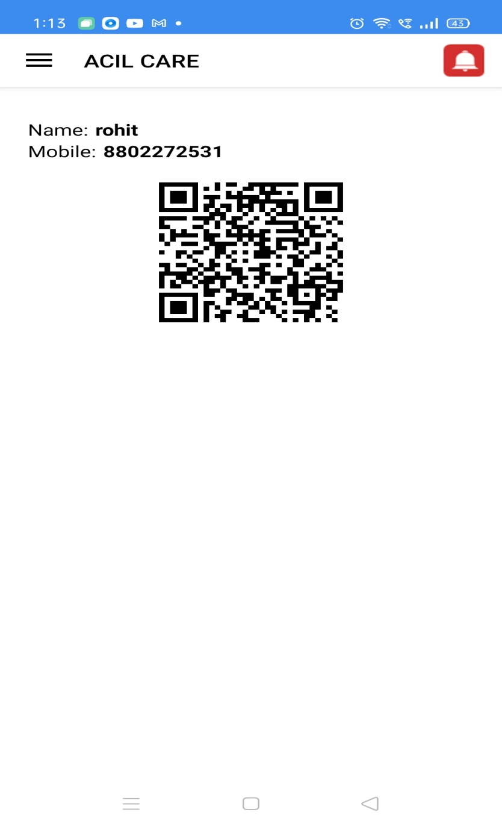

**Screen:10**

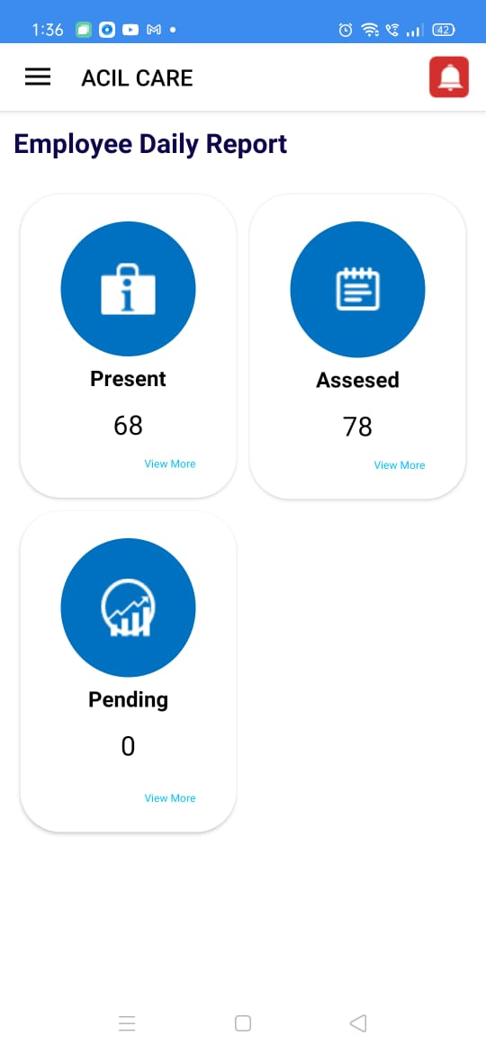

**Screen:11**

