**1) Check employee is check in or check out**

URL : http://sdf.mysita.com/webservice /api/index.php/CheckEmployeeInOrOut

Method: GET

Parameter: emp_code

complete url: http://sdf.mysita.com/webservice /api/index.php/CheckEmployeeInOrOut/ACL004

**Screen : 1**

**2)** **Update Temperature by security guard**

URL: http://sdf.mysita.com/webservice /api/index.php/UpdateTempBySecurityGuard

Method:POST

Parameter:emp_code,office_location, security_guard_id, temperature_by_security_guard, flag,remark

**Screen : 2**

**3) Employee attendance (Punch out)**

URL: http://sdf.mysita.com/webservice /api/index.php/EmployeeAttendance

Method:POST

Parameter:emp_id

**Screen : 3**

**4) Check visitor is in or out**

URL: http://sdf.mysita.com/webservice /api/index.php/CheckVisitorInOrOut

Method:GET

Parameter: visitor_id

5) **Record visitor temperature and check in**

URL: http://sdf.mysita.com/webservice /api/index.php/VisitorTempRecord

Method:POST,

Parameter:visitor_id,temperature

**Screen: 4**

**6) Visitor exit or checkout**

URL: http://sdf.mysita.com/webservice /api/index.php/CheckOutVisitor

Method:POST

Parameter:visitor_id

**Screen: 4**

**7) Extend visiting time (Visitor)**

URL: http://sdf.mysita.com/webservice /api/index.php/ExtendVisitingTime

Method:POST

Parameter:visitor_id, time

**Screen: 5**

**8) KYC for employee**

URL: http://sdf.mysita.com/webservice /api/index.php/SaveEmployeeKYC

Method:POST

Parameter:emp_id,name,father_name,pan,age,designation,department,office_location,current_address,permanent_address, domicile_state,reporting_to

**Screen:6**

{

"referred_associate": [{

"name": "Rohit",

"relation": "Brother",

"position": "cce",

"department": "1"

}, {

"name": "Rohit",

"relation": "Brother",

"position": "cce",

"department": "1"

}]

}

{

"business_activity": [{

"agent_name": "Sandeep",

"vendor_name": "Raju",

"project": "1",

},

{

"agent_name": "Sandeep",

"vendor_name": "Raju",

"project": "1",

},

]

}

**9) Employee list by office location**

URL: http://sdf.mysita.com/webservice/api/index.php/EmpBylocationID

Method: GET

Parameter: location_id

Complete <url:http://mysita.com/acilselfdeclaration/api/index.php/EmpBylocationID/8>

**10) Save office duty**

Url: http://sdf.mysita.com/webservice/api/index.php/SaveOfficeDuty

Method:POST

Parameter: emp_id, name, designation, department, off_date, from_time, to_time, place_of_visit, pusrpose, reporting_person

**Screen:7**

**11) Reporting person man no. list**

URL: http://sdf.mysita.com/webservice/api/index.php/EmpReportingPerson

Method:GET

Parameter:emp_id

Complete <Url:http://mysita.com/acilselfdeclaration/api/index.php/EmpReportingPerson/1253>

**12) Office duty response list**

Url: http://sdf.mysita.com/webservice/api/index.php/EmpOfficeDutyResponse

Method:GET

Parameter:emp_id,page

Complete Url: http://sdf.mysita.com/webservice/api/index.php/EmpOfficeDutyResponse/1254&1

**13) Office duty request list**

Url: http://sdf.mysita.com/webservice/api/index.php/OfficeDutyRequest

Method:GET

Parameter: emp_id, page

**14) Offline self assessment**

[Url: http://sdf.mysita.com/webservice /api/index.php/OfflineSelfAssessmentByEmployee](Url:mysita.com/acilselfdeclaration/api/index.php/OfflineSelfAssessmentByEmployee)

Method:POST

Parameter: emp_code, temperature, symptoms, time(date time) , emp_type, user_id, resident_in_containment, is_contact_covid_patient, is_family_member_symptoms, family_detail, contacted_covid_patient_detail, resident_in_containment_detail, symptom_days, office_location

**Screen:8**

**15)** **Offline add temperature from security guard**

Url: http://sdf.mysita.com/webservice /api/index.php/OfflineUpdateTempBySG

Method:POST

Parameter: emp_code,security_guard_id, time(date time), temperature_by_security_guard, punch_in, punch_out,created_date

**Screen:9**

**16) List Raise ticket**

Url : http://sdf.mysita.com/webservice/api/index.php/TicketByEmpId

Parameter:emp_id,page

Compete <Url:http://sdf.mysita.com/webservice/api/index.php/TicketByEmpId/1254&1>

**Screen: 10**

**17) Raise or add ticket**

Url:http://sdf.mysita.com/webservice/api/index.php/RaiseTicket

Parameter:emp_id,name,project, department, designation, doj, mobile_no, email, address, type_of_resource, location, resource_for, res_name, res_relation, res_dob, res_gender, res_blood_group

**Screen:11**

**18) Save Leave application**

Url:http://sdf.mysita.com/webservice/api/index.php/SaveLeaveApplication

Method:POST

Parameter:emp_id,leave_type,leave_from,leave_to,reason,num_of_days,reporting_to

**Screen : 1**

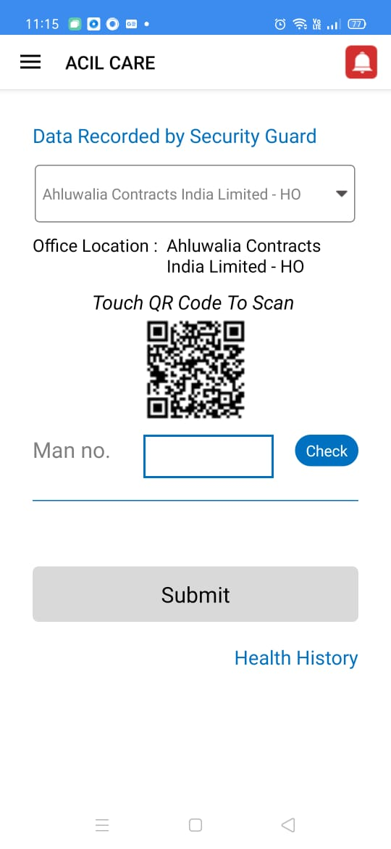

**Screen : 2**

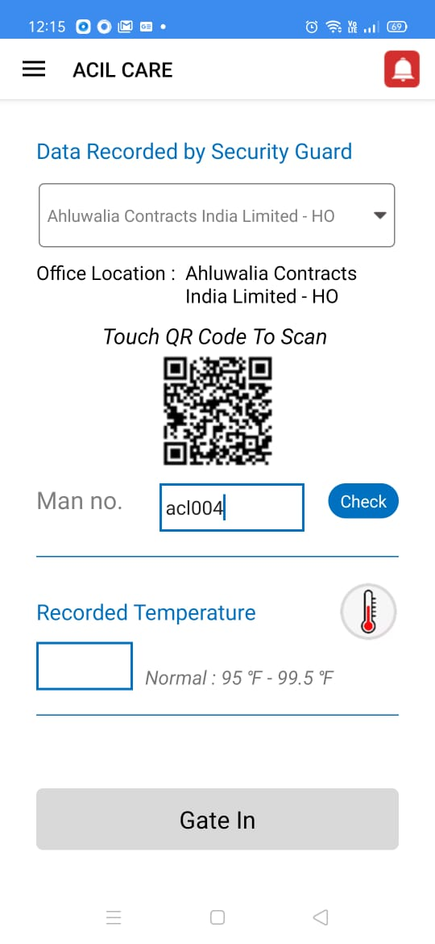

**Screen:3**

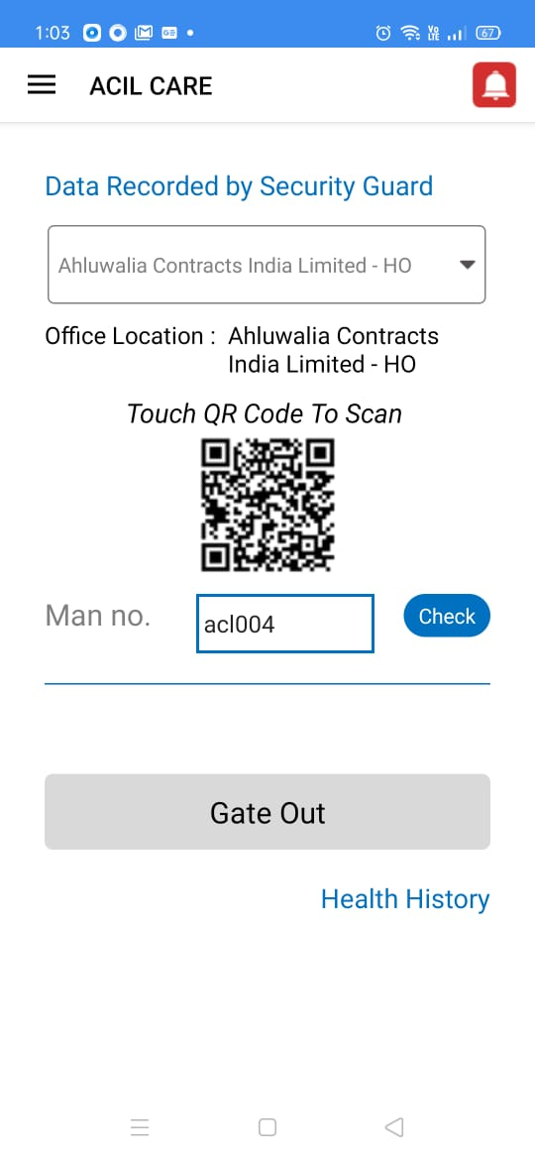

**Screen: 4**

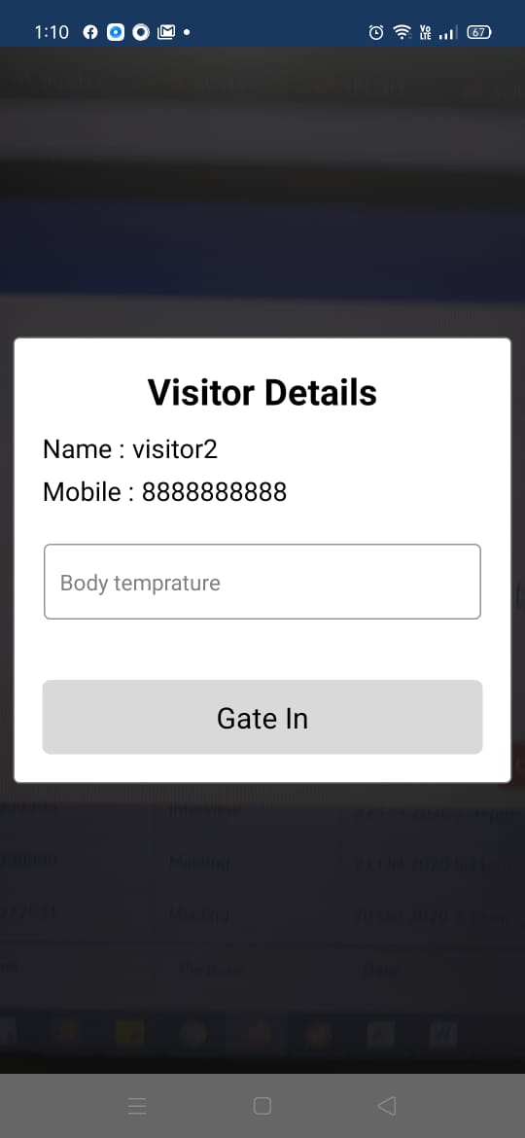

**Screen: 5**

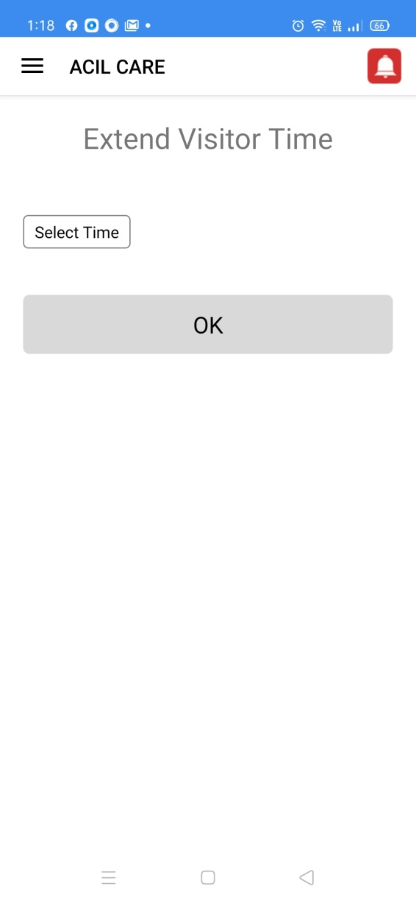

**Screen:6**

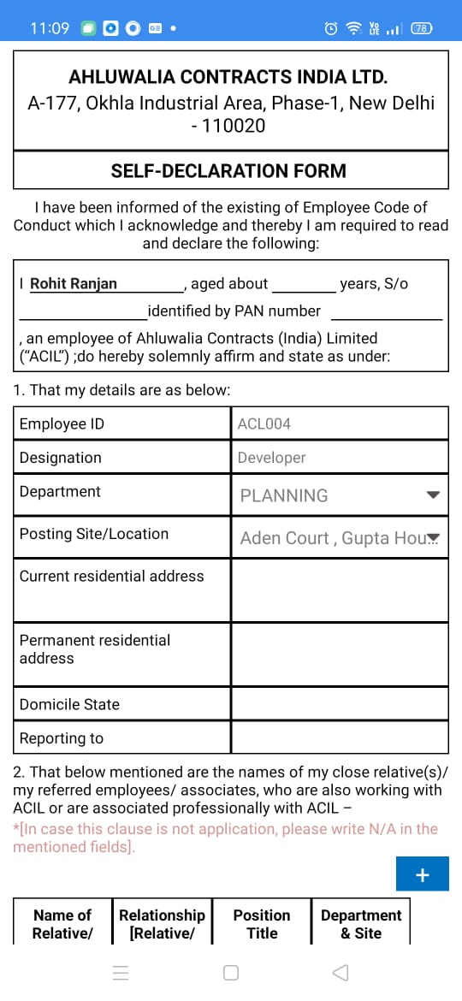

**Screen:7**

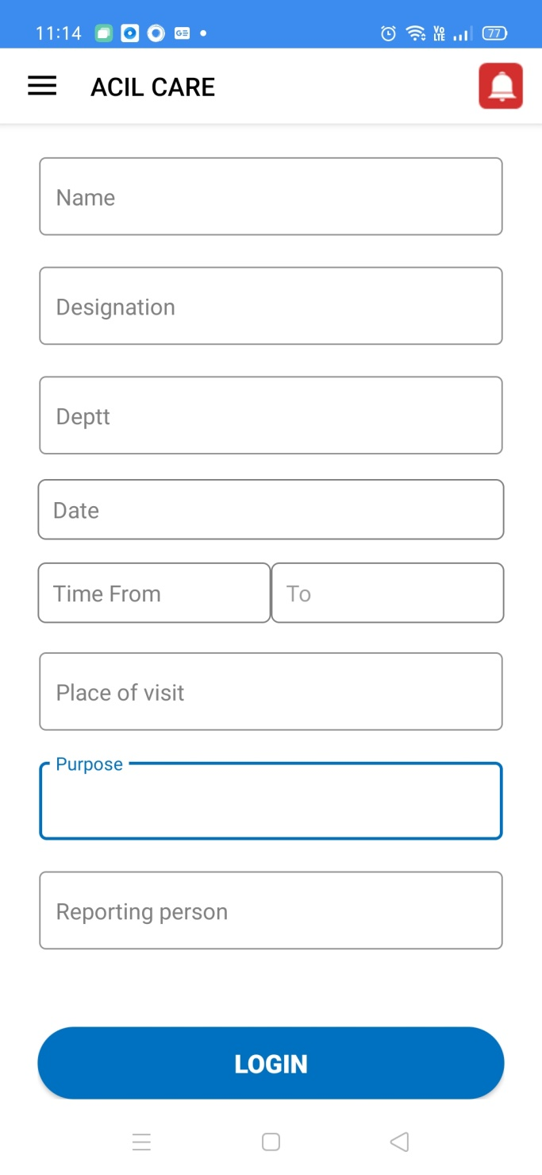

**Screen:8**

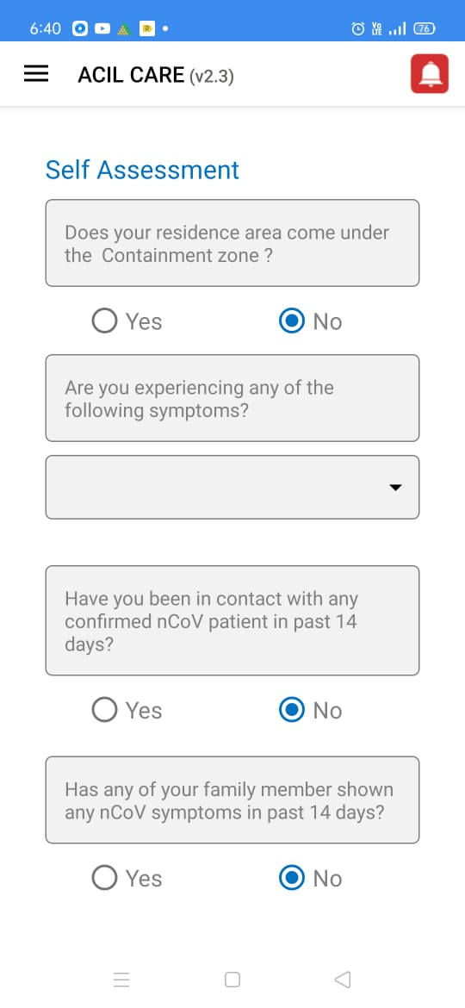

**Screen: 9**

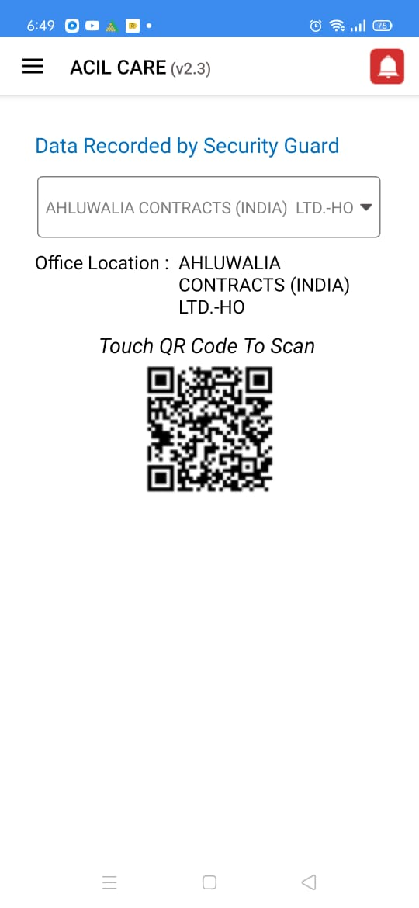

**Screen:10**

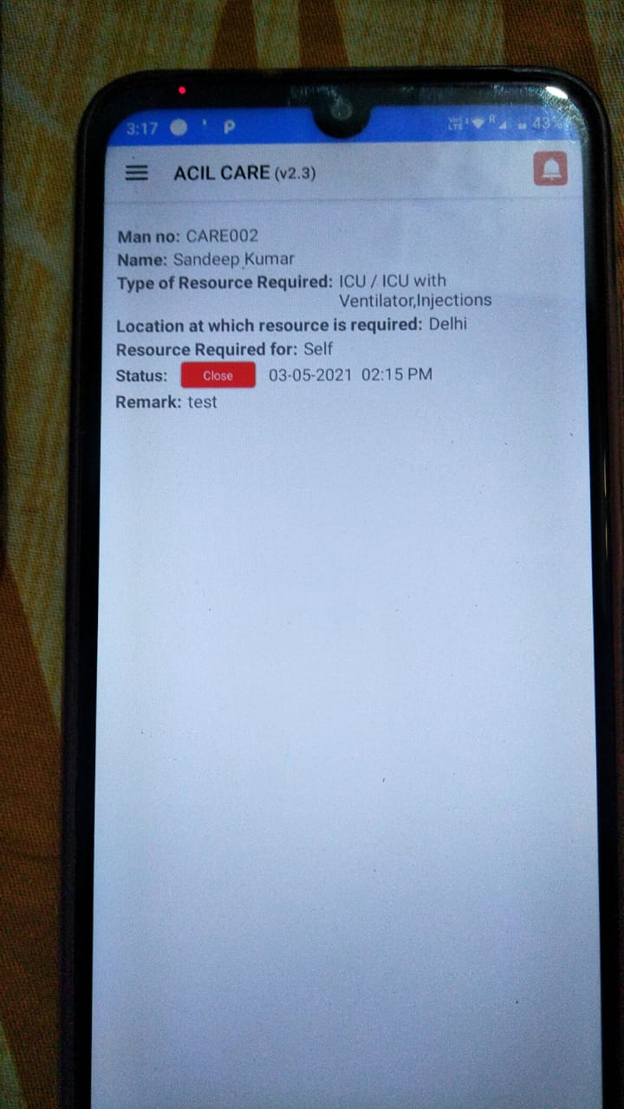

**Screen:11**

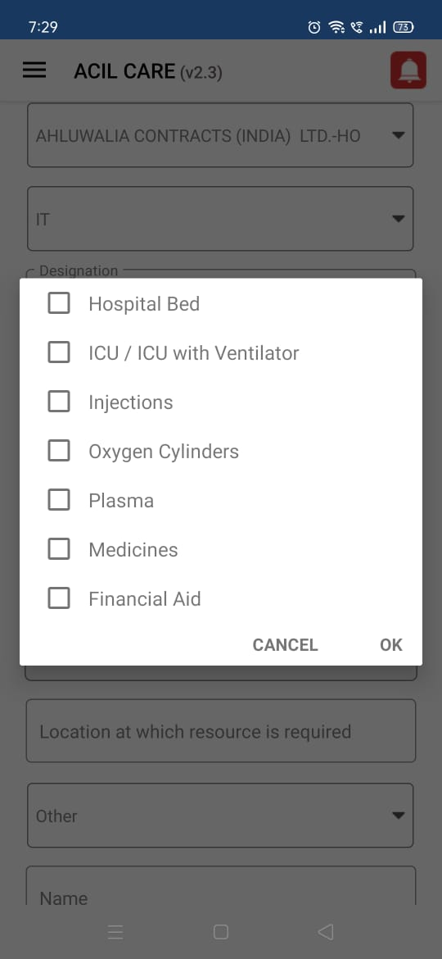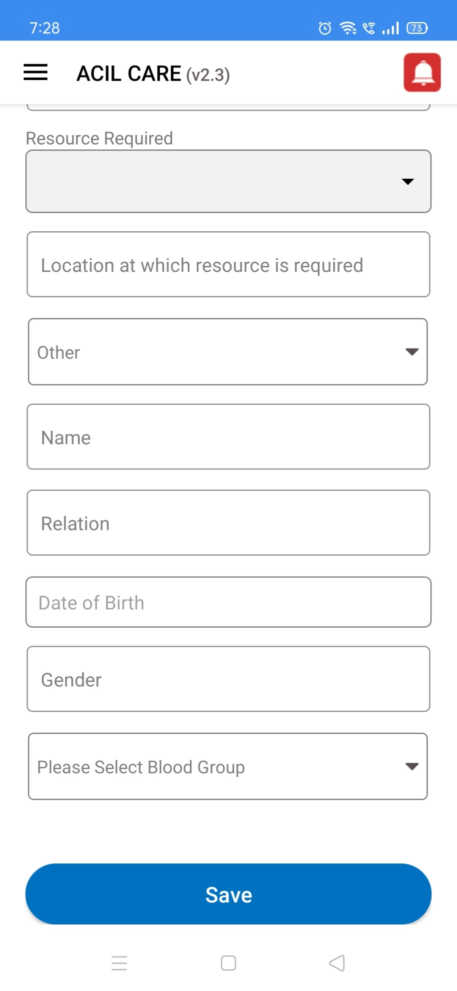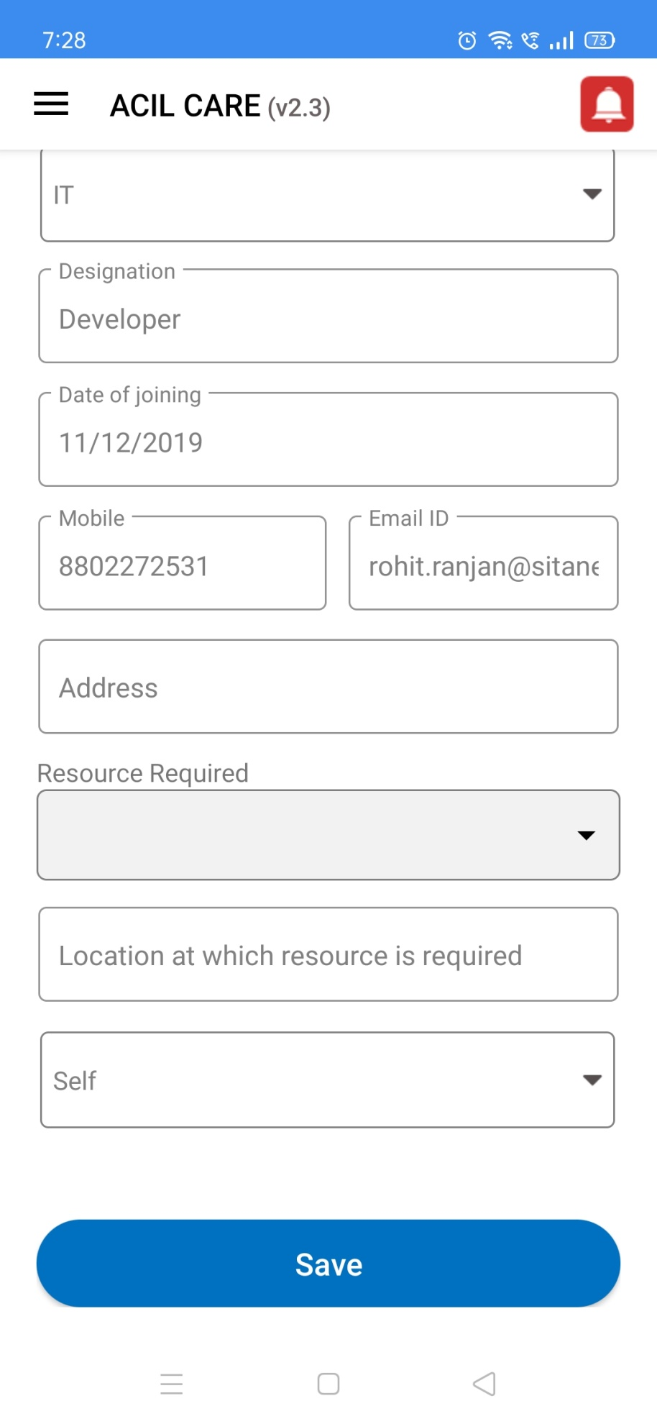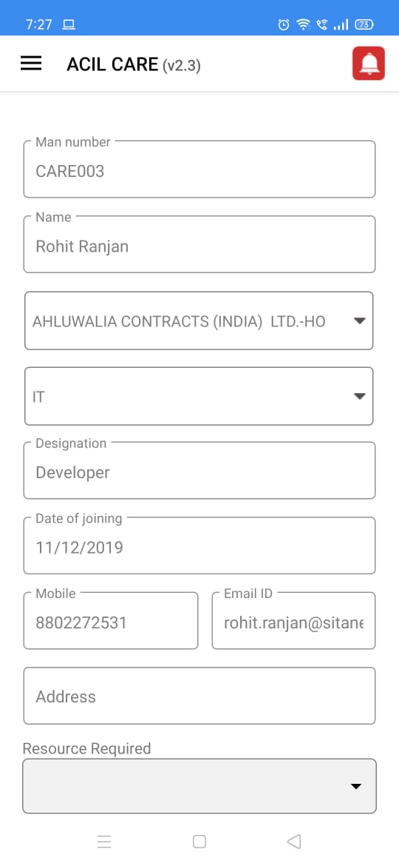

**Screen:12**

