

School of Mechanical Engineering
Industry Academia Networking Conclave
February 3-4, 2023
Numerical Aero-Thermal Investigation of Transonic Turbine NGV and Film Cooling Studies - IANC 2023
Rohit Sunil Kanchi ¹, Srijith. M. S ², Bibin John ^{3*}
^{1, 2, 3} School of Mechanical Engineering, Institution, VIT Vellore
*bibin.john@vit.ac.in
Introduction
• This investigation numerically studies the aero-thermal aspects of fluid flow through a nozzle guide vane inside of a high pressure turbine. Experimental data is available for the chosen blade LS-89 designed at VKI for an exit Mach number of 0.9 and an exit Re of approximately 1e+06.
• The methodology was validated with the available experimental data and aero-thermal investigations were carried out hence forth. Film cooling cases have been validated using the available experimental data as well. Scope of the Project
• Validation of Numerical Data with the available experimental data. • Aero-Thermal studies of flow through the NGV cascade.
• Establish methodology for future studies.
Methodology
Fig.1. An image of the workflow of the methodology followed Fig.2. The VKI test case NGV blade geometry 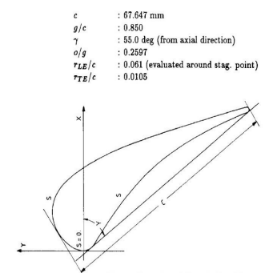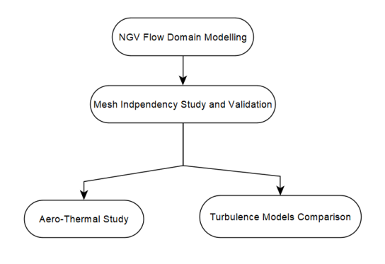
Results
Fig. 8. Mesh independency and validation
study for the Suction Side test case 1
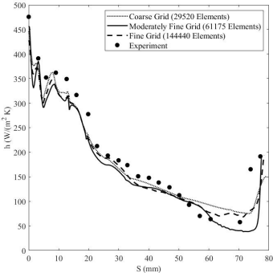
Fig. 10.
Comparison of
the RANS Trans
SST model
prediction with
the experimental
film cooling data
on suction side.
The lines on the
x-axis represent
the cooling hole
location
Fig. 9. Mesh independency and validation study for the Pressure Side test case 1
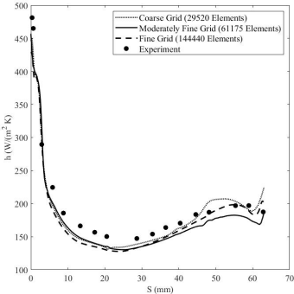
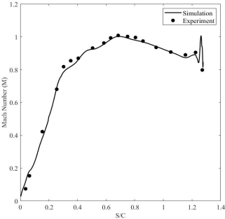
(a)
Fig. 11. Mach
number
distributions
along (a) suction
side and (b)
pressure side for
Fig. 12. the test case 2 Comparison of
Fig.3. The 2-D computational domain
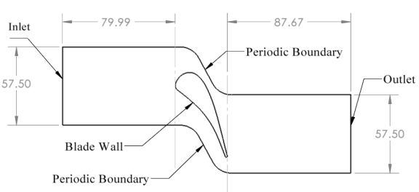
Table. 1. A list of experiments for the validation of the numerical methodology and Aero-Thermal studies
Test Case | Test Type | Exit Re | Exit Mach | Inlet Turbulence Intensity
1 | Blade Heat  Transfer  Coefficient  Distribution | 5e+05 | 0.92 | 1%
2 | Blade Mach  Number  Distribution | 1e+06 | 0.875 | 1%
3 | Blade Mach  Number  Distribution | 1e+06 | 1.02 | 1%
4 | Film Cooling,  Blowing Ratio  (BR) 0.45 Suction Side  BR 1.5 Pressure Side | 1.5e+06 | 0.8 | 4.5%

Fig.4. The 2D structured computational grid for the non-cooled case
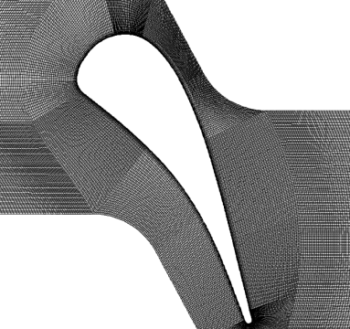
Fig. 5. 3-D computational domain for the film cooling
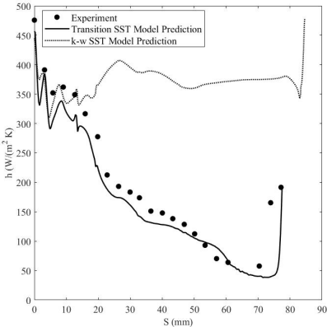
the k-w SST
model prediction with the
Transition SST model prediction and
experimental
data
Fig. 14. The
density
contours for
the film
cooling case
study plotted
at mid-plane
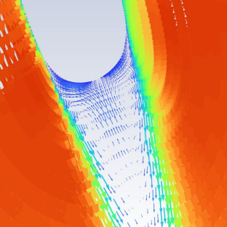
(b) 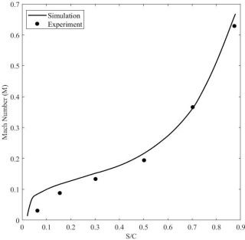
Fig. 13.
A velocity
magnitude vector plot of the wake
region behind the trailing edge
Fig. 6. Film cooling 3-D computational domain without periodicity and plume
case (No Plume shown)
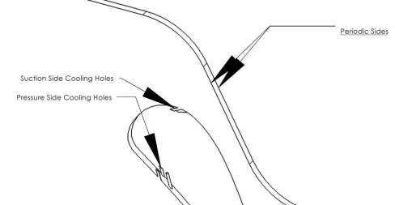Fig. 7. Structured grid of the cooling tubes with plume
Fig. 15. Heat Flux Contours for suction side film cooling
Conclusion
Fig. 16. Schlieren flow visual obtained experimentally (a) and the density gradient based shadowgraph for the test case 3 (b) (a) (b)
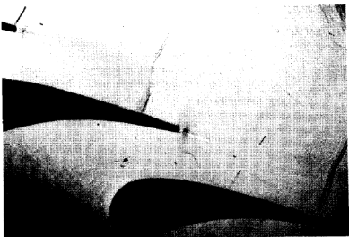
The downstream loss coefficient is given
below in equation 1.
�� = 1 −��₂2
��_{2,����2}…(1)
Where V is the velocity,
subscript “2” means exit condition measured in a plane 16mm aft the trailing edge plane, and
subscript “is” means isentropic flow variable.
The methodology followed lead to an excellent match with the experimental data. A comparison between the k-w SST and Transition SST model revealed the difference in the results created when predicting transitional boundary layer flows numerically. The Transition SST model was hence found to predict transitional flows and the non-cooled and film cooled heat transfer distributions along the blade surface very well in the given transonic NGV. The blade exit angle for the heat transfer case was found to be 72 degrees. The blade loss coefficient “n” based on equation 1 was found to be 0.2 . With film cooling, the heat transfer reduction can clearly be seen in Fig. 10.
Contact: rohitsunil.kanchi2019@vitstudent.ac.in / +91 9108152106References: Arts et al. Aero-Thermal Performance of a 2D Transonic NGV. Fontaneto et al. Aero-thermal performance of a film cooled HPT vane.

