Freight Rate Prediction
Validation approach, data split, diagnostics and December forecast

1. Summary
Task: predict the posted rate of 12,000 loads in Nov-Dec 2025 from 48,000 labelled loads in Jan-Oct 2025. The test period is the future of the development data, so every validation fold trains on the past and scores the next two months.
- Model: LightGBM on log(rate), L1 (median) objective, 5-seed average, 45-day recency weights, a linear daily-market term, and a regime-aware quote_signal feature.
- Forward-CV accuracy (mean of 5 folds, original dollar scale): MAE $111, median absolute % error 1.72%, mean absolute % error 4.73% (2.47% excluding the ~1.4% corrupted labels), R2 0.83. Most recent fold (train Jan-Aug, score Sep-Oct): median 1.33%, MAE $92.
- Reproducibility: full from-scratch run in a new virtualenv regenerated every output identically (section 10); seed counts and configurations per table are listed in section 5.
- Weak spot, stated plainly: August (a month the early folds had never seen) has median error 5.60% versus 1.0–1.8% in other months. Nov-Dec share August's regime, and only one such month exists in the labels, so the test-period error could be higher than the headline.
- December chart: $817-$829 (about $2.29/mile) for the fixed Lexington to Fort Wayne load, produced by the supplied score.py from the same final model as the validation file.

2. Validation design and data split
validation.csv spans 2025-11-01 to 2025-12-31 and train_test.csv spans 2025-01-01 to 2025-10-31, so the test set is entirely after the development data. A random split lets the model see other loads from the same day. With the same model and features, random 5-fold gave a median error of 1.44% versus 2.44% under forward-chaining, so random K-fold overstates accuracy by about 1.7x. It is shown only as a diagnostic.
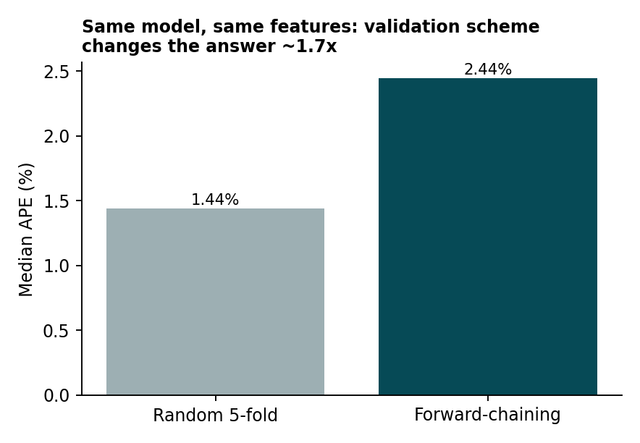
Figure 1. Same model, only the validation scheme differs.
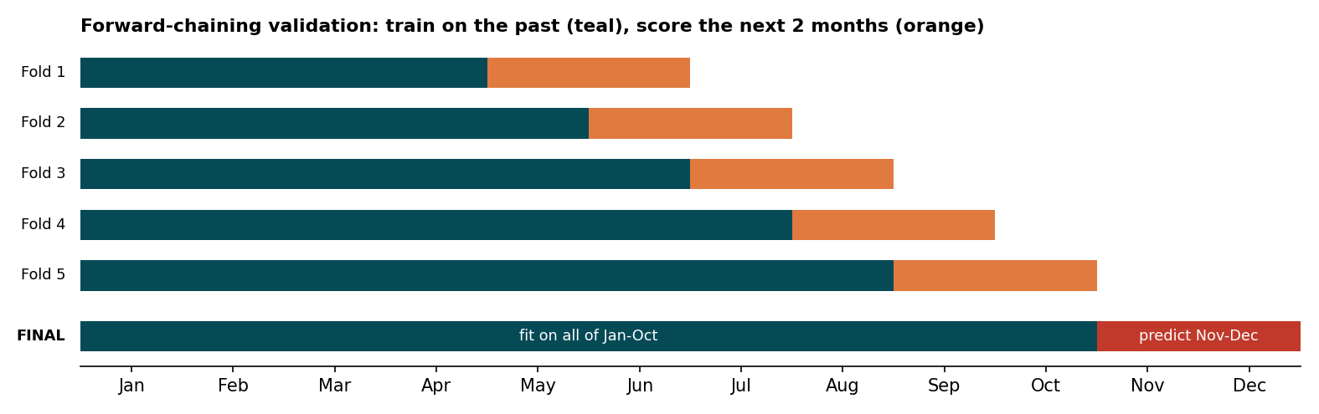
Figure 2. Five forward-chaining folds (train on the past, score the next 2 months); final model fits all of Jan-Oct.
Everything that is learned from labels (the model, recency weights, the market slope) is fitted inside each fold on the training window only. The same cleaning and feature code runs in training, in every fold and at final inference.

2.1 Information-availability assumptions (tested where possible)
- Same-day market level. The daily market level is the mean of market_index over all loads on that date, which assumes the scoring file is a batch whose same-day rows are all available. It uses features only, never labels. Its deviation from the month mean also uses other days of the same month; a strictly causal deployment would use a trailing mean instead. A strictly causal variant was built and tested (Table 1b).
- quote_signal regime. The regime is the skew of quote_signal in a month, computed from features only. I checked whether it is knowable early: using only the first 7 days of each month reproduces the full-month classification in all 12 months, including Nov and Dec (Table 1), so it is available about a week into a month.
Month | Regime (full month) | Skew | Regime (first 7 days) | Agree
1 | positive | 0.87 | positive | yes
2 | positive | 0.95 | positive | yes
3 | positive | 0.86 | positive | yes
4 | negative | -0.79 | negative | yes
5 | negative | -0.84 | negative | yes
6 | positive | 0.86 | positive | yes
7 | negative | -0.82 | negative | yes
8 | noise | -0.01 | noise | yes
9 | positive | 0.88 | positive | yes
10 | negative | -0.94 | negative | yes
11 | noise | -0.01 | noise | yes
12 | noise | 0.01 | noise | yes
Table 1. quote_signal regime by month, full month vs first 7 days.
Variant | 5-fold MAE ($) | 5-fold median % | 5-fold core MAPE % | Aug 16-31 median % | Aug 16-31 MAE ($)
Batch (shipped) | 112.4 | 1.76 | 2.50 | 1.61 | 91
Causal market feature only | 112.5 | 1.78 | 2.52 | 1.71 | 94
Causal regime only | 105.6 | 1.76 | 2.15 | 1.60 | 92
Fully causal (both) | 105.6 | 1.77 | 2.15 | 1.72 | 95
Table 1b. Batch (shipped) vs strictly causal features. 1 seed, 600 trees, same folds and splits as Table 6 and Table 5. Causal = trailing 28-day market mean and month-to-date regime (no signal for the first 4 days of a month).
Making both features strictly causal leaves the five-fold median error essentially unchanged (1.77% vs 1.76%, core MAPE 2.15% vs 2.50%) and is slightly worse on the August noise-regime test (1.72% vs 1.61% median). A deployment that must score loads before the rest of the month exists can therefore use build_day_table_causal at small cost. The shipped predictions use the batch version because the assessment scores one complete file.
- Unseen cities. 8 cities in validation never appear in training (1,447 rows). Forward folds contain none, so this is tested separately by holding out 8 random cities (3 repeats, 1 seed, identical features in both models): median error 1.43% with coordinates and 1.40% without. The model therefore handles unseen cities well, but the coordinates add nothing measurable there; it never uses city IDs, and geography enters through distance. An earlier configuration without quote_signal showed a gap (2.6% vs 3.2%) that does not persist in the final model.

3. Data quality
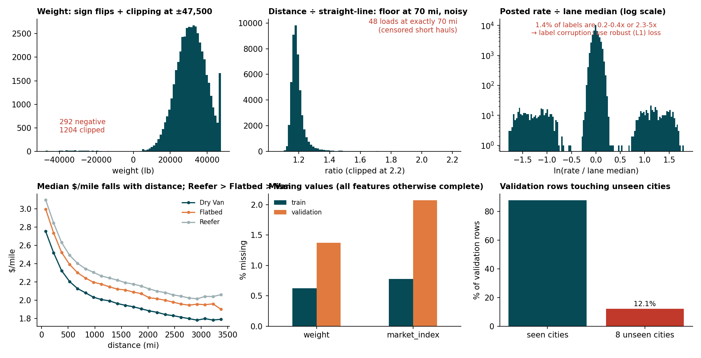
Figure 3. Data-quality panel (training data).
Check | Train | Validation
rows | 48,000 | 12,000
missing weight | 300 | 165
missing market_index | 374 | 249
negative weight | 292 | 145
weight at +/-47,500 | 1,204 | 301
distance == 70 | 48 | 21
duplicate load_id | 0 | 0
rows with unseen cities | 0 | 1,447
Table 2. Counts in both datasets (same issues appear in validation).
Issue | Load | Lane | Evidence | Fix
Negative weight | TR-000069 | Amarillo → Dayton | weight = -36,559 lb | abs() → 36,559
Corrupted label (high) | TR-000389 | Corpus Christi → Chattanooga | rate $5,485 vs lane median $1,753 (3.1x) | L1 loss
Corrupted label (low) | TR-000509 | Las Vegas → Grand Rapids | rate $699 vs lane median $3,576 (0.20x) | L1 loss
Table 3. Concrete examples.
- Weight: negatives are sign flips and become abs(); values at 47,500 are a clipping plateau; missing weight stays NaN and is handled natively by LightGBM. Rows with missing weight are predicted as well as others (median error 1.53% vs 1.58%).
- market_index: the row value is a noisy reading of a daily level, so the model uses the daily mean. A date with no usable reading gets no daily adjustment (dm_dev = 0); tests/check_outputs.py verifies this and finite predictions for missing and negative weights.
- Distance: floor at 70 miles and about 5% noise per lane, so straight-line distance from coordinates is added.
- Corrupted labels: about 1.4% of rates are above 2x or below 0.5x the lane median and are unpredictable from features (AUC 0.50). They stay in the data; the L1 loss limits their influence, and I report all-row metrics alongside "core" metrics (rows with absolute % error below 50%).

4. quote_signal: a regime-aware feature
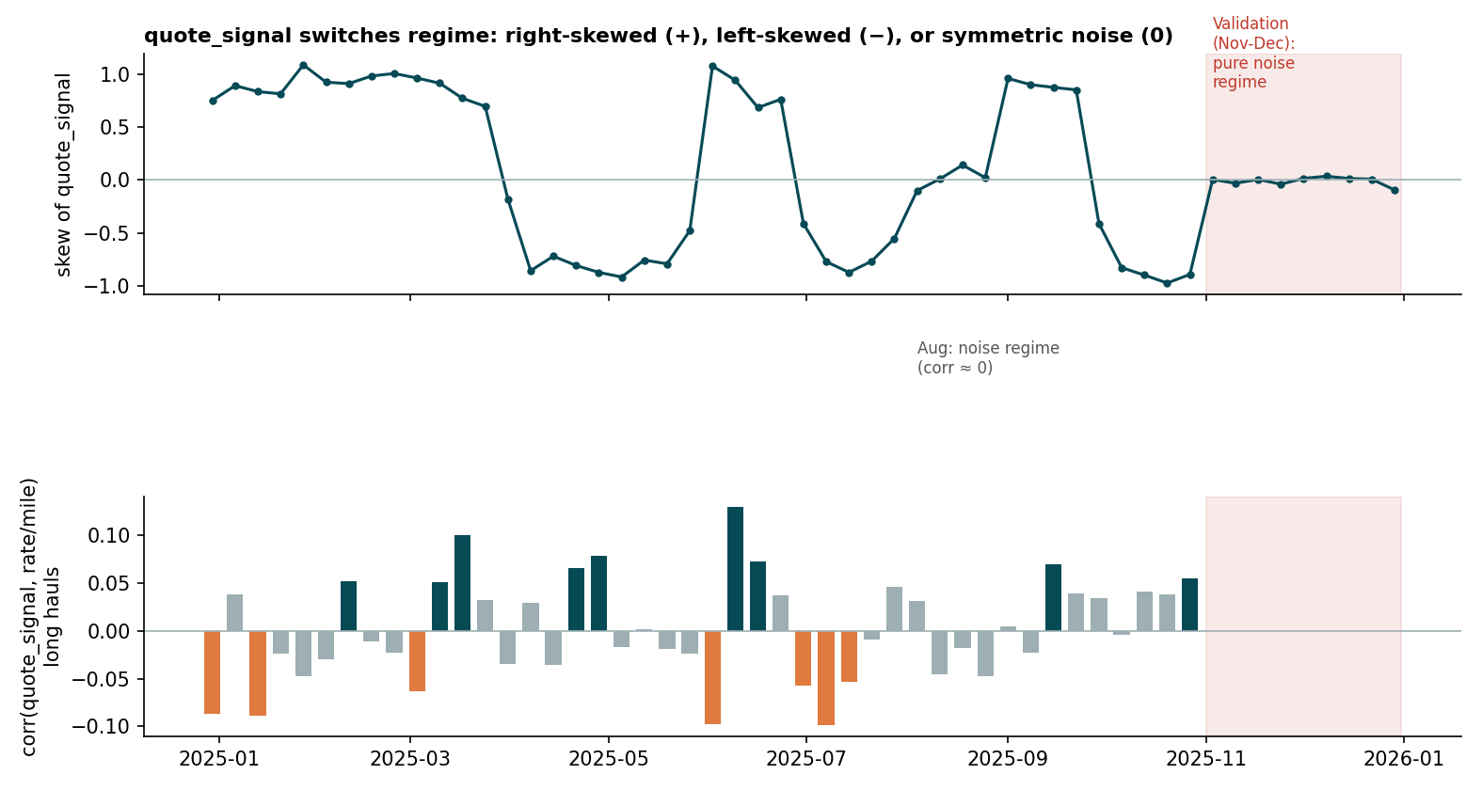
Figure 4. Skew of quote_signal and its correlation with rate per mile on long hauls, by week.
quote_signal is positively related to rate per mile in Jan-Mar, Jun and Sep, negatively in Apr, May, Jul and Oct, and unrelated in August. Nov and Dec look like August. Using it raw therefore mixes opposite effects. The model uses qs_signed = (quote_signal - 2.05) x regime sign (+1, -1, or 0 in noise months), so it learns "no information" when the regime is noise.
How the decision was made. My first version excluded quote_signal after a test that trained on no noise-regime month, which unfairly penalised any model using it. The fairer comparison below uses identical folds, cleaning and metrics for every row. Regime-aware wins on the five forward folds and on the causal noise-regime test; raw inclusion helps on the forward folds but not in the noise regime. Adding a regime indicator on top changed nothing, so the simpler signed-only version is used.
Configuration | 5-fold median % | 5-fold core MAPE % | Aug-only median % | Aug-only core MAPE %
Exclude quote_signal | 2.80 | 3.08 | 3.33 | 3.44
Include raw quote_signal | 2.10 | 2.73 | 4.05 | 4.61
Regime-aware: signed signal only (FINAL) | 1.76 | 2.50 | 5.38 | 6.00
Regime-aware: signed signal + regime indicator | 1.51 | 2.35 | 5.41 | 6.07
Table 4. 1 seed, 600 trees. Five forward folds, plus an August-only fold trained on Jan-Jul (no noise month in training, so it is unfavourable to regime-aware by construction).
Configuration | Test window | Noise rows in train | Test rows | MAE ($) | Median % | Core MAPE %
Exclude quote_signal | Aug 16-31 | 2,313 | 2,446 | 110 | 2.45 | 2.63
Exclude quote_signal | Aug 9-31 | 1,268 | 3,491 | 124 | 2.78 | 2.97
Include raw quote_signal | Aug 16-31 | 2,313 | 2,446 | 117 | 2.55 | 2.86
Include raw quote_signal | Aug 9-31 | 1,268 | 3,491 | 134 | 2.94 | 3.40
Regime-aware (FINAL) | Aug 16-31 | 2,313 | 2,446 | 91 | 1.59 | 1.88
Regime-aware (FINAL) | Aug 9-31 | 1,268 | 3,491 | 99 | 1.64 | 1.98
Regime-aware + indicator | Aug 16-31 | 2,313 | 2,446 | 90 | 1.59 | 1.87
Regime-aware + indicator | Aug 9-31 | 1,268 | 3,491 | 99 | 1.61 | 1.96
Table 5. Fairer causal noise-regime test: the model has seen part of August before being scored on the rest of it.
Caveat: Table 5 tests August on August, so it shows the model can use a noise month it has seen, not that Nov-Dec behave identically. The regime-aware choice remains a hypothesis supported by the evidence above.

5. Model
Features: log distance, distance, straight-line distance, equipment, absolute weight, pickup/delivery coordinates and qs_signed (importance: ldist 48%, hav 13%, qs_signed 13%, dist 10%). LightGBM on log(rate) with an L1 objective (the median is robust to corrupted labels; L2 was clearly worse), 15 leaves, lambda 5, 1,000 trees at learning rate 0.03.
Results | Evaluation | Model configuration
Tables 1b, 4, 6, 7 (comparisons) | 5 forward folds (+ August splits for 1b) | 1 seed, 600 trees, lr 0.04
Table 5 (noise-regime test) | 2 causal splits inside August | 2 seeds, 600 trees, lr 0.04
Table 8 (seeds) | 5 forward folds | 1 vs 3 seeds, 600 trees
Table 9, Figures 5-6, Tables 10-13 (headline CV) | 5 forward folds | 3 seeds, 1,000 trees, lr 0.03, 15 leaves
Final model (predictions) | fit on all of Jan-Oct | 5 seeds, 1,000 trees, lr 0.03, 15 leaves
Seed counts differ by design: comparisons use the cheaper 1-seed protocol, so the FINAL row of Table 6 (1.76% median) differs slightly from the 3-seed headline in Table 9 (1.72%).
Variant (same 5 forward folds, 1 seed) | MAE ($) | Median % | Mean % | Core MAPE %
Naive: median $/mile by equipment x distance bin | 157.6 | 4.11 | 6.73 | 4.52
LightGBM, no recency, no market term, no quote_signal | 137.3 | 3.19 | 5.64 | 3.42
+ daily market term (dm_dev) | 135.1 | 3.09 | 5.56 | 3.34
+ recency weights (excludes quote_signal) | 127.8 | 2.80 | 5.35 | 3.08
+ regime-aware quote_signal (FINAL model) | 112.4 | 1.76 | 4.77 | 2.50
Final but L2 objective (mean, not median) | 129.5 | 2.42 | 5.50 | 3.24
Base + raw quote_signal (not regime-aware) | 118.1 | 2.10 | 4.99 | 2.73
Final + dm_dev as a tree feature | 116.5 | 1.99 | 4.88 | 2.63
Final without weight | 114.7 | 1.80 | 4.91 | 2.65
Table 6. Ablations. The FINAL row is the production configuration with one seed.
Recency half-life | MAE ($) | Median % | Core MAPE %
none | 117.5 | 1.86 | 2.82
21 days | 110.9 | 1.74 | 2.37
45 days | 112.4 | 1.76 | 2.50
90 days | 115.0 | 1.81 | 2.68
180 days | 116.4 | 1.84 | 2.75
Table 7. Half-life sweep. 21 and 45 days are within noise of each other; 45 is kept.
Seeds | MAE ($) | Median % | Core MAPE %
1 seed(s) | 112.4 | 1.76 | 2.50
3 seed(s) | 111.7 | 1.73 | 2.48
Table 8. Seed averaging gives only a small, measurable gain; the final fit uses 5 seeds for stability.

6. Forward-chaining results
Fold | Train rows | Val rows | MAE ($) | Median % | Mean % | Core MAPE % | R2 | Market slope
2025-05→2025-07 | 19,110 | 9,696 | 93 | 1.40 | 3.90 | 1.64 | 0.83 | 0.025
2025-06→2025-08 | 24,023 | 9,695 | 90 | 1.10 | 3.41 | 1.34 | 0.82 | 0.022
2025-07→2025-09 | 28,806 | 9,671 | 140 | 2.22 | 6.10 | 3.89 | 0.82 | 0.028
2025-08→2025-10 | 33,718 | 9,429 | 143 | 2.57 | 6.12 | 3.90 | 0.83 | 0.036
2025-09→2025-11 | 38,477 | 9,523 | 92 | 1.33 | 4.12 | 1.56 | 0.83 | 0.063
Mean |  |  | 111 | 1.72 | 4.73 | 2.47 | 0.83 | 0.035
Table 9. Headline configuration: 3 seeds, 1,000 trees (the final predictions use 5 seeds). The two weakest folds are those whose validation window contains August, a regime not yet seen in training. The market slope is not constant (about 0.02 to 0.06), unlike an earlier model without quote_signal.
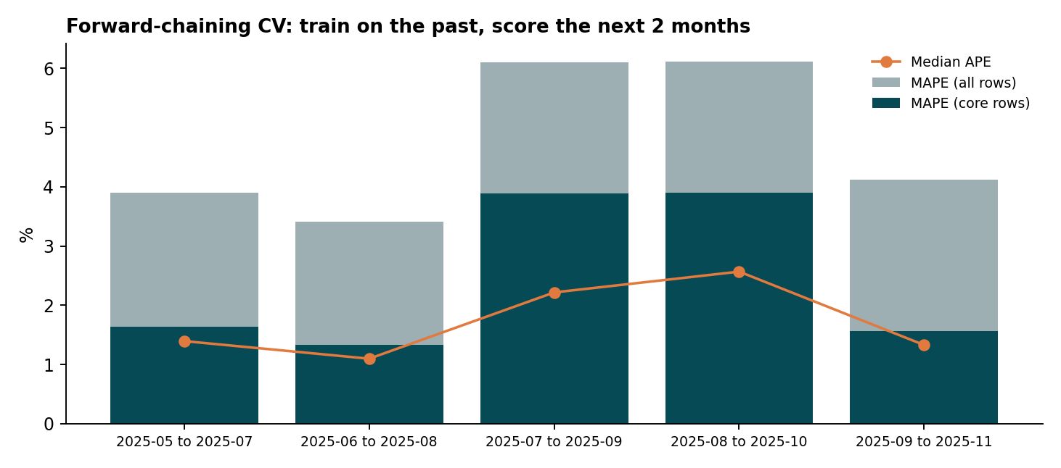
Figure 5. Error by fold.
Metric definitions. MAE = mean |pred - actual| in dollars; RMSE = root mean squared dollar error; MAPE = mean |pred - actual| / actual; MedAPE = median of the same ratio; core MAPE and core MAE are computed on rows whose absolute % error is below 50% (about 98.6% of rows), which removes the corrupted labels; R2 = 1 - SSE/SST on dollars. Unfiltered results are always shown next to core results.

7. Diagnostics by subgroup
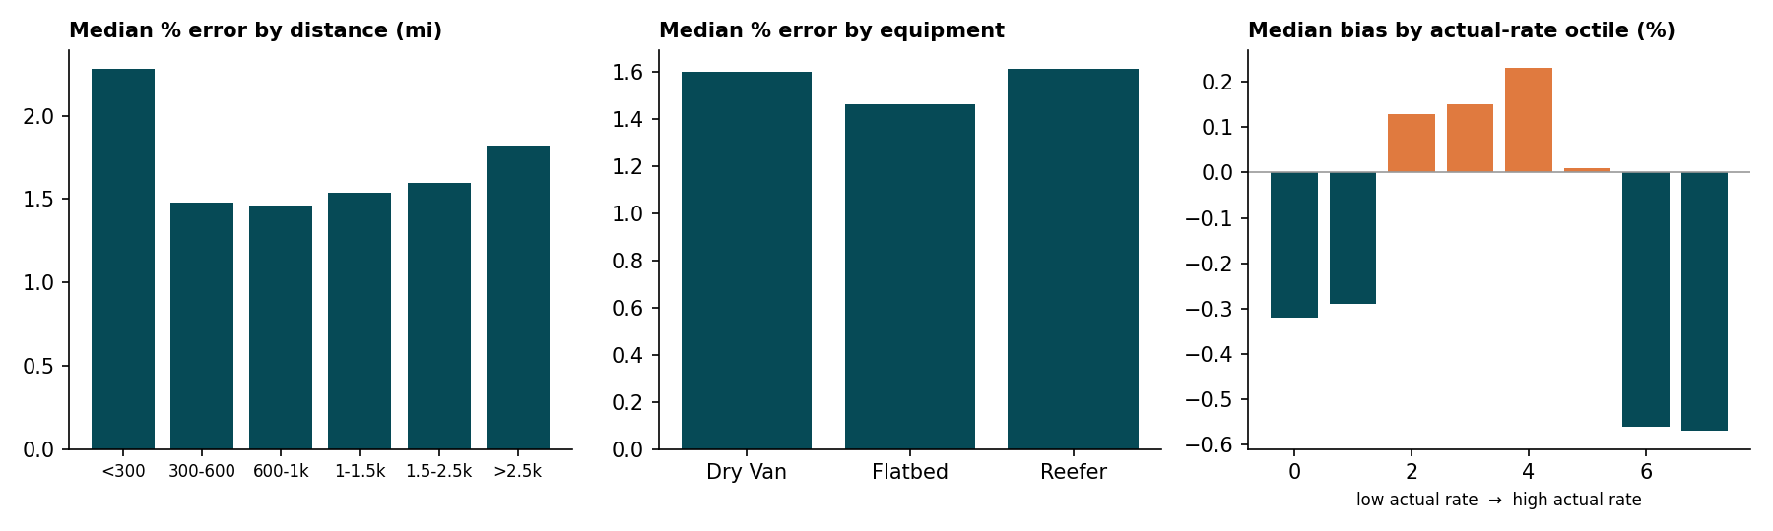
Figure 6. Error by distance, equipment and actual-rate octile (forward-fold predictions of the 3-seed headline configuration).
Month | Rows | MAE ($) | Median % | Mean % | Median bias %
2025-05 | 4,913 | 92 | 1.80 | 4.45 | -1.74
2025-06 | 9,566 | 93 | 1.04 | 3.33 | -0.12
2025-07 | 9,824 | 87 | 1.18 | 3.51 | -0.88
2025-08 | 9,518 | 193 | 5.60 | 8.54 | -0.64
2025-09 | 9,340 | 94 | 1.70 | 3.92 | 1.60
2025-10 | 4,853 | 89 | 1.03 | 4.26 | 0.06
Table 10. By validation month. August stands out.
Distance (mi) | Rows | MAE ($) | Median % | Mean % | Median bias %
0–300 | 4,018 | 31 | 2.28 | 5.54 | -0.87
300–600 | 9,474 | 49 | 1.48 | 4.88 | -0.60
600–1000 | 11,919 | 77 | 1.46 | 4.49 | -0.29
1000–1500 | 8,959 | 114 | 1.54 | 4.04 | 0.12
1500–2500 | 10,972 | 195 | 1.60 | 4.90 | 0.29
2500–5000 | 2,672 | 258 | 1.82 | 5.51 | 0.42
Table 11. By distance bucket.
Equipment | Rows | MAE ($) | Median % | Mean % | Median bias %
Dry Van | 27,212 | 117 | 1.60 | 4.73 | 0.12
Flatbed | 8,694 | 93 | 1.46 | 4.40 | -0.29
Reefer | 12,108 | 113 | 1.61 | 4.94 | -0.60
Table 12. By equipment.
Actual rate octile | MAE ($) | Median % | Mean % | Median bias %
$60–$887 | 72 | 2.09 | 14.90 | -0.56
$887–$1,272 | 45 | 1.45 | 4.22 | -0.57
$1,272–$1,662 | 39 | 1.40 | 2.71 | -0.32
$1,662–$2,059 | 48 | 1.48 | 2.60 | -0.29
$2,059–$2,562 | 51 | 1.51 | 2.24 | 0.13
$2,562–$3,389 | 77 | 1.59 | 2.60 | 0.15
$3,389–$4,232 | 104 | 1.57 | 2.72 | 0.23
$4,232–$24,295 | 453 | 1.68 | 5.77 | 0.01
Table 13. By actual rate. The lowest octile has a very high mean % error because corrupted low labels (0.2-0.4x) are unpredictable; the median error there is close to the others.
Overall median bias is -0.15% (no systematic over- or under-prediction), errors are broadly even across distance and equipment (short hauls under 300 miles are weakest), and the main error concentration is by month, i.e. the rate level, not by load type.

8. Fixed December prediction
Route: Lexington to Fort Wayne, 360 miles, Dry Van, 32,000 lb. December inputs carry no market_index or quote_signal, so each date's market deviation comes from the validation file's loads for that date and the regime is noise (qs_signed = 0). The completed file is december_chart_inputs.csv; the chart below is the unmodified output of the supplied score.py run on it with validation_predictions.csv.
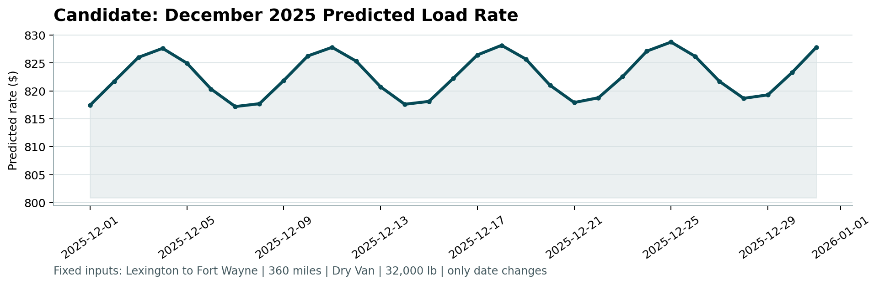
Figure 7. candidate_december.png produced by score.py.
Predictions range from $817 to $829 and follow the weekly market cycle. The model has no information about holiday effects, so no December-specific dip or spike appears.
Treat this as a model estimate, not a market quote. Across the forward-fold predictions the median absolute error is 1.6% (about ±$13 on this load), 80% of loads fall within 3.4% (about ±$28) and 90% within 6.5%. In August, the one noise-regime month, the median error was 5.6% and 80% of loads fell within 10.1% (about ±$83). Nov-Dec share that regime and holiday effects are not modelled, so the August-like band is the safer expectation for December.

9. Limitations
- The December rate level is extrapolated from recent months; seasonal effects absent from Jan-Oct are not captured.
- Only one noise-regime month exists in the labels, so the regime-aware gain for Nov-Dec is supported but not proven.
- The shipped daily-market and regime features assume the whole scoring file is available (offline batch); a strictly causal version is provided and tested (Table 1b) at small cost.
- About 1.4% of labels are corrupted; mean % error cannot fall far below about 2.5% even for a perfect model of typical loads. Laredo coordinates lie outside the training range.

10. Reproduce
python -m pip install -r requirements.txt (pinned; tested in a clean Python 3.12 virtualenv). Then: python run_pipeline.py (about 25 minutes on one core), python score.py --predictions validation_predictions.csv --december-predictions december_chart_inputs.csv, python scripts/diagnostics.py, python scripts/noise_regime_test.py, python tests/check_outputs.py. The --quick flag runs 1-seed CV into outputs_quick/ and is not the final-model metrics; the final fit and predictions always use 5 seeds.
Verification. The complete pipeline and every script were run from scratch in a newly created virtualenv built from requirements.txt (Python 3.12, pandas 2.2.3, numpy 2.1.3, LightGBM 4.5.0). Validation predictions, the completed December file, all CV tables, ablations and diagnostics regenerated with a maximum difference of 0, and the scorer chart was pixel-identical. This was verified on one machine and software stack; other library builds could differ in the last decimals.

