Multilayer Perceptron

A multilayer perceptron is composed of multiple layers of interconnected neurons.
Multiple artificial neurons in a neural network are arranged in different layers:
It consists of the following layers:
- The first layer is known as the input layer and the last layer is known as the output layer.
- The layers in between are known as hidden layers.
- The number of neurons in the input layer is equal to number of attributes/ features in the data set.
- The number is the output layer is equal to the number of classes in the target variable for classification problems.
- The number of neurons in output layer for regression problem is equal to one.

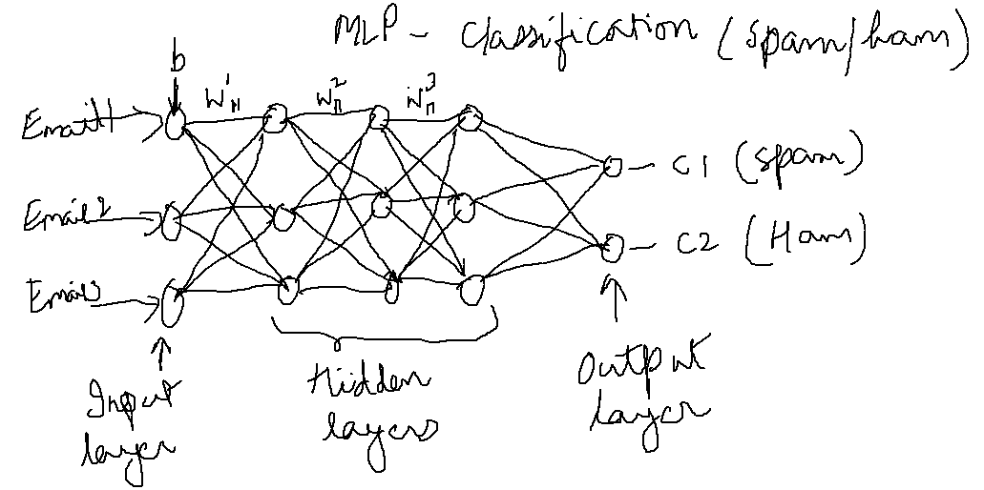

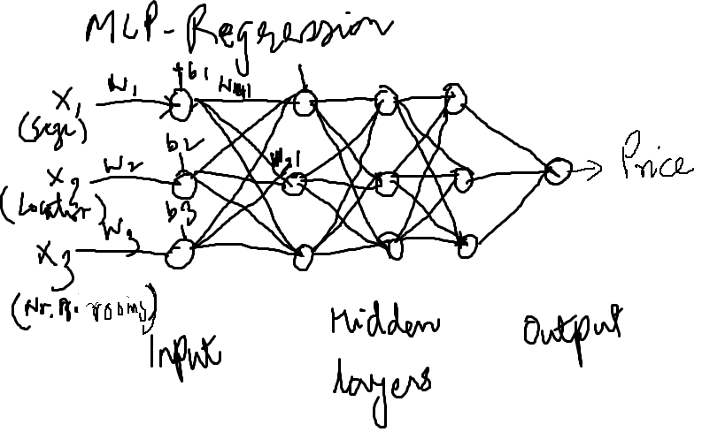

Assumptions of MLP or Neural Networks.

- The neurons are arranged in layers, and these layers are arranged sequentially.
- The neurons within the same layer do not interact with each other.
- The inputs are fed through the input layer and outputs are send out through the output layer.
- Neurons in consecutive layers are densely connected, i.e. all neurons in layer i are connected to all neurons in layer i+1.
- Every neuron has a bias associated with it and every interconnection has a weight associated with it.
- All neuron in a particular hidden layer has an activation function. Different hidden layers can use different activation function.

Topology for MLP (ANN)
There are six main elements that must be specified for any ANN:
- Input layer
- Output layer
- Hidden layers
- Network topology or structure
- Weights and biases
- Activation Functions.

Activation Functions

Sigmoid Function: Output is bound between 0 and 1 , and not centered around zero. Binary classification when you have two classes.
Tanh: The output is centered around zero and between 1 and -1.
ReLU (Rectified Linear Unit): When the input is positive it is linear in nature and it becomes zero when output is negative. It allows the network to converge very quickly. It does not help the network to learn when the output is negative.
Leaky ReLU: It is similar to ReLU, however it allows the network to learn even when the output is negative.
Softmax function: Used for multi-class classification
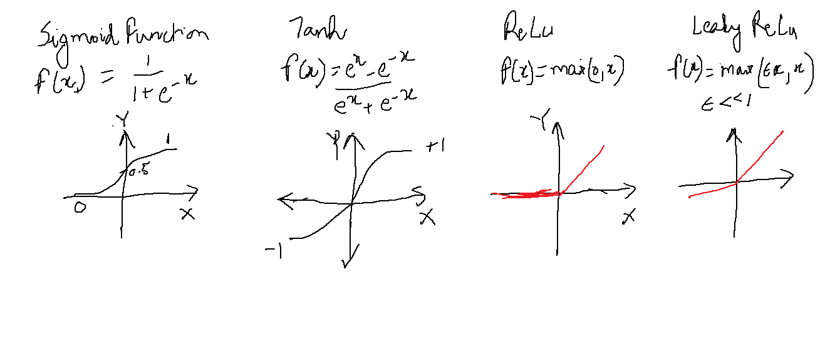

Parameters and Hyper-parameters:
Parameters:
These are learned during the neural network training.
Parameters are weights and biases.

Hyper-parameters:
The learning algorithm is trained with a fixed set of hyper-parameters.
Number of layers,
Number of neurons in input, hidden and output layers.
Learning rate (step size for updating weights and biases)
Number of epochs (number of times the entire training data passes through the neural network)

