Artificial Neural Network

What is ANN:
The understanding of Biological Nervous system (BNS) inspired the concept of ANN (Artificial Neural Networks).
BNS is a massive interconnection of nodes called Neurons located within the brain. These neurons can process and transmit signals. Biological neurons respond to both chemical and electrical signals to create the Biological Neural Network(BNN). The input and output signals can be either be excitatory or inhibitory meaning that they can either increase or decrease the potential of the neuron to fire.
ANN consists of numerous interconnected processing elements called neurons to solve specific problems. ANN is based on biological neurons but it is a mathematical function. It takes inputs in the form of binary values i.e. 0 or 1, meaning that it can be either be on or off. The output is determined by applying a threshold function to the sum of input values.
The key idea behind ANN is that they can take lot of data, process it in parallel and provide accurate output just as human brain does.

Perceptron:
Most basic concept of Deep Learning and Machine Learning, is the elementary unit of ANN. Perceptron is a single layered neural network.

Components of Perceptron:

- Inputs: A set of values or a dataset for predicting the output value. These are described as dataset features.
- Weights: It tells the importance of each feature in predicting the final value. Features with lesser weights have low significance. High weighted features have high predicting power.
Weights can be positive or negative.
- Bias: It is used to shift the activation function to right or left. It is analogous to the y-intercept in the straight line equation.
- Summation Function: Binds the weights and inputs together. It is a function to find their sum.
- Activation Function: This is required to introduce non-linearity.

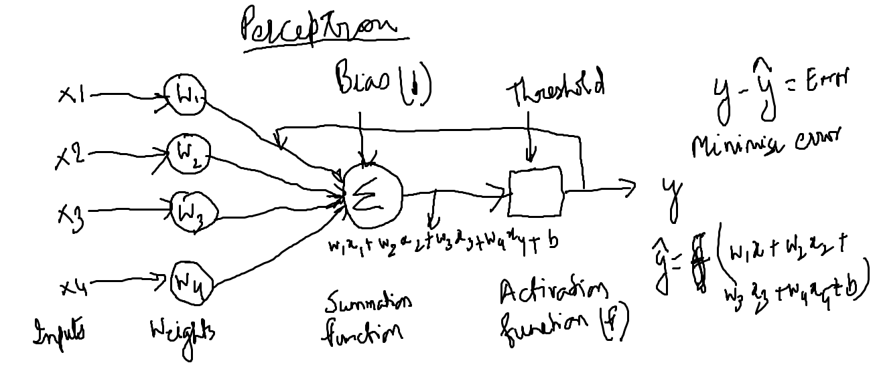

Weights and biases are the parameters that the network learns through iteration.
Error = Actual(y) – Predicted
Actual(y) is the observations.
y(predicted) = w1x1+w2x2+w3x3+w4x4+b
Error is minimized by updating the values of weights and biases using gradient descent process.

A single layer perceptron is the simplest type of ANN. It includes a feed-forward network that can analyze the linearly separable objects. So due to the inability of the single layer perceptron to solve non-linear separable cases, the learning process with never reach the point where all cases are correctly classified. This was resolved by discovery of multi-layer perceptron.

