Convolution:
It is the summation of element-wise product of two matrices.

X
1 | 2 | 3
4 | 5 | 6
7 | 8 | 9

Y
7 | 8 | 9
4 | 5 | 6
3 | 1 | 2

Z
1*7 | 2*8 | 3*9
4*4 | 5*5 | 6*6
7*3 | 1*8 | 9*2

7+16+27+16+25+36+21+8+18=

How Convolution Networks Learn?
There are four operations in image detection/classification
- Convolution
- Stride and Padding
- Feature Maps
- Pooling

Convolution:
The main purpose of convolution is to detect the features in images such as Edges, lines, color drops. Once it has learned a characteristic at a specific point in the image, it can recognize it later in any part of it.
CNN make use of filters (also known as kernels or feature detectors) to detect the features. A filter is a matrix of values. These values are called weights that are trained to detect the features. The filter moves over each part of the image to check if the particular feature is present. The filter carries out a convolution operation which is the summation of element-wise product of two matrices
When the feature is present in part of an image, the convolution operation between that part of image and filter will result in high value. If the feature is not present then the resulting value is low.

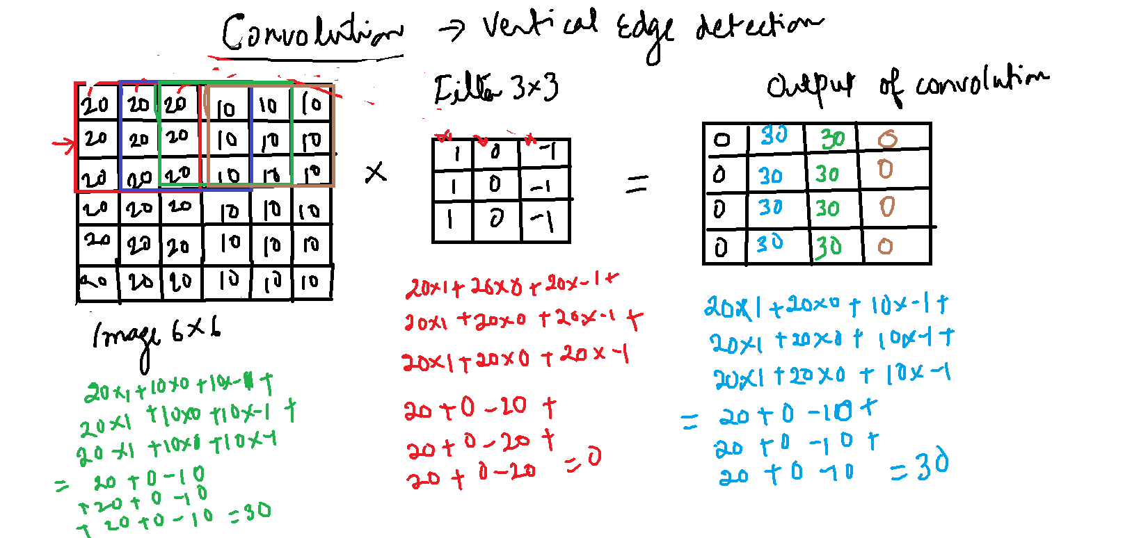

A convolution is the simple application of a filter to an image. Repeated application will result in a feature map.
CNN can automatically learn a large number of filters. The result is highly specific features that can be detected anywhere in the image.
Convolution neural network apply a filter to an input to create a feature map that summarizes the presence of detected features in the input.
Filter is applied symmetrically to each overlapping part of the filter sized patch from the input data, left to right and then top to bottom.

