LSTM (Long Short Term Memory)

LSTM is characterised by the following three main properties:
- The cells have an explicit 'memory'
- The gating mechanisms
- Constant error carousel

Reference:
https://colah.github.io/posts/2015-08-Understanding-LSTMs/

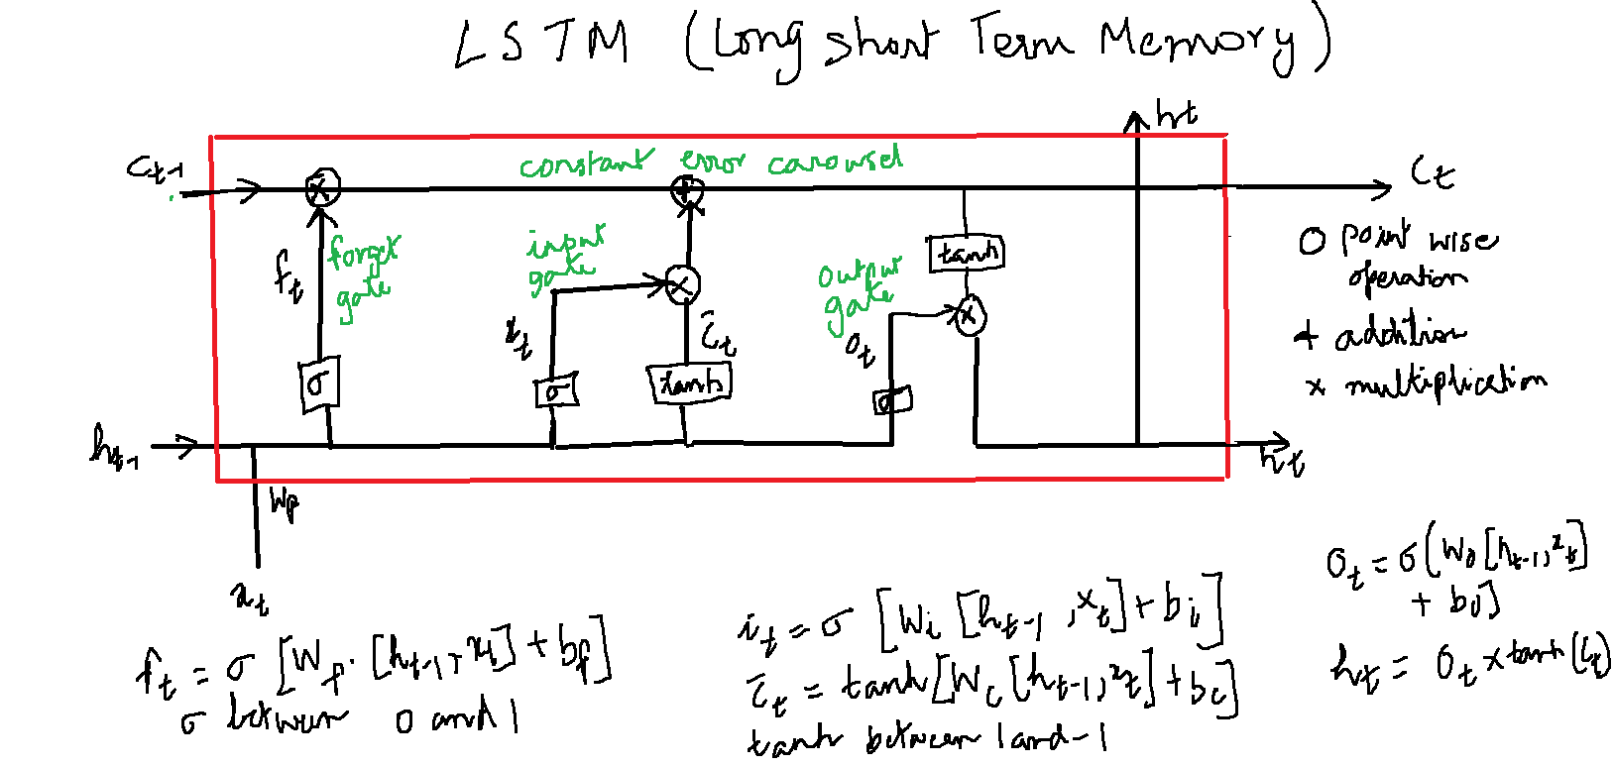

Optimizers
https://keras.io/api/optimizers/

