RNN Introduction
A recurrent neural network (RNN) is a type of artificial neural network which uses sequential data or time series data.
These deep learning algorithms are commonly used for ordinal or temporal problems, such as language translation, natural language processing (nlp), speech recognition, and image captioning; they are incorporated into popular applications such as Siri, voice search, and Google Translate.
Like feed-forward and convolutional neural networks (CNNs), recurrent neural networks utilize training data to learn.
They are distinguished by their “memory” as they take information from prior inputs to influence the current input and output.
While traditional deep neural networks assume that inputs and outputs are independent of each other, the output of recurrent neural networks depends on the prior elements within the sequence.

Sequential data is where there is a natural notion
Text (sequence of words)
Videos (sequences of images)

What are sequences?
In sequential data , entities occur in a particular order. If you break the order it is no longer meaningful. Eg : Sequence of words that make up a document. Sequence of images which make up a video.

RNN Architecture:
RNN have input, output and hidden layers but now the neurons are connected to themselves through time. The idea behind this is neurons have some short term memory.
The main difference between ANN and RNN is that RNNs have two dimensions – time t (along the sequence length) and the depth (usual layers).
The output of any layer at time t will depend on two things:
- Output of previous layer at the same time step.
- Output of its own previous time step
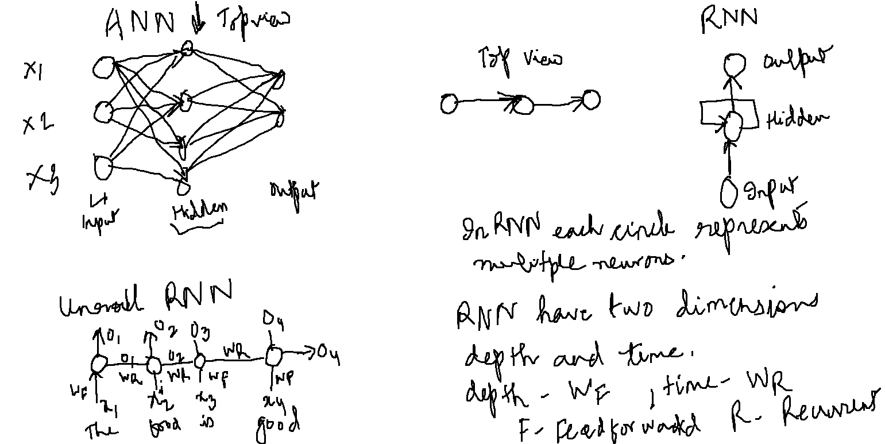

Types of RNN

Many to one RNN:
Input is a sequence and output in a single element. Eg : Classifying a sentence as grammatically correct / incorrect.

Many to Many RNN:(Equal length input and output).
Input and output both are sequence. Eg Part of speech tagger.

Many to many (unequal input and output)
Input and output both are sequence but lengths of input and output are different. Eg : machine translation Length of English sentence can be different from Hindi sentence.

One to many RNN:
Input is a single entity and output is a sequence. Eg Generative model , given a genre generating music, generating an image given a keyword.
