Recurrent Neural Network

Training
Many to one: output is a single element. Loss is simply the difference between predicted and actual.
Many to many RNN: Network emits an output at each timestep. Loss is calculated at each timestep.
Total loss= sum of all losses at each time step. Total loss is back propagated into the network after entire sequence has been ingested.

Issue

Vanishing and Exploding Gradients.

In a machine translation task , RNN have to learn the long term dependencies between first word and last word. Learn the grammar of the language. This is done through the recurrent layer. Each state learns the cumulative knowledge.

Output depends upon the depth and also time.

Thus the loss at any time step t will depend on all inputs and weights that appear before time t. If you change the weight at any time step all subsequent output will be affected.
Gradient of loss at any time step needs to be propagated through all time steps and all layers.
This is called back propagation through time (BPTT).

You have to calculate Gradient of subsequent layers with previous layer. This quantity depends linearly on recurrent weight.
The longer the sequence the higher the number of times you need to multiply the recurrent weight will be more.

Recurrent weight is less than one: Value will become smaller and smaller. This is called vanishing gradient problem.
Recurrent weight is larger than one: Value will become larger and larger. This is called exploding gradient problem.
This will impede the learning process of the RNN.

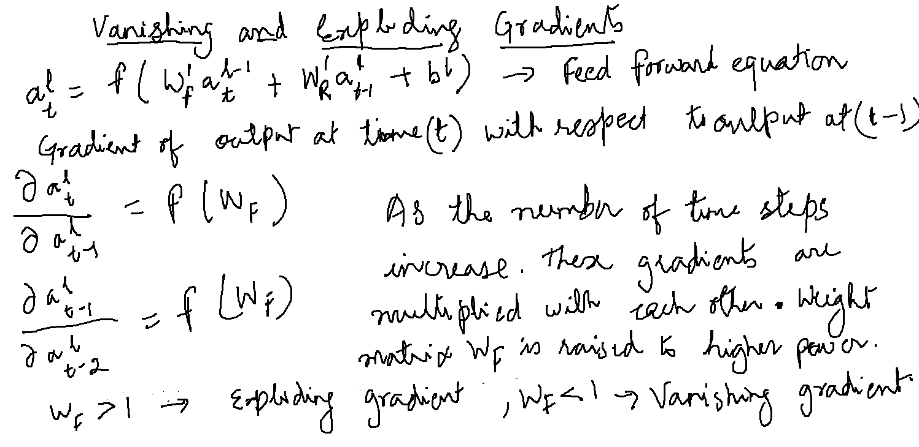
Possible solutions:
Gradient clipping : By controlling the maximum value of gradient.
Use short sequences rather than long sequences.
There are different variants of RNN like LSTM (long short term Memory) and GRU (Gated Recurrent Units). These variants can handle this kind of problem.

