RNN Trainable Parameters.

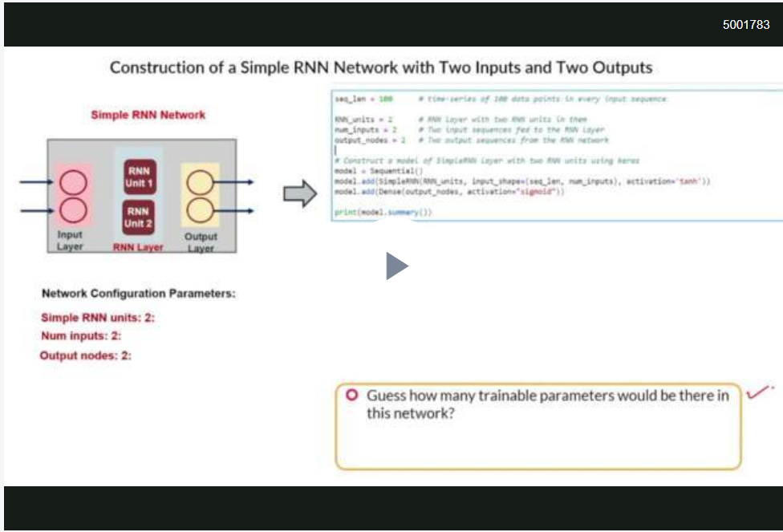

So you saw that output layer parameters are due to the dense connections between the output layer and the RNN layer (hidden layer). Output parameters will only be present when we add an explicit output layer on top of RNN layer. Since it will be a dense connection, you can get the number of output parameters in the following way.
Number of output layer weights = Number of RNN units * Number of output nodes
Number of biases = Number of output nodes

Now, let’s learn about the parameters involved with the input layer as well as the RNN layer.

So, you learnt the following formula to calculate the number of parameters for a particular type of layer.
Number of input weights = Number of input features * Number of RNN units
Number of recurrent weights = Number of RNN units * Number of RNN units
Number of biases = Number of RNN units

Summing all of the aforementioned parameters, you can get the total number of parameters for a model. Let’s understand through an example. Assuming we have an RNN network with 4 input features, then 5 RNN units and then 3 output labels. Note that there will be an output layer as well because it is a classification problem depicted by output labels.
Number of input weights = Number of input features * Number of RNN units
= 4 * 5 = 20

Number of recurrent weights = Number of RNN units * Number of RNN units
= 5 * 5 = 25

Number of biases = Number of RNN units
= 5

Number of output layer weights = Number of RNN units * Number of output nodes
= 5 * 3 = 15

Number of biases = Number of output nodes
= 3

Hence total parameters = input parameters + recurrent parameters + output parameters
= 20 + (25 + 5) + (15 + 3) = 68

Just like the ANNs, the dimensions of the weights and biases in RNNs will be dependent upon the number of input features, number of hidden RNN units and number of output nodes. In the network we used above, considering that each input will be a single numeric value hence overall dimensions (1x4), the input weights will be of dimension (4x5). Similarly the recurrent weights will have dimensions (5x5), the recurrent bias (1x5) and Output weight will be a matrix of dimension (5x3).

