Implementation Report:
task2_retriever_module.py
Queries are provided in the list of queries – query_list.txt
Below processing is done for one query at a time. From inverted indices weight of each query term, dij is calculated using the formula, where fik is the frequency of the kth term in ith document. N = total number of documents in the corpus. Nk = Number of documents the term can be found

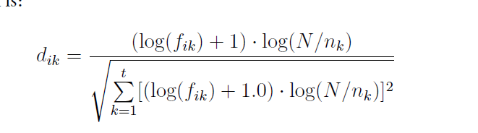

The results from this is used to create a document vector and each term weight for each document is stored in a data structure provided by python dictionary.
Similarly, a query vector is calculated for the given query.

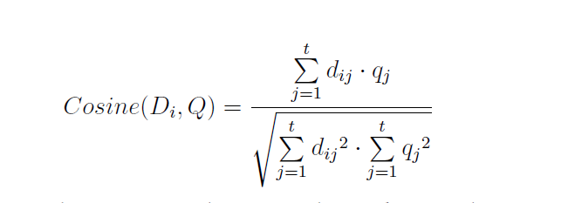
Using the above formula cosine similarity is calculated for each document for the current query, and the results are sorted and written to a file for each query.

